

**MILITARY INSTITUTE OF SCIENCE AND TECHNOLOGY**

**SMART ROOF CONTROL**

**ARDUINO PROJECT**

**CSE 306**

**MICROPROCESSOR, MICROCONTROLLER AND ASSEMBLY LANGUAGE SESSIONAL**

**GROUP 06**

**SUBMITTED BY:**

**202114014 - Aunindya Prosad Saha**

**202114025 - G M Fahim Tazwar**

**202114052 - Md Raiyan Buhiyan Loreen**

**202114072 - Nahiyan Ashraf Siddique**

**TABLE OF CONTENTS:**

|  |  |  |
| --- | --- | --- |
| **SL NO.** | **TOPICS** | **PAGE NO.** |
| **1** | Introduction | iii |
| **2** | Functionalities | iii |
| **3** | Components | iv |
| **4** | Methodology | v, vi |
| **5** | Outcome | vii |
| **6** | Contribution | viii |

**INTRODUCTION:**

The Smart Roof Control System is an innovative, Arduino-based project designed to automate the protection of outdoor clothing during rain while promoting sustainable water use. By integrating a rain sensor, servo motor, and submersible pump, the system ensures an immediate response to rainfall, retracting a roof to shield clothes from getting wet.

Simultaneously, rainwater is collected and stored for future irrigation. The submersible pump, controlled via a relay module, repurposes the stored water to hydrate plants, combining convenience with environmental responsibility. This intelligent system not only simplifies daily tasks but also contributes to efficient water management, aligning with eco-friendly practices.

**FUNCTIONALITIES:**

1. Rain Detection and Roof Deployment:
   * Rain Sensor: The system is equipped with a rain sensor that detects the presence of raindrops in real time.
   * Servo Motor: Upon detecting rain, the sensor sends a signal to the Arduino, which triggers the servo motor.
   * Automated Roof Mechanism: The servo motor controls a retractable roof mechanism. When rain is detected, the roof automatically extends over the area where clothes are hung, shielding them from getting wet.
2. Rainwater Collection and Plant Irrigation:
   * Water Collection: Rainwater is efficiently collected and stored in a reservoir.
   * Submersible Pump with Relay Module: The system utilizes a submersible pump, controlled by the Arduino through a relay module, to manage water flow.
   * Automatic Irrigation: The stored rainwater is repurposed to irrigate plants. The Arduino can be programmed to pump water at specific intervals or based on soil moisture levels (if a soil moisture sensor is integrated).

**COMPONENTS:**

|  |  |  |
| --- | --- | --- |
| **SL NO** | **COMPONENT NAME** | **QUANTITY** |
| 1 | Arduino Uno | 1 |
| **2** | Servo Motor | 1 |
| **3** | Rain Meter | 1 |
| **4** | Jumper wires | 2 sets |
| **5** | Breadboard | 1 |
| **6** | Battery | 1 |
| **7** | Submersible Pump | 1 |
| **8** | Pipe | 1 |
| **9** | Relay Module | 1 |
| **10** | Soil Moisture Sensor | 1 |
| **11** | Plywood structure | 1 |

**METHODOLOGY:**

A rain sensor detects precipitation and sends a signal to the Arduino, triggering a servo motor. The servo motor controls a retractable roof mechanism that automatically extends to cover outdoor areas where clothes are hung, protecting them from rain.

Rainwater is collected in a reservoir. A submersible pump, managed by the Arduino through a relay module, pumps the stored water for irrigation. The system can be automated using a soil moisture sensor to control irrigation based on soil dryness or scheduled intervals.

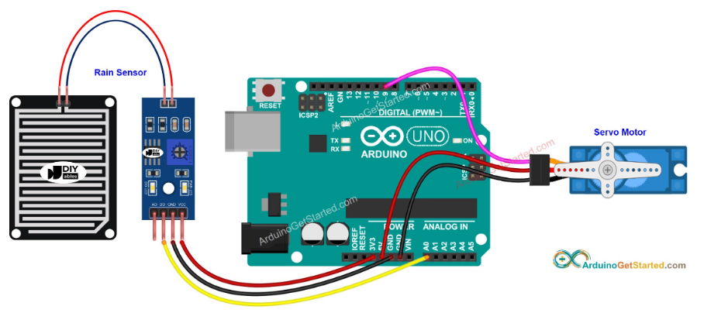

Fig: Arduino Uno and Rain Sensor connection

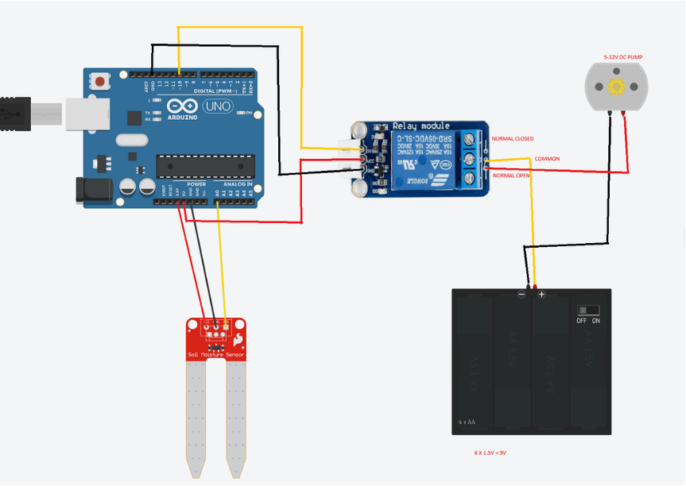

Fig: Pump and Relay Connection

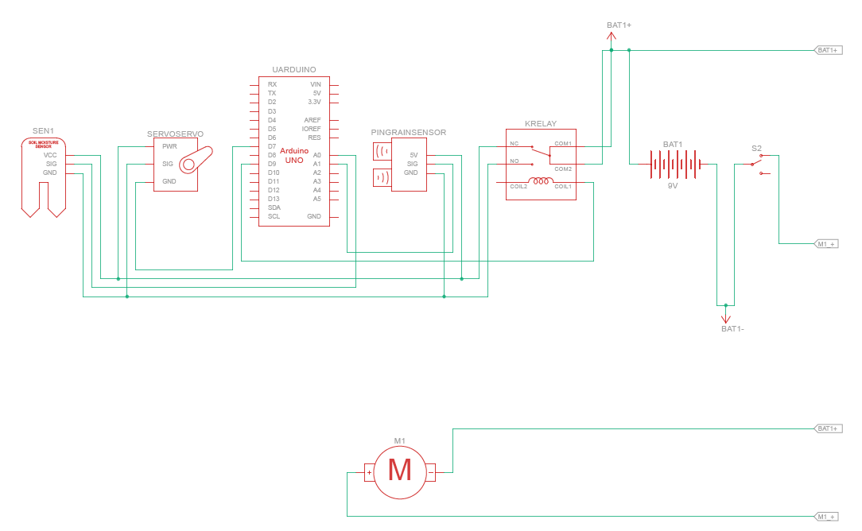

Fig: Schematic Diagram

**OUTCOME:**

Front View:

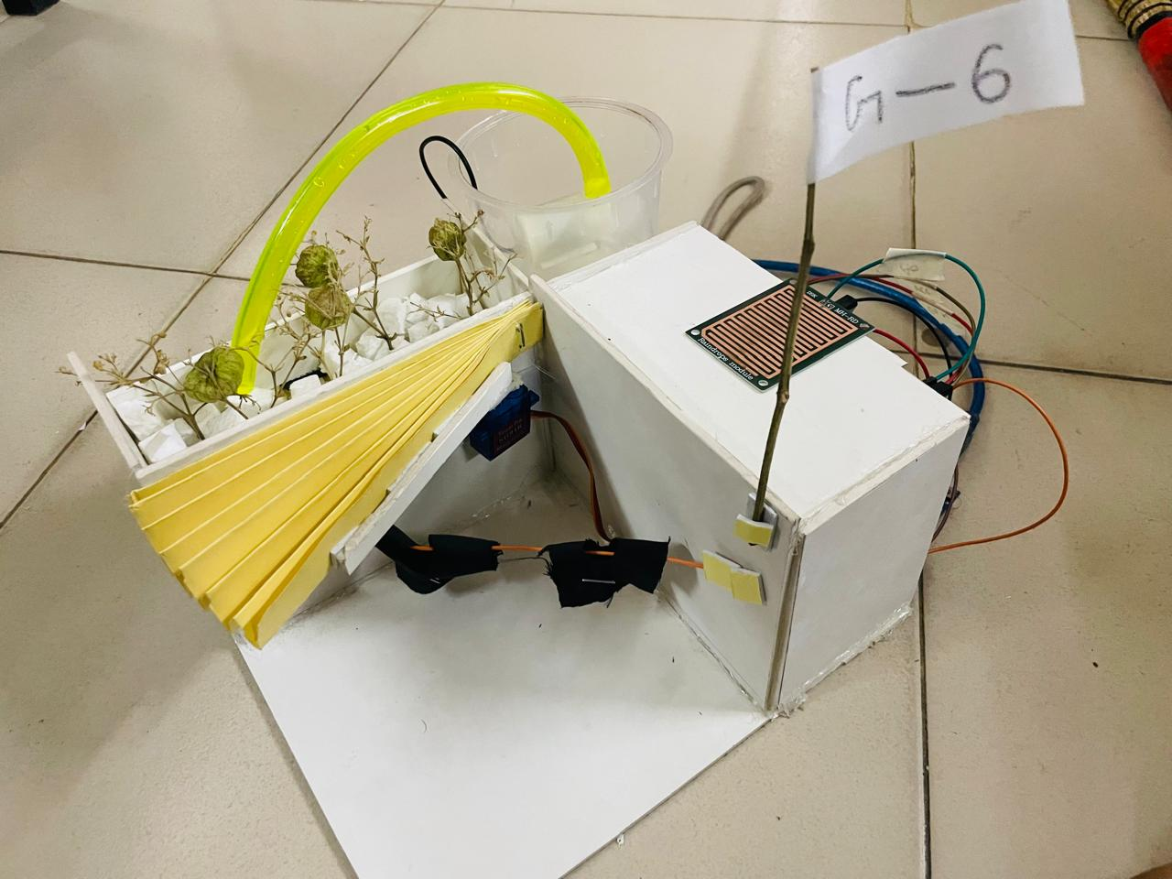

Back View:

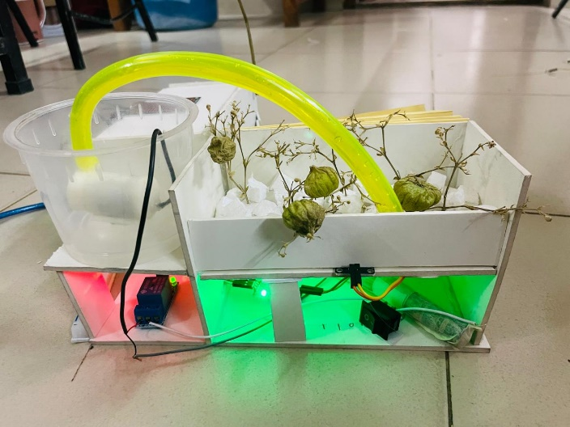 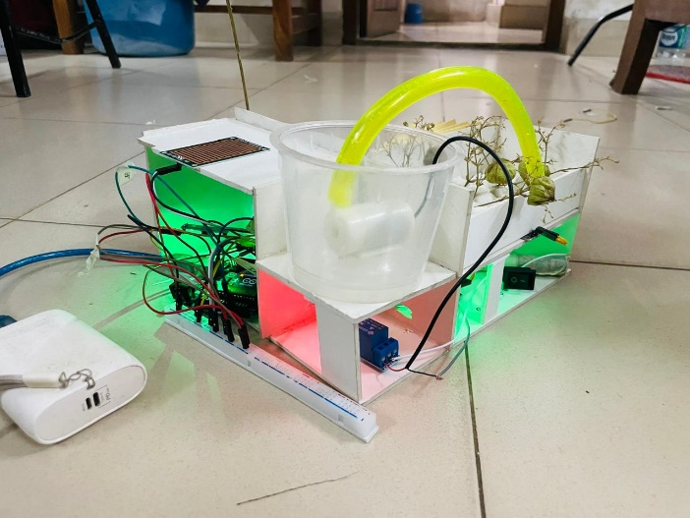JJ

**CONTRIBUTION:**

|  |  |  |
| --- | --- | --- |
| **ID** | **NAME** | **CONTRIBUTION** |
| 202114014 | Aunindya Prosad Saha | * Coding part of the rain detection and servo motor * Contributed to develop the roof deployment system * Collecting information about the components |
| 202114025 | G M Fahim Tazwar | * Setting up the rain sensor and servo motor connection * Situating the roof deployment system with servo * Report writing as per instruction |
| 202114052 | Md Raiyan Buhiyan Loreen | * Setting up the irrigation system * Coding part of irrigation system * Designing and testing the whole circuit diagram of the project |
| 202114072 | Nahiyan Ashraf Siddique | * Building the overall plywood structure * Collecting all materials of the project * Ensured the overall progress of the project |