Clinical Note Router: routing clinical notes to the right department
MA6700 Applied AI and Machine Learning, Assignment 3 · Team Zero: Immanuel James Wong Hon Leung (leader), Mevin Ramjeet, Jeffrey Li Chiu Lim, Deevesh Rughoo · Oct 24, 2026 · @deev

Executive summary
The problem. Every clinical note that reaches a hospital must go to the correct specialist department. Today a person reads each note and chooses. A wrong choice delays the patient and wastes clinical time.
What we built. Clinical Note Router suggests one of nine departments for a note. It combines a TF-IDF and logistic regression model with a fine-tuned PubMedBERT. We trained both on public sample transcriptions (MTSamples). An audit showed that the 4,999 rows hold only 2,357 different notes, so we deduplicated before one fixed split. A person confirms every suggestion.
What it achieves. On 291 held-out notes, PubMedBERT reaches a macro F1 of 0.942 and TF-IDF 0.924. A keyword rule list reaches only 0.738. The gap between the two models is not significant (p = 0.36). The more accurate model is also the less safe one. PubMedBERT is confident on 51.6% of notes from departments it has never seen.
Our two-key rule pre-fills a suggestion only when both models are confident and agree. It does this for 67.4% of notes, at 97.4% accuracy. It cuts the unknown-department notes on the fast track to 11.5%. Removing names, dates and record numbers costs no accuracy. The main weaknesses are confident errors, General Medicine (F1 0.83) and data that are not a hospital's own notes.
What we recommend. Pilot the system in shadow mode at one hospital department for one month: the tool suggests, and staff route as today. Retrain and re-threshold on local notes, and add an "other department" class. Then use it with the two-key rule and a person confirming every note. Never deploy it as automatic routing.

1. Problem and motivation
Hospitals receive clinical notes and referrals all day, and each one must reach the correct specialist department. Today a person reads each note and chooses the department. We built a model that suggests the department, so that this person decides faster and makes fewer errors.
Who has this problem. Referral coordinators and medical secretaries in large hospitals and hospital networks. In Mauritius, regional hospitals receive referrals from many area health centres. The clinicians in the receiving departments also pay for errors.
What it costs. Each note gets one department, so each routing error is two errors at once:
- The correct department does not see the note. The patient waits, and a delay in specialist care can harm the patient.
- The wrong department receives a note it cannot act on. A clinician must notice the error and send the note back, which uses clinical time.
We have no hospital data on time or money per note, so we do not estimate a monetary cost. We measure the error rates that drive the cost instead.
What the system is, and what it is not. The input is the text of one note. The output is one of nine departments. This is single-label specialty routing, not diagnosis: two cardiology notes share a label but can have very different diagnoses. The system cannot assign a diagnostic code, and we make no such claim. A person confirms every suggestion (Section 6).
Why a learned model and not rules. A rule system is the obvious alternative: list the words of each department and count them. We wrote such a list from anatomy and procedure words (102 words, 12 for most departments) and did not tune it on the data. Notes with no match go to General Medicine, the department with no organ of its own.
Router (291 test notes) | Macro F1 (95% CI) | Accuracy
Keyword rules | 0.738 (0.688–0.782) | 0.753
Model 1: TF-IDF + logistic regression | 0.924 (0.891–0.952) | 0.921
Model 2: PubMedBERT | 0.942 (0.914–0.967) | 0.938
The rules are wrong on 61 test notes that Model 2 routes correctly. The clearest case is a diagnostic cerebral angiogram for a 13-year-old boy after the clipping of a brain aneurysm. The word "artery" occurs 20 times, so the rules send the note to Cardiovascular / Pulmonary, with only 4 hits for Neurology. Model 2 sends it to Neurology with 0.95 confidence. A word such as "artery" belongs to several departments, and only the context (cerebral, aneurysm) decides. A rule list cannot hold every context, but a model learns them from labelled notes.

2. Data
The 4,999 rows of the dataset hold only 2,357 different notes. After our quality checks, 1,453 notes in nine departments remain. We split them once, 60 / 20 / 20.
Source and licence. We use Medical Transcriptions (Boyle, 2018), a Kaggle scrape of mtsamples.com, under the CC0 1.0 public-domain licence. The website publishes sample transcription reports from the USA as examples for medical transcriptionists, and it removes patient names. Each row has five columns: description, medical_specialty (40 labels), sample_name, transcription and keywords.
Quality checks. The data module of our code runs each check below and prints the counts.
Check | Finding | Action
Missing values | 33 rows have no transcription; 1,068 have no keywords | Drop the 33 rows
Label leakage | In 97.9% of rows with keywords (3,850 of 3,931), the keyword string starts with the label | Use only transcription; a hospital gets no keywords with a new note
Exact duplicates | 4,966 rows hold 2,357 unique texts; 91.1% of them carry two or more labels | Group by text before any split, so no text is in two splits
Document-type labels | 7 labels name a format (for example "Discharge Summary"), not a department | Remove these labels; 34 notes had no other label
Two specialties | 367 notes keep two specialties (most often Neurosurgery + Orthopedic, 46) | Remove: a single-label model cannot be right for both
Too short | 30 notes have fewer than 20 words (headings only) | Remove
Near-duplicates | 12 pairs have a TF-IDF cosine of 0.9 or more (11 with the same label) | Remove one note of each pair
The duplicates had the largest effect on the project. The website lists one note on several pages, for example a wrist operation on "Surgery" and on "Orthopedic". A random split of the rows would put the same text in training and in test. We give each unique note one department with a fixed rule. We drop document-type labels. "Surgery" and "Radiology" are umbrella pages, so we use them only when no specialty remains.
Class balance. 1,914 single-department notes remain in 33 departments. Our proposal dropped classes with fewer than 50 notes. That rule leaves Hematology - Oncology with only 11 test notes, so one note moves its recall by 9 points. We use 75 notes instead, chosen from the counts before any model was trained.
Rule: keep a class with at least | Classes | Notes | Smallest class | Its test notes (20%)
50 notes (proposal) | 10 | 1,509 | Hematology - Oncology (56) | 11
75 notes (used) | 9 | 1,453 | Ophthalmology (75) | 15
100 notes | 7 | 1,301 | Neurology (122) | 24
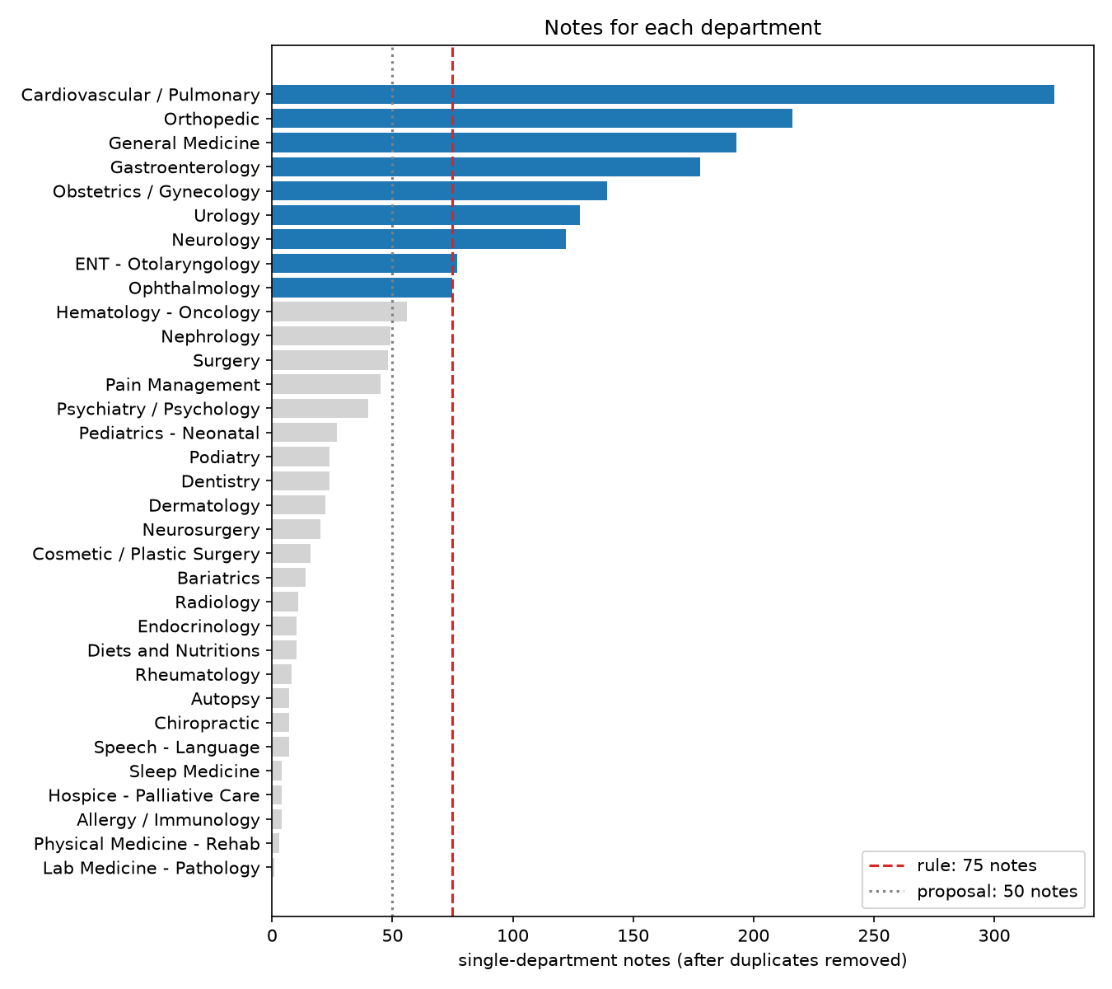
Figure 1. Single-department notes per department after duplicate removal. Blue: the nine departments kept by the 75-note rule.
The largest class (Cardiovascular / Pulmonary, 325 notes) has 4.3 times the notes of the smallest. The 461 notes of the 24 removed departments are not discarded. They become an out-of-scope test set for Section 7.
The split. The split step of our code makes one stratified split with seed 6700 and checks that no text is in two parts. The MD5 fingerprint of the test split starts with 1604267baf04. Every model uses this split. All choices use the validation split, and the test split is used only in Section 5.
Department | Train | Validation | Test
Cardiovascular / Pulmonary | 195 | 65 | 65
Orthopedic | 129 | 43 | 44
General Medicine | 116 | 38 | 39
Gastroenterology | 107 | 36 | 35
Obstetrics / Gynecology | 83 | 28 | 28
Urology | 77 | 26 | 25
Neurology | 73 | 25 | 24
ENT - Otolaryngology | 46 | 15 | 16
Ophthalmology | 45 | 15 | 15
Total | 871 | 291 | 291

3. Preprocessing
Model 1 reads lower-case single words with English stop words removed. We tested negation markers and word pairs on the validation split and rejected both. Model 2 reads the repaired text with no other change.
The traditional pipeline (Model 1). Each step is in the preprocessing module and runs on every note.
Step | What it does | Why, for this task
1. Format repair (both models) | Removes the ", " that the scrape puts after each heading | Without it "HISTORY: ," and ",HISTORY:" are different tokens, and headings run into sentences
2. Lower case, words only | Keeps words that start with a letter | A number alone (a dose, a date) names no department
3. Stop words | Removes the 318 words of the scikit-learn English list | The department comes from anatomy and procedure words; the test below shows the list does no harm
4. TF-IDF weighting | Words in at least 2 notes and at most 90% of notes; logarithmic term counts | Drops typing errors and names; stops a word repeated 20 times in a long note from dominating it
5. Negation scope (tested, not used) | Marks the next six words after a cue such as "denies" with neg_, up to the end of the clause | "denies chest pain" should not count as chest pain
We did not stem or lemmatise the words, and we did not test it.
Before and after, on one real training note.
Stage | Text (first words)
Raw, as scraped | CHIEF COMPLAINT: , "I have had trouble breathing for the past 3 days",HISTORY: , 69-year-old Caucasian male complaining of difficulty breathing ...
1. Format repaired | CHIEF COMPLAINT: "I have had trouble breathing for the past 3 days" HISTORY: 69-year-old Caucasian male complaining of difficulty breathing ...
2. Words only | chief complaint have had trouble breathing for the past days history year old caucasian male complaining of difficulty breathing ...
3. Stop words removed (Model 1 input) | chief complaint trouble breathing past days history year old caucasian male complaining difficulty breathing ...
5. Negation markers (rejected) | denies neg_any neg_illicit neg_drug neg_use ... denies neg_any neg_drug neg_allergies
Negation is everywhere, but it does not name a department. 771 of the 871 training notes (88.5%) contain a negation cue. The most frequent negated words are general: "of", "or", "the", "any", "evidence", "acute" (as in "no acute distress"). These phrases occur in the notes of every department.
The settings test. We tested eight combinations of negation markers, the stop word list and word pairs. Each used logistic regression with C = 10 and balanced weights, scored on the validation split.
Negation markers | Stop words | Words | Features | Validation macro F1
No | Removed | Single | 8,189 | 0.893
Yes | Kept | Single | 9,711 | 0.890
Yes | Removed | Single | 9,467 | 0.890
No | Kept | Single | 8,435 | 0.886
No | Removed | Single + pairs | 30,511 | 0.884
Yes | Kept | Single + pairs | 45,784 | 0.878
- Negation markers do not help (best with markers 0.890, without 0.893). One changed prediction moves the score by about this much, so the markers add features and no signal.
- Word pairs are worse in every combination. They make 30,000 to 46,000 features from 871 notes, so most pairs are too rare to learn.
- Stop word removal does no harm here. In Assignment 2 the list removed "not" and hurt sentiment. For routing, "not" says nothing about the department.
Model 2 input. The transformer gets the format-repaired text. Its own tokenizer lower-cases and splits the words. We do not remove stop words, because the model reads "no" and "not" in context. The only other step is the head + tail cut of Section 4.

4. Modelling
We combine a traditional model and a fine-tuned transformer. They read notes differently, so they rarely make the same confident error. A suggestion goes on the fast track only when both models are confident and agree (Section 7).
Why a hybrid fits this problem. Most departments have their own anatomy and procedures, so word counts carry most of the signal. A linear model on TF-IDF is cheap, fast and transparent. Some notes need context instead: a general-medicine history touches many organs, and a long note hides its department in its last lines. A transformer reads words in context. The two models also fail on different notes, and Section 7 uses this as a safety check.
Model 1, the baseline: TF-IDF and logistic regression. The input is the cleaned text of Section 3: 8,189 single words. The classifier is a multinomial logistic regression with balanced class weights. We chose C and the class weights on the validation split from 12 combinations. C = 100 with balanced weights was best (validation macro F1 0.897). Model 1 has 73,710 parameters and trains in under one second on a CPU. Logistic regression gives probabilities for the thresholds of Section 7, and readable weights: its strongest terms for Urology are "bladder", "prostate" and "cystoscopy".
Model 2: PubMedBERT, fine-tuned. PubMedBERT (Gu et al., 2021) is a BERT-base encoder pretrained from scratch on PubMed abstracts and full-text articles, with its own biomedical vocabulary. It has 12 transformer layers, 768 hidden units, 12 attention heads and 109.5 million parameters. We add one linear layer on the [CLS] token that gives nine department scores. The model reads 512 positions, so for each long note we keep the first 128 and the last 382 tokens (head + tail, Sun et al., 2019).
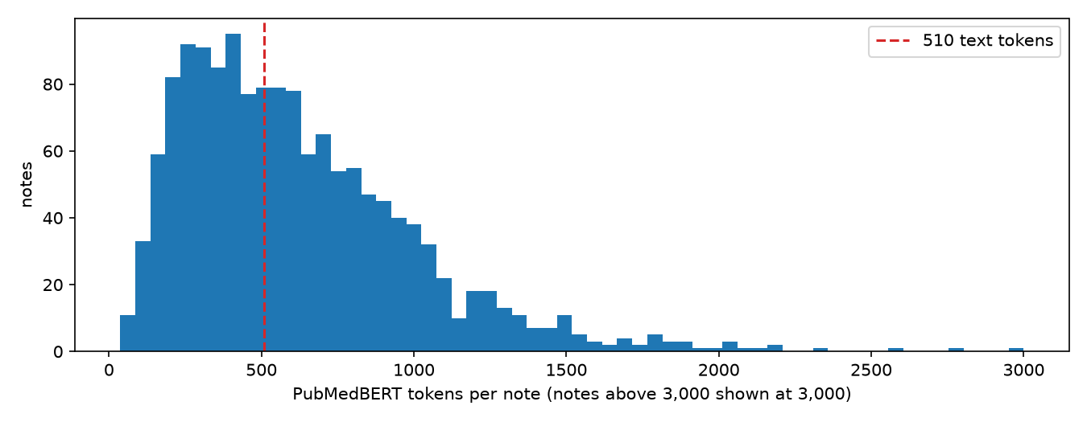
Figure 2. PubMedBERT tokens per note. 778 of the 1,453 notes (53.5%) are longer than the 510 text tokens the model reads; a first-512 rule would remove 36.3% of a typical long note.
Hyperparameter | Value | Why
Optimiser | AdamW, learning rate 3e-5, weight decay 0.01 | In the range Devlin et al. (2019) recommend for BERT fine-tuning
Schedule | Linear, 10% warm-up | Avoids large early updates to the pretrained weights
Batch size | 8 | The largest that fits a 6 GB GPU at 512 tokens
Epochs | 6, keep the best epoch by validation macro F1 | 871 notes over-fit fast; the best epoch was 3 to 6
Loss | Cross-entropy with balanced class weights | The largest class is 4.3 times the smallest
Precision | bfloat16, gradient clipping at 1.0 | Half the memory, no loss scaling needed
We fixed these values before the experiments and used them for every checkpoint, so the comparisons are fair. We did not grid-search them: a run takes 3 minutes, and we spent the GPU time on three design questions instead. Each was decided on the validation split.
Experiment | Option | Validation macro F1 | Note
Long-note option (PubMedBERT) | Head (first 510 tokens) | 0.919 | Long-note accuracy 0.884
 | Head + tail (128 + 382) | 0.940 | Long-note accuracy 0.913
 | Chunks (510-token windows, mean of probabilities) | 0.920 | Long-note accuracy 0.861; twice the cost
Checkpoint (head + tail) | PubMedBERT (1.34 tokens per word) | 0.940 | Selected
 | Bio_ClinicalBERT (1.56 tokens per word) | 0.903 | Clinical pretraining, general vocabulary
 | BERT-base (1.49 tokens per word) | 0.905 | General-domain control
Seed (selected design, 5 seeds) | Mean (standard deviation) | 0.928 (0.008) | Test: 0.947 (0.008)
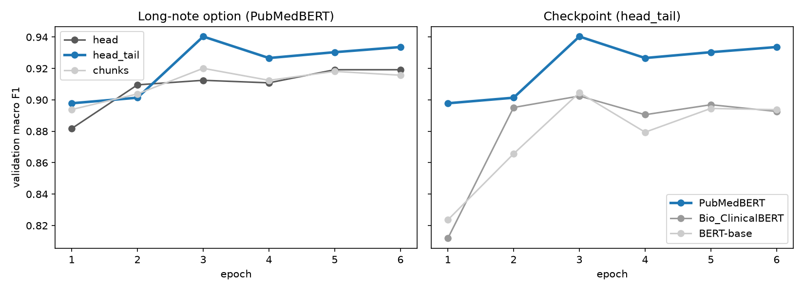
Figure 3. Validation macro F1 per epoch. Left: the three long-note options; right: the three checkpoints. Blue: the selected PubMedBERT with head + tail.
Head + tail wins on long notes because the end of a note holds the plan and the follow-up department. Chunks read everything but give equal weight to long procedure descriptions that say little about the department. PubMedBERT beats both other checkpoints by more than four seed standard deviations. Its vocabulary keeps "cholecystectomy" as one token, where the others make six pieces, so it loses less text to the 512 limit. Bio_ClinicalBERT was pretrained on clinical notes but did not beat the general BERT-base. The gap between head + tail and head is about 2.5 seed standard deviations, so it is probable, not proven.
What we rejected from the module, and why.
- Recurrent networks (LSTM, GRU) and 1D CNNs on word embeddings. We have 871 training notes with a median of 544 tokens and a clinical vocabulary. A network trained from random or general embeddings cannot learn that vocabulary from so little data. A pretrained transformer brings it in. We did not train one.
- Averaged Word2Vec or GloVe embeddings. An average blurs the rare, specific words ("cystoscopy", "intraocular") that decide a department, and general embeddings lack many clinical terms. TF-IDF keeps each word as its own feature.
- DistilBERT, our Assignment 2 model. It has six layers and a general vocabulary. BERT-base is the stronger general-vocabulary control, and it lost to PubMedBERT.
- A long-context model (Clinical-Longformer, 4,096 tokens). It does not train with a useful batch size on our 6 GB GPU.
- Prompting a hosted large language model. It sends health data to an outside service, and the hospital cannot control or audit that model.
- Tested and rejected: negation markers and word pairs for Model 1 (Section 3), and the head and chunk options for Model 2 (above).

5. Evaluation
On the 291 test notes, PubMedBERT reaches a macro F1 of 0.942 and TF-IDF reaches 0.924. The gap is probably real but not statistically significant (McNemar p = 0.36). The test split was used here for the first time.
Why these metrics. Macro F1 is the primary metric because each department has the same right to its notes. A model that is good only on the large departments scores low. Accuracy and weighted F1 give context. The test split is small, so every score has a 95% bootstrap interval from 2,000 resamples. Both models are scored on the same resamples, so they can be compared pair by pair. The fast track depends on confidence, so Section 7 adds calibration and the accuracy of confident suggestions.
Test split, 291 notes | Macro F1 (95% CI) | Accuracy | Weighted F1
Keyword rules | 0.738 (0.688–0.782) | 0.753 | 0.731
Model 1: TF-IDF + logistic regression | 0.924 (0.891–0.952) | 0.921 | 0.922
Model 2: PubMedBERT, head + tail | 0.942 (0.914–0.967) | 0.938 | 0.938
Is the difference real? Model 2 is ahead by 0.018. The paired bootstrap interval of the gap is −0.007 to +0.047, and Model 2 is ahead in 90.6% of the resamples. Only 19 notes are routed correctly by one model alone: 12 by Model 2 and 7 by Model 1 (McNemar exact p = 0.36). All five seeds of Model 2 score higher than Model 1 on test (0.940 to 0.959). Our reading: Model 2 is probably 1 to 3 points better, and 291 notes cannot prove a gap of this size.
Per department. Model 2 gains most on Neurology (0.800 to 0.875), Orthopedic (0.953 to 0.989) and ENT (0.938 to 0.970). General Medicine is the weakest class for both models (0.83): it has no anatomy of its own and reads like the history notes of every other department. Ophthalmology scores 1.000 for both.
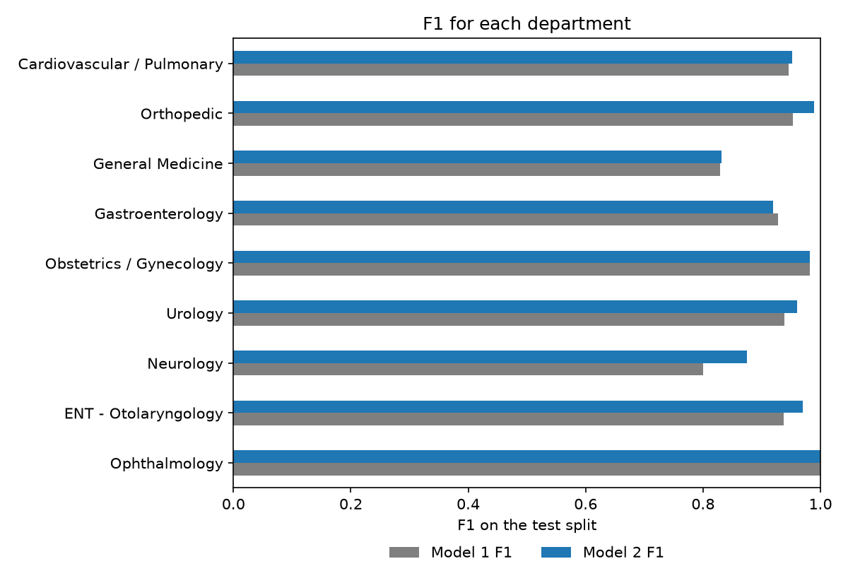
Figure 4. Test F1 for each department, Model 1 (grey) and Model 2 (blue).
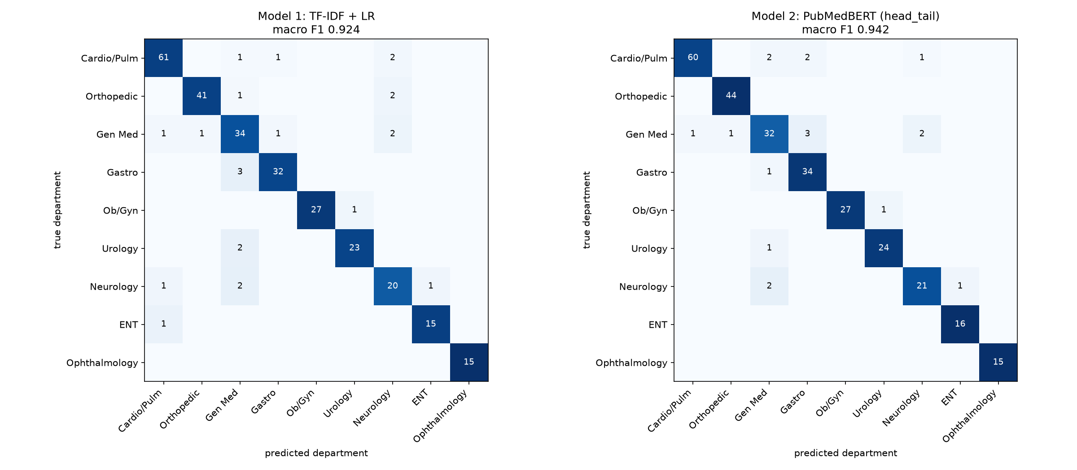
Figure 5. Confusion matrices on the test split. No confusion occurs more than three times; most involve General Medicine or Neurology.
Error analysis on real notes. We read the six test notes that Model 2 got wrong with the highest confidence.
Note title | True | Model 2 (confidence) | Our reading
Fall - ER Visit | General Medicine | Orthopedic (0.993) | An 88-year-old woman who fell: orthopaedics is a correct reader
Hematuria - Consult | Urology | General Medicine (0.989) | Blood in the urine, written as a general history note
MRI of Lung - Adenocarcinoma | Cardiovascular / Pulmonary | Neurology (0.988) | The note starts "Found unresponsive ... severe headache": a brain problem
MRI Brain - CO poisoning | General Medicine | Neurology (0.988) | A brain MRI: a neurologist is a correct reader
Triple Lumen Catheter Insertion | Cardiovascular / Pulmonary | Gastroenterology (0.988) | A real error: a femoral line, abdominal words; Model 1 is right
Aortobifemoral Bypass | Cardiovascular / Pulmonary | Gastroenterology (0.986) | A real error: vascular surgery in the abdomen
Four of the six notes also fit the predicted department. The labels are website pages, not routing decisions by clinicians, so part of the measured error is label noise. The other lesson is confidence: Model 2 is 98.6% to 99.3% sure in each of these errors (Section 7).
Long notes. Long notes are harder for both models. Model 1 reads every word and still falls from 0.946 on short notes to 0.895 on long ones. Model 2 reads only 510 tokens but falls less, from 0.953 to 0.923. Head + tail costs no accuracy against a model that reads everything.
What did not work.
- Negation handling. Markers did not help Model 1 (Section 3). When we delete every negation cue from the test notes, only 0.7% of Model 1's and 0.3% of Model 2's predictions change. Routing does not need negation, although diagnosis would.
- Clinical pretraining. Bio_ClinicalBERT, trained on intensive-care notes, did not beat the general BERT-base (0.903 against 0.905 on validation).
- Reading the whole note. The chunk option was the worst on long notes (0.861 validation accuracy) at twice the cost.
- Confidence as a safety signal. Model 2's confidence does not show its own errors, and it is high on departments it has never seen (Section 7).
- General Medicine. No model or setting raised it above 0.83.

6. Ethical and responsible AI analysis
The most costly error is a confident wrong suggestion that a person accepts without checking. Our threshold, our safety rule and our legal design all aim to make such suggestions rare and visible.

6.1 Who is affected, and which error costs more
Three groups are affected. Patients wait when a note goes to the wrong department. Clinicians in the wrong department lose time and must send the note back. Reviewing staff spend time on every note that needs a full review.
The system makes one decision per note: fast track (both models confident and in agreement, the suggestion arrives pre-filled) or full review. The two errors do not cost the same:
- A wrong fast-track suggestion is the worse error. It looks certain, the reviewer may accept it, and the patient waits in the wrong queue.
- An unneeded full review costs a few seconds of staff time, and the reviewer still sees the two best suggestions (top-2 accuracy 98.6% for Model 2).
Our choices reflect this. We set each threshold for accuracy, not coverage: the lowest confidence at which fast-track suggestions were at least 95% correct on validation (Model 1 0.81, Model 2 0.97). Then we added the second key. Per 1,000 in-scope test notes:
Rule | Wrong fast-track suggestions | Full reviews | Unknown-department notes put on the fast track (per 1,000)
Model 2 alone | 27 | 131 | 516
Model 1 alone | 24 | 271 | 150
Two keys (used) | 17 | 326 | 115
We accept 195 more full reviews per 1,000 notes to cut wrong fast-track suggestions by 10 per 1,000, and unknown-department notes on the fast track by 401 per 1,000. Macro F1 applies the same logic to departments: a missed Ophthalmology note (15 test notes) weighs as much as a missed cardiology note (65).

6.2 Where bias could enter the pipeline
Stage | Applies? | In our system | What we did
Problem framing | Yes | Single-label routing removed 367 notes that belong to two departments, such as spine operations under Neurosurgery and Orthopedic. Patients with multi-system conditions are the ones the model was never tested on. | Named as a limit; multi-label routing is the next step
Data collection (representation) | Yes | US sample notes in English; 9 of 33 departments; 19 test notes for children. Mauritian notes can contain French or Kreol words. | Out-of-scope test on 461 notes; local validation required before use
Labelling (measurement) | Yes | Labels are website pages, not routing decisions. Four of Model 2's six most confident errors also fit the predicted department. Sex and age are read from the text. | Reported as label noise; clinician review of doubtful labels proposed
Features and preprocessing | Weakly | Stop-word removal and redaction could remove signal. | Both tested: no loss (Sections 3 and 7)
Training (learning) | Yes | The four largest departments would dominate the loss. | Balanced class weights in both models; selection by macro F1
Evaluation | Yes | The test notes come from the same website; 291 notes give intervals of about ±0.03. | Bootstrap intervals, five seeds, out-of-scope and subgroup tests
Deployment (automation bias) | Yes | Reviewers may accept a pre-filled suggestion without reading. | Named reviewer, reason for every change, time logged, warning under 5 seconds
Historical bias | No | The label is the page a note sits on, not a past human judgement about the patient (no approval, no risk score). It cannot copy past decisions against a group. | None needed now
Feedback loop | No, not yet | The models are frozen and never learn from their own accepted suggestions. Retraining on confirmed routes would make rubber-stamped suggestions into labels. | Retrain only on fully reviewed or audited notes

6.3 Performance by patient group
The dataset has no sex or age column. We read them from the text ("a 69-year-old male"), else from pronouns.
Group | Test notes | Model 1 accuracy (95% CI) | Model 2 accuracy (95% CI)
Female | 107 | 0.925 (0.88–0.97) | 0.925 (0.87–0.97)
Male | 98 | 0.867 (0.81–0.93) | 0.908 (0.85–0.96)
Sex unknown | 86 | 0.977 (0.94–1.00) | 0.988 (0.95–1.00)
Age 0–17 | 19 | 0.895 (0.74–1.00) | 0.947 (0.84–1.00)
Age 18–64 | 82 | 0.915 (0.85–0.96) | 0.927 (0.87–0.98)
Age 65+ | 43 | 0.884 (0.79–0.98) | 0.884 (0.79–0.98)
Age unknown | 147 | 0.939 (0.90–0.97) | 0.959 (0.93–0.99)
Model 1 is 5.8 points less accurate for men than for women, and Model 2 cuts this gap to 1.7 points. All intervals overlap. The department mix explains part of the gap: male notes hold more Neurology (13 against 7) and Urology (13 against 3) notes, and Neurology is a weak class. Female notes hold 21 Obstetrics / Gynecology notes, an easy class. Patients aged 65 or more have the lowest accuracy with both models (0.884).
What this means for our claims. With about 100 notes per sex and 19 children, we can say only that we found no gap larger than the uncertainty. We cannot say that the models are fair. The data have no ethnicity, language or insurance information, so we make no claim for those groups. A hospital must repeat this check with sex and age from its patient records.

6.4 The legal position
Clinical notes are health data, a special category under GDPR Article 9 and the Mauritius Data Protection Act (DPA) 2017. The sample notes have no names, but 48.8% give an age and 15.9% a date; real notes would identify patients.
Requirement | GDPR | DPA 2017 | How the system meets it
Lawful basis for health data | Art. 6(1)(e), 9(2)(h) | ss.28, 29(1)(d)(ii) | Provision of health care; the hospital confirms it
No decision by the machine alone | Art. 22 | s.38 | A named person confirms or changes every note; a change needs a reason; patients can contest. Section 38(3) bars automated evaluation based on health data, with no exception
Data minimisation by design | Art. 5(1)(c), 25 | s.21 | Names after a title, dates, phones, e-mails and record numbers are removed before a model reads a note; macro F1 0.924 to 0.925 (Model 1), unchanged for Model 2
Impact assessment and records | Art. 35, 30 | ss.34, 33 | A DPIA and a record of processing are in the code package
Security | Art. 32 | s.31 | Local processing; the audit log keeps a pseudonymous ID, never the note text, for 30 days
Access, erasure | Art. 15, 17 | ss.37, 39 | One screen shows or erases everything stored about a note
EU AI Act. For its intended use, routing non-emergency notes to a department with a person deciding each one, we place the system in the minimal-risk category. It is not in Annex III, and it does not diagnose, monitor or treat, so it is not medical-device software that needs third-party assessment (Article 6(1)). Two changes would make it high-risk: use for emergency patient triage, which Annex III point 5(d) lists, or ranking patients by urgency, a medical purpose. We already build to the high-risk duties: human oversight (Article 14), logging (Article 12) and documented accuracy (Article 15). The Act binds only systems used in the EU; Mauritius has no equivalent law yet.
Membership inference is our one measured privacy risk. A simple attack separates training notes from test notes with an AUC of 0.76 for Model 1 (C = 100 fits closely) and 0.58 for Model 2. The notes are public samples today. Before any training on hospital notes, Model 1 needs stronger regularisation and staff-only access.

6.5 What we would refuse to do
We would refuse to let the system route notes without a person, even for the 67.4% of notes on the fast track, even if a hospital asked us to save staff time. The evidence is our own. Model 2 is 98.6% to 99.3% confident in its worst errors. It puts 51.6% of notes from departments it has never seen on the fast track, with a mean confidence of 0.894. The two-key rule cuts this to 11.5%, not to zero. A machine-only route would send these notes to a wrong queue where nobody looks for them. For a Mauritian hospital it would also break DPA section 38(3).

7. Deployment and limitations
The system runs on one hospital computer with no GPU: Model 2 needs 341 ms per note on a CPU, about 10,500 notes an hour. The first thing to break would be the check for unknown departments, when the hospital's departments and writing differ from the sample notes.
How a note moves through the system. The note arrives, and identifiers are removed. Both models read it. If both are over their thresholds and agree, the suggestion arrives pre-filled (fast track); otherwise the reviewer gets a full review with the two best suggestions. A named person confirms or changes the department, and an audit log records the decision without the note text. Our demonstration tool does this for one note or a batch, and shows each step.
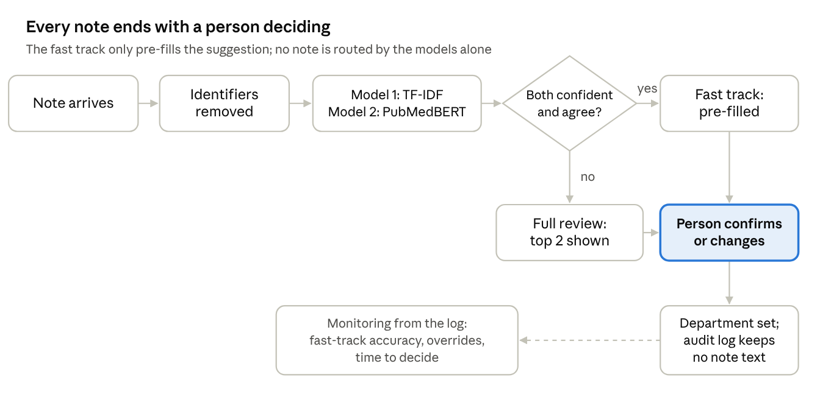
Routing flow in the tools · one decision, one person, one log
Figure 6. How a note moves through the tools.
Inference cost.
 | Model 1 | Model 2
Parameters | 73,710 | 109.5 million
File size | 0.8 MB | 438 MB
Training | Under 1 s on a CPU | 3.0 min on a 6 GB laptop GPU
Inference per note | 0.5 ms on a CPU | 341 ms on a CPU; 7.5 ms on the GPU
Model 2 costs about 700 times more CPU time per note than Model 1, but one CPU still routes a day's notes in minutes. The hospital does not need a GPU for routing, only for retraining.
Calibration and the thresholds. The two models are wrong about their own confidence in opposite directions. Model 2 is over-confident: mean confidence 0.975, accuracy 0.938 (expected calibration error 0.053). Model 1 is under-confident: 0.853 against 0.921 (0.070). Thus each model gets its own threshold from the validation split: 0.97 for Model 2, 0.81 for Model 1. With both keys, 67.4% of test notes go on the fast track, and 97.4% of those suggestions are correct.
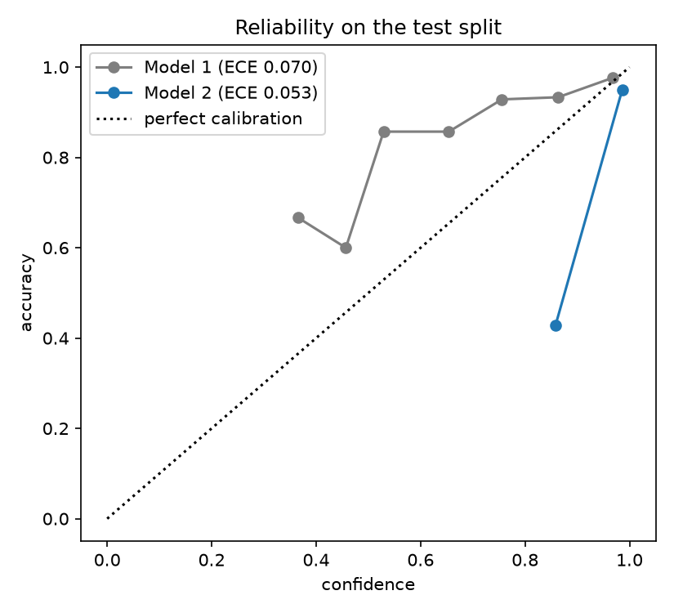
Figure 7. Reliability on the test split: Model 2 (blue) sits under the diagonal (over-confident), Model 1 (grey) above it.
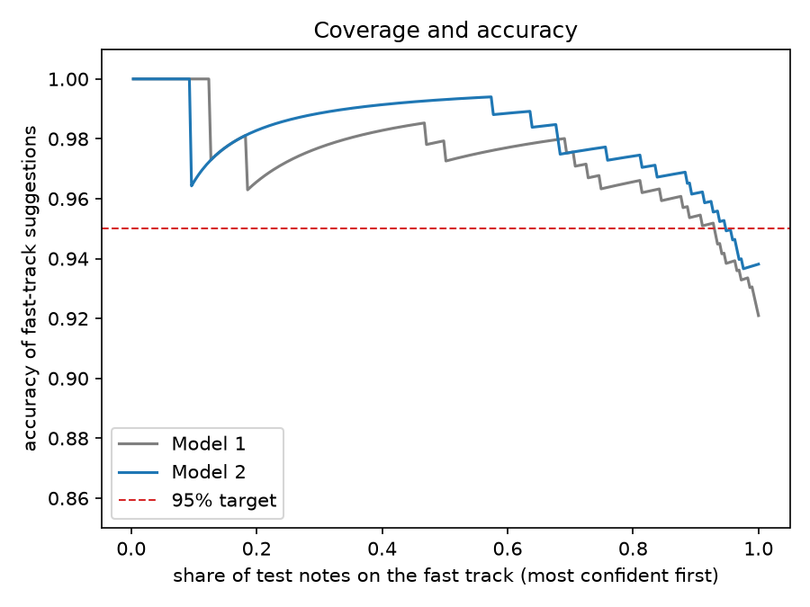
Figure 8. Accuracy of the suggestions as more test notes go on the fast track, most confident first. Red: the 95% target.
Retraining. One fine-tuning run takes 3 minutes, and the whole pipeline with all nine runs about 45 minutes. We would retrain in four cases:
- Before first use, on the hospital's own labelled notes, after a shadow period in which the tool only suggests and staff route as today.
- When a department is added or merged.
- When monitored fast-track accuracy falls below 95%.
- When a patient whose note is in the training data asks for erasure: full retraining without that note.
After each retraining, the thresholds must be chosen again. GPU training is not bit-for-bit repeatable: our re-trained copy of Model 2 scored 0.930 on validation (the original 0.940) and needed a threshold of 0.98, not 0.97. One run of the pipeline repeats every check of this report.
Monitoring. Every review is a label, so the audit log measures the system without extra work:
- the accuracy of fast-track suggestions, from reviewers' changes (alarm below 95%);
- the override rate and the time to decide (warnings for rubber-stamping: under 1% overrides, or a median under 5 seconds);
- the share of notes on the fast track, and how often the two models disagree, which is our signal of unknown departments;
- recall per department, from an audited weekly sample;
- the share of words not seen in training, a signal of new templates or languages.
What would break first.
- Notes from other departments. A hospital has more than nine departments, and 11.5% of such notes still reach the fast track. A tenth class, "other department", trained on local notes, is the fix.
- Local language and templates. French or Kreol terms and local abbreviations are unknown words for Model 1 and shift the confidence of both models, so the thresholds stop holding.
- Reviewer attention. Automation bias grows as the suggestions keep being right.
Limitations. The notes are US website samples, not a hospital's notes. The labels are website pages, not routing decisions. Notes with two departments were removed. The test split has 291 notes, so intervals are about ±0.03, and we used one split. Sex and age come from the text. Our negation rule is simple. Every number in this report comes from the same sample data, so none of it holds for a hospital until it is measured again there.

8. References
- Alsentzer, E., Murphy, J., Boag, W., Weng, W.-H., Jin, D., Naumann, T. and McDermott, M. (2019) 'Publicly available clinical BERT embeddings', Proceedings of the 2nd Clinical Natural Language Processing Workshop, pp. 72–78.
- Boyle, T. (2018) Medical Transcriptions [dataset]. Kaggle. Available at: https://www.kaggle.com/datasets/tboyle10/medicaltranscriptions (CC0 1.0). Original notes: https://www.mtsamples.com.
- Chapman, W.W., Bridewell, W., Hanbury, P., Cooper, G.F. and Buchanan, B.G. (2001) 'A simple algorithm for identifying negated findings and diseases in discharge summaries', Journal of Biomedical Informatics, 34(5), pp. 301–310.
- Devlin, J., Chang, M.-W., Lee, K. and Toutanova, K. (2019) 'BERT: pre-training of deep bidirectional transformers for language understanding', Proceedings of NAACL-HLT 2019, pp. 4171–4186.
- Efron, B. and Tibshirani, R.J. (1993) An introduction to the bootstrap. New York: Chapman and Hall.
- European Union (2016) Regulation (EU) 2016/679 (General Data Protection Regulation). Official Journal of the European Union, L 119.
- European Union (2017) Regulation (EU) 2017/745 on medical devices. Official Journal of the European Union, L 117.
- European Union (2024) Regulation (EU) 2024/1689 (Artificial Intelligence Act). Official Journal of the European Union, L series, 12 July 2024.
- Gu, Y., Tinn, R., Cheng, H., Lucas, M., Usuyama, N., Liu, X., Naumann, T., Gao, J. and Poon, H. (2021) 'Domain-specific language model pretraining for biomedical natural language processing', ACM Transactions on Computing for Healthcare, 3(1), pp. 1–23.
- Guo, C., Pleiss, G., Sun, Y. and Weinberger, K.Q. (2017) 'On calibration of modern neural networks', Proceedings of the 34th International Conference on Machine Learning, pp. 1321–1330.
- Hugging Face (2024) Fine-tune a pretrained model. Transformers documentation. Available at: https://huggingface.co/docs/transformers/training.
- Li, Y., Wehbe, R.M., Ahmad, F.S., Wang, H. and Luo, Y. (2023) 'A comparative study of pretrained language models for long clinical text', Journal of the American Medical Informatics Association, 30(2), pp. 340–347.
- McNemar, Q. (1947) 'Note on the sampling error of the difference between correlated proportions or percentages', Psychometrika, 12(2), pp. 153–157.
- Pedregosa, F. et al. (2011) 'Scikit-learn: machine learning in Python', Journal of Machine Learning Research, 12, pp. 2825–2830.
- Republic of Mauritius (2017) Data Protection Act 2017 (Act No. 20 of 2017).
- Sun, C., Qiu, X., Xu, Y. and Huang, X. (2019) 'How to fine-tune BERT for text classification?', China National Conference on Chinese Computational Linguistics (CCL 2019), pp. 194–206.
- Suresh, H. and Guttag, J. (2021) 'A framework for understanding sources of harm throughout the machine learning life cycle', Equity and Access in Algorithms, Mechanisms, and Optimization (EAAMO '21).
- Yeom, S., Giacomelli, I., Fredrikson, M. and Jha, S. (2018) 'Privacy risk in machine learning: analyzing the connection to overfitting', IEEE 31st Computer Security Foundations Symposium, pp. 268–282.

Use of an AI assistant
We used an AI assistant (Claude, from Anthropic) to write and restructure the code, run it, and draft this report from the code's outputs. Every number in this report comes from the output of the submitted code.
[Team: before submission, replace this sentence with what each member checked, changed and can explain.]

