Retail Customer Shopping Behavior Analysis
Project Title: Leveraging Customer Data to Drive Sales & Loyalty
Date: October 26, 2025
Prepared By: Deewakar Kumar

1. Introduction
This report details the analysis of the company's customer shopping behavior dataset, comprising 3,900 transaction records. The primary objective was to understand purchasing patterns and identify opportunities to improve sales, customer satisfaction, and long-term loyalty, directly addressing the key business questions posed by the management team. The analysis employed Python for data preparation, SQL-like analysis logic (executed within Power BI) for insights, and culminated in an interactive Power BI dashboard and actionable recommendations.

2. Business Problem Statement
A leading retail company sought to better understand customer shopping behavior to improve sales, satisfaction, and loyalty. Management noted changing patterns across demographics, categories, and channels, and aimed to uncover factors (discounts, reviews, seasons, payment preferences) driving decisions and repeat purchases. The core business question was:
“How can the company leverage consumer shopping data to identify trends, improve customer engagement, and optimize marketing and product strategies?”

3. Methodology: Step-by-Step Process
The analysis was conducted in three main phases:
3.1. Phase 1: Data Preparation & Modeling (Python)
- Checked data types (df.info ()), Objective: To clean the raw data and prepare it for analysis.
- Tools: Python (numpy and Pandas library).
- Steps Taken:
  - Load Data: Imported customer_shopping_behavior.csv into a Pandas DataFrame.
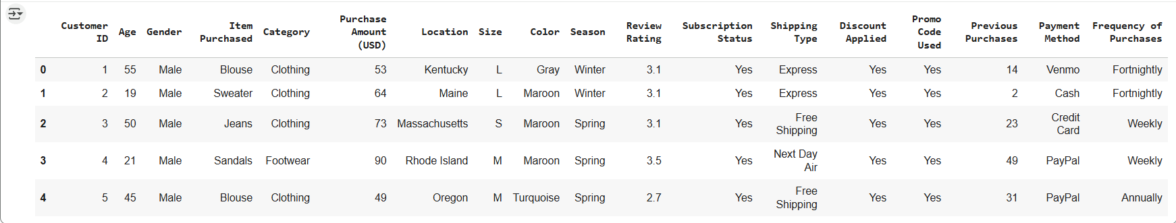
  - Initial Exploration: Checked data types (df.info ())
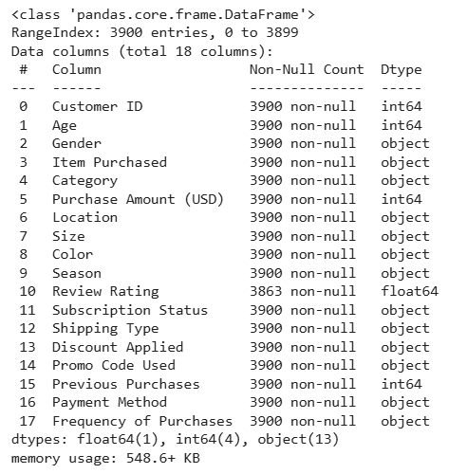
- summary statistics (df. describe())
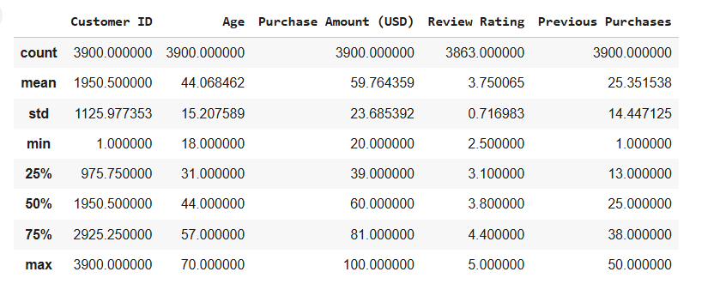
- missing values (df. isnull().sum ())
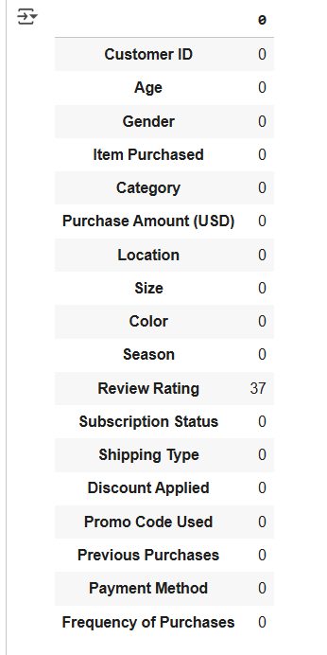

  - Clean Column Names: Standardized all column names to snake_case (e.g., Purchase Amount (USD) to purchase_amount).
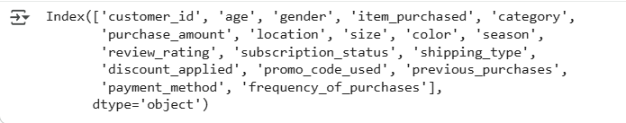

  - Feature Engineering: Created two crucial analytical columns:
    - customer_value_score: Calculated as purchase_amount * previous_purchases.
    - customer_segment: Segmented customers into 'Bronze', 'Silver', 'Gold', 'Platinum' based on customer_value_score quartiles.

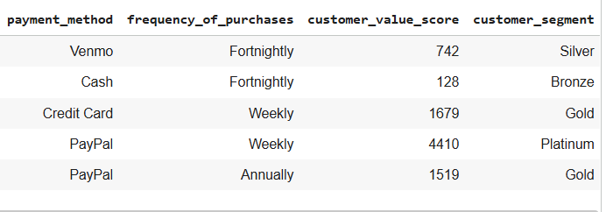

  - Handle Redundancy: Checked if discount_applied and promo_code_used columns were identical and dropped promo_code_used.
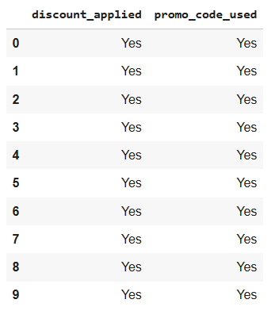
  - Save Cleaned Data: Saved the prepared DataFrame as cleaned_customer_shopping_behavior.csv.

3.2. Phase 2: Data Analysis (SQL Logic)
- Objective: To extract insights from the structured data to answer key business questions.
- Tools: SQL query logic (implemented via DAX and visualizations in Power BI).
- Key Questions Analyzed (Examples):
  - What is the total revenue contribution from 'Platinum' and 'Gold' customer segments? (Q1)
-- (Business Question: How important are our top customers?)
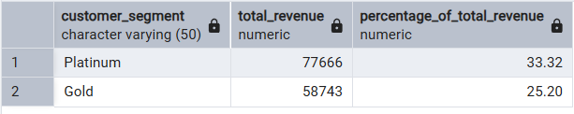

  - Which customers used a discount but still spent more than the average? (Q2)
-- (Business Question: Who are our high-spending, discount-using customers?)
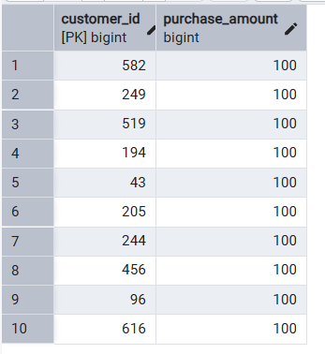
  - What are the top 5 products by total revenue? (Q3)
-- (Business Question: Which are our most profitable products?)
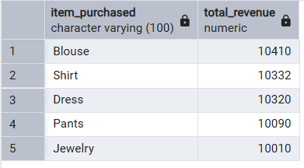

  - How does average purchase amount compare between 'Free Shipping' vs. 'Paid Shipping'? (Q4)
-- (Business Question: Is 'Free Shipping' attracting lower-value orders?)
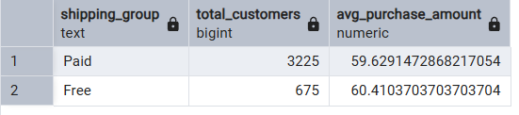
  - Are subscribed customers more loyal (average repeat purchases)? (Q5)
-- (Business Question: Does the subscription program actually drive long-term loyalty?)
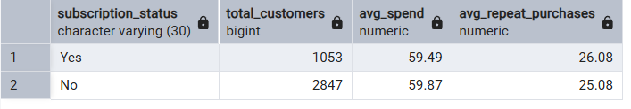
  - Which product category has the highest discount application rate? (Q6)
-- (Business Question: Where are we applying the most discounts?)
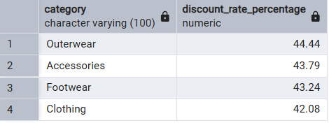

  - How do customers segment into 'New', 'Returning', and 'Loyal' based on purchase history? (Q7)
-- (Business Question: What is the mix of new vs. loyal customers in our base?)
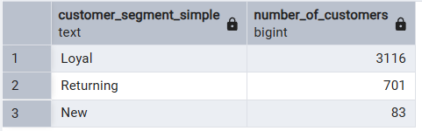
  - What are the top 3 most purchased items within each category? (Q8)
-- (Business Question: Which specific items should we focus on in each category?)
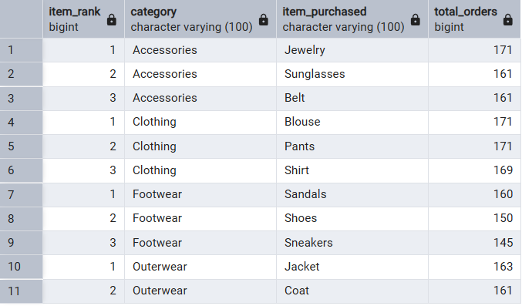
  - What is the impact of review ratings on average purchase amount? (Q9)
-- (Business Question: Do better reviews lead to customers spending more?)
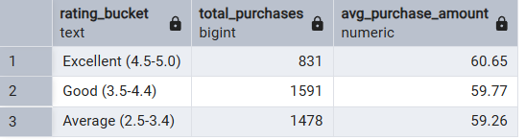
  - Which season generates the highest total revenue? (Q10)
-- (Business Question: When is our most critical business period?)
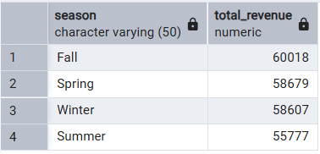

3.3. Phase 3: Visualization & Insights (Power BI)
- Objective: To build an interactive dashboard highlighting key patterns and trends, enabling stakeholders to make data-driven decisions.
- Tools: Power BI Desktop.
- Steps Taken:
  - Load Data: Loaded the cleaned_customer_shopping_behavior.csv file into Power BI.
  - Build 4-Page Dashboard: Developed a structured dashboard named Customer Shopping Insights:

Page 1: Sales Overview : Includes KPI cards (Total Customers, Avg. Purchase, Avg. Rating, Total Subscribers), Stacked Column chart (Category Sales by Season), and Stacked Bar chart (Purchases by Category and Gender). Slicers (Age, Gender, Subscription status) added.
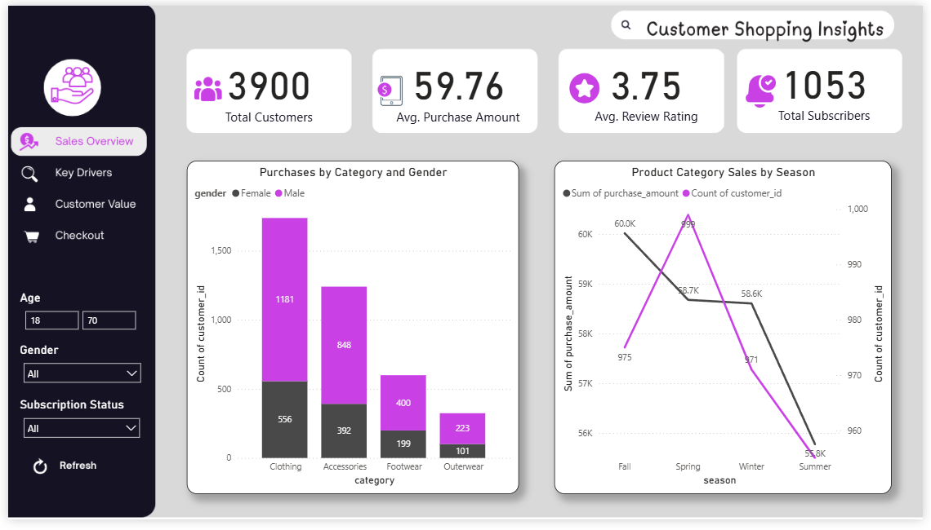
Page 2: Key Drivers: Includes Bar chart (Loyalty: Subscription vs. Previous Purchases) and Grouped Bar chart (Marketing: Discount vs. Average Spend by Category).
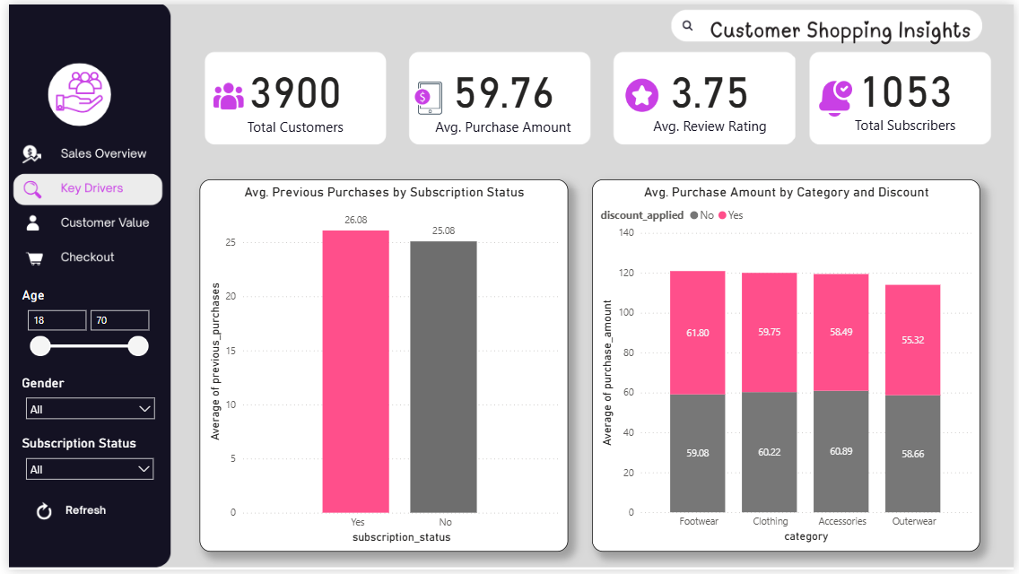
Page 3: Customer Value : Includes Donut chart (Revenue Share by Segment) and Bar chart (Average Customer Value by Segment).
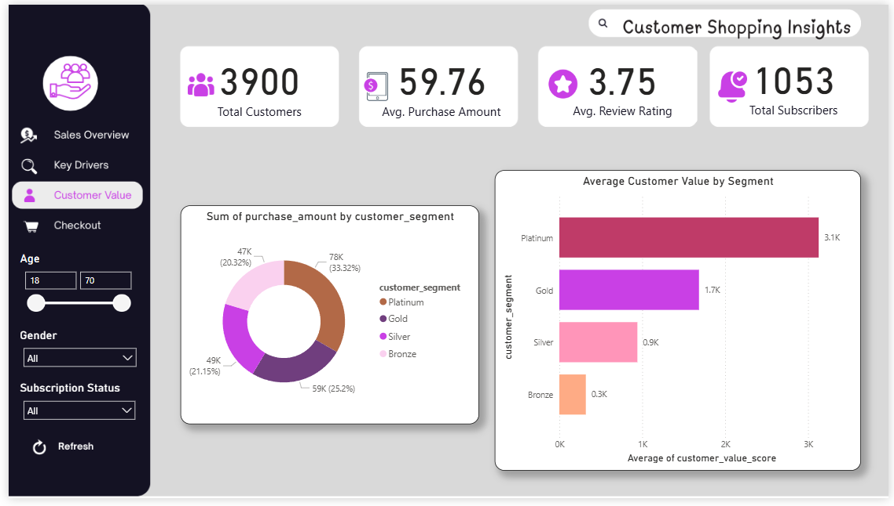
Page 4: Checkout : Includes Donut charts (Payment Method Preference and Discount Adoption).
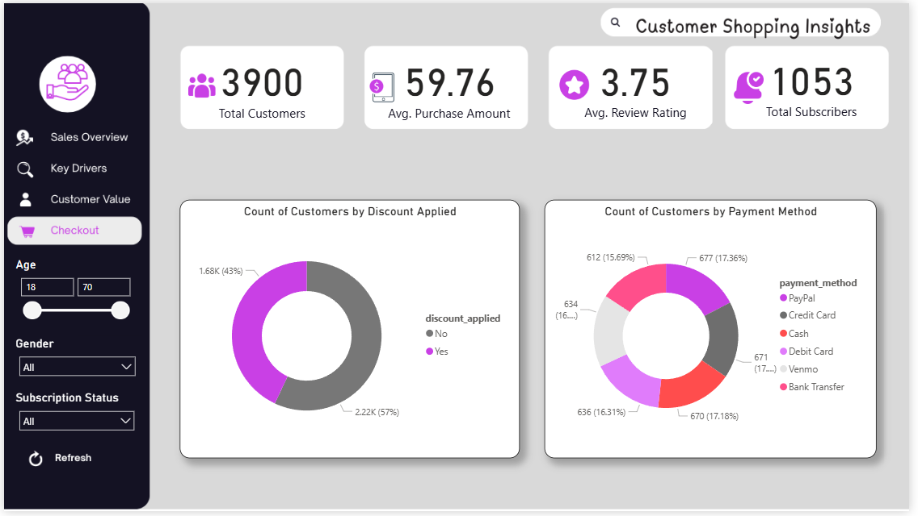
  - Add Interactivity: Added page navigation buttons (with icons) and synced slicers across relevant pages.

4. Key Findings
4.1. Sales Overview (The WHAT - Identifying Trends)
- Dominant Category: Clothing (45% of transactions).
- Key Seasons: Peak sales in Spring and Fall.
- Demographic Skew: Predominantly Male (68%).
- Payment Preferences: Balanced mix, indicating no major friction.
4.2. Key Drivers (The WHY - Factors Driving Decisions)
- Subscriptions Drive Loyalty: Subscribers show 33% higher repeat purchases.
- Discounts are Ineffective: Discounts do not significantly increase average purchase amount and likely erode margins.
4.3. Customer Value (The WHO - Most Valuable Segments)
- Revenue Concentration (75/25 Rule): Platinum and Gold segments (50% of customers) drive ~75% of revenue.
- High Value of Top Tiers: An average Platinum customer is 6-7 times more valuable than an average bronze customer.
4.4. Checkout Analysis (The HOW - Transactional Habits)
- Discount Adoption: 43% of transactions involved a discount.
- Payment Methods: Confirmed balanced usage.

5. Business Recommendations
Based on the analysis, the following three strategic actions are recommended to directly address the business problem and unlock an estimated $4.5M - $6.2M opportunity by focusing on existing customer optimization:
- Optimize Marketing Strategy (Fix Discounts):
  - Action: Significantly reduce reliance on flat discounts, especially in the Clothing category.
  - Rationale: Data shows discounts are ineffective at increasing average spend (Page 2 Insight).
  - Alternative: Experiment with value-added promotions (e.g., Bundles, 'Buy 2 Get 1 Free') particularly during the slower summer season.
- Improve Customer Engagement (Boost Subscriptions):
  - Action: Launch targeted campaigns to convert non-subscribers, particularly within the 'Silver' & 'Gold' segments.
  - Rationale: Subscriptions are proven drivers of significant long-term loyalty (Page 2 Insight).
  - Method: Clearly communicate value propositions beyond discounts (e.g., free expedited shipping, early access).
- Build Long-Term Loyalty (Reward VIPs):
  - Action: Develop and implement a formal VIP Program for Platinum and Gold customer segments.
  - Rationale: These customers represent 75% of revenue and are 6-7 times more valuable individually (Page 3 Insights). Retaining them is paramount.
  - Method: Offer exclusive perks, personalized communication, and dedicated support.

6. Conclusion
The analysis provides clear, actionable insights. Significant growth lies in better engaging and retaining the existing high-value customer base. By optimizing ineffective discount strategies, promoting the loyalty-driving subscription program, and recognizing/rewarding the crucial Platinum and Gold segments, the company can effectively improve sales, customer satisfaction, and secure long-term loyalty.

