NAME | DEXTER B. RAMOS
PROJECT TITLE | RDB-ClinixDocs: A Web-Based Clinic Patient Document Management System
SUBJECT:  CODE:  TIME: | IT15/L Integrative Programming and Technologies  8441  10:00 AM – 12:00 PM
TOPIC (Type of Business Process) | #17 Document Management System
Products/Services | Medical Clinic
Tools Needed: | Visual Studio 2022– IDE, SSMS, Domain, Hosting
Technology: | C#, ASP.NET Core, Blazor, REST API, SQL Server
Security Features | Authentication and Authorization, Role-Based Access Control, Input Validation, Secure File Upload Handling, Patient Document API, Activity Logs / Audit Trail API
Target user/s: | Clinic Administrator and Authorized Clinic Staff
Subs System / Management Transaction/Modules | 1.Document Storage Modules  2.Version Control Modules  3.Access Control Modules  4.Document Retrieval Modules  5.Archiving and retention Modules
LOGO | 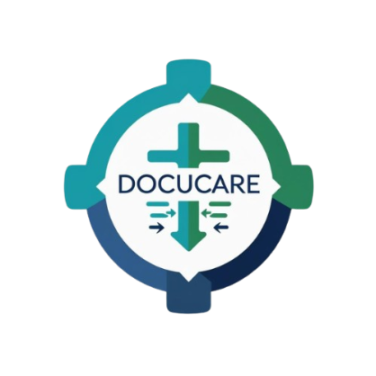
Project Objectives: | Securely Store Patient Documents  To provide a centralized and safe system for storing medical records, lab results, and prescriptions, reducing the reliance on paper-based records.  Track Document Versions  To maintain previous versions of patient documents, allowing staff to reference updates and ensuring data integrity over time.  Control User Access  To implement role-based access so only authorized administrators and staff can view, upload, or modify documents, protecting patient privacy.  Retrieve Documents Efficiently  To allow staff to quickly search and find patient records using filters like patient name, document type, or date, improving workflow and saving time.  Archive and Retain Old Documents  To automatically manage outdated or inactive documents, ensuring compliance with retention policies while freeing storage space.
Project Description: | The Clinic Patient Document Management System is a web-based application designed to help small medical clinics securely manage patient documents such as medical records, lab results, prescriptions, and other healthcare documents. The primary users of the system are clinic administrators and authorized clinic staff, who require a reliable, organized, and secure platform to store, retrieve, and manage patient records efficiently. The system is designed to meet user expectations for ease of access, document security, version tracking, and workflow efficiency.  The application aims to have a significant positive impact on its users and the clinic as a whole. By centralizing patient documents in a digital system, the project reduces reliance on paper records, minimizes human error, and improves the speed and accuracy of document retrieval. It also supports better compliance with data retention policies through archiving and automated document retention rules. Overall, the system enhances clinic productivity, ensures patient privacy, and contributes to improved healthcare service delivery.  The technology stack for this project includes C#, ASP.NET Core, Blazor, Razor Components, Entity Framework Core, RESTful Web API, and Microsoft SQL Server. These technologies were chosen for their compatibility with web-based application development, ability to implement role-based access control, and support for secure document management and database operations. Blazor and Razor Components allow for a responsive, interactive user interface, while Entity Framework Core simplifies data handling between the application and SQL Server. The use of a RESTful Web API ensures that document operations such as upload, retrieval, and version tracking can be handled efficiently and securely.  This combination of technologies aligns with the project requirements by providing a robust, maintainable, and secure platform for managing patient documents, supporting both the functional needs of the clinic staff and the non-functional needs for security, scalability, and usability.
Use Case Diagram  (Role-Based Access) | 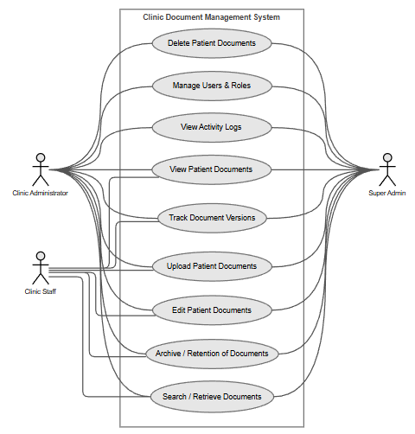  Role-Based Access for Clinic Document Management System  Super Admin  - Manage user accounts and assign roles  - Control access permissions for clinic staff  - Upload, edit, and delete patient documents  - View and retrieve all patient records  - Track document versions and changes  - Manage document archiving and retention  - View system activity logs and audit records  - Access all system modules  Clinic Administrator  - Manage user accounts and assign roles  - Control access permissions for clinic staff  - Upload, edit, and delete patient documents  - View and retrieve all patient records  - Track document versions and changes  - Manage document archiving and retention  - View system activity logs and audit records  - Access all system modules  Clinic Staff  - Upload patient documents such as medical records and lab results  - Edit existing patient documents  - Search and retrieve patient records  - View patient documents  - Track document version history  - Archive inactive or outdated documents
Date Submitted: | January 29, 2026
Teacher’s Feedback | _________________________________________________________________  _________________________________________________________________  _________________________________________________________________  _________________________________________________________________  _________________________________________________________________  _________________________________________________________________  ________________________________ __________________________  Student’s Signature (after feedbacking) Teacher’s Signature

