NAME | DEXTER B. RAMOS
PROJECT TITLE | RDB-ClinixDocs: A Web-Based Clinic Patient Document Management System
SUBJECT:  CODE:  TIME: | IT15/L Integrative Programming and Technologies  8441  10:00 AM – 12:00 PM
TOPIC (Type of Business Process) | #17 Document Management System
Products/Services | Medical Clinic
Agile Model - SDLC | Requirements and Planning Phase  1. Requirements Identification  The Requirements and Planning phase focuses on identifying the core needs of the RDB-ClinixDocs system based on the daily document management activities of small medical clinics. The primary goal of this phase is to define system functionalities that ensure secure, organized, and efficient handling of patient documents.  Requirements were identified by analyzing clinic workflows related to document storage, retrieval, version tracking, and access control. These requirements serve as the foundation for planning development tasks in subsequent Agile sprints.  2. Functional Requirements  - The system shall allow clinic administrators and authorized clinic staff to upload patient documents such as medical records, lab results, and prescriptions.  - The system shall store patient documents in a centralized and secure digital repository.  - The system shall support document version control to maintain previous versions and track document changes.  - The system shall enable users to retrieve patient documents using search filters such as patient name, document type, and upload date.  - The system shall implement role-based access control to ensure that only authorized users can access specific system features.  - The system shall allow authorized users to archive inactive or outdated patient documents.  - The system shall automatically manage document retention based on predefined clinic policies.  - The system shall record user activities through an audit trail for monitoring and security purposes.  3. Non-Functional Requirements  - The system shall ensure data security and patient confidentiality through authentication and authorization mechanisms.  - The system shall provide secure file upload handling to prevent unauthorized or malicious file access.  - The system shall be user-friendly and easy to use for clinic staff with minimal technical knowledge.  - The system shall be scalable to support future enhancements and increased document storage needs.  - The system shall provide reliable system performance with minimal downtime.  4. User Roles and Access Planning  Super Admin  - Full access to all system modules  - Manages user accounts, roles, and permissions  - Oversees document archiving, retention policies, and audit logs  Clinic Administrator  - Manages clinic staff accounts and access permissions  - Uploads, edits, retrieves, and archives patient documents  - Monitors document versions and activity logs  Authorized Clinic Staff  - Uploads and edits patient documents  - Searches and retrieves patient records  - Views document version history  - Archives documents when permitted  5. Product Backlog Planning  Initial Product Backlog Items:  - User authentication and role-based authorization  - Patient Document API for document upload and retrieval  - Document storage and management module  - Version control module for patient documents  - Document retrieval and search module  - Archiving and retention management module  - Activity logs and audit trail module  6. Sprint Planning Strategy  - Early sprints focus on system setup, database design, and core document upload and retrieval features.  - Later sprints focus on advanced functionalities such as version control, archiving, retention policies, and audit logging.  7. Planning Outcome  The Requirements and Planning phase establishes a clear understanding of system objectives, user roles, and prioritized features for RDB-ClinixDocs. By applying the Agile SDLC, the project ensures that development remains flexible, secure, and aligned with the operational needs of small medical clinics.  This phase provides a structured yet adaptable roadmap for building a secure and efficient Web-Based Clinic Patient Document Management System.
Use Case Diagram  (Diagram Only) | 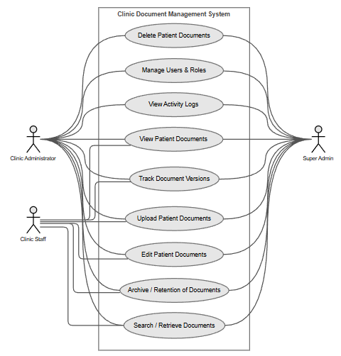
Entity Relational Diagram | 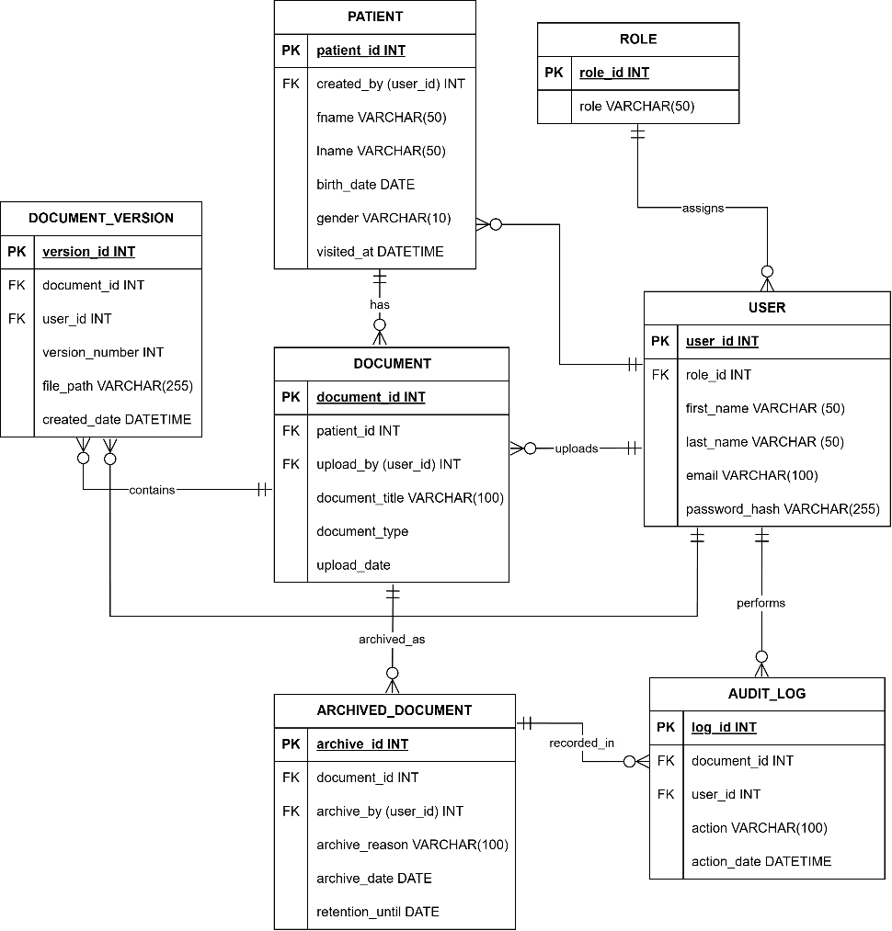
Data Dictionary | RDB-ClinixDocs: A Web-Based Clinic Patient  Document Management System  Role table  Field Names Datatype Length Description  RoleID-PK Int-AI 9 Unique identifier for each role  Role Varchar 50 Name of the role  User table  Field Names Datatype Length Description  UserID-PK Int-AI 9 Unique identifier for each user  RoleID-FK Int 9 Role assigned to the user  FirstName Varchar 50 User’s first name  LastName Varchar 50 User’s last name  Email Varchar 100 User’s email address  PasswordHash Text 255 Encrypted password of the user  Patient table  Field Names Datatype Length Description  PatientID-PK Int-AI 9 Unique identifier for each patient  UserID-FK Int 9 User who created the patient record.  FirstName Varchar 50 Patient’s first name  LastName Varchar 50 Patient’s last name  BirthDate Date — Patient’s date of birth  Gender Varchar 10 Patient’s gender  Document table  Field Names Datatype Length Description  DocumentID-PK Int-AI 9 Unique identifier for each document  PatientID-FK Int 9 Patient associated with the document  UserID-FK Int 9 User who uploaded the document  DocumentTitle Varchar 100 Title of the document  DocumentType Varchar 50 Type of document (e.g., Lab Report, Prescription)  UploadDate Date — Date the document was uploaded  DocumentVersion table  Field Names Datatype Length Description  VersionID-PK Int-AI 9 Unique identifier for each document version  DocumentID-FK Int 9 Associated document  UserID-FK Int 9 User who updated the version of document.  VersionNumber Int 9 Version number of the document  FilePath Text 255 File Storage Path  CreatedDate DateTime — Patient’s gender  ArchiveDocument Table  Field Names Datatype Length Description  ArchiveID-PK Int-AI 9 Unique identifier for each archived document  DocumentID-FK Int 9 Document being archived  UserID-FK Int 9 User who archive the document  ArchiveReason Varchar 100 Reason for archiving  ArchiveDate Date — Date the document was archived  RetentionUntil Date — Retention expiration date  AuditLog table  Field Names Datatype Length Description  LogID-PK Int-AI 9 Unique identifier for audit log entry  DocumentID-FK Int 9 Document involved in the action  UserID-FK Int 9 User who performed the action  Action Varchar 100 Action performed e.g., (viewed, uploaded, archived)  ActionDate DateTime — Date and time of the action
Date Submitted: | February 16, 2026
Teacher’s Feedback | _________________________________________________________________  _________________________________________________________________  _________________________________________________________________  _________________________________________________________________  _________________________________________________________________  _________________________________________________________________  ________________________________ __________________________  Student’s Signature (after feedbacking) Teacher’s Signature

