Tuteria Virtual Classroom: Product Requirements Document
Version 6, 30 October 2026. This version adds everything decided since version 5: the join and class changes built in the prototype, the Spaces, Library, Sessions and Settings pages, AI generation, and quizzes. Where they differ from earlier versions, they replace them.

What changed since version 1
The structure of version 1 is kept. The table lists only what is different, as it now stands.
Area | Version 1 | Now
Guests | Watch only, name entered | Students who do not create an account, for example someone attending only 4 classes. They must enter a name and take part like students. Only observers join without a name
Invite links | One Invite Others link | Invite Others is one link for students and guests that never changes. The observer link is separate and sits in the host controls menu, away from Invite Others
Observers | Hidden, policy undecided | Fully hidden from everyone in the class. No name collected. Logged for admins only
Joining | Students wait in the lobby | Students and guests can join any class whose link they have, before or after the tutor. Anyone not signed in chooses Continue with email or Continue with name
Spaces | Created by admins | Admins and tutors can both create spaces
Sign-in | Own email and password | The classroom has its own accounts on a Tuteria domain, separate from the main platform, like Lessonspace. Sign-in, set-your-password and forgot-password screens
Tutor devices | Laptops and phones | Tutors use laptops, tablets or phones held in landscape. The phone layout is for students
Resource tab | Apps, links and a browser | Apps (calculator, graphing tool, GeoGebra), Documents with Apply, and Links that play YouTube videos in a shared window
Tabs | Tab bar only | Tab search and a deleted-tabs bin
Scheduling | Not covered | None in version 1. The permanent invite link is shared once and used for every class
After class | Not covered | Everyone sees a Class ended screen. Signed-in people also get a button back to Spaces
Recording purpose | Let students replay | Mainly to review what the tutor does and how well they run the class
Recording rules | Every room recorded | Nothing records unless a tutor, or an admin acting as tutor, and at least one other person are present. One recording per session, always the tutor's view
Recording format and access | Video, available to students | Audio of the tutor's room plus the board's drawing history, played in a replay player. Kept 30 days. Admins only, through a shareable link that stops working when the recording is deleted
Student recording | Not covered | Dropped. No recording ever happens without a tutor, to save cost
Whiteboard | Excalidraw, sync built in house | Still Excalidraw, with free open-source Yjs and Hocuspocus for live sync, boards and permissions
Leading Mode | Everyone follows pan and zoom | Everyone shares the tutor's board and tab until the tutor stops leading. Then students can open other tabs they have access to
Documents on the board | PDF viewer layer | Pages become images placed on the board, so nothing sits on top of it
Breakout rooms | Manager only | Manager as before, plus Spy mode for watching other rooms and one-click jump to a room. Only tutors and admins create rooms, and only once a tutor is in the class. Students never can
Chat | Per room | History is kept in the space, like the whiteboard, and there is no Clear chat button (removed in version 6). Each message shows the sender's name above it. New messages show as a short preview when the panel is closed, files can be sent, and chat appears in the admin replay
Ending a class | Not covered | Leave session and End session for all, an automatic end 10 minutes after the tutor is gone, and an are-you-still-there check after 20 minutes without activity, also in rooms with only students
Network drops | Reconnect to the same room | Automatic return to the same room, breakout room and tab, with a short confirmation card after longer drops
Phones and weak networks | Stated as a goal | Audio and board sync come first. Video defaults to 144p, with cameras on by default. Measurable targets and a Nigeria-first feature list
Brand | Not specified | Tuteria colors listed, with rules for readable text
Cost | Up to 200 classes a month | Cost model for 500 tutors at the same time, a comparison with Lessonspace, and a plan to build on free tiers

What changed in version 6
The table lists what differs from version 5, as it now stands. Where version 6 and earlier versions disagree, version 6 applies.
Area | Version 5 | Now
Guest admission | No admit step | Guests wait until the tutor lets them in. Signed-in students go straight into the class
Join screens | Continue with email or Continue with name | That's Not Me opens the Join Space as Guest screen: Back, required name, Join as Guest (disabled until a name is typed) and Join with Email
Tutors on phones | Never. Laptops or tablets only | Allowed in landscape. The classroom locks to landscape where the browser allows it, otherwise a Turn your phone sideways screen shows. To confirm with the product manager
Clear chat and Empty bin | Tutor could clear the chat with its files, and empty the deleted-tabs bin | Both buttons removed. Chat is kept with the space
Timer | Shared timer shown in the top bar | A clock icon with a dropdown: 15 minutes, 30 minutes, 1 hour, Set End Time, Set Custom Time and Stopwatch. The time shows only inside the dropdown
Side panel | One vertical bar. Layout buttons and Spy mode on the right | Two bars: a controls bar and a video layout bar (Grid, Sidebar, Floating and, for tutors and admins while a breakout exists, Spy mode). Students and guests get no layout bar
Chat panel | Opened over the video tiles | Video tiles move left and sit beside the chat. Attachments are images or PDFs
Breakout rooms | Manager opened from the + menu | Main Room becomes a dropdown with the Breakout Manager and every existing room. People are dragged into rooms and Apply changes moves them
Resource tab | Apps, Documents, Links, Browser | Opens as a panel with the sections, plus AI Assistant and Quizzes
Spaces page | Large cards showing class days | Small cards showing people in class. Menu: Copy invite link, Rename, Copy observer link, and Delete for admins
Library | Saved files | Plus button and drag and drop. Files are private or organisation files. AI-generated files are tagged
Sessions and Settings pages | Described in one line each | Sessions list with attendance, recordings and share links. Settings with automatic or manual recording and the class permission defaults
Recording pause | Not covered | Tapping the recording indicator pauses and resumes (assumed)
AI generation | Not covered | Notes, quizzes and images, on the dashboard and in class, saved as private or organisation files (section 25)
Quizzes | Not covered | The tutor types or imports questions and gives the quiz to every student in the class (section 26)

1. Overview and goals
Tuteria will build its own web-based online classroom to replace Lessonspace, the tool it used last year. The aim is a classroom that matches Lessonspace for quality and features and is better suited to Nigerian tutors and students: it must work well on mid-range Android phones and on weak mobile data, and it must stay affordable at scale.
Goals
- Real-time audio and video for one tutor with one student, or one tutor with up to 6 students and guests, with no noticeable delay.
- A whiteboard-first lesson: a shared board, a separate board per student, and documents placed on the board so nobody has to share a screen.
- Persistence: whatever is written or added in a space is still there when people return, unless the tutor clears it.
- Works on phones and low bandwidth, with quality that adapts to the connection instead of freezing or lagging.
- A lightweight web app that does not carry or store video itself.
- A class students enjoy, with reactions and stars.
- Recordings that show what the tutor saw and did, so Tuteria can review teaching quality.
- A low cost per class-hour that holds at 500 tutors teaching at the same time.
Out of scope for version 1
- Classes larger than 6 students and guests combined.
- Native iOS or Android apps. The web app can be installed on the home screen instead.
- Tutors teaching from phones in portrait. A tutor on a phone must hold it sideways.
- A data saver mode.
- Multiple organizations. There is one organization, Tuteria.
- Heavy screen sharing. It is available but secondary.
- Scheduling: no calendar, booking or reminders. The permanent invite link is shared once and used for every class.
Team and timeline: one full-stack developer, Tersoo, builds the front end and back end, reporting to a supervisor and a product manager. Hosting and the backend language are to be agreed with Tersoo. See section 23 for the timeline. With Excalidraw, the whiteboard sync is built in house, which lengthens the original 3 months.

2. Users and roles
There are five roles. The tutor is the host of a class and controls what everyone else can do.
Role | Signs in | Speak and show video | Draw, chat, react | Visible to others | End session for all
Admin | Yes | Yes | Yes | Yes | Yes
Tutor (host) | Yes | Yes | Yes | Yes | Yes
Student | Yes, or enters a name only | Yes, if the host allows | Yes, if the host allows | Yes, by name | No, can only leave
Guest | No. Enters a name | Yes, if the host allows. On by default | Yes, if the host allows. On by default | Yes, by name | No, can only leave
Observer | No. No name or identity collected | No | No | No. Not shown anywhere | No, can only leave

Host controls. The tutor can switch each of these on or off for one person or for everyone: editing, microphone, camera, screen share, raise hand, reactions, chat and file uploads. Leading Mode makes everyone share the tutor's board. The tutor can also remove and ban people. Guests are controlled the same way as students. The host controls menu also holds the observer link.
- Admins and tutors can create spaces. Admins manage tutors and students and can end any session. Admins and tutors can get the observer link.
- Tutors teach from laptops or tablets, and may also use a phone in landscape (version 6, to confirm with the product manager). On a phone the classroom locks to landscape where the browser allows it. Where it does not, the tutor sees a Turn your phone sideways screen. Students may use phones, tablets or laptops.
- Guests are students who do not create an account, for example someone attending only 4 classes. They take part like students, under the same host controls. Each class a guest starts with a fresh board, because without an account the app cannot tell that a returning guest is the same person. The tutor's main board is still kept.
- A student with an account can also choose to join with a name only. They are then treated like a guest for that class.
- Observers join through their own link, see and hear the room they are in, and cannot be seen or heard. They can move between breakout rooms.

3. Invite links
There are two links with different purposes. One cannot be turned into the other, and each carries its own permissions on the server.
 | Invite link | Observer link
Purpose | Bring students and guests into the class to take part | Let someone watch without being seen, for example for quality review
Where it is found | Invite Others in the top bar | The host controls menu, placed away from Invite Others so tutors do not mix them up
Who can get it | Tutors and admins | Tutors and admins
On joining | Signed-in people go to the join card. Anyone else chooses Continue with email (then signs in) or Continue with name (then types a name). Then the join card and the lobby. Guests then wait until the tutor lets them in. Signed-in students go straight in | No lobby. Joins straight in with camera and microphone off and locked. No name asked
What others see | A tile and list entry with the person's name | Nothing. No tile, no list entry, no join sound
Personal data | The name entered, or the account if the person signs in | None. A random session ID only
Counts toward class size | Yes | No. Up to 3 observers per room (proposed)
Counts toward starting a recording | Yes, as the second person | No
Expiry | Always on. One link per space that never changes | Default one session, can be revoked

Links use long random tokens that cannot be guessed. The server stores only a hash of each token. Because the invite link never changes, anyone who gets hold of it can ask to join. Signed-in students go straight in and guests wait until the tutor lets them in, so the link should still be shared only with the class. The tutor can remove and ban anyone.

4. Product structure
The dashboard is organized around spaces. A space is a permanent classroom, for example a class that meets every Tuesday. A session is one occasion when people meet in that space. Whatever is written, drawn or added in a space is kept until a tutor clears it.
Sidebar section | Purpose | Version 1
Spaces | List of classrooms as small cards showing name, the number of people currently in the class and last used, with search, filters, sort, grid and list views, and a New Space button for admins and tutors. The three-dot menu on each card has Copy invite link, Rename and Copy observer link, and admins also see Delete | Yes
Sessions | History of past and live classes, newest first, with space, date, duration, tutor, number of people and status, plus search and filters. Each row opens the attendance log. Admins open recordings from here, copy the share link and delete them | Yes, basic
Library | Saved PDFs, images and documents that can be placed on any board. A plus button and drag and drop add files, which are private or organisation files. AI-generated files are tagged | Yes
Teachers and Students | Admin lists for adding and managing people | Yes
Settings | Profile and organization settings. Includes Record classes automatically or manually, for all classes or per space, and the class permission defaults | Yes, basic
Overview | Summary dashboard | Later
Notes | Separate from Library. Contents to be confirmed from Lessonspace | Later
Support | Help link | Later

The menu under the user's name shows the profile and log out. There is no organization switcher, because Tuteria is the only organization.
Spaces page (version 6). Space cards are small. Each card shows the space name, the number of people currently in the class (or Empty), the learner avatars, last used and an Enter space button. The class days no longer appear on the card. The three-dot menu has Copy invite link, Rename (change the space name and save) and Copy observer link. Admins see a fourth option, Delete, with a confirmation, which removes that space.
Library page (version 6). A plus button and drag and drop add documents and photos, within the file types and 25 MB limit in section 11. Files are private to the person who added them or organisation files available to every tutor and admin. The owner and admins can change this later from a menu on the file, and can rename or delete it.
Sessions page (version 6). Modelled on Lessonspace, whose help pages only confirm that Sessions lists past sessions and opens a recording from a View Recording action, with access following the recording access policy. Everything else here is proposed. Sessions are listed newest first with the space, date and start time, duration, tutor, number of people and a status of Live now or Ended. A search box and filters narrow by space, date range and tutor. Each row opens the attendance log from section 14, with observers shown to admins only. Admins see View recording, which opens the replay player, Copy link for the shareable link, the days left before the 30-day deletion and Delete. Tutors and students never see recording buttons.
Settings page (version 6). Holds the permissions from this document: Record classes automatically or manually, for all classes or for one space, and the class defaults for who can use chat, share files, edit the board, speak, show video, raise a hand and react, plus the waiting rule for guests. Settings that only admins may change are hidden from tutors. The settings for AI in section 25 are decided there.

5. Core user flows
Sign-in. The classroom is its own product on a Tuteria domain, separate from Tuteria's main platform, in the same way Lessonspace stands alone. Admins, tutors and students have classroom accounts with email and password. This needs a sign-in screen, a set-your-password screen for new accounts (sent by email when an admin adds someone, assumed) and a forgot-password flow.
Joining a class (tutor, student, guest)
- Open the invite link, or open a space from the Spaces page if signed in.
- Anyone who has not been here before sees the Join Space as Guest screen: a Back link, a required Your Name field, a Join as Guest button that stays disabled until a name is typed, and a Join with Email button that leads to sign-in. Guests are students who are not logged in.
- A person who was here before sees a card that says You're joining as [name] with Continue and That's Not Me. That's Not Me opens the Join Space as Guest screen. The order is: invite link, the returning-person card if the person was here before, otherwise the guest screen, then the camera and microphone lobby, then the class.
- The lobby shows the camera preview with camera and microphone switches (camera on by default), a Devices menu for camera, microphone and speaker, an effects button that holds noise cancellation, Test Speakers, and a Request Microphone and Camera Permission button. A signed-in person also sees Logged in as [name] with Logout.
- Signed-in students can enter any class whose link they have, even if the tutor has not arrived. A guest waits to be let in, so in a class with no tutor a guest waits until a tutor or an admin arrives (assumed). While no tutor is present, the space's default permissions apply and breakout rooms cannot be created.
- The classroom opens with the whiteboard and the side panel.
Guests follow the same path, usually choosing Continue with name. After the lobby a guest sees a waiting screen until the tutor lets them in. Signed-in students do not wait and go straight into the class.
Joining as an observer. The person opens the observer link and enters the room directly, unseen, with microphone and camera off. No name is asked.
Leaving and ending. Students, guests and observers see Leave session only. Tutors and admins see Leave session and End session for all. See section 6 for what happens when a tutor leaves without ending. When a class ends, everyone sees a Class ended screen, and signed-in people also get a Back to Spaces button.
- A person can join without a camera or microphone if permission is denied or the device is missing.

6. Staying connected and ending a class

Automatic return after a network drop
Mobile networks and power supply in Nigeria are unreliable, so coming back after a drop is a core feature, not a fallback. The person should not need to click the link again.
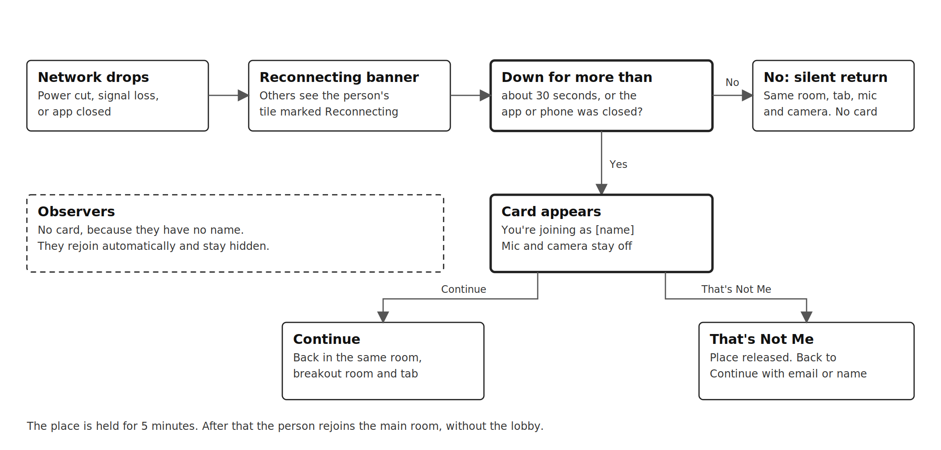
What happens when a person's network drops
Situation | What happens
Network drops | A Reconnecting message shows to the person. Everyone else sees the person's tile marked Reconnecting instead of the person disappearing
Back within about 30 seconds | Silent return to the same room, board tab, and microphone and camera state. No card
Down for longer, or the app or phone was closed (power cut, restart) | When the network returns, the card You're joining as [name] appears with Continue and That's Not Me. Continue returns the person to the same room, the same breakout room if they were in one, and the same board tab, without the lobby
That's Not Me | The person's place is released and they return to the Join Space as Guest screen, signed out if they were signed in. The next person on a shared phone or laptop does not inherit the place
While the card is waiting | The person is not in the room. Microphone and camera stay off, and others see the tile as Reconnecting
Place held for | 5 minutes. After that the person rejoins the main room as a fresh join, still without the lobby
Breakout room closed while away | The person returns to the main room
Tutors | Same card. A tutor who is gone pauses the recording and starts the auto-end timer, so the card should be quick to tap through
Guests | The same card as everyone else, with the name they entered
Observers | No card, because they have no name. They rejoin automatically and stay hidden throughout
Browser or phone fully closed | Opening the class link again, or the home-screen app, shows the card and then returns the person to where they were
The class cannot open at all, for example a server problem or a very weak connection | A message: We can't open this class right now. Check your connection and try again. With a Try again button, never a blank or broken screen

The 30 second threshold is a starting value to tune in testing. Short blips on mobile data are common and the card should not interrupt a class every time.

Ending a class
Situation | What happens
Tutor or admin chooses End session for all | The session ends for everyone. Recording stops and is saved. Everyone sees the Class ended screen
Anyone chooses Leave session | That person leaves. The class carries on
Tutor closes the tab and does not end the session | The class keeps running until no tutor or admin has been connected for 10 minutes, then ends by itself. Students still in the room are warned 2 minutes before: the tutor has left and the class will end in 2 minutes
Only students or guests in the room, no tutor | The room stays open while there is activity. After 20 minutes without activity they see the same check, and the class ends if no one answers within 5 minutes
No activity for 20 minutes while a tutor is present | The tutor sees the check below. No answer within 5 minutes ends the class

The 10 minute auto-end is longer than the 5 minute place-holding window, so a tutor whose network drops briefly does not lose the class.

The are-you-still-there check
Activity means the tutor's voice and any interaction by the tutor: drawing or another board change, a tab change, a file added, a chat message, a reaction. A tutor who is explaining out loud is active, so the check does not appear. In a room with only students or guests, any of their voices or interactions count, and any of them can answer. The check appears as a pop-up, not as a chat message, because on phones the chat panel is often closed.
Are you still in class?
There has been no activity for 20 minutes. Tap Yes to keep the class going. If we do not hear from you, this class will end in 5:00.
Buttons: Yes, we're still here. End class.
- Recording carries on while the pop-up is showing.
- Each time the check appears and each answer goes into the session log.
- The check is only about whether the class is really still running. It does not keep any server awake. The servers are always on (section 20).

7. Classroom layout and UX
On a laptop the whiteboard fills about 75% of the screen and a side panel fills the rest, following Lessonspace. Nothing sits on top of the board: video, chat and controls stay in the side panel and top bar.
Top bar. Tabs, where the first tab is Main Room, a Grids view and extra whiteboards or documents, with a + button to add more. Next to the tabs are Invite Others, End Session, the host controls menu (shown as a crown icon, holding permissions, Leading Mode and the observer link), the recording indicator and a clock icon for the timer. The timer shows no time in the bar: the clock icon opens a dropdown with 15 minutes, 30 minutes, 1 hour, Set End Time, Set Custom Time and Stopwatch, and the running time appears inside that dropdown. Main Room is a dropdown for tutors and admins that holds the Breakout Manager and a list of every breakout room that exists, with the number of people in each. Choosing a room takes the tutor or admin there, and Back to main room returns. Students and guests do not see this list. The observer link is kept in the host controls menu, away from Invite Others, so tutors do not mix them up. While the tutor leads, students see a Following [tutor name] label in the tab bar.
Board toolbar. Excalidraw's own tools for select, hand, pen, shapes, text, eraser, images and undo and redo, plus zoom. A highlighter and equation input are added later if needed.
Side panel. Video tiles and two separate vertical bars. The controls bar holds settings, share screen, microphone, camera, reactions, raise hand, participants and chat. The video layout bar holds Grid (every video in an equal grid), Sidebar (videos in an anchored column that scrolls when full) and Floating (tiles that can be dragged and resized). Spy mode sits in the layout bar and appears only while a breakout room exists and only for tutors and admins (section 12). Students and guests do not get the video layout bar and always see the Sidebar layout (assumed). When chat is open, the video tiles move to the left and sit beside it instead of being covered, and return when chat is closed.
The + menu opens: new whiteboard, new document tab, import PDF and the resource tab. The Breakout Manager opens from the Main Room dropdown instead.
Phone layout, for students. The board takes the full screen. Video tiles are small and draggable, and touches pass through to the board except on a tile. Controls move to a bottom bar. Chat and the participant list open as slide-up panels. Tabs scroll sideways. On a phone a person sees the tutor and the current speaker as video and everyone else as an avatar until tapped, to save data and processing power.
Tutors on laptops, tablets and phones. Every tutor control, including the Breakout Manager, Spy mode and the Grids view, is designed for laptop and tablet screens first. A tutor on a phone uses the classroom in landscape: it locks to landscape where the browser allows it, and otherwise a Turn your phone sideways screen is shown. On a tablet, controls work by touch, the layout fits portrait and landscape, and a stylus can be used to write on the board.
Design principles
- Large touch targets, at least 44 by 44 points, and few controls on screen at once, because many users are children.
- Clear state at all times: who is speaking, who has a hand raised, which board is shown, whether the tutor is leading and whether the class is being recorded.
- Friendly, but never at the cost of board space.

8. Visual design and brand
The classroom uses Tuteria's brand colors. Vivid Blue is the only brand color dark enough for white text, so the lighter colors carry dark text or are used as fills and accents.
Color | Hex | Use in the classroom | Text on it
Vivid Blue | #0054E5 | Primary buttons, links, active tab, the Following label, selected tools | White
Vivid Turquoise | #2FEEDB | Speaking ring around a video tile, online status | Dark text
Turquoise | #3DB586 | Success messages, joined, good connection, saved | Dark text
Vivid Orange | #FF7F50 | Recording indicator, attention states, the still-in-class check | Dark text
Yellow | #FFCE00 | Stars, raised hands, reactions, timer warning | Dark text

- Dark text is a near-black navy such as #14213D. Body text never uses the light brand colors.
- Errors and destructive actions (End session for all, Remove, Ban, Clear board) need a red that the palette does not include. Proposed: #D93636, used only for these.
- Typography follows the brand guide: Sora for the interface, and Shantell Sans for playful touches such as reactions and empty states.
- Light and dark modes use the brand guide's Platinum and Night Forest backgrounds. The board stays light by default because most teaching material is on white.
- Recording, speaking and raised hand each pair color with an icon or label, so color is never the only signal.

9. Live video and audio
Video and audio must be real time. The provider is LiveKit: LiveKit Cloud at launch, moving to self-hosted LiveKit when volume makes it cheaper (section 20).
- One tutor with up to 6 students and guests combined per room, plus up to 3 hidden observers (proposed).
- Each person sends one stream to a media server, which forwards it to the others. Streams are not sent person to person.
- Microphone, camera, device switching and screen sharing. Screen sharing is secondary.
- Video is captured at 144p by default for everyone, including the tutor, to save data. Cameras are on by default. Anyone can turn theirs off with the camera switch in the lobby or the camera button in the control rail.
- On a weak network, audio and the board's view and sync come first. Video drops before either of them.
- Host controls: mute a person, turn a person's camera off, change permissions during the class, remove a person. LiveKit lets the server change a connected person's permissions at any time.
- Observers join as hidden, subscribe-only participants. The recorder joins the same way.
- The backend creates a short-lived access token for each person and room, stating what they may do. The front end never decides permissions alone.
- Reactions, raise hand, the timer and the tutor's leading state travel as small messages in the room, not as video.
Why LiveKit and not Daily.co. Per participant-minute LiveKit Cloud costs about $0.0004 to $0.0005 and Daily about $0.004 before volume discounts, roughly ten times more. LiveKit is also open source, so the same app can move to Tuteria's own servers later. It includes simulcast, adaptive stream and dynacast for weak networks, and supports hidden participants and server-side permission changes, which observers and the recorder need. All provider calls go through the backend so the provider can be changed later. Prices come from published pricing in October 2026 and must be checked before the budget is approved.

10. Whiteboard
The whiteboard is Excalidraw, which is free to use commercially (MIT license). Excalidraw runs in each person's browser, so it has no server of its own that can go to sleep. What it does not include is classroom features: multiple boards, permissions per board, and following the tutor. Those are built on two free open-source pieces.
Piece | Role
Excalidraw | The board itself: drawing, text, shapes, images, zoom. Its own toolbar is used, styled with Tuteria's colors
Yjs | Keeps every person's copy of a board in step, and lets a person keep drawing and catch up after a network drop. MIT license
Hocuspocus | A Yjs server Tuteria hosts itself. Saves each board to the database and checks on every connection whether the person may edit or only view that board. MIT license
y-excalidraw | A community connector between Excalidraw and Yjs. Smaller and less proven than Excalidraw, so it is tested in week 1 (section 23)

Excalidraw's public collaboration server is not used. It has no login protection, so anyone with a live link can join, and it does not store boards. It does not fit a classroom with children.
Boards and permissions
- Each tab is its own live board: the tutor's main board, one board per student, one set per breakout room, and document tabs. The tab bar shows them as tabs.
- The tab list has a search box for finding a tab by name, and a Deleted tabs bin where a tab closed by mistake can be restored. Tabs stay in the bin until the tutor leaves the session, and there is no Empty bin button (version 6).
- The tutor can edit every board. A student or guest can edit their own board, and the main board when the tutor allows editing. Everyone else can only view.
- The sync server checks every change against these rules. A read-only screen on its own is not enough.
- The tutor can let students see each other's boards.
- Guests start with a fresh board each class.
Leading Mode. When the tutor enters they are the leader, and everyone shares the tutor's whiteboard until the tutor stops leading. The tutor's current tab and pan and zoom are broadcast through Yjs awareness, the channel that also carries live cursors. Students' screens apply it through Excalidraw's own controls, so nothing is added on top of the board.
Situation | What students see
Tutor is leading (default) | The tutor's tab and the tutor's pan and zoom. When the tutor changes tab, everyone changes. Other tabs are locked. Students can draw when editing is allowed. On a phone a student can pinch to zoom in and read, and the view returns to the tutor's when they let go
Tutor stops leading | Everyone stays on the board they are on and keeps seeing it. Students can now open other tabs they have access to and move around freely. A Back to tutor's board button is always available
Tutor leads again | Everyone returns to the tutor's tab and view
Tutor is in a breakout room | Leading applies only to the room the tutor is in
No tutor in the room | No leader. Everyone moves around the tabs freely

The recorder follows the tutor through the same mechanism, which is how recordings mirror the tutor's view (section 13).
Working with many boards
- On the main board, a small circle or thumbnail for each student sits beside the tab bar. Clicking one opens that student's board, and the tutor can write on it too.
- A Show all button opens the Grids tab, which tiles every board in read-only form. Clicking a tile opens that board.
Sending a task to students. The tutor writes a task once, selects it and chooses Send to all or Send to selected. The server copies it onto each student's board, so it appears live and is still there after a refresh.
Persistence. Boards are saved continuously by the sync server and reloaded when the space opens. A board only empties when a tutor clears it, after a confirmation.
Keeping the board fast, especially on phones
- Drawing appears instantly on the local screen and never waits for the server.
- Only changes are sent, and cursor positions are sent less often than drawing.
- Nothing is layered over the board. Documents are placed inside it as images, and the toolbar is the board's own.
- Excalidraw slows down on phones when a board holds many large images, so document page images are capped at about 1,600 pixels wide, compressed, and loaded only when they scroll near the visible area.
- Only the board being viewed is loaded and kept live. Other tabs load when opened.
Cost of this route. There is no license fee, but the developer builds the multiple boards, per-board permissions and Leading Mode on top of Yjs. This is estimated at 4 to 6 weeks more than a board with these built in.

11. Resource tab and documents
The resource tab keeps tutors inside the classroom, so they never leave it to calculate something, find a document or play a video. It opens from the + menu, and choosing Resources opens a panel with its sections arranged one under another instead of only a link field. Version 6 adds two sections for tutors and admins, AI Assistant and Quizzes (sections 25 and 26).
Section | What it does
Apps | A scientific calculator, a graphing tool (such as Desmos) and GeoGebra for geometry, with ruler, protractor and compass. They open inside the classroom. Embedding terms for Desmos and GeoGebra in a commercial product must be checked
Documents | The same files as the Library. The tutor selects a file and clicks Apply, and it opens on the whiteboard for the class to see (details below)
Links | The tutor pastes a link and clicks Apply. A YouTube link plays in a shared video window (details below)
Browser | The remote browser, built last (section 17)
AI Assistant | Tutors and admins generate lesson notes, worksheets, quizzes and images with the organisation's AI, without leaving the class. Results can be placed on the board with Apply or saved to the Library as private or organisation files (section 25)
Quizzes | The tutor types questions one after another or imports them, then starts the quiz for every student in the class (section 26)

Apps open in a window that everyone in the room sees, as in Lessonspace (assumed).

Documents and Apply
File type | How it is shown
Image (PNG, JPG) | Compressed and placed on the board as a resizable image
PDF | Each page is turned into an image on the server and placed on the board, so everyone can write on it
DOCX and PPTX | Converted to PDF on the server in a background job, then treated like a PDF. Animations and some fonts will not survive

When the tutor clicks Apply on a PDF, a small dialog offers three choices, as in Lessonspace:
- Into the current board. This is the default. The pages are placed where the tutor is looking, next to existing work rather than on top of it.
- All pages in one new tab, one under another, scrolling down.
- Each page in its own new tab.
The tutor can untick pages they do not want, such as a cover or an answer key. Placed pages are locked automatically, so students can write on them without moving them. Files can also be added with the board's Upload button or by dragging them onto the board, with the same three choices.
Turning pages into images on the server, instead of showing a PDF viewer over the board, removes the separate layer that caused lag. The trade-off is that text in a document cannot be selected or copied in the class.
Students and guests can write over a document when the tutor allows editing, and upload files only when the tutor allows file uploads.

Links and the shared video window
- A pasted YouTube link opens in a video window over the classroom. It is full screen by default, and the tutor can shrink it to a smaller window.
- The video uses YouTube's own player. It streams straight from YouTube to each person's device, not through Tuteria's servers or the live call, and the classroom does not play, store or screen-share it. This keeps the classroom light.
- When the tutor plays, pauses or skips, a tiny message makes everyone's player do the same. Stop sharing closes the window for everyone.
- A few video owners block playing inside other sites. Then the window says the video cannot be played in the class and offers Open on YouTube.
- Other links open in the same kind of window when the site allows it. Otherwise the tutor gets Open in a new tab. The remote browser, built last, will show any site.
- The tutor cannot draw on a playing video. To mark something up, the tutor pauses and takes a screenshot onto the board.
- Each student uses their own data while a video plays, as when watching YouTube normally.
Storage and limits. Uploaded files and page images live in Cloudflare R2, and the app keeps only links to them. Proposed limit: 25 MB per file, with a clear message when a file is too large or a conversion fails.

12. Breakout rooms and Spy mode
A breakout room is a class inside a class. Each breakout has its own audio, video and whiteboards. People in one breakout cannot see or hear another room, except observers, who can move between rooms unseen.
Breakout Manager, opened from the Main Room dropdown in the top bar, follows Lessonspace. The same dropdown lists every breakout room that exists, so tutors and admins can see and enter rooms without opening Spy mode.
- New Breakout creates a room, which can be renamed.
- Students and guests are dragged from the People list into rooms, and whiteboard or document tabs are dragged into them. A menu on each person offers move to room and remove from room as an alternative to dragging.
- Apply Changes moves all people and content at once, so everything can be arranged first. After it is clicked, each student finds themselves in the room they were placed in. Cancel discards the arrangement.
- A room can hold one student or several.
Who can create breakout rooms
- Nobody can create a breakout room until a tutor has entered the class. Before that the option is shown but locked, with the note Available when your tutor joins.
- Once a tutor is present, tutors and admins can create rooms. Students can never create breakout rooms.
- If the tutor leaves, existing rooms stay open but no new ones can be created.
Moving around
- The tutor joins a room from the participant list or by dragging their own name into it. Their audio and video go only to that room, and the recording follows them.
- Jump to view in a participant's menu takes the tutor straight to that person's room and tab.
- The tutor can drag a student into the main room to explain something, then drag them back. The rest of that group keeps working.
- A student in a breakout can raise a hand. The tutor is notified even when in another room and can choose to join.
- The tutor can send an announcement to every room, or a chat message to one room.
- The tutor can bring everyone back to the main room. Breakout boards are kept.
Rules. A student or guest is in one room at a time. The backend decides who may join which room by issuing a separate access token for each. Each breakout is a separate LiveKit room, and because a person is in only one at a time, connection minutes do not increase.

Spy mode
Say 9 students are split across 3 breakout rooms and the tutor is inside one of them. Spy mode lets the tutor see what the other rooms are doing without entering them.
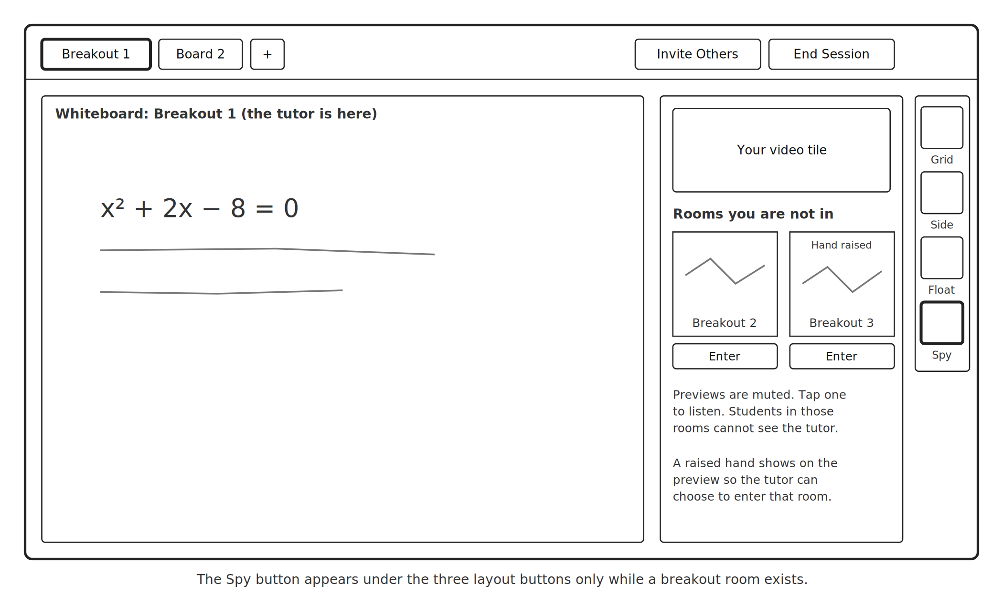
Spy mode on a laptop. The tutor is in Breakout 1 and previews Breakouts 2 and 3
- The layout buttons are Grid, Sidebar and Floating. Spy mode is a fourth button that appears under them only while a breakout room exists, and disappears when all breakouts are closed, so it never misleads anyone.
- Spy mode is for tutors and admins only. Students never see it.
- Each room the tutor is not in shows as a square preview. The main content is that room's board, live but slightly delayed, because that shows whether students are working and costs little data. Small low-quality student video tiles are an optional extra.
- Previews are muted. The tutor can tap one to listen in.
- The tutor is not in those rooms, and the students there cannot see or hear the tutor. A raised hand shows on the preview.
- To go into a room, the tutor clicks its preview and chooses Enter.
- Placement. On a laptop the previews sit in the side panel with the video tiles. On a tablet they sit in the side panel in the same way. On a phone, in landscape, Spy mode opens as a panel over the tutor controls.
- Spy mode previews are never recorded.
- Students in the rooms are not told when they are being previewed, so Tuteria's terms for families and tutors must say so (section 22).
Idle students. The participant list marks a student as idle after 3 minutes with no drawing, speaking or mouse movement (proposed). The tutor can mute, turn off video or restrict editing from the list without leaving their room.

13. Recording
Recording exists mainly to show what the tutor is doing and how well they run the class. So the recording mirrors the tutor's view at all times: the board as the tutor sees it and what the tutor hears. It is audio plus the board's drawing history, played back in a replay player, not video. A session produces one recording, including one-on-one classes and classes with breakout rooms.
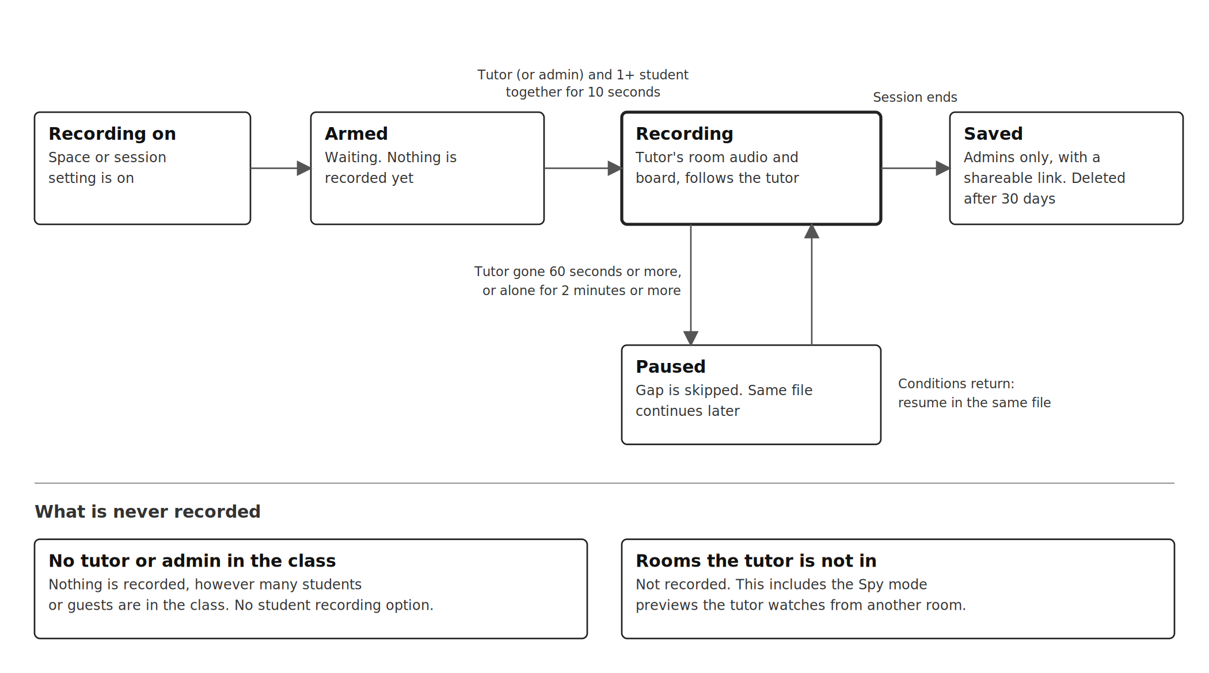
When recording starts, pauses and stops

Rules
Situation | What happens
Record classes automatically is off for the space | Nothing is recorded
It is on and only the tutor is present | Armed. Nothing is recorded yet
The tutor and at least one student or guest have been present together for 10 seconds | Recording of the tutor's view starts. Observers and the recorder do not count
An admin and at least one student or guest, with no tutor in the class | The admin counts as the tutor, and the admin's view is recorded
A tutor and an admin are both in the class | The tutor's view is recorded
No tutor or admin in the class | Nothing is recorded, whatever the number of students. There is no student recording option
One-on-one class or group class | One recording, the tutor's view
Breakout rooms | Still one recording. It moves with the tutor from room to room. Rooms the tutor is not in, and Spy mode previews, are not in it
The tutor disconnects for more than 60 seconds, leaves, or is alone for more than 2 minutes | Recording pauses and resumes in the same file when the conditions return. The gap is skipped
The session ends | The recording is ready within minutes. Only admins can open it, and each recording has a shareable link. The recording and its link are deleted after 30 days
Manual pause (assumed, version 6). Tapping the recording indicator in the top bar pauses and resumes the recording. The earlier versions do not say what triggers a manual pause, so this needs confirming with the product manager. The pause and resume are logged like any other recording event.

Whenever anything is being recorded, everyone in that room sees a Recording indicator in the top bar, and a person joining hears a short notice.
The setting Record classes automatically is in Settings and can apply to all classes or per space. Even when it is on, the rules above decide when recording actually starts. This saves recording cost, because empty or tutor-less time is never recorded.

What the recording shows
- The board as the tutor saw it, redrawn from its drawing history: the same tab, pan and zoom, and drawing as it happened, including when the tutor opened a student's board.
- The audio of the tutor's current room.
- A marker such as Moved to Breakout 2 when the tutor changes room.
- Chat messages in a panel beside the board, each appearing at the moment it was sent.
- A marker such as Video played: [title] when a shared video plays. The video's own sound is not in the recording, because it plays from YouTube on each device.
- No video of faces.

How it is built
Instead of paying the video provider to record every room, Tuteria runs its own lightweight recorder.
- A recorder joins the tutor's room as a hidden participant that only listens. It records the room's audio and moves with the tutor when they change room, because the backend gives it a token for the new room at the same moment.
- The board sync server already keeps every board change. The recorder notes which board and tab the tutor had open and their pan and zoom at each moment, the same information students follow in Leading Mode, so the replay can redraw exactly what the tutor saw.
- Audio is about 15 MB per hour, and board history is usually a few MB more (estimate). No video is encoded, so the approved 10 frames per second setting would apply only if a video export is ever added.
- Audio is uploaded to R2 in one-minute parts while it runs, so a crashed recorder loses at most a minute.
- A replay player plays the audio and redraws the board in time with it.
- Recorders scale up and down with demand. If none is free within 30 seconds, admins are alerted.

Watching recordings
- Only admins can open recordings in the app. Each recording has a shareable link that an admin can copy and send, for example by WhatsApp or email. Anyone with the link can watch until the recording is deleted after 30 days, when the link stops working.
- Sending links automatically is not part of this build. Tuteria will build that later.
- Playback at 1x, 1.5x and 2x.
- Session timeline for review (proposed): chapters at each room change and when leading turns on or off, files added and hands raised, plus the tutor's talk time and time in each room. This comes from the session log and costs almost nothing.
- Recordings are stored privately. Share links are long and hard to guess.

14. Attendance and session log
- For every session, store each person's role, join time and leave time. Signed-in people are stored by account. People who joined with a name are stored by that name and a random ID. Observers are stored by a random session ID only, with no name.
- Store key events in order: tutor joined and left, room changes, leading on and off, breakouts created, files added, boards cleared, permissions changed, recording armed, started, paused, resumed and stopped, idle checks shown and answered, and how the session ended.
- Observers are hidden from everyone in the class but are logged. Only admins can see observer entries.

15. Engagement
- Reactions. The reactions button in the controls bar opens a small emoji picker. Thumbs up, star and similar reactions appear briefly on the person's tile. The tutor can give a star to a student, with a running count per student per session (proposed).
- Raise hand. A raised hand shows on the student's tile and in an ordered queue the tutor can see. The tutor lowers it when answered.
- Chat. Text chat in the side panel, available in every space. Each message shows the sender's name above it, the name they signed in with or entered. The history is kept in the space like the whiteboard: it is still there when people leave and come back. There is no Clear chat button (removed in version 6). Each room has its own chat (breakout chat is kept with that room, assumed), and the tutor can announce to all rooms. The tutor can switch chat off for one person.
- Chat previews. The full history shows only when the chat panel is open. When it is closed, a new message appears as a small preview near the chat icon, with the sender's name and the start of the message, and the chat icon shows the number of unread messages. On a phone the preview is a thin banner just above the bottom bar that disappears after about 2 seconds, so it never stays over the board. Tapping it opens the chat.
- Files in chat. A paperclip in the message box lets people attach an image or a PDF, shown as a preview before sending. Attachments use the same 25 MB limit as board uploads, follow the file uploads permission, and are kept with the chat (assumed).
- Timer. A shared timer behind a clock icon in the top bar. The tutor opens the dropdown and picks 15 minutes, 30 minutes, 1 hour, Set End Time, Set Custom Time or Stopwatch. A countdown alerts everyone when time is up.
These travel as tiny messages, not video, so they cost almost no bandwidth.

16. Library
The Library holds saved PDFs, images and documents that can be placed on any board and reused across spaces. Recordings are not kept in the Library. Admins open them from Sessions (assumed) and share them by link. A plus button and drag and drop add documents and photos. Every file is either private to the person who added it or an organisation file that every tutor and admin can use in class, and files made with AI carry an AI generated tag (section 25).

17. Remote browser
The tutor can search the web and browse pages inside the classroom, and everyone sees it. This is the riskiest and most expensive feature, so it is built last, after every other feature is done.
- Many sites, including Google and YouTube, refuse to be shown inside another site, so a real browser (Chromium) runs on a Tuteria server and its picture is streamed into the room. One person controls it at a time.
- Highlighting means drawing on a transparent layer above the page. It cannot select the page's real text.
- Each active use needs its own server-side browser, so it needs its own server and budget.
- Every session starts with a clean browser, saved logins are never kept, and the browser is deleted at the end.
- Safety for children: content filtering, a log of visited addresses, and tutor control over whether students may use it.
Until it is built, YouTube links play in the shared video window, and other links open in a window when the site allows it or in a new browser tab.

18. Performance on phones and weak networks
The product must stay usable on a mid-range Android phone with a weak connection. Quality should drop gracefully instead of freezing. The targets below are proposals to agree with the product manager and are tuned during testing.
Area | Requirement
Audio and board first | Audio and the board's view and sync have priority. On a poor connection video pauses automatically and a banner explains why. A student can always hear the tutor and see the board
Videos on a phone | A phone shows the tutor and the current speaker as video. Everyone else is an avatar until tapped
Video quality | Default capture at 144p for everyone, including the tutor. Cameras on by default and can be turned off. Simulcast, adaptive stream and dynacast so each viewer gets what their connection allows. VP8 codec by default, which is lighter on phones than VP9
Board | Drawing appears instantly on the local screen. Only changes are sent. A short drop loses no drawing. Document pages load only near the visible area
Opening a class | Within 5 seconds on 4G. The first screen is small and the board and video code load only when a class is entered
Board sync | A change reaches other people within 1 second on 3G
Audio delay | Low enough for natural conversation, about 400 milliseconds or less one way on 4G (to be measured)
Data use | Estimated 60 to 150 MB per hour with 144p video, falling to about 20 to 40 MB while video is paused on a weak connection (to be measured)
Shared videos | Played by YouTube's own player. The classroom only sends play, pause and skip commands
Connection indicator | Each person's connection quality is shown, so the tutor knows who is struggling
Devices and networks | Latest two versions of Chrome, Safari, Edge and Firefox. Tested on mid-range phones such as Tecno, Infinix and Samsung A-series, on MTN, Airtel and Glo data, in weak signal

Before launch, run a class on a real mid-range Android phone with throttled data. Audio must continue and board changes must reach others within a second or two.

19. Built for Nigerian users
These features go beyond Lessonspace and respond to how Nigerian families actually use online classes. Of the extras, only installing on the home screen is in the launch. There is no data saver mode.
Feature | What it does | Status
Automatic return after drops and power cuts | Puts the person back in the same room, breakout room and tab (section 6) | Decided
Join with a name only | Short-term students can join without creating an account | Decided
Install on the home screen | The web app installs like an app, with no separate Android build | Decided, launch
Parent updates by WhatsApp or SMS | After each class, parents get a short summary: attended, duration, stars earned and a link to the recording | Not now. Tuteria will build the sending later
Light replay | The tutor's voice and the board being drawn, which uses far less data than video | Decided as the recording format. Admin only for now
WAEC, NECO and JAMB library | Tutors place past questions and syllabus topics straight on the board | Not now
Join by phone call | A student dials in for audio when mobile data fails. Has a per-minute cost | Not now

20. Cost model and hosting
The target is 500 tutors teaching at the same time. The estimates use one-hour classes with an average of 3 connected people, every class recorded as audio and board history, and recordings kept for 30 days. They exclude developer pay and the remote browser. Video is priced at 360p, so with the 144p default treat the video line as an upper estimate. All figures are estimates from published pricing in October 2026 and must be checked before the budget is approved.
Monthly volume | Pilot | Launch | Target
Class-hours | 500 | 2,000 | 50,000
Live video (LiveKit Cloud) | $50 to $60 | about $250 | about $5,900
Recording (audio and board) | $15 to $30 | $70 to $100 | $1,300 to $1,800
Servers (API, board sync, database) | $40 to $60 | $60 to $100 | $300 to $600
Recording storage (R2) | $0 (free tier) | about $1 | about $15
Website hosting | $0 | $0 | $0
Total per month | $105 to $150 | $380 to $450 | $7,500 to $8,300
Per class-hour | $0.21 to $0.30 | $0.19 to $0.23 | $0.15 to $0.17

Most of the recording cost at target is the recorder's connection time on LiveKit Cloud. At the target, moving live video and recording onto Tuteria's own servers would bring the total to roughly $1,900 to $3,900 a month, or about $0.04 to $0.08 per class-hour. That only makes sense once the LiveKit bill is around $2,000 a month or more for two months in a row.

Compared with Lessonspace
Lessonspace bills per hour, and only while two or more connections are in a Space. Its Basic plan is $9 a month including 10 hours, and its Starter plan is $29 a month including 30 hours, with extra hours at $1.80. Sessions with more than 6 people cost an extra $1 an hour. Larger organizations may negotiate, so $1 to $1.80 per class-hour is used here.
Class-hours per month | Lessonspace | This build
500 | about $500 to $900 | about $105 to $150
2,000 | about $2,000 to $3,600 | about $380 to $450
50,000 | about $50,000 to $90,000 | about $7,500 to $8,300

The saving is real at volume, but the table leaves out developer time and maintenance. At pilot volume the monthly saving is only about $350 to $800, which may not cover upkeep. The build pays off as classes grow. If Tuteria expects to stay small, staying on Lessonspace could be cheaper overall.
Where this build is better for Tuteria: it records only when a tutor is present (Lessonspace reviewers say it records everything, even setup time), Tuteria owns the recordings and decides who gets the link, recordings are light enough to watch on mobile data, and it is designed for Nigerian phones, data and power cuts.

Building on free tiers
While the developer builds and tests, almost everything runs free. Real classes need paid, always-on servers.
Part | During building
Live video | LiveKit's free Build plan: 5,000 participant-minutes a month, 50 GB of bandwidth and up to 100 connected people. That is about 20 one-hour test classes with 4 people each
Recording | Tuteria's own recorder runs on the same test server, so no extra charge
File storage | Cloudflare R2, with the first 10 GB free
Website | Cloudflare Pages, free
Database and queue | Free tiers such as Neon or Supabase for Postgres and Upstash for Redis
API and board sync | A free Render server is fine for testing. Free servers sleep after about 15 minutes without traffic and take around 30 seconds to wake, which is only acceptable before real classes

Building should cost roughly $0 to $20 a month. Before the first real class: switch to paid always-on servers, run a short load test on paid plans for a few hours (a few dollars), and run the weak-network phone test.

Hosting for real classes (to agree with Tersoo)
These are recommendations for the full-stack developer, Tersoo, to review. The final choice is made with him.
Layer | Recommendation | Estimated cost
Website | Cloudflare Pages. Vercel's free plan is for non-commercial use, so Vercel would need its Pro plan | Free
API, board sync and Redis | One always-on server with about 4 GB of memory to start, for example on DigitalOcean. Split onto separate servers as usage grows | about $24 a month
Database | A managed Postgres database so backups are handled | about $15 a month
Recorder workers | Separate servers billed by the hour, switched on for busy periods | Grows with recorded hours
Files and recordings | Cloudflare R2, which does not charge for downloads | See cost table
Region | London or Frankfurt. No low-cost provider has servers in Nigeria. Drawing is instant locally, and LiveKit connects each person to its nearest media server

Hetzner is usually the cheapest option but is not recommended right now: it raised prices twice in 2026 and listed its cheapest plans as unavailable in September, which makes budgeting hard.

Cost decisions
Already in the plan: recording only the tutor's view, only when a tutor is present, one recording per session, and the auto-end and idle check. The cost options from version 2 were decided as follows.
Option | Decision
Record audio and the board's drawing history instead of video, replayed in a player | Approved. This is now the recording format. It needs a custom replay player and shows no faces
Lower recording frame rate from 15 to 10 | Approved. With no video recorded, it applies only if a video export is ever added
Keep recordings 30 days instead of 60 | Approved
Student cameras off or small by default | Replaced. Cameras are on by default at 144p, and anyone can turn theirs off

21. Technical architecture and data model
Browsers send audio and video straight to LiveKit and board changes to the board sync server. The Tuteria API handles logins, permissions, invite links, recording rules, files and records. Code is kept in GitHub as the source of truth, so the product does not depend on any one builder tool or host.
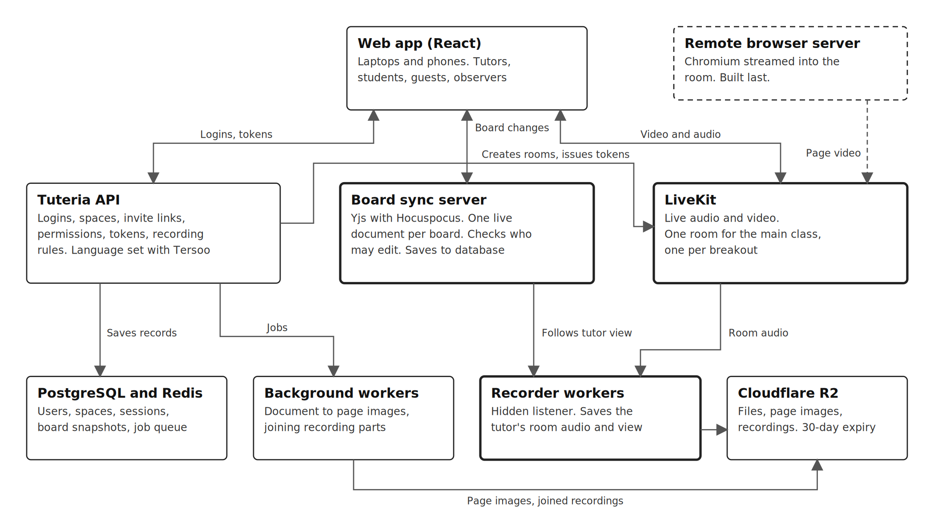
Architecture: video goes to LiveKit, boards go to the sync server, the API never carries media
Layer | Choice | Why
Front end | React web app on a Tuteria domain, installable on the home screen | One codebase for students' phones and tutors' laptops and tablets
Shared video | YouTube's embedded player, with play, pause and skip sent as small room messages | Keeps video off Tuteria's servers and the live call
API | Node.js with TypeScript, or Python with FastAPI. To decide with Tersoo | Either works. Board sync needs a small Node service in both cases. The developer's strongest language is the better choice
Board sync | Yjs with Hocuspocus, on Tuteria's own server | Per-board permissions, saved boards, no per-seat cost
Whiteboard | Excalidraw (MIT) | Free, light, runs in the browser
Database and queue | PostgreSQL and Redis | Users, spaces, sessions, attendance, board snapshots, job queue
Video and audio | LiveKit Cloud, then self-hosted LiveKit | Section 9 and section 20
Recording | Own recorder: a hidden listener for audio, the board history from the sync server, and a replay player | Far cheaper than video and light to watch
File storage | Cloudflare R2 | Uploads, page images and recordings, no download fees
Document conversion | LibreOffice and a PDF-to-image tool in a background worker | Turns PPTX, DOCX and PDF into board-ready page images
Servers | One low-cost cloud provider for the API, sync and workers, to agree with Tersoo | Board sync needs long-lived connections that serverless hosting does not hold

Main data tables. Each carries an organization column, set to Tuteria for now.
Table | Holds
users | Name, email, password hash and role (admin, tutor or student)
spaces | Class name, owning tutor and settings, including Record classes automatically and whether students may enter before the tutor
space_members | Which tutors and students belong to a space
sessions | One row per class held: space, start, end and how it ended (tutor ended, auto-ended, idle timeout)
rooms | The main room or a breakout room in a session, with its LiveKit room name
participants | One row per person per session: user ID for signed-in people, a random ID and the entered name for people who joined with a name, or a random ID only for observers, plus role, join and leave times
participant_state | Each person's last room, board tab and microphone and camera state, used to put them back after a drop
boards | Tab name, order, room, owner (a student, or none) and sync document ID
files | Library items: name, type, storage link and uploader
invite_links | Space, type (invite or observer), created by and token hash. The invite link has no expiry. Observer links have an expiry and a revoked time
chat_messages | Space, room, sender name, user ID or random ID, text, time and any attached file link. Kept with the space
recordings | Session, whose view it follows (tutor, or admin acting as tutor), status, length, audio and board-history files, share-link token and delete date (30 days)
recording_parts | Recording, order, room, start and end time and storage link for each audio part
events | Session log entries in time order

22. Security, privacy and safeguarding
Many users will be children, so safety rules are part of the product.
- Sign-in. The classroom has its own accounts, separate from Tuteria's main platform. Admins, tutors and students sign in with email and password, stored hashed, with set-your-password and forgot-password flows. Students and guests can instead join with a name only. Observers give no details.
- Files sent in chat follow the file uploads permission and are kept with the chat.
- The invite link never changes, and people can ask to join with just a name, but the tutor must let each guest in. So the link must be shared only with the class. The tutor can remove and ban anyone, and nobody can message anyone privately.
- Observers and Spy mode previews are invisible to the people being watched. Observer links are found only in the host controls menu for tutors and admins, every observer is logged for admins, and Tuteria's terms for families and tutors must say that classes may be observed and recorded for quality. This needs sign-off before launch.
- The server verifies every action: who may join which room, who may write to which board, who may open which file. Hiding a button on screen is never the only protection.
- Room access tokens are short-lived and carry the person's permissions.
- Recordings are clearly indicated, open only to admins in the app, and deleted after 30 days. Anyone a share link is forwarded to can watch until then, so links should be sent with care. A recording includes children's voices in the tutor's room, so the terms should cover this.
- The product holds students' names and recordings of children. Check Nigeria's data protection requirements before launch.

23. Phases and timeline
With Excalidraw the whiteboard sync, tabs and Leading Mode are built in house. This is estimated to stretch one developer from about 3 months to about 4 to 4.5 months, with the remote browser after that. The alternatives are a second developer, or moving Spy mode and the review timeline to a later release.
Weeks (estimate) | Build | Gate
1 to 2 | Classroom sign-in with set and reset password, Continue with name, spaces, lobby, LiveKit rooms and host controls. Spike: Excalidraw with Yjs and Hocuspocus on a laptop and a real phone | Spike result decides the whiteboard route
3 to 6 | Invite and observer links, persistent chat with previews and files, boards and tabs, per-board permissions, Leading Mode, documents on the board, Library | Demo of the core classroom
7 to 11 | Breakout rooms and manager, Spy mode, per-student boards, Grids and Send to all, engagement, student phone layout and tutor tablet layout, resource tab (apps, documents with Apply, YouTube window), tab search and bin, automatic return after drops. Week 8: recorder test that measures real cost per recorded hour | Recorder cost confirmed
12 to 16 | Recorder, replay player, recording rules, admin share links, End session, auto-end and idle check, session log, review timeline | Recording works end to end
17 to 18 | Weak-network phone test, load test on paid servers, fixes | Weak-network test passes
19 to 22 | Remote browser, built after every other feature is done | Content filtering and server budget in place

- If time runs short, cut in this order: review timeline, resource tab apps, Spy mode video tiles. The remote browser always comes last.
- Real classes need the hosting budget approved first.

24. Risks, open questions and acceptance criteria
Risks
Risk | Effect | Mitigation
y-excalidraw is less proven than Excalidraw | Board plan slips | Week 1 to 2 spike on a phone and laptop. If it fails, build sync directly on Yjs or add time
Excalidraw slows on phones with many images | Lag on the core feature | Small compressed page images, lazy loading, only the viewed board kept live. Test early on real phones
Replay does not match what the tutor saw | Weaker review evidence | The replay uses the same board data and the tutor's tab and view at each moment. Test with real tutors
Replay player takes longer to build than expected | Recording slips | Start the player in week 12 with the simplest version: audio plus board redraw
Hidden observers and Spy mode raise privacy concerns | Complaints or legal risk | Observer link only in the host controls menu, logging, and clear wording in the terms
The permanent invite link leaks | Strangers could join a class with children | Share only with the class. Tutor can remove and ban. Whether a leaked link can be replaced is open
Recording links are forwarded too widely | Privacy risk | Hard-to-guess links that stop working after 30 days. Admins send them with care
Weak-network performance falls short | Breaks the core promise | Test early on a real phone with throttled data. Audio first, adaptive quality
Free servers sleep | A class drops | Free tiers for building only. Paid always-on servers before any real class
Remote browser is costly and complex | Could consume the schedule | Built last, after everything else, with its own budget. Fallback is links and video embeds
Some videos block playing inside other sites | A tutor cannot show that video in the class | The window offers Open on YouTube
One developer | Little slack | Core demo by week 6. Agreed cut order

Decided
- Whiteboard is Excalidraw with Yjs and Hocuspocus.
- Recording is the tutor's view as audio and board history, one recording per session, kept for 30 days, admin only, shared by link.
- No recording ever happens without a tutor present. An admin counts as the tutor only when no tutor is in the class. The student Record my view option is dropped.
- Guests are students without accounts. Everyone except observers gives a name. Observers are fully hidden.
- One permanent invite link for students and guests. The observer link is in the host controls menu, for tutors and admins.
- Students never create breakout rooms. Chat history is kept in the space, new messages show as a short preview, files can be sent in chat, and chat appears in the admin replay. The tutor can mute one person's chat.
- Video defaults to 144p, cameras on by default. Audio and board sync come first on weak networks.
- The remote browser is built last.
- Admins and tutors can create spaces. No scheduling in version 1.
- A Class ended screen for everyone, with Back to Spaces for signed-in people.
- Guests start with a fresh board each class. The lobby's effects button holds noise cancellation only.
- Automatic return after drops, with the confirmation card after longer drops.
- Leave session for everyone, End session for all for tutors and admins, auto-end after 10 minutes without a tutor, and the 20-minute check, counting voice and all interactions, also in rooms with only students.
- Spy mode for tutors, board-first previews, muted by default, not recorded.
- The classroom has its own sign-in, separate from Tuteria's main platform, on a Tuteria domain.
- Tutors use laptops, tablets or phones held in landscape.
- Resource tab: Apps (calculator, graphing tool, GeoGebra), Documents with Apply and three PDF choices (current board by default), and Links with a shared YouTube window that YouTube plays.
- Tab search and a deleted-tabs bin. A Can't open this class screen with Try again.
- Install on the home screen at launch. No data saver mode.
Open items. None of these block design.
- Hosting and the backend language: for Tersoo to decide.
- Hosting budget: for Tuteria management to approve, once Tersoo has costed it.
- A notice to families about recording, observation and Spy mode: to be addressed later.
- Replacing the invite link if it leaks: to be addressed later.
- The Notes section: not in version 1.
Acceptance criteria
- A tutor creates a space, draws and adds a file, leaves, returns later, and finds everything still there.
- A student joins through the lobby, and audio and video work with 6 students and guests and no multi-second delay.
- A person who is not signed in opens the invite link, can choose Continue with email or Continue with name, and cannot continue with an empty name.
- A guest joins with a name, appears by that name, and can speak, show video and draw when allowed.
- An observer joins from the observer link in the host controls menu and does not appear anywhere for anyone in the class.
- With Leading Mode on, every student sees the tutor's tab and view. When the tutor stops leading, students stay on the board and can open other tabs they have access to.
- A tutor uploads a PDF or PPTX, its pages appear on the board, and students can write on it when allowed with no extra lag.
- The tutor opens any student's board, sees all boards in the Grids tab, and sends one task to every student's board.
- Turning off a person's editing, microphone, camera or chat takes effect at once, and the server refuses changes that are not allowed.
- Only tutors and admins can create breakout rooms, and only once a tutor is in the class. Rooms have separate audio, video, boards and chat, and the tutor can move between them.
- The Spy mode button appears only while a breakout room exists. From a breakout room the tutor sees live previews of the other rooms, can listen to one, and can enter one.
- With recording on, nothing records while the tutor is alone or while only students are present. Recording starts once a student or guest has been present with the tutor, or with an admin when no tutor is there, for 10 seconds.
- A session with breakout rooms produces one recording of audio and board history that follows the tutor through every room they visit, without Spy mode previews. Only admins can open it, and its share link plays it for anyone who has the link.
- Recordings and their share links stop working after 30 days.
- Chat history is still there when people leave and come back, and each message shows the sender's name.
- With the chat panel closed, a new message shows as a short preview. On a phone it disappears after about 2 seconds.
- A file can be sent in chat and opened by others in the room.
- When a class ends, everyone sees the Class ended screen, and signed-in people can go back to Spaces.
- Both an admin and a tutor can create a space.
- Cameras are on by default at 144p and can be turned off in the lobby or the control rail.
- When a person's network drops for a short time they return without any card. After a longer drop or a phone restart they see the You're joining card, and Continue returns them to the same breakout room and board tab.
- That's Not Me returns the person to the Join Space as Guest screen.
- If a tutor closes the tab without ending the class, the class ends after 10 minutes without a tutor, and students get a warning 2 minutes before.
- After 20 minutes without the tutor's voice or any interaction, the tutor sees the still-in-class check, and the class ends if there is no answer within 5 minutes. A room with only students gets the same check after 20 minutes without activity.
- On a mid-range Android phone with weak data, audio continues and board changes arrive within a second or two.
- The student classroom works in phone browsers, and the tutor classroom works on laptops and tablets, including by touch, and on phones held in landscape.
- A person can sign in, set a password from the email for a new account, and reset a forgotten password.
- Applying a PDF offers the three choices, with the current board as the default, and placed pages are locked.
- A pasted YouTube link plays in a shared window. Play, pause and skipping by the tutor are mirrored for everyone, and a blocked video offers Open on YouTube.
- A tutor can find a tab by searching and restore a deleted tab from the bin.
- If a class cannot open, the person sees the message with a Try again button.

25. AI assistant
Source: the supervisor's request. The classroom gets AI tools on the dashboard and inside the class, so tutors never have to leave the class or use a personal ChatGPT account. They use the organisation's access. Anything marked assumed was not in that request.

What it can generate
- Learning resources. Lesson notes, worksheets, summaries and study guides, from a topic, subject and class level.
- Quizzes. A set of questions with answers, from a topic, level, number of questions and question type (multiple choice or short answer).
- Images. A diagram or illustration from a written description.

Where it lives
- Dashboard. A Generate with AI button in the Library, next to the add-file plus button. Each result can be regenerated, edited (text and quizzes), saved to the Library or discarded.
- In class. An AI Assistant section in the Resources panel with the same three modes. A result can be placed on the board with Apply, in the same way Documents work, or saved to the Library.

Saving and sharing
- A saved file is private to the person who made it (the default) or an organisation file that every tutor and admin can use in class.
- Saved files show Private or Organisation, an AI generated tag and the creator's name. The owner and admins can change the setting later, and admins can remove any organisation file.

Open items for the supervisor
- Who may use AI. The request names tutors without ChatGPT accounts and organisation files for all users, but does not say whether students or guests may use the AI. The prototype shows it to tutors and admins only (assumed).
- Cost control. Every generation costs money. The request does not mention a limit per person or per day. This needs a decision before launch.
- Provider and key. Choice of AI service. The key stays on the Tuteria server and is never sent to the browser.
- Safety for children. Generated text and images need content filtering, and no student names or personal details should be sent to the AI service.
- Review. Whether tutors must look at a generated quiz or resource before it can be shared as an organisation file.

26. Quizzes in class
Source: the supervisor's request. The tutor imports questions or types them one after another, and the quiz is given to each student in the class. The details below are assumed unless stated.
- Creating. In the Quizzes section of the Resources panel, the tutor adds questions one at a time (type, options, correct answer), reorders and deletes them, or imports questions from a file or from a saved quiz in the Library, including quizzes made with AI. A quiz has a title and an optional time limit. Question types are multiple choice and short answer (assumed).
- Saving. A quiz can be saved to the Library as private or as an organisation file.
- Giving it. When the tutor clicks Start quiz, it goes to every student and guest in the class. Each sees one question at a time with a progress indicator and a Submit button, and cannot see anyone else's answers.
- Marking. Multiple choice is marked automatically. Short answers are shown to the tutor to mark (assumed).
- Tutor view. A live panel shows who has started and who has submitted. A results view after the quiz shows each student's score and a summary for each question. The tutor can end the quiz early and chooses whether students see their own score.
- Breakout rooms. The quiz goes to the people in the room where the tutor starts it, and the tutor may choose All rooms (assumed).
- Observers never see quizzes.
- Phones. The student screen works in the phone layout and uses text only, so it costs almost no data.
- Recording. Quiz questions and answers are not part of the tutor-view recording (assumed). Quiz results are stored with the session.

