Pflichenheft

Tasks

- DB structure ( sum = 3.5h)

- TBL_Login_User (0.5h)

- UserID (PK)

- Password

- TBL_User (1h)

- UserID (PK)

- Name

- Adress

- ZIP_Code

- City

- OrderID

- Bill ID

- TBL_Order (1h)

- OrderID (PK)

- OrderDate

- ArticleID

- Amount

- SumTotal

- Status

- TBL_Bill (1h)

- Bill ID (PK)

- Date of delivery

- ArticleID

- Amount

- SumTotal

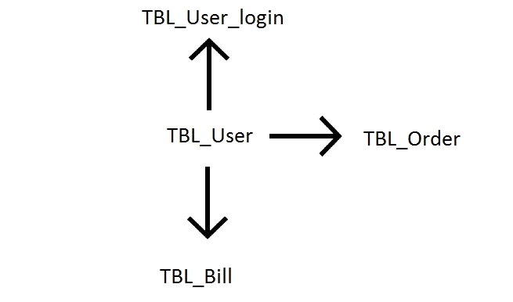

- Login (2h)

- GUI Login

- Funktion Login: check with existing users

- allocate session ID

- direct to window -> select template needed (radiobutton or dropdown)

- error message + redirect if login failed

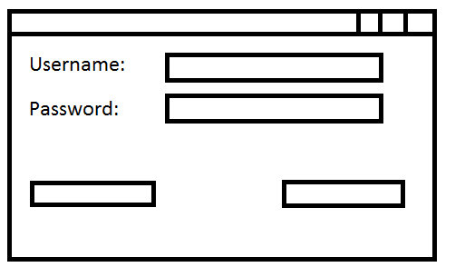

-Logout (1h)

- deallocate session ID

- return to login page

- clear login fields

- Create account (0.5h)

- new entry in the TBL_Login_User and TBL_User

- Check with existing users to avoid duplicates

- Select template and specify data export (2h)

- select template needed (radiobutton or dropdown)

- insert data needed (date)

- direct to selected template

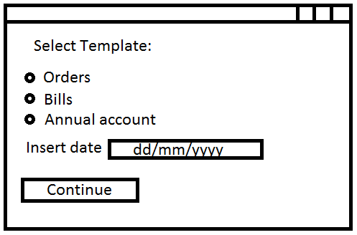

- Template design + functionality (6h)

- Lieferschein Template

- search for specific order which was already delivered

- Rechnung Template

- search for specific order which wasn't delivered yet

- Bestellungen Jahresabrechnung

- sums amount of all orders placed by logged in user in specific year

- Import data (4h)

- Check with User in TBL_User -> Bestellungen, Rechnungen

- Check with existing users to avoid duplicates

ASP FrameNetwork 45