Pflichenheft

Languages: C#, LaTex, SQL

Summary: The goal is to create an application which prints the Orders, Bills and the annual account of private customers. The Orders are placed into the database by an SAP system.

Tasks

- DB structure (sum = 4h)

- TBL_Login_User

- UserID (PK)

- Username

- Password

- TBL_User_Data

- UserID (PK)

- Name

- Address

- ZIP_Code

- City

- TBL_Order

- OrderID (PK)

- UserID (FK)

- OrderDate

- ArticleID (FK)

- Amount

- SumTotal (calculated column)

- Status

- Date of delivery

- Articles

- ArticleID (PK)

- Name

- Price_netto

- Taxes

- Price (incl. taxes)

- DB internal connections between tables (2h):

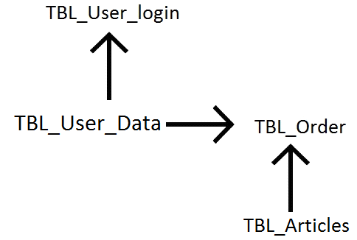

* Create communication interface between SAP an MSSQL database to insert order data (5h)

- Login (6h)

- GUI Login

- Function Login: check with existing users

- allocate session ID/create html listener

- Direct to window -> select template needed (radio button or dropdown)

- Error message + redirect if login failed

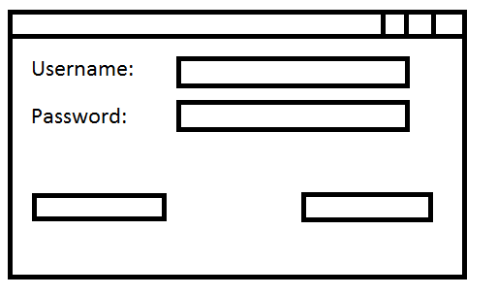

-Logout (2h)

- deallocate session ID

- Return to login page

- Clear login fields

- Create account (2h)

- New entry in the TBL_Login_User and TBL_User_Data

- Check with existing users to avoid duplicates

- Select template and specify data export (2h)

- Select template needed (radio button or dropdown)

- Insert data needed (date)

- Direct to selected template

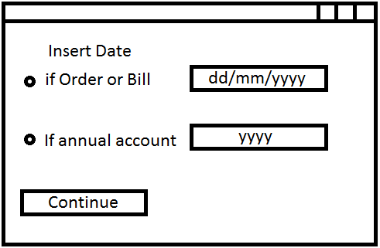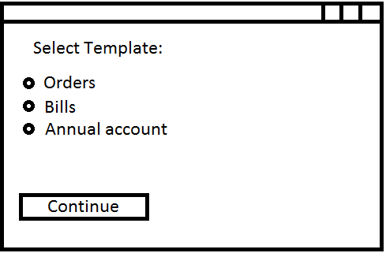

- Template design + functionality (10h)

- Order Template

- Search for specific order which was already delivered

- Bill Template

- Search for specific order which wasn't delivered yet

- Annual account

- Sums amount of all orders placed by logged in user in specific year

- Design (4h)

- Testing (8h)

- Unexpected issues (10h)

Time total needed: 53h