Pflichenheft

Languages: C#, LaTex, SQL

Summary: The goal is to create an application which prints the Orders, Bills and the annual account of private customers. The Orders are placed into the database by an SAP system. Orders by new customers creates new entryies in User_Data and User_Login.

Tasks

- DB structure (sum = 4h)

- TBL_Login_User

- UserID (PK)

- Username

- Password

- TBL_User_Data

- UserID (PK)

- Name

- Adress

- ZIP_Code

- City

- TBL_Order

- OrderID (PK)

- UserID (FK)

- OrderDate

- ArticleID (FK)

- Amount

- ArticleSumTotal

- OrderSumTotal

- Status

- Date of delivery

- Articles

- ArticleID (PK)

- Article description

- Name

- Taxes

- DB internal connections between tables (2h):

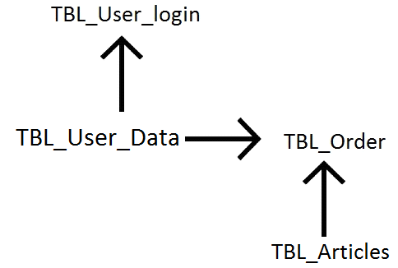

* Create communication interface between SAP an MSSQL database to insert order data (XML) (5h)

- Login (6h)

- GUI Login

- Function Login: check with existing users

- create html listener

- Direct to window -> select template needed (radio button or dropdown)

- Error message + redirect if login failed

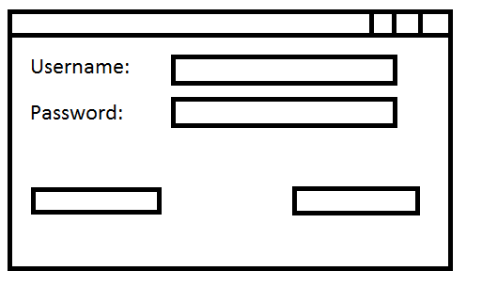

-Logout (2h)

- Return to login page

- Clear login fields

- Select template and specify data export (2h)

- Select template needed (radio button or dropdown)

- Insert data needed (date year)

- Direct to selected template

- Preview of templates

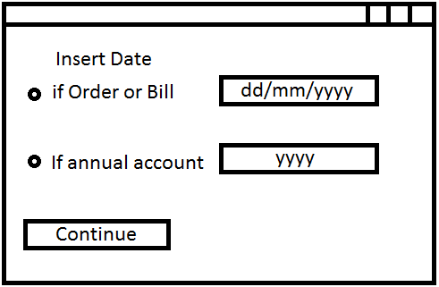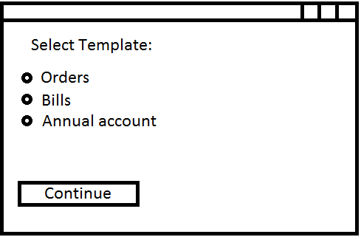

- Template design + functionality (10h)

- Order Template

- Search for specific order which was already delivered

- Bill Template

- Search for specific order which wasn't delivered yet

- Annual account

- Sums amount of all orders placed by logged in user in specific year

- Design (4h)

- Testing (8h)

- Unexpected issues (10h)

Time total needed: 53h