Decline on the Path to Recovery: Analysis

Authors

2016-09-27

Table of Contents

Introduction 1

Filter no-decline 1

Quick tables 2

Basic explanations of lower numbers 2

Separate threats and demography criteria? 3

Three Rs? 3

Science of decline 4

Plan years 4

## Introduction

## Filter no-decline

dat$prop_ind_at_listing <- dat$N_ind_req_recovery / dat$N_ind_at_listing  
dat$prop_ind_at_plan <- dat$N_ind_req_recovery / dat$N_ind_at_plan  
dat$prop_pop_at_listing <- dat$N_pops_req_recovery / dat$N_pops_at_listing  
dat$prop_pop_at_plan <- dat$N_pops_req_recovery / dat$N_pops_at_plan  
dim(dat)

## [1] 164 36

filt <- filter(dat, prop_ind_at_listing < 1 |  
 prop_ind_at_plan < 1 |  
 prop_pop_at_listing < 1 |  
 prop_pop_at_plan < 1)  
dim(filt)

## [1] 134 36

30 species dropped seems about right...which species?

drop <- setdiff(dat$Scientific_Name, filt$Scientific_Name)  
drop

## [1] "Charadrius alexandrinus nivosus"   
## [2] "Halcyon cinnamomina cinnamomina"   
## [3] "Myrsine juddii"   
## [4] "Picoides borealis"   
## [5] "Rallus longirostris yumanensis"   
## [6] "Oncorhynchus (=Salmo) keta (Hood Canal summer-run)"   
## [7] "Oncorhynchus (=Salmo) mykiss (Upper Columbia River)"  
## [8] "Dudleya nesiotica"   
## [9] "Helianthemum greenei"   
## [10] "Pentachaeta lyonii"   
## [11] "Polygonella myriophylla"   
## [12] "Thelypteris pilosa var. alabamensis"   
## [13] "Thlaspi californicum"   
## [14] "Falco peregrinus anatum (Alaska)"   
## [15] "Himantopus mexicanus knudseni"   
## [16] "Alasmidonta atropurpurea"   
## [17] "Arabis perstellata"   
## [18] "Lessingia germanorum (=L.g. var. germanorum)"   
## [19] "Schiedea spergulina var. leiopoda"   
## [20] "Branchinecta lynchi"   
## [21] "Eleutherodactylus jasperi"   
## [22] "Peltophryne lemur"   
## [23] "Pelecanus occidentalis occidentalis"   
## [24] "Sterna antillarum browni"   
## [25] "Pleurobema clava"   
## [26] "Gila cypha"   
## [27] "Canis lupus (Western Great Lakes)"   
## [28] "Cynomys parvidens"   
## [29] "Hymenoxys herbacea"   
## [30] "Lomatium bradshawii"

## Quick tables

### Basic explanations of lower numbers

table(filt$Taxon)

##   
## BIRD Clam Crustacean FISH Insect MAMMAL   
## 3 1 1 5 3 4   
## Plant REPTILE Snail   
## 111 3 3

table(filt$reason_lower_N_pop)

##   
## Implicit NA No Yes   
## 2 7 87 19

table(filt$reason_lower_N_pop_sufficient)

##   
## Explicit Implicit NA No   
## 3 21 7 92

table(filt$reason_lower_N_ind)

##   
## Implicit NA No Yes   
## 3 15 28 8

table(filt$reason_lower_N_ind_sufficient)

##   
## Explicit Implicit NA No Yes   
## 2 7 15 29 1

table(filt$threat_amelior_suffic)

##   
## Explicit Implicit No   
## 3 24 107

### Separate threats and demography criteria?

table(filt$threat_demog_explicit_criteria)

##   
## Combined Either/Or Explicit Implicit   
## 83 8 1 42

table(filt$threat_demog_explicit_actions)

##   
## Combined Implicit   
## 10 124

### Three Rs?

table(filt$resiliency)

##   
## Explicit Implicit No   
## 2 106 25

table(filt$redundancy)

##   
## Explicit Implicit No   
## 4 103 26

table(filt$representation)

##   
## Explicit Implicit No   
## 13 102 19

### Science of decline

That is, models used? (Note that some plans use a combination of model types.)

mods <- filt$pop_models  
mods <- str_replace_all(mods, "verbal", "Verbal")  
mods <- str_replace_all(mods, "models|[Mm]odel", "")  
mods <- str_replace_all(mods, "literature", "Literature")  
mods <- str_replace_all(mods, "references|reference", "")  
mods <- str_replace_all(mods, " $", "")  
mod2 <- str_split(mods, " & ")  
mod3 <- str_replace_all(unlist(mod2), " $", "")  
table(unlist(mod3))

##   
## Literature No Quantitative semi-quantitative   
## 48 59 6 2   
## Verbal   
## 60

### Plan years

qplot(filt$plan_year, geom = "histogram") + theme_hc()

## `stat_bin()` using `bins = 30`. Pick better value with `binwidth`.

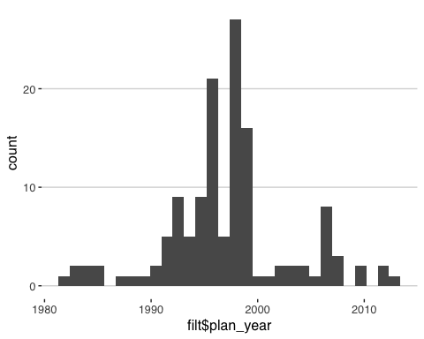

That's all for now...