Use of Recovery Units

Michael Evans, Jacob Malcom, Ya-Wei Li

December 15, 2016

## Introduction

The vast majority of species listed as Threatened or Endangered under the U.S. Endangered Species Act (ESA) are not yet recovered. The threats facing these species are increasingly diverse, and the agencies responsible for their recovery are challenged with limited budgets that do not match the growing number of listed species. A critical mission for advancing endangered species conservation is to identify and develop ESA implementation methods that can both improve efficiency and efficacy of species recovery. To this end, the designation of species recovery units is a potentially underused resource.

Recovery units were defined in the National Marine Fisheries Service Threatened and Endangered Species Recovery Planning Guidance document as "a special unit of the listed entity that is geographically or otherwise identifiable, and is essential to the recovery of the entire listed entity." Analysis of whether federal actions may jeopardize the continued existence of a listed species during section 7 consultations can be performed at the recovery unit level. Additionally, recovery actions and criteria may differ among recovery units, potentially allowing for more targeted and efficient recovery planning. Finally, because recovery units can be delineated according to a wide range of factors - genetic diversity, developmental stages, and ecosystem diversity - they provide an adaptable framework for a wide range of taxa. Taken together, recovery units provide a tool that could be used both for more flexible and, when necessary, more stringent limits on adverse effects.

Recovery units are a particularly appealing tool, because they already exist within the current ESA framework. Currently, only 32 out of 1364 species with recovery plans have recovery units defined, and 491 listed species do not have recovery plans finalized. Thus, recovery units present a practical and immediate opportunity to improve endangered species conservation and recovery. The goal of this paper was to understand what has guided the agencies current use of recovery units, and evaluate their utility for recovering endangered species. Our first objective was to quantify patterns of recovery unit designation. Our second objective was to assess how recovery units are used in ESA implementation during recovery planning and section 7 consultation. Finally, we assess whether species with recovery units show greater evidence of recovery than those without units designated.

## Methods

### Data

We used data from the Fish and Widlife Service (FWS) and National Marine Fisheries Service (NMFS), hereafter referred to collectively as the Services, to quantify the role of recovery units in conservation and recovery. Unless otherwise specified, we collected and analyzed data from species listed as Threatened or Endangered, (hereafter listed species) in the United States. As recovery units are designated in recovery plans, we considered only those species with existing recovery plans, which we refer to as all species.

We considered species taxonomic membership, geographic region, range size, recovery prioritization, and extent of genetic research as potential correlates of recovery unit designation. We followed FWS taxonomic grouping, designating species as either Amphibians, Arachnids, Birds, Crustaceans, Fishes, Insects, Mammals, Mollusks, Plants, or Reptiles. Region was the lead FWS Region, or NMFS, responsible for a listed species. We estimated range size as the total area in acres of counties in which the Services report a species to occur.

Recovery prioritization numbers are used by the Services to prioritize recovery efforts and actions among listed species. These scores range from 1 - 18, with 1 representing high priority, and are based hierarchically on the degree of threat faced by a species ('High', 'Moderate', or 'Low'), the species' potential for recovery ('High', or 'Low'), and its taxonomic uniqueness ('Monotypic genus', 'Species', 'Subspecies'). Additionally, the Services may designate a species as potentially in conflict with economic activities using a 'C' suffix (e.g., '2C'). We separated the priority number and conflict designation into two variables, Priority and Conflict.

As the justification for delineation of recovery units in the Recovery Planning Guidance document references the importance of genetic diversity and robustness, we considered the relative amount of genetic research for a species as a potential predictor of recovery unit designation. The number of Google scholar citations returned using the search term "[Species] population genetics" was used as a proximal indicator of the extent of scientific knowledge of a species' population genetics. We refer to this measure as genetic citations.

To assess the use of recovery units during ESA implementation we examined biological opinions (BIOPS) written by the Services during Section 7 consultations. Due to the nationally low rates of jeopardy and/or adverse modification determinations (Malcom & Li, 2016), we use the proportion of consultations that were formal for each species to indicate the... Finally, we also examined five year reviews to evaluate the recovery of listed species. These documents provide updated status information for listed species, including recommendations as to whether changes in listing status or recovery prioritization are warranted. (i.e., Recommended delisting, increase in priority number, or down listing from Endangered to Threatened). We used changes in species' recovery priority numbers as a proximal indicator of status improvement, considering only changes reflecting either reduced threat level, or increased recovery potential. For example, a change from 2 to 3 represents a reclassification from species to subspecies, and not an improvement in status. Recommended down listings also indicated status improvement.

### Analyses

Chi-squared contingency tests were used to test for significant differences in the proportions of species with recovery units falling into taxonomic groups, and between FWS regions, relative to these distributions among all species with recovery plans. We also tested for differences in the proportions of species designated as conflicting with development.

To test for differences in species range size among taxonomic groups, and genetic citation rates per year, we used one-way analysis of variance (ANOVA).

We used student's t-tests to compare characteristics of species with recovery units to the population of all species with recovery plans, testing for differences in mean recovery priority number, range size, and mean number of genetic citations.

We used classification tree analyses as a multivariate framework for characterizing and predicting which species have recovery units designated based on taxonomic group, adjusted citation rate, adjusted area, recovery prioritization, region, and status. We used a minimum threshold of a >= 0.90 for node creation, and evaluated tree performance using receiver operating characteristic (ROC) curves. We generated trees using all species with recovery plans, as well as excluding plant species, and selected the tree with the greatest predictive ability, indicated by the area under the curve (AUC). ROC curves were also used to identify the appropriate class probability threshold for prediction, as the value maximizing the ratio of sensitivity to specificity. Classification trees and ROC curves were generated using the party and pROC packages for R.

The relationship between these characteristics and recovery unit designation was further investigated by comparing characteristics between each species with recovery units and a paired set of 1 - 3 comparable listed species without recovery units. We chose listed species with recovery plans that were similar taxonomically, prioritizing shared Genera, and no more distantly related than a shared Family. We used conditional logistic regression to estimate the log odds of recovery unit designation as a function of the same set of predictor variable used in classification tree analyses. First we fit univariate models for all predictors, and then a full model including all variables that were significant (p < 0.10) univariate predictors.

To evaluate how recovery plans provide guidance on the use of recovery units, we examined all recovery plans in which recovery units were designated for several criteria. First, we looked for whether the function of recovery units, as defined in the guidebook, was explicitly provided in the recovery plan. Second, we assessed whether and how designation of recovery units was justified. We further attempted to characterize the reasons provided by broad themes, guided by those provided in the planning guidebook. Third, we looked for whether the function of recovery units in section 7 consultation, as defined in the consultation handbook, was referenced in recovery plans. Finally, we examined recovery plans to determine whether specific recovery criteria, actions, and/or threats were enumerated for recovery units. We only considered actions/criteria or threats as specified per unit in instances in which different actions/criteria and threats were specified per recovery unit. Thus, cases when recovery units were referenced but actions/threats applied generically to all units (i.e., "High-quality habitat sufficient to ensure long-term survival and recovery is protected within each recovery unit”) were not counted.

We also evaluated the role of recovery units in five-year reviews. We calculated the proportion of five year reviews conducted for a species with recovery units, after recovery unit designation, referencing the recovery units. We also calculated how often species status and recovery objectives were reported by recovery unit. We tested for differences in the proportion of species showing improvement at five-year reviews between species with recovery units and all species with recovery plans. To evaluate whether these proportions were statistically different, we performed a bootstrapping procedure in which random samples of 32 five-year reviews were taken, and the frequency with which improvements were observed in each sample was compared to the observed frequency among species with recovery units. We took 100 samples, and used the proportion of samples with a higher frequency as our measure of significance.

We tested for a difference in the rate of formal consultation, defined as the proportion of all section 7 consultations that were formal for a given species, between species with recovery units and all species with recovery plans using a Chi-square test for difference in proportions.

## Results

#### Recovery Unit Characteristics and Patterns

We identified 42 recovery plans designation recovery units for 55 Threatened or Endangered species. Number of units per species ranged from 11 to 9. Units were as small as 7 ac and as large as 12,492,233 ac. The rate of recovery unit designation has remained consistently low, between 0 and 3 species per year since 1995, apart from a peak in 2003, in which 8 species were given recovery units.

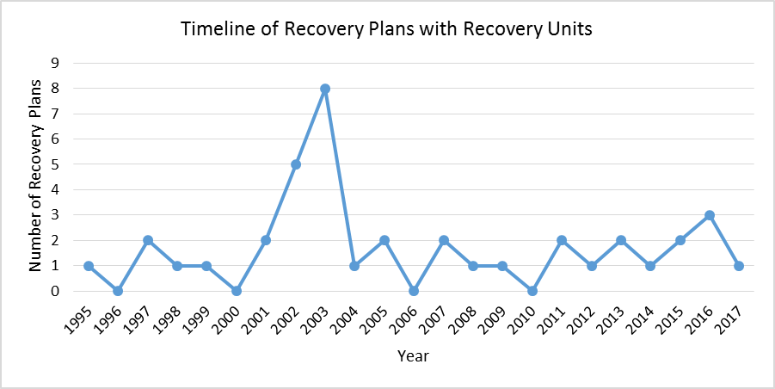

Designation of recovery units differed significantly among taxa (X2 = 48.52, df = 9, p = 0). The odds of designation for plants were significantly lower than those of Amphibians, Fish, Mammals, and Reptiles. No other odds ratios were significant (Table ##) and were not considered (X2 = 15.79, df = 8, p = 0.05). Specifically, amphibians, fishes, insects, mammals, and reptiles are more frequently given recovery units relative to their frequency among listed species with recovery plans.

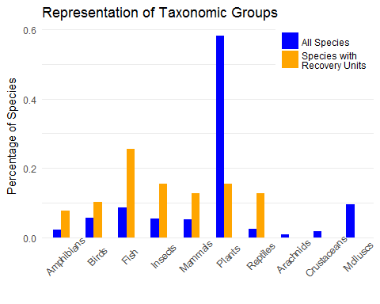

Species range size differed significantly among taxonomic groups, indicated by an ANOVA using the log of range area as the response variable (F9,1352 = 0.5265, p = 0.856144). Thus, we used standardized z-scores of area per taxonomic group to account for differences in means among taxa when performing statistical tests using range size. Similarly, the number of genetic citations differed between years (F9,500 = 28.5067, p = 7.82301710^ {-44}), and we transformed raw citation numbers to z-scores calculated within 5-year bins.

Mean range size relative to taxonomic means was greater among species with recovery units (x = 1.820619110^ {11}ac, z = 1.4779249) than among all species with recovery plans (x = 4.197415110^ {10}ac, z = 0.33, t = 5.08, df = 38.9967803, p = 0).

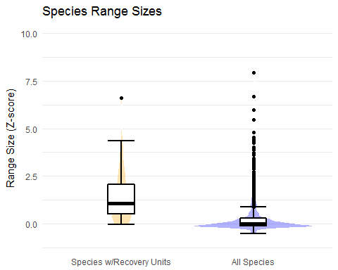

Mean number of genetic citations relative to five-year means were higher (t = 4.0129305 df = 39.26, p = 0) for recovery unit species (12.3609) than for all species with recovery plans (3.5085).

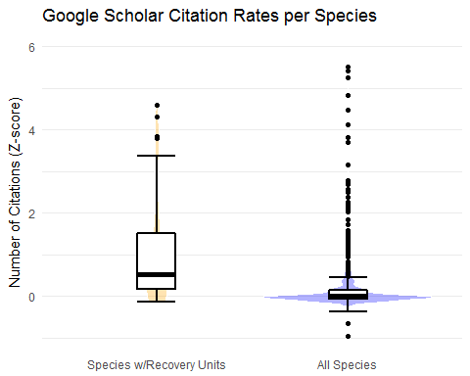

Finally, there were no differences in frequencies of recovery unit designation among species between FWS regions (X2 = 40, df = 7, p = 0.26), nor did recovery priority numbers differ significantly between species with and without recovery units (p = 0.55). However, a significantly (X2 = 30.870743, df = 1, p = 2.757983910^ {-8}), greater proportion of species with recovery units had an economic conflict designation (0.72) than did all species with recovery plans (0.29).

Classification trees built using all species exhibited better predictive performance of recovery unit designation (AUC = 0.9149043) than trees build excluding plant species (0.8561275). When plant species were excluded, the resulting tree indicated that species with range sizes above the 71st percentile of their taxonomic group, and genetic citation rates above the 72nd percentile for a five-year period had a 0.70 probability of having recovery units designated. Taxonomic group and FWS region were important predictors for species falling below the range size and citation rate thresholds. We identified a classification probability threshold of 0.467 as providing the maximum ratio of sensitivity and specificity.

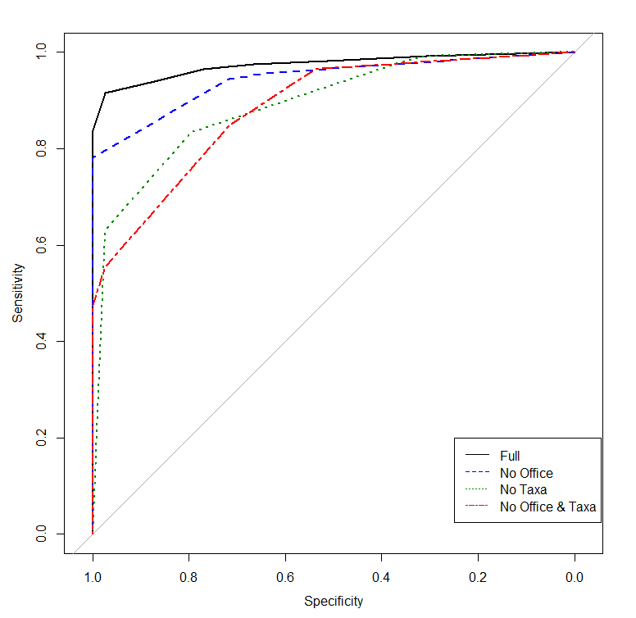

Results from conditional logistic regression corroborated results from classification tree analysis. The only significant univariate predictors of recovery unit designation were genetic citations (B = 0.68 +- 0.2908644, p = 0.018598), and range size (B = 0.53 +- 0.2108943, p = 0.0112411). Greater number of genetic citations, and larger range size increased the probability of recovery unit designation. A full model including these predictors did not indicate any significant relationships between species characteristics and probability of recovery unit designation.

#### Use of Recovery Units in ESA Implementation

Of the 42 recovery plans designating recovery units, 23 provided an explicit reference to recovery units as 'essential for species recovery' as stated in the planning guidebook. Except for three species (*Rana draytonii, Gopherus agassizii, and Lessingia germanorum*), all plans provided some justification for the designation of recovery units in terms of their role and importance in facilitating persistence and recovery of the entire species. Justifications fell into two major categories; addressing variance of threats and necessary recovery actions between units, and addressing the '3Rs' of conservation (Redundancy, Representation, and Resilience). Of the 39 plans providing justification, 30 plans referenced the importance of preserving either geographic and/or genetic variability and representation.

All but 6 recovery plans (*Rana draytonii, Cynomys parvidens*) provide unit-specific recovery actions and/or criteria in. Threats were less frequently enumerated on a per unit basis (10/32).

Additionally, 10 recovery plans provided guidance on the role of recovery units during Section 7 consultation, explicitly referring to the use of recovery units in jeopardy analysis.

#### Impact of Recovery Units on Recovery

Of the 39 species with designated RUs, 24 had five-year reviews conducted after the recovery plan designating RUs was written. Of these 24, RUs were explicitly mentioned for all but one species (*Manduca blackburnii*). Additionally, for each of these species the population statuses and recovery criteria were evaluated and reported by recovery unit. We used a sample of 560 five year reviews for all species with recovery plans. These The rate of improvement indicated by changes in recovery priority number among species with recovery units (0.174), was significantly higher than the rate observed among all five-year reviews (0.086), as determined by bootstrapping (p < 0.01). Species with recovery units have a significantly higher (p < 0.001) rate of formal section 7 consultation (0.36) than all listed species (0.24).  
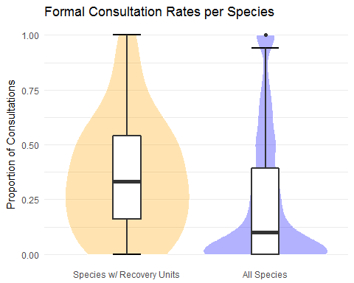

## Discussion

Recovery units are designated for relatively few species, and our analyses indicated common characteristics of species with recovery units. Specifically, species with a greater number of genetic studies, larger range size, and potentially in conflict with economic development were more likely to receive recovery units. Together, these characteristics suggest a common profile for species receiving recovery unit designation. These criteria may not be used explicitly by Agency biologists during recovery plan development, but rather characterize well-studied, wide-ranging species that are implicitly more likely to match the description (i.e., 'geographic subsets') and purpose (i.e., 'preserve genetic robustness') of recovery units provided in the recovery planning guidance document. The finding that neither listing status nor recovery priority number were important in predicting the designation of recovery units further suggests that the 'well-studied, wide-ranging' profile may implicitly or explicitly be the driving factor determining recovery unit designation.

To ensure that species are provided the full protection potentially afforded by recovery units, recovery plans should more frequently emphasize the use of recovery units as the unit of jeopardy analysis during Section 7 consultations. Overlooking could undermine species recovery, as consultations are one of the primary ways in which the ESA is implemented to protect listed species. As stated in the ESA Section 7 Consultation Handbook, jeopardy analysis may be based on an assessment of impacts 'to recovery units when those units are documented as necessary to both the survival and recovery of the species in a final recovery plan'. Thus, it seems the justification of recovery units is important if recovery units are to be used by the Services to uphold stronger protection for species. Our examination of recovery plans indicated that the Services generally provide thorough and robust justification for the designation and importance of recovery units, most often citing the importance of maintaining multiple sub segments of a specie's population to preserve diversity, and provide resilience.

These justifications for the use and delineation of recovery units closely matched the reasons explicitly stated in the NMFS handbook (e.g. 'genetic robustness', 'demographic robustness', 'important life-history stages'). While the guidance provided in the handbook leaves room for interpretation with the phrase 'or some other feature necessary for long-term sustainability of the entire listed entity,' it seems that the Services rarely go beyond the specific examples identified. This presents a potential opportunity to expand the use of recovery units to offer more robust protection. For instance, population fragmentation and climate change are two of the most often cited threats to species persistence, aside from direct habitat loss. As connectivity and the capacity to adapt to climate change are clearly scientifically supported as necessary for long-term sustainability, the Services might use recovery units to afford extra protection to subsets of species ranges providing connectivity and future capacity for range shifts.

We found some evidence that the designation of recovery units corresponds to stronger conservation measures, and improved recovery relative to species without recovery units. Increased formal consultation rates may indicate that federal actions are more likely to trigger formal consultation when their effects are considered at the scale of recovery units. Alternatively, the services may designate recovery units for species that they anticipate will have a high rate of formal consultation. Although the use of change in recovery priority number is a proximal indicator, greater frequency of improvement in this measure suggests species with recovery units exhibit stronger recovery. Quantitative population data and monitoring reports, such as those provided in the 2012 Utah prairie dog five-year review, would allow for more robust assessment of both the effect of recovery units and listed species recovery overall.

While our data does not allow inference of causality, these findings suggest that additional species could benefit from the designation of recovery units. In particular, species for which no finalized recovery plan exists provide an excellent opportunity to designate recovery units for appropriate species. Thresholds in important characteristics identified by classification tree analyses can be used to identify species for which recovery units may be warranted and aid recovery efforts. Our results showed that species in the upper 29th percentiles of range size, relative to taxonomic means, and upper 27th percentile of genetic citation rate, relative to five year means, would be consistent with current recovery unit designation patterns. While many species not fitting this profile could arguably also benefit from recovery units, these criteria provide a justifiable starting point for additional recovery unit designation consistent with both existing patterns as well as the impetus for recovery unit designation stated in Agency recovery planning and consultation guidance documents.