Use of Recovery Units

Michael Evans, Jacob Malcom, Ya-Wei Li, Ryan Covington

December 5, 2016

## Background

The vast majority of species listed as Threatened or Endangered under the U.S. Endangered Species Act (ESA) are not yet recovered. The threats facing these species are increasingly diverse, and the agencies responsible for their recovery are challenged with limited budgets that do not match the growing number of listed species. A critical mission for advancing endangered species conservation is to identify and develop ESA implementation methods that can both improve efficiency and efficacy of species recovery. To this end, the designation of species recovery units is a potentially underused resource.

Recovery units are defined as "a special unit of the listed entity that is geographically or otherwise identifiable, and is essential to the recovery of the entire listed entity." Analysis of whether federal actions may jeopardize the continued existence of a listed species during section 7 consultations can be performed at the recovery unit level. Additionally, recovery actions and criteria may differ among recovery units, potentially allowing for more targeted and efficient recovery planning. Finally, because recovery units can be delineated according to a wide range of factors - genetic diversity, developmental stages, and ecosystem diversity - they provide an adaptable framework for a wide range of taxa. Taken together, recovery units provide a tool that could be used both for more flexible and, when necessary, more stringent limits on adverse effects.

Recovery units are a particularly appealing tool, because they already exists within the current ESA framework. Currently, only 31 out of 1364 species with recovery plans have recovery units defined, and 491 listed species do not have recovery plans finalized. Thus, recovery units present a practical and immediate opportunity to improve endangered species conservation and recovery.

## Proposed Project

The goal of this project was to understand what has guided the agencies current use of recovery units, and evaluate their utility for recovering endangered species. Our first objective was to quantify patterns of recovery unit designation. Our second objective was to assess how recovery units are used in ESA implementation during recovery planning and section 7 consultation. Finally, we used changes in species' status to estimate whether species with recovery units show more frequent improvement than those without units designated.

#### Objective 1: Quantify patterns of recovery unit designation

**Q1:** How many recovery units exist, and what are their basic characteristics? **Q2:** Are there factors predicting which species have recovery units?

#### Objective 2: Assess how recovery units are used in ESA implementation.

**Q3:** Do recovery plans provide guidance on how recovery units are to be used? **Q4:** Are recovery units explicitly considered during section 7 consultation? **Q5:** Are recovery units considered in five year status reviews? **Q6:** Do recovery units lead to stronger conservation measures?

#### Objective 3: Estimate impacts on species recovery

**Q7:** Do species with recovery units show greater improvement?

## Outcomes

Results of this analysis will allow Defenders to make specific policy recommendations to the services on where recovery units should be designated, and how they can help recover species. The current backlog of listed species without recovery plans provides a concrete set of species to which these recommendations can be applied.

## Results

We found 32 Threatened or Endnagered species with recovery units. Number of units ranged from NA to NA. Units were as small as 7ac and as large as 12492233.

The use of recovery units appears to be biased towards specific taxa, both when plant species are (X2 = 48.52, df = 9, p = 0) and are not considered (X2 = 15.79, df = 8, p = 0.05). Specifically, amphibians, fishes, insects, mammals, and reptiles are more frequently given recovery units.

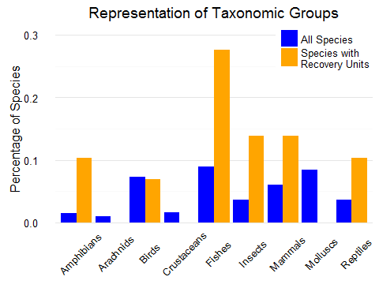 Similarly, recovery units are applied to species with larger ranges, measured by the area encompassed by counties in which they are listed (W = -10.56, p = 0).

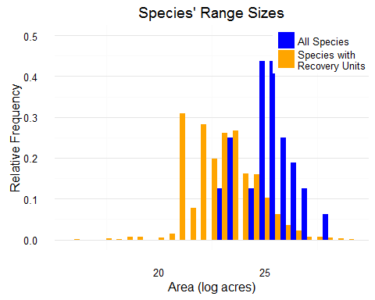 Google scholar citations using the search term "[Species] population genetics" was used as a proximal indicator of the extent of scientific knowledge of a species' population genetics. Mean citation rate was higher for recovery unit species (11.6013616) than the mean citation rate of all species (4.4664986). 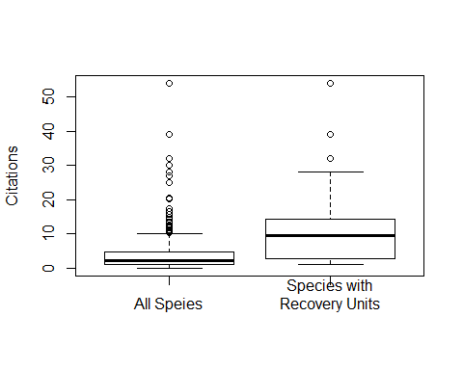 Classification tree analyses combined these factors to provide a potential framework for predicting which species have recovery units designated. This analysis indicated that the estimated area of a species' range were the two significant (p < 0.10) factors predicting whether recovery units were designated.  
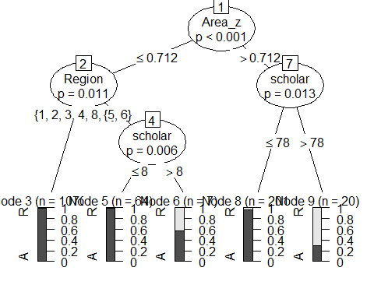 The relationship between these factors and recovery unit desination was further investigated using conditional logistic regression comparing species with recovery units to approximally comparable species.

##   
## Iteration 1 - Deviance = 24.8241  
## Iteration 2 - Deviance = 22.60523  
## Iteration 3 - Deviance = 20.68796  
## Iteration 4 - Deviance = 20.45228  
## Iteration 5 - Deviance = 20.45158  
## Iteration 6 - Deviance = 20.45158  
## converged

##   
## Iteration 1 - Deviance = 26.51413  
## Iteration 2 - Deviance = 26.26284  
## Iteration 3 - Deviance = 26.18816  
## Iteration 4 - Deviance = 26.16146  
## Iteration 5 - Deviance = 26.15173  
## Iteration 6 - Deviance = 26.14816  
## Iteration 7 - Deviance = 26.14685  
## Iteration 8 - Deviance = 26.14637  
## Iteration 9 - Deviance = 26.1462  
## Iteration 10 - Deviance = 26.14613  
## Iteration 11 - Deviance = 26.14611  
## Iteration 12 - Deviance = 26.1461  
## Iteration 13 - Deviance = 26.14609  
## Iteration 14 - Deviance = 26.14609  
## Iteration 15 - Deviance = 26.14609  
## Iteration 16 - Deviance = 26.14609  
## converged

##   
## Iteration 1 - Deviance = 31.68266  
## Iteration 2 - Deviance = 31.67738  
## Iteration 3 - Deviance = 31.67738  
## converged

##   
## Iteration 1 - Deviance = 28.11918  
## Iteration 2 - Deviance = 28.09635  
## Iteration 3 - Deviance = 28.09634  
## Iteration 4 - Deviance = 28.09634  
## converged

##   
## Iteration 1 - Deviance = 30.64562  
## Iteration 2 - Deviance = 30.53491  
## Iteration 3 - Deviance = 30.49984  
## Iteration 4 - Deviance = 30.48705  
## Iteration 5 - Deviance = 30.48236  
## Iteration 6 - Deviance = 30.48064  
## Iteration 7 - Deviance = 30.48  
## Iteration 8 - Deviance = 30.47977  
## Iteration 9 - Deviance = 30.47968  
## Iteration 10 - Deviance = 30.47965  
## Iteration 11 - Deviance = 30.47964  
## Iteration 12 - Deviance = 30.47964  
## Iteration 13 - Deviance = 30.47963  
## Iteration 14 - Deviance = 30.47963  
## Iteration 15 - Deviance = 30.47963  
## converged

These analyses revealed that the only significant predictor of recovery unit designation was Google scholar citation (p = 0.024), and range size (0.083) Species with recovery units have a significantly higher (p < 0.001) rate of formal section 7 consultation (rmean(compare$frate, na.rm = TRUE)) than all listed species (0.2413859). This may indicate that federal actions are more likely to trigger formal consultation when their efects are considered at the scale of recovery units. Alternatively, the services may designate recovery units for species that they anticipate will have a high rate of formal consultation. 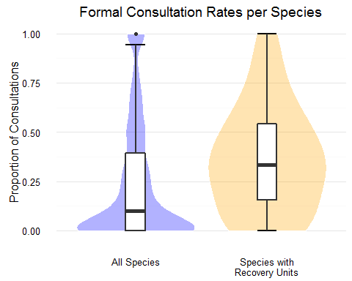 Of the 23 species with five-year reviews conducted after the designation of recovery units, units were explicitly mentioned for all but one species (Blakcburn's sphynx moth, Manduca blackburnii). Additionally, for each of these species the population statuses and recovery criteria were evaluated and reported by recovery unit. The rate of improvement indicated by change to a lower priority number among species with recovery units (0.174), was significantly higher than the rate overall (0.092), determined by bootstrapping (p < 0.01)