Recovery Units

Michael Evans

November 1, 2016

## Background

The vast majority of species listed as Threatened or Endangered under the U.S. Endangered Species Act (ESA) are not yet recovered. The threats facing these species are increasingly diverse, and the agencies responsible for their recovery are challenged with limited budgets that do not match the growing number of listed species. A critical mission for advancing endangered species conservation is to identify and develop ESA implementation methods that can both improve efficiency and efficacy of species recovery. To this end, the designation of species recovery units is a potentially underused resource.

Recovery units are defined as "a special unit of the listed entity that is geographically or otherwise identifiable, and is essential to the recovery of the entire listed entity." The effects of federal actions subject to section 7 consultations can be evaluated at the recovery unit level, including jeopardy and adverse modification of critical habitat. Additionally, recovery actions and criteria may differ among recovery units, potentially allowing for more targeted and efficient recovery planning. Finally, because recovery units can be delineated according to a wide range of factors - genetic diversity, developmental stages, and ecosystem diversity - they provide an adaptable framework for a wide range of taxa. Taken together, recovery units provide a tool that could be used both for more flexible and, when necessary, more stringent limits on adverse effects.

Recovery units are a particularly appealing tool, because they already exists within the current ESA framework, requiring no new rules. Currently, only 31 out of 1364 species with recovery plans have recovery units defined, and 491 listed species do not have recovery plans finalized. Thus, recovery units present a practical and immediate opportunity to improve endangered species conservation and recovery.

## Proposed Project

The goal of this project is to understand what has guided the agencies current use of recovery units, and demonstrate their utility for recovering endangered species. We propose to conduct analyses that will address the following objectives:

#### Objective 1: Quantify patterns of recovery unit designation

**Q1:** How many recovery units exist, and what are their basic characteristics? **Q2:** Are there factors predicting which species have recovery units?

#### Objective 2: Assess how recovery units are used in ESA implementation.

**Q3:** Do recovery plans provide guidance on how recovery units are to be used? **Q4:** Are recovery units explicitly considered during section 7 consultation? **Q5:** Are recovery units considered in five year status reviews? **Q6:** Do recovery units lead to stronger conservation measures?

#### Objective 3: Estimate impacts on species recovery

**Q7:** Do species with recovery units show greater improvement?

## Outcomes

Results of this analysis will allow Defenders to make specific policy recommendations to the services on where recovery units should be designated, and how they can help recover species. The current backlog of listed species without recovery plans provides a concrete set of species to which these recommendations can be applied.

## Initial Analyses

We have begun to analyze data from Fish and Wildlife Service, and will add NMFS data as it is collected. The use of recovery units appears to be biased towards specific taxa, both when plant species are (X2 = 48.52, df = 9, p = 0) and are not considered (X2 = 15.79, df = 8, p = 0.05). Specifically, amphibians, fishes, insects, mammals, and reptiles are more frequently given recovery units.

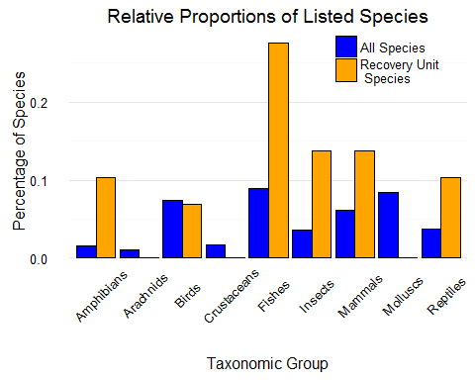 Similarly, recovery units are applied to species with larger ranges, measured by the area encompassed by counties in which they are listed (W = -2.72, p = 0.01).

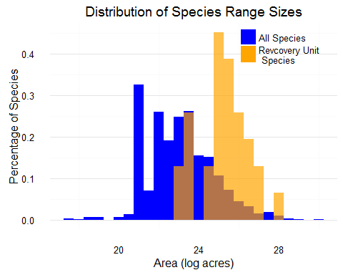 The proportion of section 7 consultations that are formal is significantly higher (p < 0.001) for species with recovery units than for all listed species. This may indicate that evaluating the effects of federal actions at the recovery unit level is a more conservative approach to determining adverse affects during informal consultation. Alteratively, the services may designate recovery units for species that they anticipate will have a high rate of formal consultation. Examination of Biological Opinions from these consultations will help clarify the directionality.

