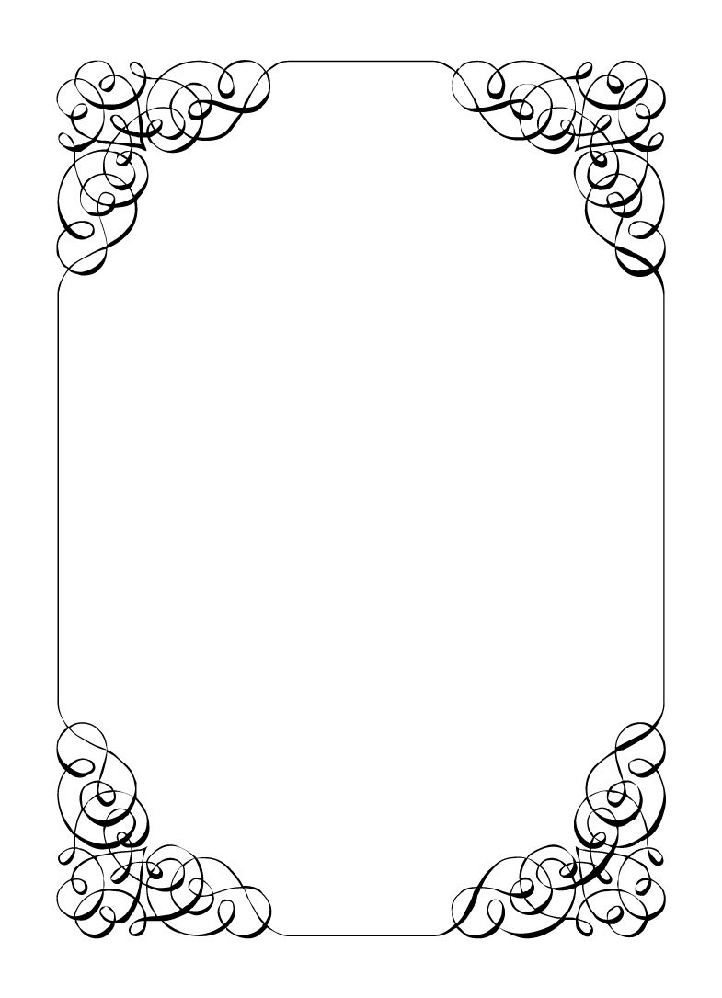

Not here to wed spiders

Corolla Castro

*In the small town of Duck Rise, Victoria, Stralya live: BOGANS. Bogans are much like the regular folk, but drunker and louder. Some of them even fall in love. But before they settle down and poop out a mess of kids, they gotta have a wedding! Weddings are the best. Everyone gets proper plastered. Lots of kissing. Lots of drama. Fun times for all. Nothing ever goes wrong at a wedding...*  
*\*\*ominous thunder clack\*\**

Corolla Castro

Bride *Bridezilla, Boisterous, Laser Focused*

Every since you were little, you loved a wedding. You got to be the Flowergirl for your cousin's friend's mother's wedding when you were young and loved it.  
You met Chad and convinced him to ask so now it is your turn and it WILL BE P E R F E C T!!!  
  
Last Night: It was your Bachelorette party. It was you, Gemini, Mercedes, Vectra, and Mungo. You asked for a night in of party games & Rom Coms but Gemini had other plans. She and Vectra rocked up, drunk as skunks. You went to a Casino, Pole Dancing and then did donuts in a local parking lot. The Maid of Honour puked over your favourite party dress and you yelled at her for ruining your bachelorette party.  
Somewhere in the calamity, Gemini lost the ring.

**Goals**

* **Have the perfect wedding:** BIG ring. Mercedes as Flowergirl. No drunks. Any groom (meh I'm easy).
* **Get divorced from Malibu:** You can't get married until you first get divorced. Find out who or how to get it annulled and keep it a secret.
* **Uninvite anyone trying to sabotage the wedding:** If anyone doesn't want you to marry the love of your life, then they need to go.
* **Keep the baby a secret:** You don't want anyone to know. It would ruin the wedding. Also, no drinking while pregnant.
* **Mercedes is such a bitch:** She thinks she is so tough, well she HAS to be here and wear that dress. Don't let her get uninvited and generally make her time here unpleasant.

**Other People**

**Chad Marolla**

Maybe one day you'll grow to love him. You managed to trick this guy into asking you to marry him. Great job. Good thing too, because you are up the duff with his baby. You'll tell him eventually.

**Gemini Belmont**

Your Maid of Honour and best friend. She has only recently returned from police academy and you just want her close by on this important day. Just like back at school.

**Mercedes Bennie**

Your dad adopted her when her parents died, so she is kinda like your foster sister. She's always rude to you but you need a cute Flowergirl for a perfect wedding. You'd figured she would compromise and be a cute girl in a nice dress for at least one day. It's your wedding, after all.

**Robin Smith**

The only person who would agree to all your terms for your perfect wedding. They seem like they think this is their event though. Don't they know the Bride is the most important person here?

**Dave Torana**

Chad's best mate. They get along great. If Chad isn't with you, he is usually with Dave.  
You appreciate that they have such a strong friendship but have made it clear that you need to be the priority after the wedding. Dave understood and agreed completely.

**Malibu Singer**

You and Malibu used to be married. You figured you just wanted to be married so bad, that Malibu would do. It didn't really pan out and you got separated. Never did finalise that divorce though.  
You are still good friends and so naturally you asked them to help plan the wedding.

**Sparkie Castro**

Ya dad. Ya love ya dad, don't ya? Well not really. That dude is clingy. You don't know how a Dad manages to be so dependant on his daughter, but this guy found a way.  
If he isn't missing for days, he is asking you about your every waking moment and how it is going. At least he is supportive of the wedding.

**Wayne Marolla**

Someone's uncle. Chad's you think. There's always someone that goes a bit too hard at these things, and Wayne already has it seems.  
Seems like a cool enough guy, but you don't know too much about him.

**Mungo Joint**

The cheapest photographer you could find. You want a perfect wedding, but any rube can push buttons on a camera. They are everywhere.

**Abilities**

Use these to do things. They have a limited use, so check them off when you use them.

|  |  |
| --- | --- |
| Ability | Oh are you talking about me? |
| If you overhear someone say your name (or The Bride) walk over and show them this ability. If you do, the player must show you their other people section for the character of your choice. |
| Usages: O O O |

|  |  |
| --- | --- |
| Ability | Storm Off |
| If someone uses an ability on you that forces you to reveal your information or secret, show this ability to them and keep your information or secret hidden instead. Then storm off in a huff. |
| Usages: O O O |

|  |  |
| --- | --- |
| Ability | GET OUT! |
| Make a huge scene about how a player is ruining your wedding, and show them this ability. If you do, that player is uninvited from the wedding and cannot attend the ceremony. Tell an Organiser when this happens. |
| Usages: O |

**Secret and Information**

Your Secret contains your guilty secret, while your Information contains one or more items of information you know. Both may be affected by abilities. Your lie may need to be filled out later.

While you can show your Secret and Information to whomever you like, you will probably not want to reveal your Secret too often. (Please note that you can’t solve the crime by looking at everyone’s Secret and Information – it’s not that easy!)

|  |  |
| --- | --- |
| Secret | You are 3 months pregnant. |

|  |  |
| --- | --- |
| Information | Gemini got hammered last night. |

**The Organiser’s Word is Law:** The organisers are impartial. If you have a problem or want to do something unusual, see an organiser. The organiser’s power is absolute – and cannot be affected by ability cards!

**Winning and Losing:** You can achieve most of your goals simply by talking to people. The organisers will announce when the game is over. If you haven’t succeeded by that point – you’re too late! Be warned – not everyone here will want you to succeed!

**Doing Stuff:** Ordinary actions are resolved by simply carrying them out. If you want to try something unusual (such as trying to hack the pentagon), see an organiser. The organisers knows everything – and will be able to tell you the outcome of whatever it is that you are trying to do. (For example, you are trying to hack over state lines and you are caught.) Do use your imagination, though! – this is a very flexible game, and you can do all sorts of things beyond what’s listed in these rules.

**Fighting:** If an ability or item lets you hard another player, don’t just dive in! See the organisers first and tell them what you plan to do so they can oversee and give you more detailed rules if it’s necessary.

**Leaving:** You cannot leave, it is rude to leave a wedding and you are in the middle of nowhere!

**Role Cards:** If someone asks you for your role in the wedding ceremony, and you have one, you must show them all your roles.

**Item Cards:** Any items of importance within the game are represented as Item cards – and the only items that can affect the game are those detailed on the cards. If you do not have an Item card, you do not have that item with you.

**Time:** This game is played over three (ish) hours, including time for reading your character etc. There will be breaks throughout the evening! The organisers will tell you when each period starts and finishes.

**Character List**

**Chad Marolla – *Groom***

The soon to be husband. A bit nervous about the wedding, but is letting Corolla take care of the hard stuff.

**Corolla Castro – *Bride***

She knows what kind of wedding she wants, and that's the kind of wedding we are having! NO EXCEPTIONS!

**Gemini Belmont – *Maid of Honour***

She carries herself like she just escaped a warzone. Maybe she did? She's real quiet and might throat punch you if you ask stupid questions.

**Mercedes Bennie – *Flowergirl***

She's 12 but everyone knows better than to treat her like a 12 year old. Punk AF and will burn this all down on a whim.

**Robin Smith – *Priest***

Not from here. Better than everyone else (or at least thinks so).

**Dave Torana – *Best Man***

Childhood friends with the Groom. He was the smooth talking hottie that picked up enough for both of them. But that part of his life is over now.

**Malibu Singer – *Wedding Planner***

For a professional organiser, not very organised. Has just managed to keep everything running so far.

**Sparkie Castro – *Bride's Father***

He's been waiting his whole life for this moment. His baby girl is finally gonna get married and he knows just how to get through the day without crying...

**Vectra Marolla – *Groom's Mother***

The Queen that runs this town. Knows where the bodies are buried, but will never tell. Everyone respects her.

**Wayne Marolla – *Drunk Uncle***

He's maybe had a few too many. Started stumbling around and saying weird things. Every wedding has one.

**Lucky the Wonder Dog – *Dog***

A good dog. *bark* *bark* "What's that Lucky? You want pats?"

**Mungo Joint – *Photographer***

Seems like they are creeping on everyone, but they were hired to take wedding photos so it's probably fine.