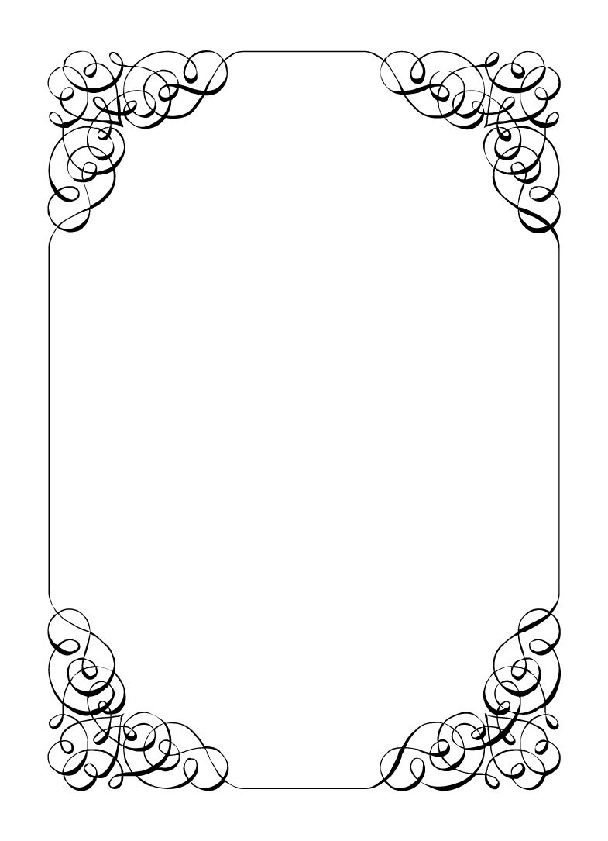

Not here to wed spiders

Chad Marolla

*In the small town of Duck Rise, Victoria, Stralya live: BOGANS. Bogans are much like the regular folk, but drunker and louder. Some of them even fall in love. But before they settle down and poop out a mess of kids, they gotta have a wedding! Weddings are the best. Everyone gets proper plastered. Lots of kissing. Lots of drama. Fun times for all. Nothing ever goes wrong at a wedding...*  
*\*\*ominous thunder clack\*\**

Chad Marolla

Groom *Airhead, Joyous, Casual*

Life is easy for Chad Marolla. No one knows that better than Chad Marolla. That's you. You are Chad Marolla. Nice!  
A bit ago you met Corolla and liked her well enough. She nagged enough to get married, and your figured "Sure. Sounds easy.".  
But it's all going a bit wrong. Ehh, things usually work out for the best when you are Chad Marolla. Don't stress it.  
  
Last Night: It was your bachelor party. Dave, Wayne, Malibu, Sparkie, and Lucky were there. You were grabbed from your bed, black bagged and taken on an 8 hour pub crawl, finishing at the casino late in the night. You had to drink every time anyone else did and got pretty blasted. Sparkie left at some point, you think he was worse than you. You all went to a hotel, and were told there would be some 'friends' coming over soon by your Uncle. They never rocked up, and as you sat talking to your Best Man you realised that you hadn't experienced all there was in the single life yet. One thing led to antoher and well... The sex with Dave was fantastic. You still love your bride but getting married seems a little rude at this point.  
Best call it off now and try to fix it later.

**Goals**

* **Save face, but get Corolla to give up on you.:** During your vows, explain why Corolla cannot marry. If you can't find a reason and get her to step down, then it would be rude to say no to the I do's.
* **What happens on Buck's night...:** Make sure no-one (especially Corolla) knows what you did with Dave last night.
* **Shut down your mother:** Your mother has been completely against the marriage ever since the first time you introduced Corolla. Make sure she is intoxicated as much as possible to keep drama to a minimum.
* **Repay your uncle:** Make sure he knows you are thankful, even though he doesn't want to talk about the money, maybe drop a nod to him in your vows?
* **Rip up any Prenups you are asked to sign.:** Love isn't about money, man. Unless there is a good reason to sign something...
* **Father in LOSER:** Sparkie hasn't paid a dime for this wedding. Isn't that meant to be his job? Make sure he knows what that means to you.

**Other People**

**Corolla Castro**

The love of your life. She's pretty nice. You like her ok. You wonder if you are just falling into this marriage because it is your first serious relationship.  
She wants to control this wedding like a genocidal dictator and it's easier to just let her.

**Mercedes Bennie**

Your cousin or something. She thinks she's cool, but she's just posing. Corolla thought she would make a cute Flowergirl. Punks generally aren't that cute, but you just went with it.

**Dave Torana**

He has been your best mate since you were tiny menaces. He was always the charmer that managed to do all the talking for you and you would go along with it.  
Great for picking up chicks at the pub. The wedding has made you nervous about missing that part of your life, so you have decided to go out on a bang. Literally. You totally banged that guy last night.

**Malibu Singer**

An old friend of Corolla. Corolla insisted on them helping plan everything. You reckon Corolla and Malibu had a fling in the past, but they have never admitted it.  
You know it is petty, but you don't like the idea of an old flame being at the wedding.

**Sparkie Castro**

Bit of a scumbag. He seemed ok with you dating his daughter, but you could never get past the fact he was a dole bludger loser.  
He seemed way too into Corolla, but whenever you tried to connect he always disappeared. Just one of those things.

**Vectra Marolla**

She's ya mum. Ya love ya mum don't ya? She always wanted you to be a mumma's boy, but you don't think you are.  
Sure, she still buys all your clothes and does your laundry and makes you dinner when you want it, but that doesn't make you a mumma's boy.  
She never approved of Corolla, but wanted you to be happy anyway.

**Wayne Marolla**

He is kinda a controlling nightmare. He came into money a bit ago, but insists everyone keep it secret while also insisting everything that him for paying for everything.  
How can you do both? You like the stuff you give, but a tired of always keeping up appearances around him.

**Lucky the Wonder Dog**

What a good dog. Maybe the best dog. Way smarter then you would think a dog could be. Like some dog out of a children's TV show.

**Mungo Joint**

They are the cheapest wedding photographer in town. Corolla wanted pictures of he magical day, but Mungo has inserted themselves into your life for this.  
You just want a bit of privacy, but it all has to be documented supposedly.

**Abilities**

Use these to do things. They have a limited use, so check them off when you use them.

|  |  |
| --- | --- |
| Ability | We are all family here |
| Get permission and hug someone, then show them this ability. If you do, the player must show you their information. |
| Usages: O O O |

|  |  |
| --- | --- |
| Ability | That's need to know only |
| If someone uses an ability on you that forces you to reveal your information or secret, show this ability to them and keep your information or secret hidden instead. |
| Usages: O O O |

|  |  |
| --- | --- |
| Ability | I didn't see your wedding present on the table |
| If another player has an item in their hands, show them this ability and then get the item. |
| Usages: O O O |

|  |  |
| --- | --- |
| Ability | Oh hell no! You're uninvited |
| If a player raises their voice to you, you can show them this ability. If you do, that player is uninvited from the wedding and cannot attend the ceremony. Tell an Organiser when this happens. |
| Usages: O |

**Secret and Information**

Your Secret contains your guilty secret, while your Information contains one or more items of information you know. Both may be affected by abilities. Your lie may need to be filled out later.

While you can show your Secret and Information to whomever you like, you will probably not want to reveal your Secret too often. (Please note that you can’t solve the crime by looking at everyone’s Secret and Information – it’s not that easy!)

|  |  |
| --- | --- |
| Secret | Hooked up with my Best Man at the Bachelor party. |

|  |  |
| --- | --- |
| Information | Wayne gave me a huge cash gift before the wedding. |

**The Organiser’s Word is Law:** The organisers are impartial. If you have a problem or want to do something unusual, see an organiser. The organiser’s power is absolute – and cannot be affected by ability cards!

**Winning and Losing:** You can achieve most of your goals simply by talking to people. The organisers will announce when the game is over. If you haven’t succeeded by that point – you’re too late! Be warned – not everyone here will want you to succeed!

**Doing Stuff:** Ordinary actions are resolved by simply carrying them out. If you want to try something unusual (such as trying to hack the pentagon), see an organiser. The organisers knows everything – and will be able to tell you the outcome of whatever it is that you are trying to do. (For example, you are trying to hack over state lines and you are caught.) Do use your imagination, though! – this is a very flexible game, and you can do all sorts of things beyond what’s listed in these rules.

**Fighting:** If an ability or item lets you hard another player, don’t just dive in! See the organisers first and tell them what you plan to do so they can oversee and give you more detailed rules if it’s necessary.

**Leaving:** You cannot leave, it is rude to leave a wedding and you are in the middle of nowhere!

**Role Cards:** If someone asks you for your role in the wedding ceremony, and you have one, you must show them all your roles.

**Item Cards:** Any items of importance within the game are represented as Item cards – and the only items that can affect the game are those detailed on the cards. If you do not have an Item card, you do not have that item with you.

**Time:** This game is played over three (ish) hours, including time for reading your character etc. There will be breaks throughout the evening! The organisers will tell you when each period starts and finishes.

**Character List**

**Chad Marolla – *Groom***

The soon to be husband. A bit nervous about the wedding, but is letting Corolla take care of the hard stuff.

**Corolla Castro – *Bride***

She knows what kind of wedding she wants, and that's the kind of wedding we are having! NO EXCEPTIONS!

**Gemini Belmont – *Maid of Honour***

She carries herself like she just escaped a warzone. Maybe she did? She's real quiet and might throat punch you if you ask stupid questions.

**Mercedes Bennie – *Flowergirl***

She's 12 but everyone knows better than to treat her like a 12 year old. Punk AF and will burn this all down on a whim.

**Robin Smith – *Priest***

Not from here. Better than everyone else (or at least thinks so).

**Dave Torana – *Best Man***

Childhood friends with the Groom. He was the smooth talking hottie that picked up enough for both of them. But that part of his life is over now.

**Malibu Singer – *Wedding Planner***

For a professional organiser, not very organised. Has just managed to keep everything running so far.

**Sparkie Castro – *Bride's Father***

He's been waiting his whole life for this moment. His baby girl is finally gonna get married and he knows just how to get through the day without crying...

**Vectra Marolla – *Groom's Mother***

The Queen that runs this town. Knows where the bodies are buried, but will never tell. Everyone respects her.

**Wayne Marolla – *Drunk Uncle***

He's maybe had a few too many. Started stumbling around and saying weird things. Every wedding has one.

**Lucky the Wonder Dog – *Dog***

A good dog. *bark* *bark* "What's that Lucky? You want pats?"

**Mungo Joint – *Photographer***

Seems like they are creeping on everyone, but they were hired to take wedding photos so it's probably fine.