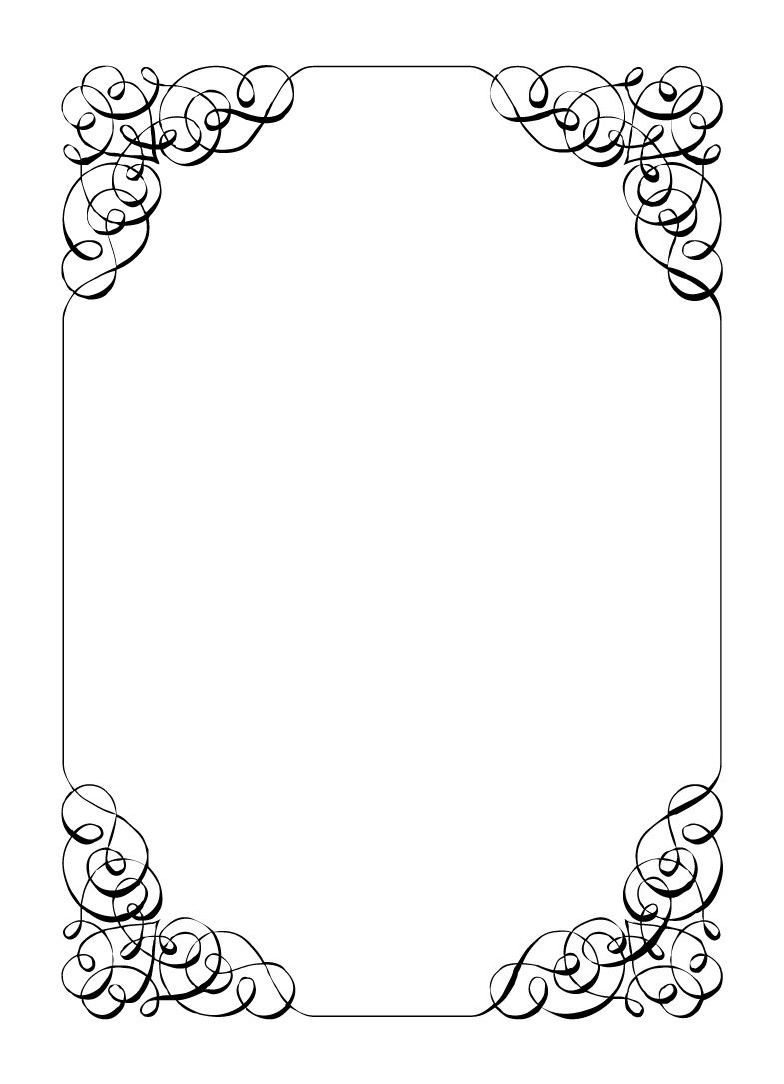

Not here to wed spiders

Mungo Joint

*In the small town of Duck Rise, Victoria, Stralya live: BOGANS. Bogans are much like the regular folk, but drunker and louder. Some of them even fall in love. But before they settle down and poop out a mess of kids, they gotta have a wedding! Weddings are the best. Everyone gets proper plastered. Lots of kissing. Lots of drama. Fun times for all. Nothing ever goes wrong at a wedding...*  
*\*\*ominous thunder clack\*\**

Mungo Joint

Photographer *Messy, Desperate, Wracked with guilt*

Most days you just sit alone in your apartment in the dark. You watch TV, but don't pay attention enough to remember. You cook, but all food tastes like ash so you mostly just have tinned soup.  
Some days, the phone rings. Someone wants you to take pictures of their wedding. You always say yes. Gotta pay for the soup.  
This is weird wedding though. It actually intrigues you. Finally... something.  
  
Last Night: You were hired to join the Bachelorette party. It was you, Gemini, Mercedes, Corolla, and Corolla. Strange but they are country folk. You got some great shots, the Maid of Honour was super blasted, and the  
Flowergirl would not let herself be photographed.

**Goals**

* **Object at the wedding!:** There is definitely something fishy going on here. If you find evidence make sure to object and explain the whole travesty.
* **Find out why the Wayne gave Chad a large sum of money:** Confront them and try to find why money is changing hands.
* **Get a photo of Mercedes doing something illegal (Use you phone):** Mercedes didn't want their photo taken at the Bachelorette party. Weird.

**Other People**

**Chad Marolla**

A sucker. I'm pretty sure you could charge him anything. He seems pretty disconnected from the whole wedding thing.

**Corolla Castro**

You've met a ton of brides before on other jobs but Corolla has to be the pushiest most controlling one yet.

**Gemini Belmont**

Was absolutely smashed at the bachelorette party. You have photos of her to prove it.

**Mercedes Bennie**

When you have had nightmares in the past, about your accident, you always imagine it was a child. Children make you remember. Best avoid this one.

**Robin Smith**

You saw them on the train into town. Must of come from the city to do this event, like you.

**Dave Torana**

A smooth talker, with even smoother skin. You should go out of your way to get some extra photos of this man to keep for yourself.

**Vectra Marolla**

She was the first one to arrive at the bachelorette party with a bunch of bags. She holds her booze well.

**Abilities**

Use these to do things. They have a limited use, so check them off when you use them.

|  |  |
| --- | --- |
| Ability | Research |
| Bring an item to an Organiser. They will tell you something useful about it. |
| Usages: O O |

|  |  |
| --- | --- |
| Ability | Say cheese |
| Ask someone if you can take a photo of someone. If you take a photo of them, the player must show you their secret. |
| Usages: O O O |

|  |  |
| --- | --- |
| Ability | What are we all talking about? |
| Interrupt another private conversation between two people, and get them to ask you to go away. If you manage this, those players must show you their other people section for the character of your choice. |
| Usages: O O O |

**Secret and Information**

Your Secret contains your guilty secret, while your Information contains one or more items of information you know. Both may be affected by abilities. Your lie may need to be filled out later.

While you can show your Secret and Information to whomever you like, you will probably not want to reveal your Secret too often. (Please note that you can’t solve the crime by looking at everyone’s Secret and Information – it’s not that easy!)

|  |  |
| --- | --- |
| Secret | Years ago, while driving late at night you hit someone. It was dark, but you kept on driving... |

|  |  |
| --- | --- |
| Information | You heard there is an off duty cop at the wedding. |

**The Organiser’s Word is Law:** The organisers are impartial. If you have a problem or want to do something unusual, see an organiser. The organiser’s power is absolute – and cannot be affected by ability cards!

**Winning and Losing:** You can achieve most of your goals simply by talking to people. The organisers will announce when the game is over. If you haven’t succeeded by that point – you’re too late! Be warned – not everyone here will want you to succeed!

**Doing Stuff:** Ordinary actions are resolved by simply carrying them out. If you want to try something unusual (such as trying to hack the pentagon), see an organiser. The organisers knows everything – and will be able to tell you the outcome of whatever it is that you are trying to do. (For example, you are trying to hack over state lines and you are caught.) Do use your imagination, though! – this is a very flexible game, and you can do all sorts of things beyond what’s listed in these rules.

**Fighting:** If an ability or item lets you hard another player, don’t just dive in! See the organisers first and tell them what you plan to do so they can oversee and give you more detailed rules if it’s necessary.

**Leaving:** You cannot leave, it is rude to leave a wedding and you are in the middle of nowhere!

**Role Cards:** If someone asks you for your role in the wedding ceremony, and you have one, you must show them all your roles.

**Item Cards:** Any items of importance within the game are represented as Item cards – and the only items that can affect the game are those detailed on the cards. If you do not have an Item card, you do not have that item with you.

**Time:** This game is played over three (ish) hours, including time for reading your character etc. There will be breaks throughout the evening! The organisers will tell you when each period starts and finishes.

**Character List**

**Chad Marolla – *Groom***

The soon to be husband. A bit nervous about the wedding, but is letting Corolla take care of the hard stuff.

**Corolla Castro – *Bride***

She knows what kind of wedding she wants, and that's the kind of wedding we are having! NO EXCEPTIONS!

**Gemini Belmont – *Maid of Honour***

She carries herself like she just escaped a warzone. Maybe she did? She's real quiet and might throat punch you if you ask stupid questions.

**Mercedes Bennie – *Flowergirl***

She's 12 but everyone knows better than to treat her like a 12 year old. Punk AF and will burn this all down on a whim.

**Robin Smith – *Priest***

Not from here. Better than everyone else (or at least thinks so).

**Dave Torana – *Best Man***

Childhood friends with the Groom. He was the smooth talking hottie that picked up enough for both of them. But that part of his life is over now.

**Malibu Singer – *Wedding Planner***

For a professional organiser, not very organised. Has just managed to keep everything running so far.

**Sparkie Castro – *Bride's Father***

He's been waiting his whole life for this moment. His baby girl is finally gonna get married and he knows just how to get through the day without crying...

**Vectra Marolla – *Groom's Mother***

The Queen that runs this town. Knows where the bodies are buried, but will never tell. Everyone respects her.

**Wayne Marolla – *Drunk Uncle***

He's maybe had a few too many. Started stumbling around and saying weird things. Every wedding has one.

**Lucky the Wonder Dog – *Dog***

A good dog. *bark* *bark* "What's that Lucky? You want pats?"

**Mungo Joint – *Photographer***

Seems like they are creeping on everyone, but they were hired to take wedding photos so it's probably fine.