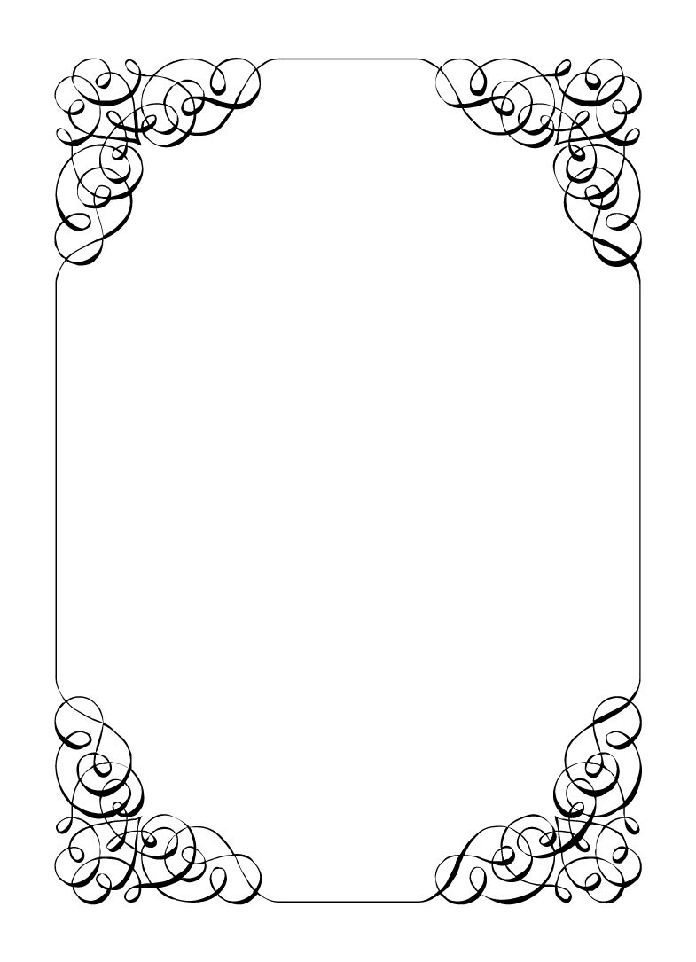

Not here to wed spiders

Robin Smith

*In the small town of Duck Rise, Victoria, Stralya live: BOGANS. Bogans are much like the regular folk, but drunker and louder. Some of them even fall in love. But before they settle down and poop out a mess of kids, they gotta have a wedding! Weddings are the best. Everyone gets proper plastered. Lots of kissing. Lots of drama. Fun times for all. Nothing ever goes wrong at a wedding...*  
*\*\*ominous thunder clack\*\**

Robin Smith

Priest *Polite, Judgemental, Difficult*

Your mother always told you to act proper. You figured marriage was a good career for creating order. But you came out from the big city for this?!?!  
Maybe something can be done to teach these Bogans how they are meant to be.  
  
Last Night: You were not at either of the Bachelor or Bachelorette parties, but everyone seems real hung over.

**Goals**

* **This wedding has to happen:** SOMEONE is getting married. You don't really care who.
* **Make the wedding proper:** The bride needs something borrowed, something blue, something old & something new or this wedding is just pedestrian. Don't let these Bogans sully the sanctity of marriage.
* **Run this wedding:** You are the one in charge around here. Make sure no one else thinks otherwise. You have a great speech planned for the ceremony you have to give. (note: maybe write one?)
* **Get Dave uninvited:** You can't risk them ruining everything by being best man. If you cannot get them uninvited at least get them replaced.
* **Vectra is your nemesis:** She acts like she is better than the rest, but she is just another bogan scum. Make sure she knows that at every opportunity.
* **Get Lucky to come home with you:** If the dog likes you best then you can collect the reward!

**Other People**

**Corolla Castro**

It was clear that she was the one that wanted you hired. Excellent taste. Now if she would only stop fussing and let you deal with the wedding. It is kind of your expertise.

**Gemini Belmont**

She is one of the few that are trying to keep everything from falling apart. A practical lady. She just might be your only ally in fixing this wedding.

**Mercedes Bennie**

Of all the 12 year old flowergirls that have been at YOUR weddings, this has to be the most disinterested, bad mouthed, drongo you've ever met. Perhaps these is someone more appropriate for the role out there.

**Dave Torana**

You hate it when a womaniser starts sleeping his way through the bridal party. The number one reason for drama at a wedding is people like Dave getting with someone they shouldn't.

**Sparkie Castro**

$15,000 dollars in cash is not what you expected from this bumbling, barely sober man. Stranger again that he had it delivered anonymously.

**Vectra Marolla**

Sometimes, a backwater country hick gets it in their head that they are 'classy' or 'sophisticated'. They could hardly spell those words. There has to be some way to show her how little she has crawled from her origins.

**Lucky the Wonder Dog**

When you were told there would be a dog at the wedding you presumed a mangey old thing, dirtying the decorations. Lucky however is an absolutely lovely and well behaved creature!

**Mungo Joint**

You've seen Mungo taking photos for other weddings you've conducted. Capable but always deathly tired looking.

**Abilities**

Use these to do things. They have a limited use, so check them off when you use them.

|  |  |
| --- | --- |
| Ability | Confession |
| Have a brief private conversation with someone. If you manage this, the player must show you their secret. |
| Usages: O O O |

|  |  |
| --- | --- |
| Ability | We need more people like you |
| Pick a player that has been uninvited from the wedding. They are re-invited. |
| Usages: O |

|  |  |
| --- | --- |
| Ability | No secrets from God |
| Give a small speech about the virtues of marriage. If a player sticks around to listens, that player must show you all items they have on them. |
| Usages: O O O |

|  |  |
| --- | --- |
| Ability | Anullment |
| Bring a certificate of marriage to an Organiser and you can annull it. |
| Usages: O |

**Secret and Information**

Your Secret contains your guilty secret, while your Information contains one or more items of information you know. Both may be affected by abilities. Your lie may need to be filled out later.

While you can show your Secret and Information to whomever you like, you will probably not want to reveal your Secret too often. (Please note that you can’t solve the crime by looking at everyone’s Secret and Information – it’s not that easy!)

|  |  |
| --- | --- |
| Secret | You have been paid $15,000 anonymously to make sure this wedding goes ahead. |

|  |  |
| --- | --- |
| Information | Malibu is married, but didn't bring their partner. |

**The Organiser’s Word is Law:** The organisers are impartial. If you have a problem or want to do something unusual, see an organiser. The organiser’s power is absolute – and cannot be affected by ability cards!

**Winning and Losing:** You can achieve most of your goals simply by talking to people. The organisers will announce when the game is over. If you haven’t succeeded by that point – you’re too late! Be warned – not everyone here will want you to succeed!

**Doing Stuff:** Ordinary actions are resolved by simply carrying them out. If you want to try something unusual (such as trying to hack the pentagon), see an organiser. The organisers knows everything – and will be able to tell you the outcome of whatever it is that you are trying to do. (For example, you are trying to hack over state lines and you are caught.) Do use your imagination, though! – this is a very flexible game, and you can do all sorts of things beyond what’s listed in these rules.

**Fighting:** If an ability or item lets you hard another player, don’t just dive in! See the organisers first and tell them what you plan to do so they can oversee and give you more detailed rules if it’s necessary.

**Leaving:** You cannot leave, it is rude to leave a wedding and you are in the middle of nowhere!

**Role Cards:** If someone asks you for your role in the wedding ceremony, and you have one, you must show them all your roles.

**Item Cards:** Any items of importance within the game are represented as Item cards – and the only items that can affect the game are those detailed on the cards. If you do not have an Item card, you do not have that item with you.

**Time:** This game is played over three (ish) hours, including time for reading your character etc. There will be breaks throughout the evening! The organisers will tell you when each period starts and finishes.

**Character List**

**Chad Marolla – *Groom***

The soon to be husband. A bit nervous about the wedding, but is letting Corolla take care of the hard stuff.

**Corolla Castro – *Bride***

She knows what kind of wedding she wants, and that's the kind of wedding we are having! NO EXCEPTIONS!

**Gemini Belmont – *Maid of Honour***

She carries herself like she just escaped a warzone. Maybe she did? She's real quiet and might throat punch you if you ask stupid questions.

**Mercedes Bennie – *Flowergirl***

She's 12 but everyone knows better than to treat her like a 12 year old. Punk AF and will burn this all down on a whim.

**Robin Smith – *Priest***

Not from here. Better than everyone else (or at least thinks so).

**Dave Torana – *Best Man***

Childhood friends with the Groom. He was the smooth talking hottie that picked up enough for both of them. But that part of his life is over now.

**Malibu Singer – *Wedding Planner***

For a professional organiser, not very organised. Has just managed to keep everything running so far.

**Sparkie Castro – *Bride's Father***

He's been waiting his whole life for this moment. His baby girl is finally gonna get married and he knows just how to get through the day without crying...

**Vectra Marolla – *Groom's Mother***

The Queen that runs this town. Knows where the bodies are buried, but will never tell. Everyone respects her.

**Wayne Marolla – *Drunk Uncle***

He's maybe had a few too many. Started stumbling around and saying weird things. Every wedding has one.

**Lucky the Wonder Dog – *Dog***

A good dog. *bark* *bark* "What's that Lucky? You want pats?"

**Mungo Joint – *Photographer***

Seems like they are creeping on everyone, but they were hired to take wedding photos so it's probably fine.