Charles Hanzel D. Gerardo  
Oct 11, 2024  
DSALGO – IDB2

Code:  
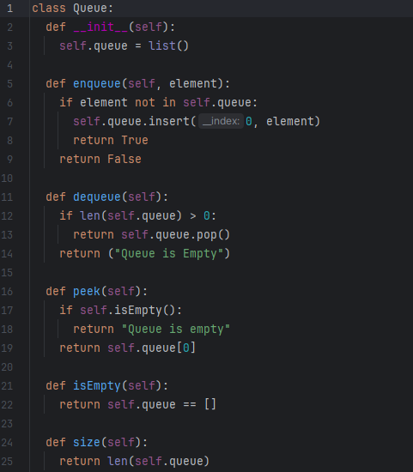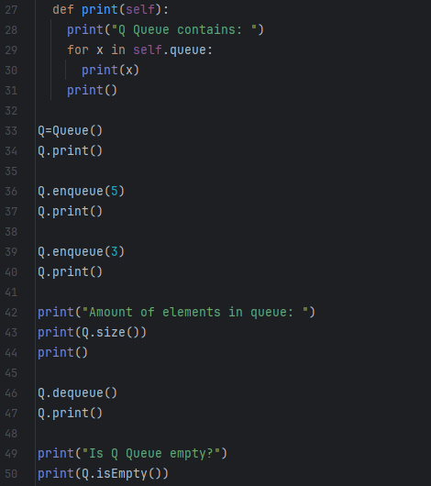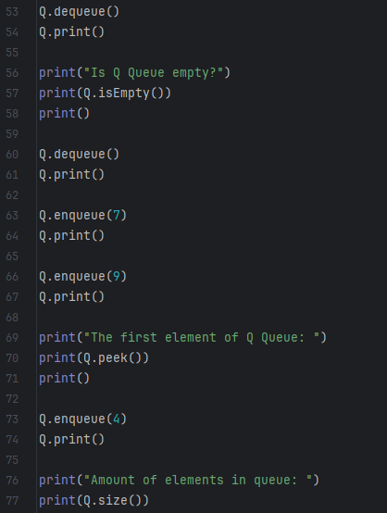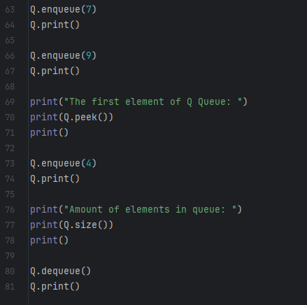

class Queue:  
 def __init__(self):  
 self.queue = list()  
  
 def enqueue(self, element):  
 if element not in self.queue:  
 self.queue.insert(0, element)  
 return True  
 return False  
  
 def dequeue(self):  
 if len(self.queue) > 0:  
 return self.queue.pop()  
 return ("Queue is Empty")  
  
 def peek(self):  
 if self.isEmpty():  
 return "Queue is empty"  
 return self.queue[0]  
  
 def isEmpty(self):  
 return self.queue == []  
  
 def size(self):  
 return len(self.queue)  
  
 def print(self):  
 print("Q Queue contains: ")  
 for x in self.queue:  
 print(x)  
 print()  
  
Q=Queue()  
Q.print()  
  
Q.enqueue(5)  
Q.print()  
  
Q.enqueue(3)  
Q.print()  
  
print("Amount of elements in queue: ")  
print(Q.size())  
print()  
  
Q.dequeue()  
Q.print()  
  
print("Is Q Queue empty?")  
print(Q.isEmpty())  
print()  
  
Q.dequeue()  
Q.print()  
  
print("Is Q Queue empty?")  
print(Q.isEmpty())  
print()  
  
Q.dequeue()  
Q.print()  
  
Q.enqueue(7)  
Q.print()  
  
Q.enqueue(9)  
Q.print()  
  
print("The first element of Q Queue: ")  
print(Q.peek())  
print()  
  
Q.enqueue(4)  
Q.print()  
  
print("Amount of elements in queue: ")  
print(Q.size())  
print()  
  
Q.dequeue()  
Q.print()

Output:  
  
