Joshua Krasnogorov

Martin Cenek

CS-429

2 April 2025

Lab 8

I did the TensorFlow beginners tutorial and the CNN tutorial from the TensorFlow website. I decided to use TensorBoard instead of matplotlib, since I found that I could get a lot more data visualized with much less effort on my end. The CNN ended up being significantly more accurate than running the extracted features, although training time was much longer.

**Part 2**

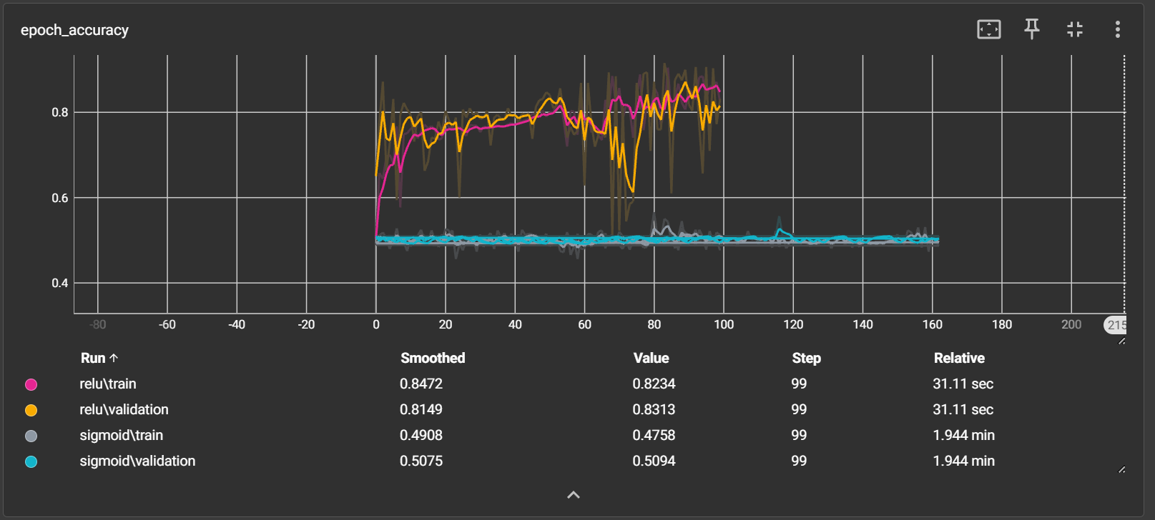

**Part 3**

I tested 3 configurations – one with a lot of filters, one with a larger kernel size, and one with fewer filters. After 5 epochs, every configuration had perfect test accuracy and 0 test loss, aside from the fewer filter model which had a test loss of 0.0003. However, the configuration with the larger kernel size converged the soonest to perfect accuracy and trained about twice as fast as the others.

|  |  |  |  |
| --- | --- | --- | --- |
| configuration | average step time (ms) | test accuracy | test loss |
| more filters | 224 | 1.0 | 0 |
| larger kernel | 110 | 1.0 | 0 |
| fewer filters | 290 | 1.0 | .0003 |

