**2 Interface description**

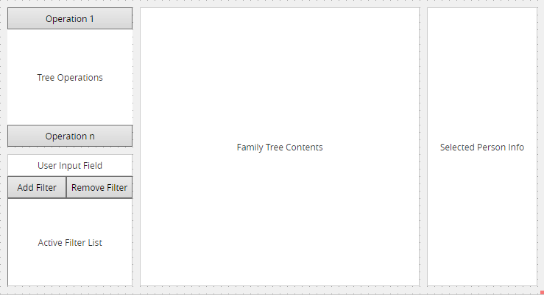

**Tree Operations :** It allows us to select one of the operations in the tree operation and reach the pop-up screen of that operation.

**Filtters:** It allows us to find the person or people we are looking for by adding and removing filters in this place.

**Family tree contents :** In family tree contents we can see family members and we select person from family tree.

**Selected Person Info** : We can see the selected person's information in this place.