

**Use Case Diagrams**

**By**

**EBOWOICHO EMMANUEL ONAH**

**500252011**

The Use Case Diagram Screen Shot

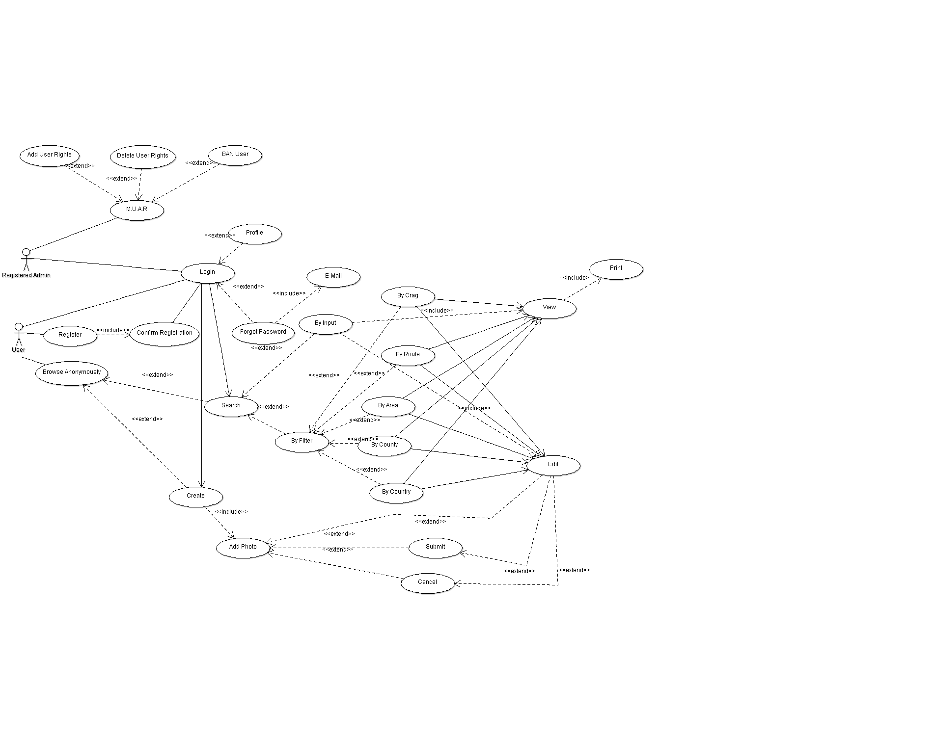

Use case Diagram Described

|  |  |
| --- | --- |
| **ZuntechiUseCaseModelUse Case**  *Login* **Use Case** | **(Login)**  Every use case must have a name. Use case is shown as an ellipse containing the name of the use case. |
| **ActorZuntechiUseCaseModel**  *User* **Actor** | **[User]**  Standard UML icon for actor is "stick man" icon with the name of the actor above or below the icon. Actor names should follow the capitalization and punctuation guidelines for classes. The names of abstract actors should be shown in italics. All actors must have names. |
| **<<Extend>>**  ZuntechiUseCaseModel***Login*** *Use case is meaningful on its own, and it could be extended with optional* ***Profile*** *and* ***Forgot Password*** *Use cases* | **(Login)<(Forgot Password)**  **Extend** is a [directed relationship](http://www.uml-diagrams.org/uml-core.html#directed-relationship) that specifies how and when the behaviour defined in usually supplementary (optional) **extending use case** can be inserted into the behaviour defined in the **extended use case**. |
| **ZuntechiUseCaseModel**  ***Manage User Access*** *Rights is meaningful alone, and it could be extended with* ***optional Add User Rights, Delete User Rights*** *and* ***BAN User*** *Use cases.* | **Extended** use case is meaningful on its own, it is **independent** of the extending use case. **Extending** use case typically defines **optional** behaviour that is not necessarily meaningful by itself.  The Manage User Access Right use case, enables the administrator to be able to control how much access the user's have. The Admin can either add user rights e.g. making the user an admin, Delete user right e.g. remove the user from being an admin and the admin can BAN the user if the user becomes a nuisance to the site. |
| **ZuntechiUseCaseModel<<Include>>**  ***Confirm Registration*** *Use case Requires (includes)* ***Register*** *Use case* | **(Register)>(Confirm Registration)**  The  include  relationship is analogous to a subroutine call or macro and could be used: when there are common parts of the behaviour of two or more use cases, to simplify large use case by splitting it into several use cases. |
| ZuntechiUseCaseModel  **Print** Use case | The **Print** use case allows the users to be able to print the route after viewing it. |
| ZuntechiUseCaseModel  **View** Use case | The **view** use case enables the user to be able to view the route after it has been found |
| ZuntechiUseCaseModel  **Edit** Use case | The user can edit the route. |
| **By filter, By input, By crag, By route, By area, By county, By country** use cases  ZuntechiUseCaseModel | The **By Input** use case enables the user to search for a route by inputting the name of the route from a key board.  The **By Filter** use case is used for searching for routes but with this the user may not know the name of the route so this is used by the user to find the route from a selection of predefined routes.  The **By Country** use case is used to search for a route by choosing the name of the country from a predefined countries list.  The **By County** use case is used to search for a route by choosing the name of the county from a predefined county list.  The **By Area** use case is used to search for a route by choosing the name of the Area from a predefined Areas list.  The **By Route** use case is used to find for a route by choosing the name of the route from a predefined routes list.  The **By Crag** use case is used to search for a route by choosing the name of the crag from a predefined crags list. |
| **ZuntechiUseCaseModelAdd Photo, Submit, Cancel** Use cases | The **Add Photo** Use case can be used by both a registered user and an anonymous user to add pictures.  The **Submit** use case is used to submit the picture that has been added.  The **Cancel** use case is used to cancel the add picture process if the user does not want to add the photo anymore. |
| ZuntechiUseCaseModel  **Login, Profile, Forgot password, E-mail, Search, Create** Use cases | The **login** use case enables the user who is registered to be able to log onto the web site with their credentials.  The **Profile** Use case is made for registered users to go on their profile.  The **Forgot Password** use case is used for users who are registered but forgot their passwords.  The **E-mail** use case is used to send the forgotten password back to the registered users.  The **Search** use case is used by everyone to search for routes.  The **Create** use case is used by everyone to create routes. |
| ZuntechiUseCaseModel  **Register, Confirm Registration, Browse Anonymously** use cases | The **Register** use case is used for a user who wants to be a registered user to be able to register.  The **Confirm Registration** use case is meant for a user who has registered then receives a message to validate the registration then the user can log in.  The **Browse Anonymously** use case enables people to browse the site without being registered under the name anon. |