
Use Case Diagrams
By
EBOWOICHO EMMANUEL ONAH
500252011

The Use Case Diagram Screen Shot
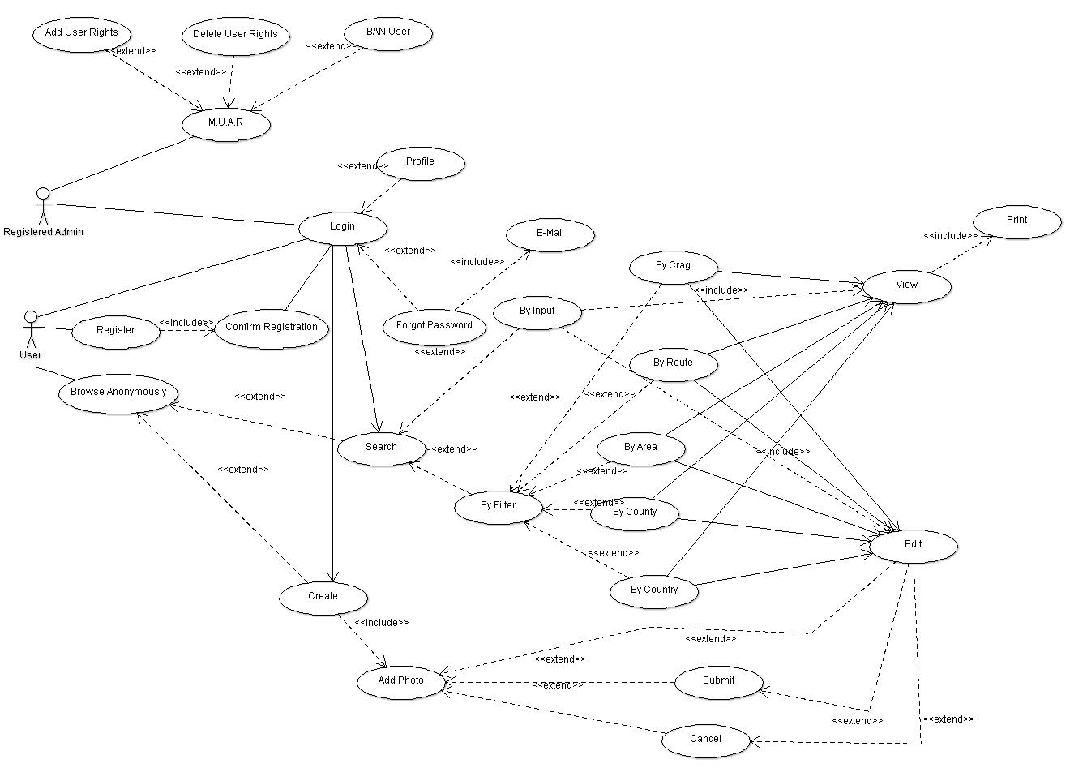

Use case Diagram Descriped
Use Case | (Login)  Every use case must have a name. Use case is shown as an ellipse containing the name of the use case.
Actor | [User]  Standard UML icon for actor is "stick man" icon with the name of the actor above or below the icon. Actor names should follow the capitalization and punctuation guidelines for classes. The names of abstract actors should be shown in italics. All actors must have names.
<<Extend>> | (Login)<(Forgot Password)  Extend is a directed relationship that specifies how and when the behaviour defined in usually supplementary (optional) extending use case can be inserted into the behaviour defined in the extended use case.  Extended use case is meaningful on its own, it is independent of the extending use case. Extending use case typically defines optional behaviour that is not necessarily meaningful by itself.
<<Include>> | (Register)>(Confirm Registration)  The include relationship is analogous to a subroutine call or macro and could be used: when there are common parts of the behaviour of two or more use cases, to simplify large use case by splitting it into several use cases.

Search Routes by Input Use case Described:
1. User comes into the site
2. User is in search of a specific route
3. The User inputs his route into the search bar and if the route is available the user clicks on the route and has the choice of either to view or to edit the route or both.

