
Use Case Diagrams
By
EBOWOICHO EMMANUEL ONAH
500252011

The Use Case Diagram Screen Shot
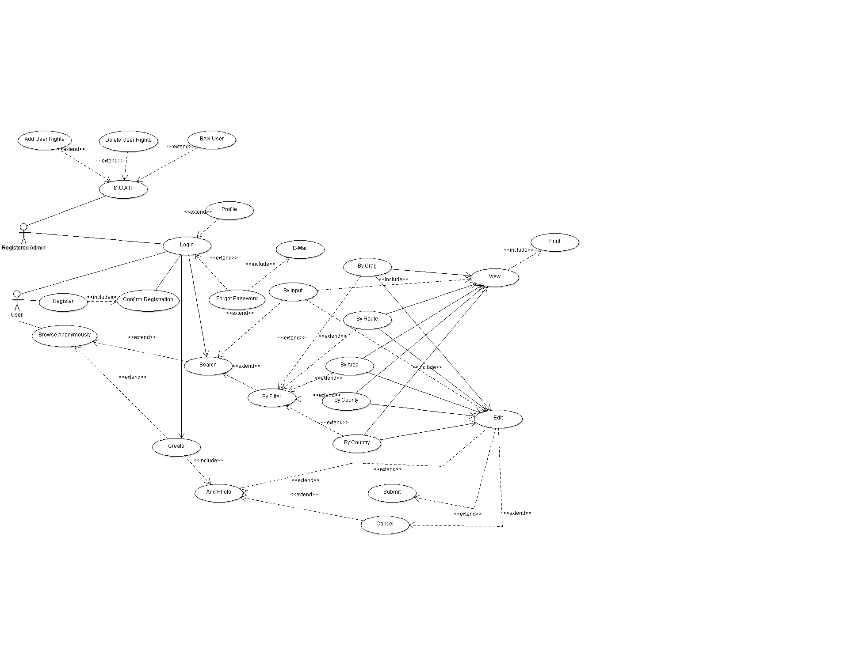

Use case Diagram Described
Use Case  Login Use Case | (Login)  Every use case must have a name. Use case is shown as an ellipse containing the name of the use case.
Actor  User Actor | [User]  Standard UML icon for actor is "stick man" icon with the name of the actor above or below the icon. Actor names should follow the capitalization and punctuation guidelines for classes. The names of abstract actors should be shown in italics. All actors must have names.
<<Extend>>  Login Use case is meaningful on its own, and it could be extended with optional Profile and Forgot Password Use cases | (Login)<(Forgot Password)  Extend is a directed relationship that specifies how and when the behaviour defined in usually supplementary (optional) extending use case can be inserted into the behaviour defined in the extended use case.
Manage User Access Rights is meaningful alone, and it could be extended with optional Add User Rights, Delete User Rights and BAN User Use cases. | Extended use case is meaningful on its own, it is independent of the extending use case. Extending use case typically defines optional behaviour that is not necessarily meaningful by itself.  The Manage User Access Right use case, enables the administrator to be able to control how much access the user's have. The Admin can either add user rights e.g. making the user an admin, Delete user right e.g. remove the user from being an admin and the admin can BAN the user if the user becomes a nuisance to the site.
<<Include>>  Confirm Registration Use case Requires (includes) Register Use case | (Register)>(Confirm Registration)  The include relationship is analogous to a subroutine call or macro and could be used: when there are common parts of the behaviour of two or more use cases, to simplify large use case by splitting it into several use cases.
Print Use case | The Print use case allows the users to be able to print the route after viewing it.
View Use case | The view use case enables the user to be able to view the route after it has been found
Edit Use case | The user can edit the route.
By filter, By input, By crag, By route, By area, By county, By country use cases | The By Input use case enables the user to search for a route by inputting the name of the route from a key board.  The By Filter use case is used for searching for routes but with this the user may not know the name of the route so this is used by the user to find the route from a selection of predefined routes.  The By Country use case is used to search for a route by choosing the name of the country from a predefined countries list.  The By County use case is used to search for a route by choosing the name of the county from a predefined county list.  The By Area use case is used to search for a route by choosing the name of the Area from a predefined Areas list.  The By Route use case is used to find for a route by choosing the name of the route from a predefined routes list.  The By Crag use case is used to search for a route by choosing the name of the crag from a predefined crags list.
Add Photo, Submit, Cancel Use cases | The Add Photo Use case can be used by both a registered user and an anonymous user to add pictures.  The Submit use case is used to submit the picture that has been added.  The Cancel use case is used to cancel the add picture process if the user does not want to add the photo anymore.
Login, Profile, Forgot password, E-mail, Search, Create Use cases | The login use case enables the user who is registered to be able to log onto the web site with their credentials.  The Profile Use case is made for registered users to go on their profile.  The Forgot Password use case is used for users who are registered but forgot their passwords.  The E-mail use case is used to send the forgotten password back to the registered users.  The Search use case is used by everyone to search for routes.  The Create use case is used by everyone to create routes.
Register, Confirm Registration, Browse Anonymously use cases | The Register use case is used for a user who wants to be a registered user to be able to register.  The Confirm Registration use case is meant for a user who has registered then receives a message to validate the registration then the user can log in.  The Browse Anonymously use case enables people to browse the site without being registered under the name anon.

