PROJECT REPORT

EML 5311

BY

AAHLAD VAIBHAV VANAM

1368-1791

**SYSTEM IDENTIFICATION:**

We use Sine sweep method for system identification for the given plant.

Following is the system identification plot:



By experimenting with a combination of choices for n, m in invfreqs() we get good results for 4,6

Following result has been eliminated even they differed

To cut down the effect of transients:

1. We use a decay time of 10 units after which the results start being collected. To decide the decay time, we looked at the response of the system with zero decay time and the transients damped around 10 units.

Effect of Measurement Noise:

1. First, we identify the range of frequencies where the noise is affecting the results
2. In that range, we figure out the SNR of the input signal and adjust its magnitude to overpower the noise.

Derivation of Controller:

Controller design block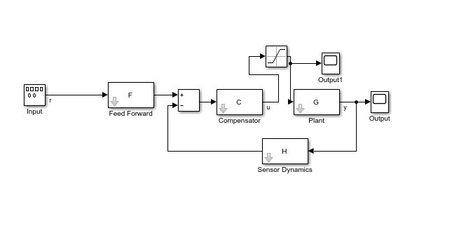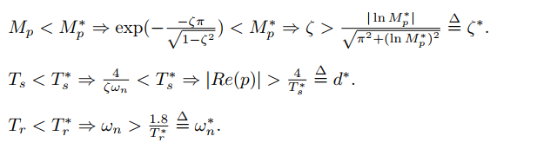

1. From the above equations we solve for zeta with Mp* as 15% and then wn* with Tr* = 2s and we get the required poles
2. However, we can also add those constraints in the LQR optimization dialog box and we get the following controller

Comp = 0.006123 + 0.05102/ s

1. For the given controller, output is saturated with the given limits of Umax = 5, Umin = -4,

Design of Controller:

Control System Designer app is used to design the given controller

Design session 1:

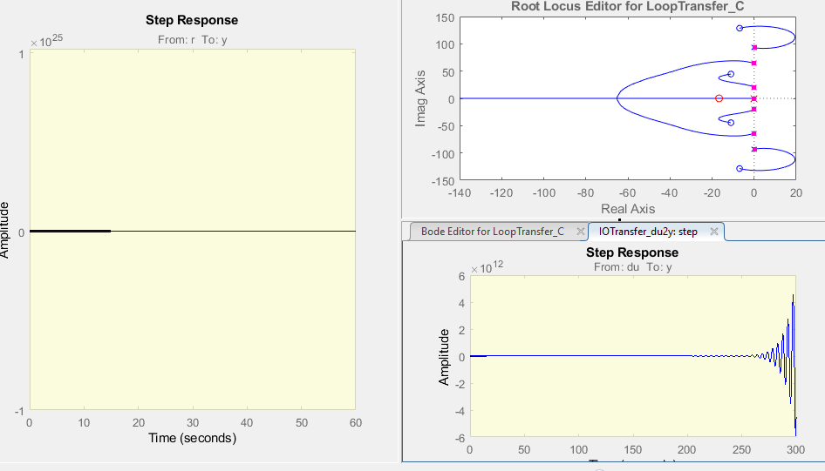

We need to change the controller pole values to the ones mentioned above to see improved performance and stability.

1. To minimize the controller reaching the saturation points, we adjust the controller gains are adjusted in Control System designer app

Uncertainty in the plant model:

1. Uncertainty in plant model is caused by its output which can be adjusted by the C matrix, thus having lesser impact on the instability and performance of the plant

**PLOTS:**

**Design Test:**

Plant output vs time:

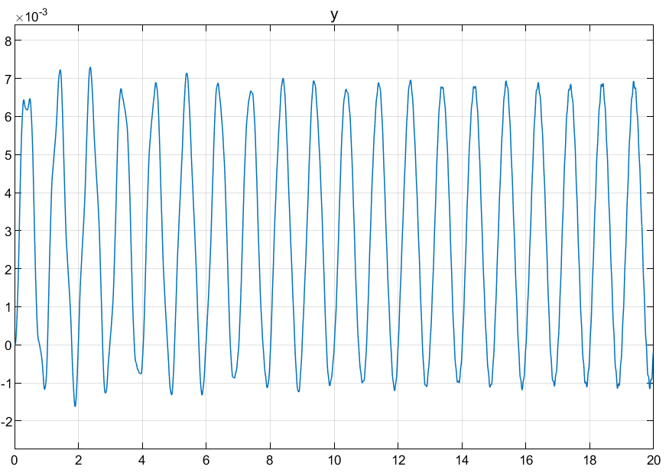

Controller Output vs time:

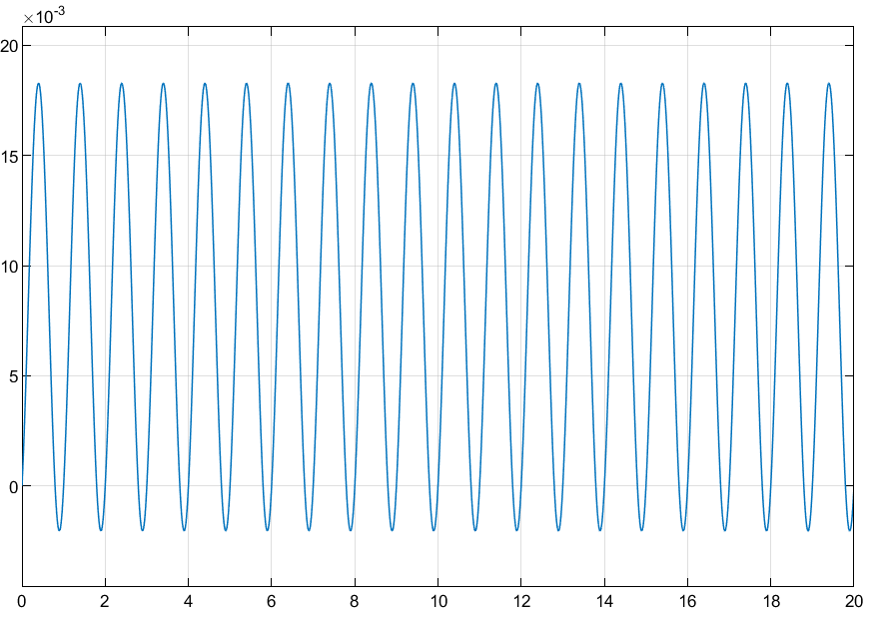

Production test:

Plant Output vs time

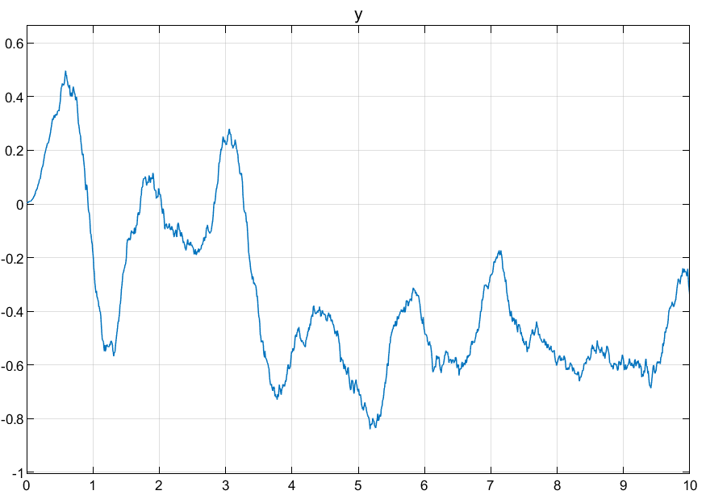

Controller Output vs time

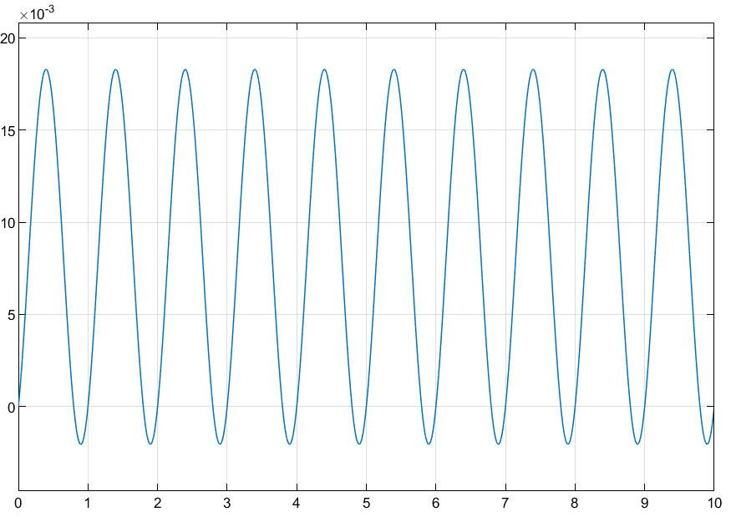

Even though the performance isn’t the best it can be, the output remains bounded and low in magnitude.

To ensure more ROBUSTNESS, we can use PID tuning with the preference for higher robustness instead of LQR

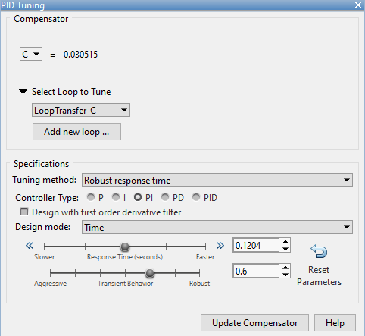

However, given controller is moderately robust to the uncertainties as verified by multiple simulation trials.