General:
Resume Builder - software application used for easy resume creation.

Platforms:
Resume Builder runs on most of the Windows platforms.

GUI:
The application's GUI should be in compliance with Microsoft GUI guidelines for Windows applications. For more info refer to the guidelines - http://www.microsoft.com/en-us/download/details.aspx?id=2695.
…………………………………

Launch:
App is launched using .exe-file (ResumeBuilder.exe in current version).
Once the application has been launched "Select Resume Profession" dialogue appears.
Dialogue contains:
- "Profession:" drop down list, which contains several professions (according to settings in "Database.xml" file).
- Buttons.
Notes:
All controls are highlighted at mouse over.
All controls look pressed by clicking them.
Default profession - the profession which was set first in "Database.xml" file
Example:
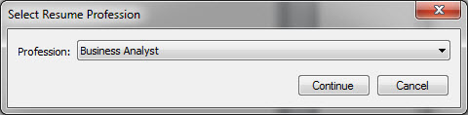
Use cases:
- User chooses a profession and clicks <X> button.
Steps:
1. Launch app.
"Select Resume Profession" dialogue appears.
2. Choose any profession from drop down list.
3. Click <X> button.
Expected result:
Application is closed.
- User chooses a profession and clicks <Cancel> button.
Steps:
1. Launch app.
"Select Resume Profession" dialogue appears.
2. Choose any profession from drop down list.
3. Click <Cancel> button.
Expected result:
Application is closed.
- User chooses a profession and clicks <Continue> button.
Steps:
1. Launch app.
"Select Resume Profession" dialogue appears.
2. Choose any profession from drop down list.
3. Click <Continue> button.
Expected result:
Application is closed.
…………………………………

"Contact info" tab.
Contains several text fields and dropdown lists:
Required:
- First Name.
- Last Name.
- City.
- State (dropdown list).
- Zip.
- Phone (3 fields + 1 dropdown list).
Not required:
- Middle Name.
- Alt. Phone (3 fields).
- Email.

Note: All required fields are shown with * sign.
Example:
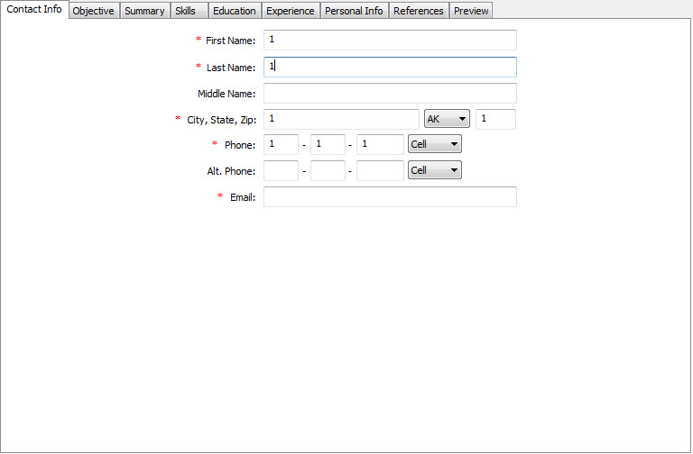
Use cases:
- User filled out all required fields:
Steps:
1. Launch app.
2. Choose any profession and click <Continue> button.
Application window is opened on "Contact info" tab.
3. Fill out all fields with * sign.
4. Click “Preview” tab.
Expected result:
Application is closed.
- User filled out NOT all required fields.
Steps:
1. Launch app.
2. Choose any profession and click <Continue> button.
Application window is opened on "Contact info" tab.
3. Leave one field with * sign empty.
Expected result:
Information message with text “All required fields should be filled out.”, <OK> and <X> buttons appears.
…………………………………

