**General:**

Resume Builder - software application used for easy resume creation.

**Platforms:**  
Resume Builder runs on OS Windows XP/Vista/7/8.

**GUI:**

The application's GUI should be in compliance with Microsoft GUI guidelines for Windows applications. For more info refer to the guidelines - <http://www.microsoft.com/en-us/download/details.aspx?id=2695>.

…………………………………

**Launch:**

App is launched using .exe-file (ResumeBuilder.exe in current version).

Once the application has been launched "Select Resume Profession" dialogue appears.

Dialogue contains:

- "Profession:" drop down list, which contains several professions (according to settings in "Database.xml" file).

- Buttons: <Continue>, <Cancel>, <X>.

Notes:

All controls are highlighted at mouse over.

All controls look pressed by clicking them.

Default profession - the profession which was set first in "Database.xml" file

**Example:**

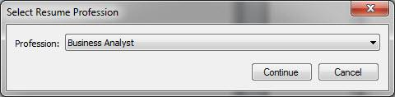

**Use cases:**

1. User chooses a profession and clicks <X> button.

Steps:

1. Launch app.

"Select Resume Profession" dialogue appears.

2. Choose any profession from drop down list.

3. Click <X> button.

*Expected result:*

Application is closed.

1. User chooses a profession and clicks <Cancel> button.

Steps:

1. Launch app.

"Select Resume Profession" dialogue appears.

2. Choose any profession from drop down list.

3. Click <Cancel> button.

*Expected result:*

Application is closed.

1. User chooses a profession and clicks <Continue> button.

Steps:

1. Launch app.

"Select Resume Profession" dialogue appears.

2. Choose any profession from drop down list.

3. Click <Continue> button.

*Expected result:*

Application window is open on "Contact info" tab. User is able to continue using an application.

…………………………………

**"Contact info" tab.**

Contains several text fields and dropdown lists:

*Required:*

- First Name.

- Last Name.

- City.

- State (dropdown list).

- Zip.

- Phone (3 fields + 1 dropdown list).

- Email.

*Not required:*

- Middle Name.

- Alt. Phone (3 fields + 1 dropdown list).

Notes:

All required fields are shown with * sign.

All fields don't validate personal information or any other data typed in by the user. They allow user as much flexibility as an average word processor would.

* sign means that fields require at least ONE any symbol, letter, or digit inside them.

**Example:**

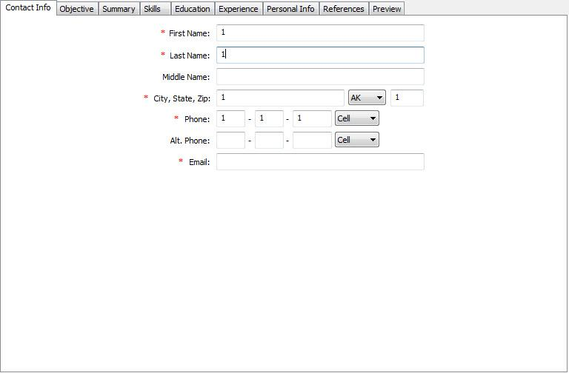

**Use cases:**

1. User filled out all required fields:

Steps:

1. Launch app.

2. Choose any profession and click <Continue> button.

Application window is opened on "Contact info" tab.

3. Fill out all fields with * sign.

4. Click “Preview” tab.

*Expected result:*

“Preview” tab is opened. All information specified by user is shown on the screen.

1. User filled out NOT all required fields.

Steps:

1. Launch app.

2. Choose any profession and click <Continue> button.

Application window is opened on "Contact info" tab.

3. Leave one field with * sign an empty.

4. Click “Preview” tab.

*Expected result:*

Information message with text “All required fields should be filled out.”, <OK> and <X> buttons appears.

…………………………………