Part1

**Task1**

On 29 October 2018, a Boeing 737 MAX 8 ( Lion Air Flight 610) crashed near Jakarta Indonesia and killed all 189 passengers and the flight crew 12 minutes after takeoff. The MCAS which is Maneuvering Characteristics Augmentation System of Boeing 737 MAX8, might contribute to this accident.

A larger engine which decreases the fuel consumption was used in Boeing 737 MAX 8. It was placed farther forward on the wings. However, this changed the airframe’s aerodynamic lift which might lead to an install. To avoid the stall, MCAS was needed. It was integrated into the operating system and designed to spin the horizontal tail in the plane to push the nose of 737 MAX 8 down when the system detects the angle-of-attack(AOA) gained by two sensors is greater than a standard value. The main problem of this design is that all adjustment commands are according to the data of those two AOA sensors without any inputs of pilots.

The black box data showed that, during the Lion Air Flight 610 crash, one single faulty sensor which the MCAS relied on provided false data. The erroneous data triggered MCAS which then swived the horizontal tail and pushed the nose down. After that, the pilot pulled the plane back up. However, the system still gained false data from that faulty sensor, triggering MCAS again which kicked the nose down again. Repeating this circle 21 times, the captain finally ceded the control. Though the data showed that the captain resumed the control in the final seconds, but it was too late. That faulty sensor which MCAS relied on could have been corrected on the ground, but there was no check or correction before the plane took off.[1] The Lion Air plane also didn't have an "AOA DISAGREE" which would have alerted crew that the AOA readings were erroneous and likely to trigger the MCAS system unnecessarily because it was an optional feature instead of a standard feature which would cost additional money to install.[2]

The MCAS was capable of swiveling the tail with a limit of 2.5 degrees, which was four times farther than the original limit(0.6 degrees) stated in the Boeing safety analysis document provided to the FAA. The reason why Boeing changed this limit was that when the plane is losing lift and spiraling down a more powerful tail movement is required. However, Boeing didn't inform FAA of that change. What's more, the MCAS was allowed to move the tail multiple times which happened in the Lion Air crash instead of one single time. Most pilots didn't get enough training of the new Boeing 737 MAX8. They even didn't know the MCAS, so it was nearly impossible for them to avoid the accident.[1]

**References**

1. Dominic Gates. Flawed analysis, failed oversight: How boeing, faa certified the suspect 737 max flight control system. The Seattle Times, March 2019. <https://www.seattletimes.com/business/boeing-aerospace/failed-certification-faa-missed-safety-issues-in-the-737-max-system-implicated-in-the-lion-air-crash/>
2. Nicolas Rivero. Everything we know about the boeing 737 max 8 crisis. Quartz, March 2019. https://qz.com/1578227/ everything-we-know-about-the-boeing-737-max-8-crashes/

**Task2**

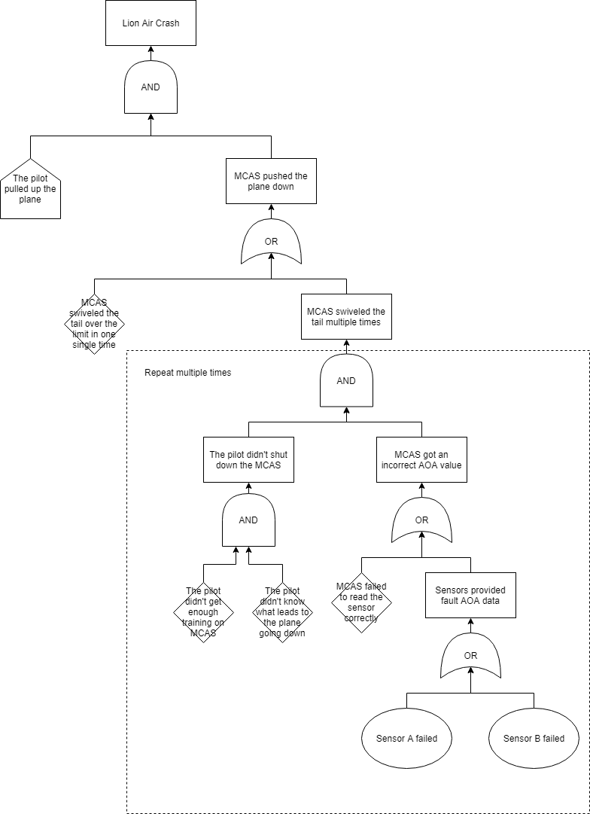

According to the black box data and the report after the Lion air crash, the main cause of the accident was that the pilot was not able to pull the plane back to secure height. The reason was that the pilot's operation triggered the MCAS to push the plane's nose down too much.

The MCAS pushed the plane down too much might because it swiveled the horizontal tail over the limit or it repeated the adjustment actions too many times. The latter one can be the real cause according to the black box data which showed that a circle of pilot lifting the plane and MCAS pushing it down repeated 21 times. In each loop, the pilot tried to lift the plane back to secure height, but it was in vain because the MCAS pushed it down again without informing the pilot. Thus the pilot didn't know that he should have switched the MCAS off to get the control of the plane. The unexpected performance of the MCAS might be because of the data from two sensors or incorrect data-reading.

The MCAS read AOA data from two sensors. However, one of those two sensors failed which triggered the MCAS to swivel the horizontal tail and push the plane down. To lift back the plane, the pilot tried again but in vain. After this loop repeated several times, the plane finally crashed.

**Task3**

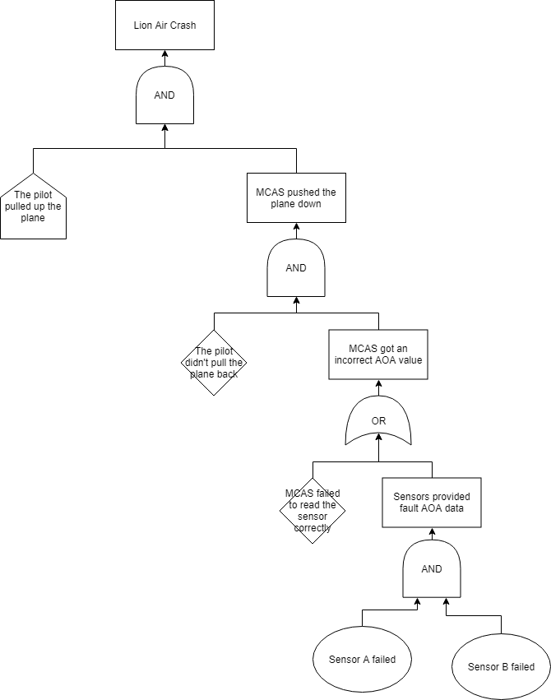

**Task4**