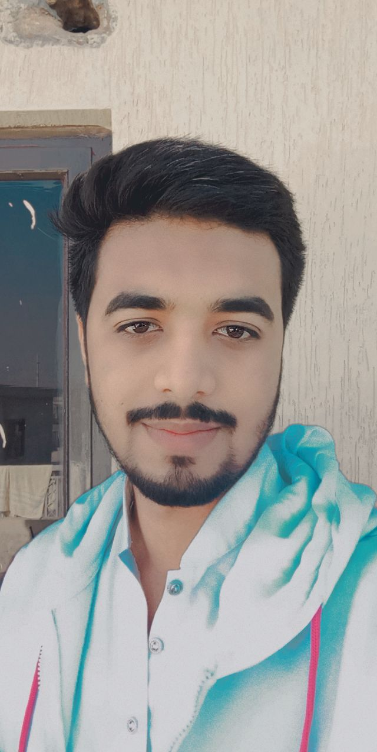

Contact

**Address:**

**Permanent:**

House No: 33/322, street sunehri masjid, Mohalla Dharowal Sialkot

**Phone:**

+923044431610

**Email:**

toqeerm250@gmail.com

Languages

English

Urdu

Toqeer

Ahmad

Summary

I am a student of BSc.IET (5th Semester) in Foundation University Rawalpindi Campus. I have basic knowledge of HTML, CSS, C, C++, java, but good grip on python. I also have a certificate in AutoCAD 2007, infographics, and in Corel draw.

Skill Highlights

|  |  |
| --- | --- |
| * SEO * Basic HTML, CSS, C, C++, java and good grip in Python. * Corel Draw | * Creative design * Innovative * Service-focused |

Experience

**Web and SEO Manager:**

Currently doing work for Patch Textile as Web and SEO Manager. I also have 2 years’ experience of social marketing on FB and Instagram.

Certifications

As I already know basic C, C++, and python. I also have a certificate in AutoCAD 2007, infographics, and in

Corel draw.