**What is Ad-Hoc Mode in Wireless Networking?**

**Question:**What is Ad-Hoc Mode in Wireless Networking?

**Answer:**On wireless computer networks, **ad-hoc**mode is a method for wireless devices to directly communicate with each other. Operating in ad-hoc mode allows all wireless devices within range of each other to discover and communicate in peer-to-peer fashion without involving central [access points](http://compnetworking.about.com/cs/wireless/g/bldef_ap.htm)(including those built in to broadband wireless [routers](http://compnetworking.about.com/library/glossary/bldef-router.htm)

To set up an ad-hoc wireless network, each wireless [adapter](http://compnetworking.about.com/library/glossary/bldef-adapter.htm) must be configured for ad-hoc mode versus the alternative**infrastructure mode**. In addition, [all wireless adapters](http://compnetworking.about.com/od/wireless/ss/wirelessgear_5.htm) on the ad-hoc network must use the same [SSID](http://compnetworking.about.com/cs/wireless/g/bldef_ssid.htm) and the same**channel number**.

An ad-hoc network tends to feature a small group of devices all in very close proximity to each other. Performance suffers as the number of devices grows, and a large ad-hoc network quickly becomes difficult to manage. Ad-hoc networks cannot bridge to wired [LANs](http://compnetworking.about.com/library/glossary/bldef-lan.htm) or to the Internet without installing a special-purpose [gateway](http://compnetworking.about.com/library/glossary/bldef-gateway.htm).

Ad hoc networks make sense when needing to build a small, all-wireless LAN quickly and spend the minimum amount of money on equipment. Ad hoc networks also work well as a temporary fallback mechanism if normally-available infrastructure mode gear (access points or routers) stop functioning.

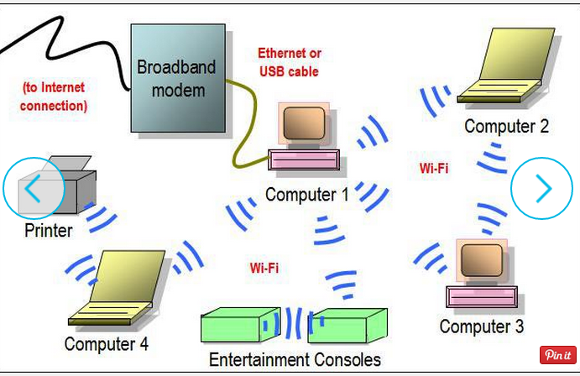

출처 : http://compnetworking.about.com/od/homenetworking/ig/Home-Network-Diagrams/Two-Router-Home-Network-Diagram.htm#step-heading