THE SIXTIETH DEATH ANNIVERSARY
A TRIBUTE TO SIR R.A.FISHER –THE FOUNDER OF MODERN STATISTICS.
Jitendra Kumar Sinha
(jksinha2007@rediffmail.com)
Retired Sr. Joint Director & Head, DES, Bihar.
ABSTRACT
Sir Ronald Fisher, F.R.S., passed away on 29th July 1962. His contributions to the advancement of science by developing statistics as new technology are finding increasing application in all-natural and social sciences. Paying tributes to the founder of modern statistics on the sixtieth death anniversary this note highlights some of his major contributions in the field of statistics.

A man of extraordinary ability and originality Sir Ronald Aylmer Fisher FRS worked much to enlarge and set boundaries of Statistics and establish it as a scientific discipline in its own right. Much of his inspiration in doing so came from the practical application in a variety of areas notably Agriculture and Human Genetics. Most of the concepts and methods introduced by Fisher are fundamental and continue to provide the framework for the discussion of statistical theory. Fisher's work is monumental, both in richness and variety of ideas, and provided the inspiration for phenomenal developments in statistical methodology for applications in all areas of human endeavor from the last century.
Fisher was very deeply concerned about the possible misrepresentation of an alleged statistical result that continues as a major concern even now and believed that it is `only by giving students the opportunity of making fine distinctions in the logic of the subject that they can learn to recognize the difference between honest and dishonest work in statistical practice'. 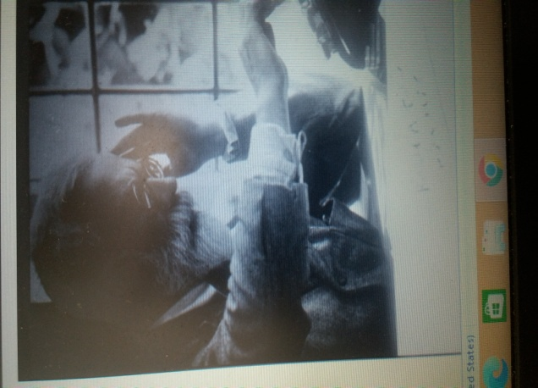
Fisher at Work, 1958 Courtesy: Fisher Memorial Trust.
.(Courtsy: Fisher Memorial Trust)
(Courtsy: Fisher Memorial Trust)

Personal Life & Education: Fisher was born in East Finchley in London to George & Kate into a middle-class household on 17th February 1890. His mother, Kate, died when he was 14, and his father lost his business 18 months later. He entered Harrow School at the age of 14 and won Medal and also a scholarship to study Mathematics. He married Eileen Guinness, with whom he had two sons and six daughters. His marriage disintegrated during World War II, and his older son George, an aviator, was killed in combat. His daughter Joan, who wrote a biography of her father, married the statistician George E. P. Box.
Fisher was very caring to friends and looked after them with rather touching solicitude and would take part in anything that was going on. Fisher was a fine mathematician, but difficult to follow as he would leap over intermediate stages in a calculation, leaving his colleagues floundering.
Following surgery for colon cancer, he died of post-operative complications in an Adelaide hospital in 1962.

Career: Fisher worked as a statistician during1913-1919 in the City of London. He began working at the Rothamsted Experimental Station in Hertfordshire in 1919, where he would remain for 14 years. In 1933, Fisher became the head of the Department of Eugenics at University College London. He become editor of the Annals of Eugenics (now called Annals of Human Genetics) in 1934.

He was with the University of Cambridge during 1943–1956.

After retirement, Fisher emigrated in 1957 to Australia, where he spent time as a senior research fellow at the Australian Commonwealth Scientific and Industrial Research Organisation (CSIRO) in Adelaide.

A major contribution by Fisher in Statistics:
- In 1921 published Studies in Crop Variation, and his first application of the ANOVA. At Rothamsted, he analyzed the vast amount of crop data accumulated since 1842 from the "Classical Field Experiments “ and the publication was the outcome of this analysis.
- Between 1912 and 1922 Fisher vastly popularized the maximum likelihood estimation method through mathematical proofs, analysis, and recommendations.

- Fisher's 1924 article On a distribution yielding the error functions of several well-known statistics presented Pearson's chi-squared test and William Gosset's Student's t-distribution in the same framework as the Gaussian distribution, and he developed Fisher's z-distribution, a new statistical method commonly used decades later as the F-distribution.
- He pioneered the principles of the design of experiments and the statistics of small samples and the analysis of real data.
- In 1925 he published Statistical Methods for Research Workers, one of the 20th century's most influential books on statistical methods.
- In 1935, he published The Design of Experiments, which was "also fundamental, [and promoted] statistical technique and application...
- The same year he also published a paper on fiducial inference and applied it to the Behrens–Fisher problem, the solution to which, proposed first by Walter Behrens and a few years later by Fisher, is the Behrens–Fisher distribution.
- In 1936 he introduced the Iris flower data set as an example of discriminant analysis.
- In his 1937 paper The wave of advance of advantageous genes he proposed Fisher's equation in the context of population dynamics to describe the spatial spread of an advantageous allele and explored its traveling wave solutions. Out of this also came the Fisher–Kolmogorov equation.
- In 1937, he visited the Indian Statistical Institute in Calcutta and often returned to encourage its development by P. C. Mahalanobis. He was the guest of honor at its 25th anniversary in 1957, when it had 2000 employees.
- In 1938, Fisher and Frank Yates described the Fisher-Yates shuffle in their book Statistical tables for biological, agricultural, and medical research. Their description of the algorithm used pencil and paper; a table of random numbers provided the randomness.
- In 1943, along with A.S. Corbet and C.B. Williams he published a paper on relative species abundance where he developed the log series distribution (sometimes called the logarithmic distribution) to fit two different abundance data sets. In the same year, he took the Balfour Chair of Genetics where the Italian researcher Luigi Luca Cavalli-Sforza was recruited in 1948, establishing a one-man unit of bacterial genetics.
- In 1936, Fisher used Pearson's chi-squared test to analyze Mendel's data and concluded that Mendel's results with the predicted ratios were far too perfect, suggesting that adjustments (intentional or unconscious) had been made to the data to make the observations fit the hypothesis.
- In 1950 he published "Gene Frequencies in a Cline Determined by Selection and Diffusion". He developed computational algorithms for analyzing data from his balanced experimental designs, with various editions and translations, becoming a standard reference work for scientists in many disciplines.
Fisher is also known for:
- Linear discriminant analysis is a generalization of Fisher's linear discriminant.
- Fisher information, ( scoring algorithm )also known as Fisher's scoring, and Minimum Fisher information, a variational principle which, when applied with the proper constraints needed to reproduce empirically known expectation values, determines the best probability distribution that characterizes the system.
- F-distribution arises frequently as the null distribution of a test statistic, most notably in the analysis of variance
- Fisher–Tippett– Gnedenko theorem: Fisher's contribution to this was made in 1927
- Fisher–Tippett distribution
- Fisher-Yates shuffle algorithm
- Von Mises–Fisher distribution
- Inverse probability, a term Fisher used in 1922, refers to "the fundamental paradox of inverse probability" as the source of the confusion between statistical terms which refer to the true value to be estimated, with the actual value arrived at by estimation, which is subject to error.
- Fisher's permutation test
- Fisher's inequality
- Sufficient statistic, when a statistic is sufficient concerning a statistical model and its associated unknown parameter if "no other statistic that can be calculated from the same sample provides any additional information as to the value of the parameter".
- Fisher's noncentral hypergeometric distribution is a generalization of the hypergeometric distribution, where sampling probabilities are modified by weight factors.
- Student t-distribution is widely used in statistics.
- The concept of an ancillary statistic and the notion (the ancillary principle) that one should condition on ancillary statistics.
Fisher was far ahead of his contemporaries, so far, indeed, that when his epoch-making book, Statistical Methods for Research Workers, was published in 1925, it did not receive one favorable review. At the time of his death in 1962, it was in its 14th edition, with reprints, and had been translated into six languages. In 1928 or 1929 he sent a paper for publication to a famous learned society. The assessors turned it down and the officers of the society unwisely left the matter there. It was published elsewhere in 1930 exactly as it stood and it has proved to be one of the fundamental works of evolutionary biology.

Recognition

Awards & Honors
- Fisher was elected to the Royal Society in 1929.
- Made a Knight Bachelor by Queen Elizabeth II in 1952.
- Awarded the Linnean Society of London Darwin–Wallace Medal in 1958.
- Won the Copley Medal and the Royal Medal. He was an Invited Speaker of the ICM in 1924 in Toronto and 1928 in Bologna.
- In 1950, Maurice Wilkes and David Wheeler used the Electronic Dela Storage Automatic Calculator to solve a differential equation relating to gene frequencies in a paper by Ronald Fisher. This represents the first use of a computer for a problem in the field of biology. The Kent distribution (also known as the Fisher–Bingham distribution) was named after him and Christopher Bingham in 1982, while the Fisher kernel was named after Fisher in 1998.
- The R. A. Fisher Lectureship was a North American Committee of Presidents of Statistical Societies (COPSS) annual lecture prize, established in 1963 until the name was changed to COPSS Distinguished Achievement Award and Lectureship in 2020.
- On 28 April 1998 a minor planet, 21451 Fisher, was named after him.
- In 2010, the R.A. Fisher Chair in Statistical Genetics was established at University College London to recognize Fisher's extraordinary contributions to both statistics and genetics.
- Others
- Anders Hald called Fisher "a genius who almost single-handedly created the foundations for modern statistical science": Fisher was the father of modern statistics and experimental design.
- Geoffrey Miller said of him: To biologists, he was an architect of the "modern synthesis" that used mathematical models to integrate Mendelian genetics with Darwin's selection theories. To psychologists, Fisher was the inventor of various statistical tests that are still supposed to be used whenever possible in psychology journals. To farmers, Fisher was the founder of experimental agricultural research, saving millions from starvation through rational crop breeding programs.
Connection with India and Mahalanobis

Fisher had been in close touch with the activities of the Indian Statistical Institute and had personal contact with its several workers and had remained a lifelong well-wisher of the Institute. In 1937, he visited the Indian Statistical Institute in Calcutta and often returned to encourage its development by P. C. Mahalanobis. He visited the Institute on eight occasions, the last being from December 1961 to February 1962.

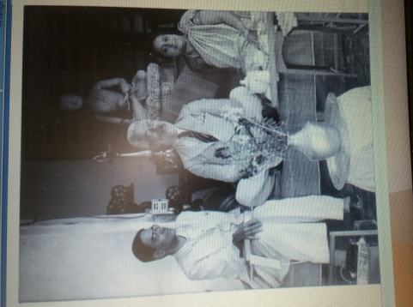
Fisher with P.C. Mahalanobis & Nirmal Kumari at ISI, Calcutta in 1940.
(Courtesy: P.C. Mahalanobis Memorial Museum and Archives, Indian Statistical Institute, Kolkata)

One could notice a histogram-shaped old structure on right, which is the first major building of ISI —the Fisher Building. Inaugurated in 1951 by none other than Ronald Fisher, it was originally named the Research and Training School. Fisher publically supported the Mahalanobis scheme to use the principle of random sampling for the Indian National Sample Survey. Fisher helped ISI, Calcutta in the most significant way in the development of the integrated research, training, and project programs and its emergence as a higher technological Institution of the new type, and also generally the advancement of statistics in India. Fisher was associated with the Institute as a member of the Examination Committee, Honorary Fellow of ISI, and awardee of the honorary degree of D.Sc. in 1962. He was also the Chairman of the Review Committee of the National Sample Survey from 1956-57.

MISSION AHEAD
Fisher provided the framework for the statistical theory which is monumental and the source of inspiration for developments in statistical methodology for applications in all areas of human endeavor with the mission to appreciate the logic of the subject and shape them in scientific temperament for the society. His contributions were not confined to methodological aspects of statistics, but greatly covered applied fields that influenced scientific thought of the past as well as the current century.
Fisher needs to be remembered for continued dedication to his mission to take Statistics to the common man as an objective and scientific tool for decision making. Actions for the fulfillment of his mission to propound statistics for the common welfare of human life will be a true tribute to the Modern Founder of Statistics – as we call him.

References
- Bennet J H (1990): Statistical inference and analysis: selected correspondence of R.A. Fisher, Oxford University Press, Oxford, UK.
- Box J F (1978): R. A. Fisher: The life of a scientist, Wiley, New York.
- Mahalanobis P C (1962): In Memorium Sir Ronald Alymer Fisher (1890-1962), Sankhya,24, 207-208.
- Rao C R (1992): R A Fisher the founder of modern statistics, Stat. Sc. 7,34-48.
- Rudra A (1997): Prasant Chandra Mahalanobis: a Biography, Oxford University Press, India.

