# 3.6

//author:孟德昊

//时间：10/10/21 18:34

//

#include<stdio.h>

#define _CRT_SECURE_NO_WARNINGS 1

main()

{

char c1='a',c2='b',c3='c',c4='\101',c5='\116';

printf("a%c b%c\tabc%c\n",c1,c2,c3);

printf("\t\b%c%c\n",c4,c5);

}

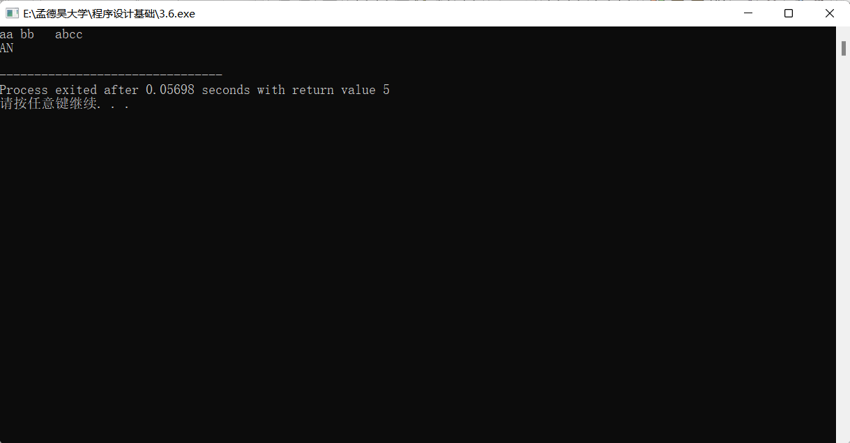

# 3.10

//author:孟德昊

//时间：10/10/21 18:35

//

#include<stdio.h>

#define _CRT_SECURE_NO_WARNINGS 1

main()

{

int i,j,m,n;

i=8;

j=10;

m=++i;

n=j++;

printf("%d,%d,%d,%d\n",i,j,m,n);

}

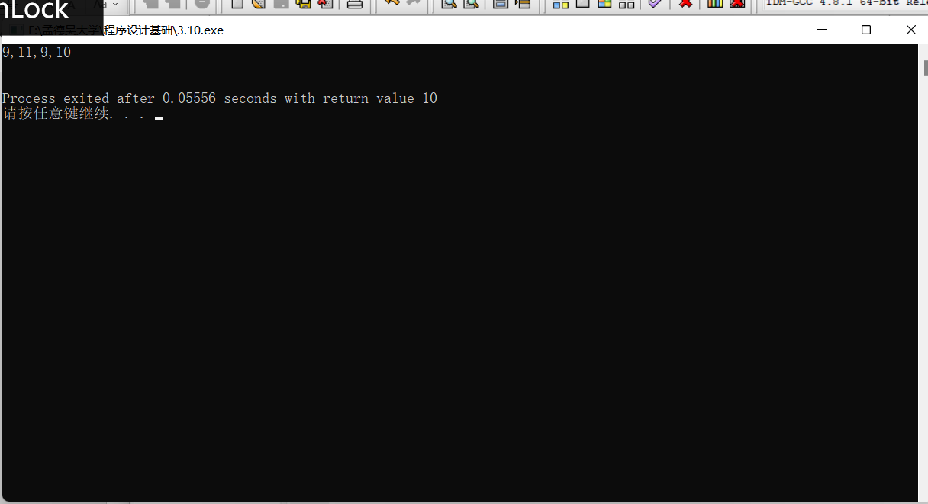

# 3.12

//author:孟德昊

//时间：10/10/21 18:37

//

#include<stdio.h>

#define _CRT_SECURE_NO_WARNINGS 1

main()

{

int a=12,n=5;

printf("%d\n",a+=a);

a=12;

printf("%d\n",a-=2);

a=12;

printf("%d\n",a*=2+3);

a=12;

printf("%d\n",a/=a+a);

a=12;

n%=2;

a%=n;

printf("%d\n",a);

a=12;

printf("%d\n",a+=a-=a*=a);

}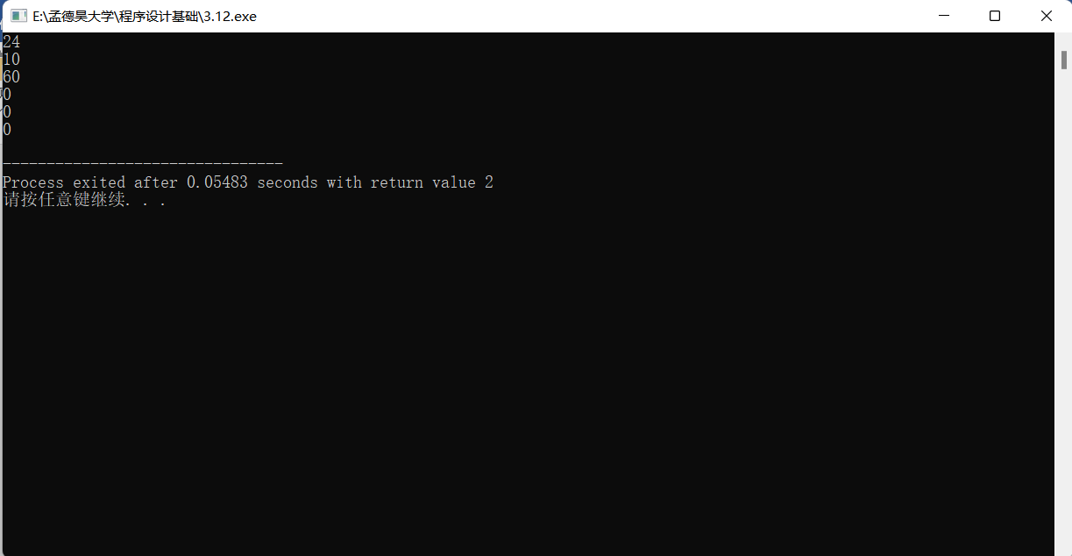

# 4.4

//author:孟德昊

//时间：10/10/21 19:00

//

#include<stdio.h>

#define _CRT_SECURE_NO_WARNINGS 1

main()

{

int a=3,b=4,c=5;

float x=1.2,y=2.4,z=-3.6;

int u=51274,n=128765;

char c1='a',c2='b';

printf("a= %d b= %d c= %d",a,b,c);

printf("\nx=%6f,y=%6f,z=%6f",x,y,z);

printf("\nx+y= %f y+z=%f z+x=%f",x+y,y+z,z+x);

printf("\nu= %d n= %d",u,n);

printf("\nc1=%c or %d",c1,c1);

printf("\nc1=%c or %d",c2-32,c2);

}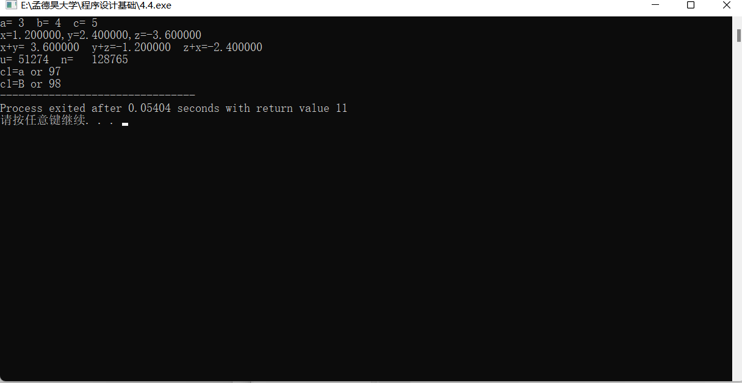

# 4.5

//author:孟德昊

//时间：10/10/21 19:09

//

#include<stdio.h>

#define _CRT_SECURE_NO_WARNINGS 1

main()

{

int a=5,b=7;

float x=67.8564,y=-789.124;

char c='A';

long n=1234567;

unsigned u=65535;

printf("%d%d\n",a,b);

printf("%3d%3d\n",a,b);

printf("%f,%f\n",x,y);

printf("%-10f,%-10f\n",x,y);

printf("%8.2f,%8.2f,%.4f,%.4f,%3f,%3f\n",x,y,x,y,x,y);

printf("%e,%10.2e\n",x,y);

printf("%c,%d,%o,%x\n",c,c,c,c);

printf("%1d,%1o,%x\n",n,n,n);

printf("%u,%o,%x,%d\n",u,u,u,u);

printf("%s,%5.3s\n","COMPUTER","COMPUTER");

}

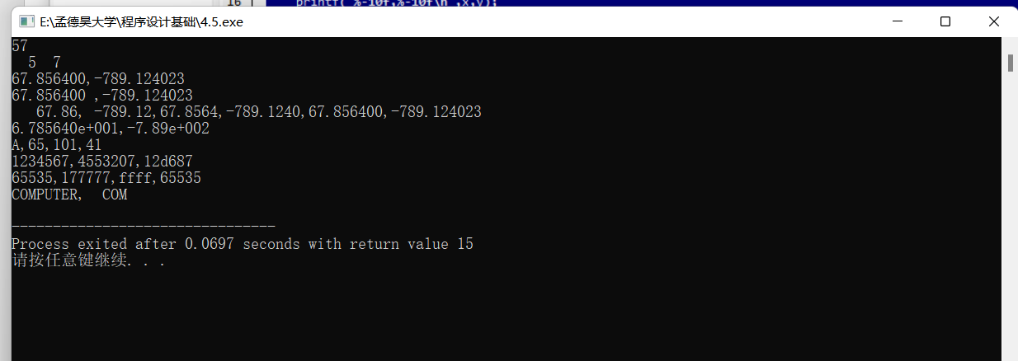

# 4.6

//author:孟德昊

//时间：10/10/21 19:19

//

#include<stdio.h>

#define _CRT_SECURE_NO_WARNINGS 1

main()

{

int a,b;

float x,y;

char c1,c2;

scanf("a=%d b=%d",&a,&b);

scanf(" %f %e",&x,&y);

scanf(" %c %c",&c1,&c2);

}

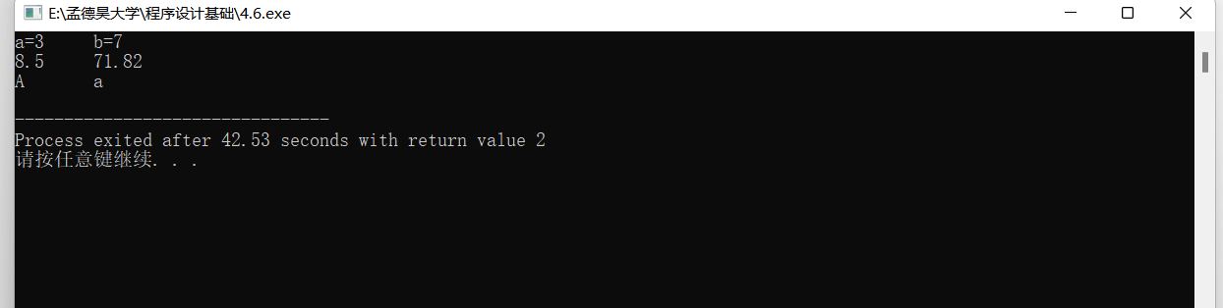

# （1）

//author:孟德昊

//时间：10/10/21 18:56

//

#include<stdio.h>

#define _CRT_SECURE_NO_WARNINGS 1

main()

{

char c1,c2;

c1=97;

printf("%c %c\n",c1,c1+1);

c2='a';

c2=c2-32;

printf("%c %c\n",c2,c2+1);

}

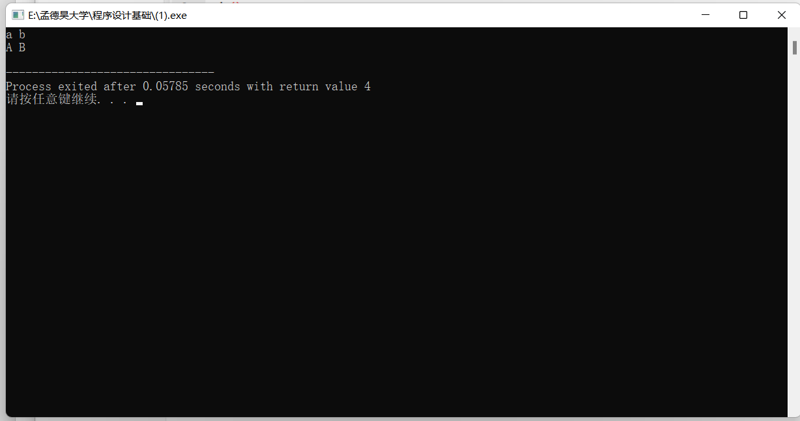

# （2）

//author:孟德昊

//时间：10/10/21 18:56

//

#include<stdio.h>

#define _CRT_SECURE_NO_WARNINGS 1

main()

{

int i=8;

printf("%d\n",++i);

printf("%d\n",--i);

printf("%d\n",i++);

printf("%d\n",i--);

printf("%d\n",-(i++));

printf("%d\n",-i--);

}

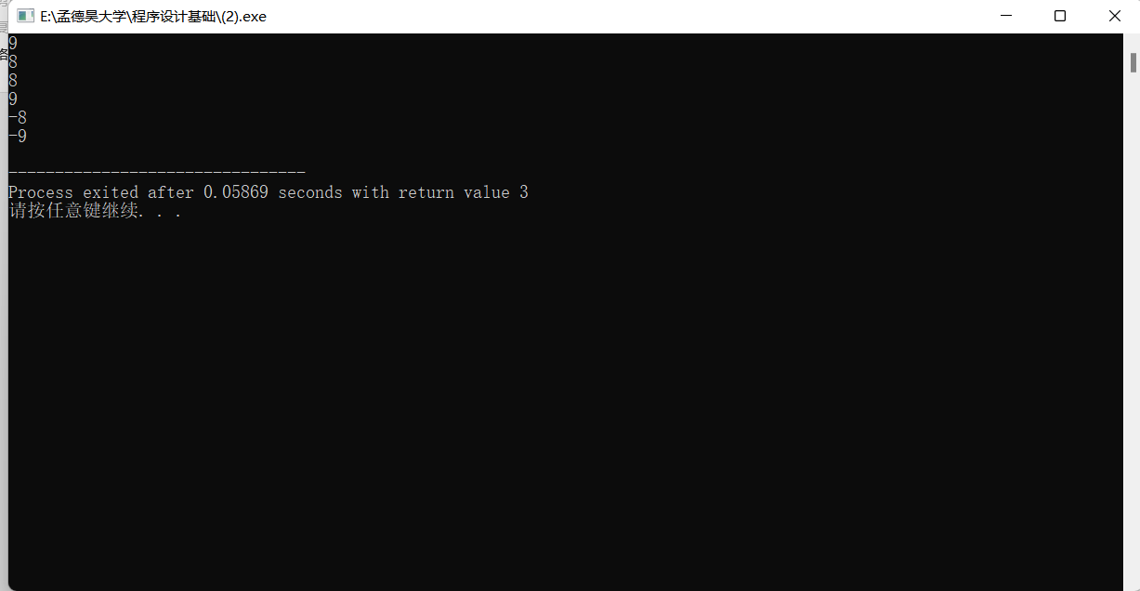

# （3）

//author:孟德昊

//时间：10/10/21 18:57

//

#include<stdio.h>

#define _CRT_SECURE_NO_WARNINGS 1

main()

{

float a1,b1,a2,b2; char ch;

printf("complexs Addition\n");

printf("please input the first complex:\n");

printf("realpart:"); scanf("%f", &a1) ;

printf("virtualpart:"); scanf("%f", &b1) ;

printf("%5.2f + %5.2f i\n",a1,b1);

printf("please input the second complex:\n");

printf("realpart:"); scanf("%f", &a2);

printf("virtualpart:"); scanf("%f", &b2);

printf("%5.2f + %5.2f i\n",a2,b2);

printf("The addition is:");

printf("%6.3f + %6.3f i\n",a1+a2,b1+b2);

printf("program normal terminated,press enter...");

ch = getchar();

}

