

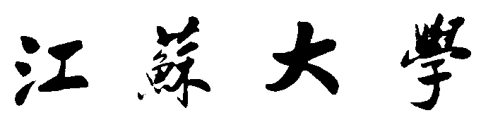

**J I A N G S U U N I V E R S I T Y**

**“物联网移动应用开发”上机报告**

**上机一：DevEco Studio UI设计（一）**

|  |  |
| --- | --- |
| 学院名称： | 计算机科学与通信工程学院 |
| 专业班级： | 物联网2001 |
| 学生姓名： | 石赟 |
| 学生学号： | 3200611006 |
| 指导教师： | 金 华 |

**2022年 9 月 22 日**

**DevEco Studio UI设计（一）**

1. 实验目的
2. 熟悉DevEco Studio 集成开发环境
3. 掌握DevEco Studio UI设计
4. 掌握常见的布局设计方法
5. 掌握常见的组件使用
6. 实验环境

在鴻蒙官网(https://developer.harmonyos.com/cn/develop/deveco-studio/)中下载DevEco Studio

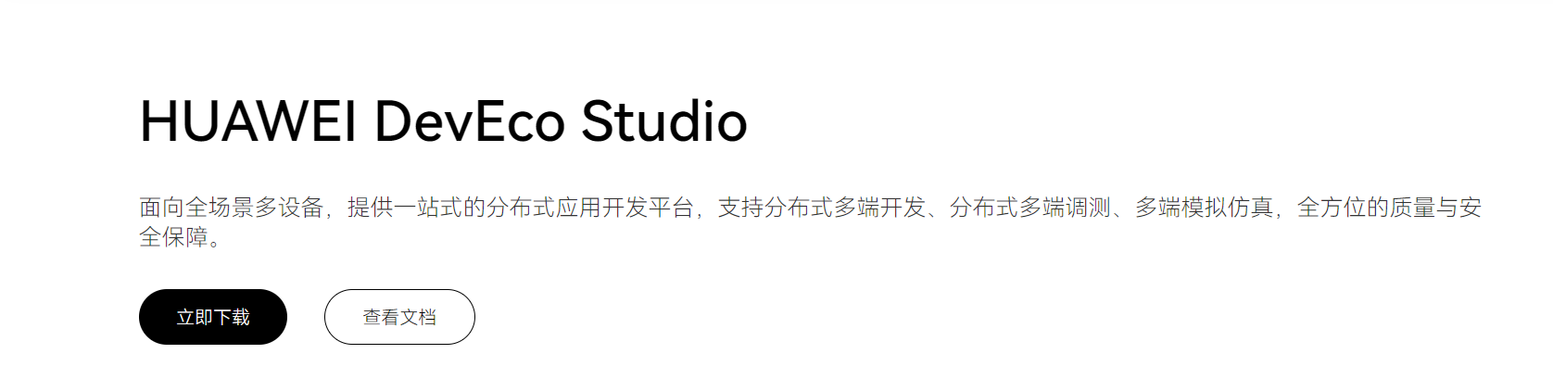

按照流程一步步next安装将安装目录改为其他盘符即可。

1. 实验内容
2. 练习熟练掌握DevEco Studio 集成开发环境。
3. 练习定向布局、依赖布局、表格布局等UI设计（报告至少介绍三种以上组件）。
4. 练习常用组件的使用方法（报告至少介绍三种以上组件）。
5. 完成“倾心家教”用户注册登录案例的UI设计。
6. 完成“倾心家教”应用程序主界面、消息界面等UI设计。
7. 实验详细报告
8. 实验内容1
9. 问题描述

练习定向布局、依赖布局、表格布局等UI设计,介绍三种以上组件

1. 设计思想与原理

定向布局：DirectionalLayout是Java UI中的一种重要组件布局，用于将一组组件(Component)按照水平或者垂直方向排布，能够方便地对齐布局内的组件。该布局和其他布局的组合，可以实现更加丰富的布局方式。

依赖布局：DependentLayout是Java UI框架里的一种常见布局。与DirectionalLayout相比，拥有更多的排布方式，每个组件可以指定相对于其他同级元素的位置，或者指定相对于父组件的位置。

表格布局：TableLayout使用表格的方式划分子组件。

1. 程序清单（含必要注释说明）

（1）定向布局：

<?xml version="1.0" encoding="utf-8"?>

<DirectionalLayout

xmlns:ohos="http://schemas.huawei.com/res/ohos"

ohos:width="match_parent"

ohos:height="60vp">

<Button

ohos:width="50vp"

ohos:height="20vp"

ohos:background_element="$graphic:color_cyan_element"

ohos:layout_alignment="left"

ohos:text="Button 1"/>

<Button

ohos:width="50vp"

ohos:height="20vp"

ohos:background_element="$graphic:color_cyan_element"

ohos:layout_alignment="horizontal_center"

ohos:text="Button 2"/>

<Button

ohos:width="50vp"

ohos:height="20vp"

ohos:background_element="$graphic:color_cyan_element"

ohos:layout_alignment="right"

ohos:text="Button 3"/>

</DirectionalLayout>

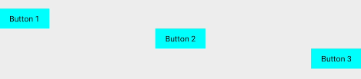

（2）依赖布局：可以轻松实现内容丰富的布局

<?xml version="1.0" encoding="utf-8"?>

<DependentLayout

xmlns:ohos="http://schemas.huawei.com/res/ohos"

ohos:width="match_parent"

ohos:height="match_content"

ohos:background_element="$graphic:color_background_gray_element">

<Text

ohos:id="$+id:text1"

ohos:width="match_parent"

ohos:height="match_content"

ohos:text_size="25fp"

ohos:top_margin="15vp"

ohos:left_margin="15vp"

ohos:right_margin="15vp"

ohos:background_element="$graphic:color_gray_element"

ohos:text="Title"

ohos:text_weight="1000"

ohos:text_alignment="horizontal_center"

/>

<Text

ohos:id="$+id:text2"

ohos:width="match_content"

ohos:height="120vp"

ohos:text_size="10fp"

ohos:background_element="$graphic:color_gray_element"

ohos:text="Catalog"

ohos:top_margin="15vp"

ohos:left_margin="15vp"

ohos:right_margin="15vp"

ohos:bottom_margin="15vp"

ohos:align_parent_left="true"

ohos:text_alignment="center"

ohos:multiple_lines="true"

ohos:below="$id:text1"

ohos:text_font="serif"/>

<Text

ohos:id="$+id:text3"

ohos:width="match_parent"

ohos:height="120vp"

ohos:text_size="25fp"

ohos:background_element="$graphic:color_gray_element"

ohos:text="Content"

ohos:top_margin="15vp"

ohos:right_margin="15vp"

ohos:bottom_margin="15vp"

ohos:text_alignment="center"

ohos:below="$id:text1"

ohos:end_of="$id:text2"

ohos:text_font="serif"/>

<Button

ohos:id="$+id:button1"

ohos:width="70vp"

ohos:height="match_content"

ohos:text_size="15fp"

ohos:background_element="$graphic:color_gray_element"

ohos:text="Previous"

ohos:right_margin="15vp"

ohos:bottom_margin="15vp"

ohos:below="$id:text3"

ohos:left_of="$id:button2"

ohos:italic="false"

ohos:text_weight="5"

ohos:text_font="serif"/>

<Button

ohos:id="$+id:button2"

ohos:width="70vp"

ohos:height="match_content"

ohos:text_size="15fp"

ohos:background_element="$graphic:color_gray_element"

ohos:text="Next"

ohos:right_margin="15vp"

ohos:bottom_margin="15vp"

ohos:align_parent_end="true"

ohos:below="$id:text3"

ohos:italic="false"

ohos:text_weight="5"

ohos:text_font="serif"/>

</DependentLayout>

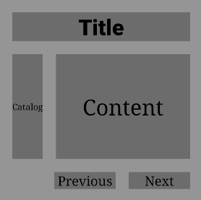

（3）表格布局：

<TableLayout

...

ohos:row_count="2"

ohos:column_count="2">

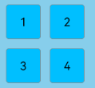

设置布局排列方向，以“vertical”为例：

<TableLayout

...

ohos:orientation="vertical">

...

</TableLayout>

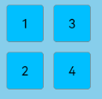

1. 结果分析（原始图示，测试数据与运行记录，分析正确性）

详细结果见程序清单中相应代码下图（如图示）

1. 调试报告

学习了相应组件，其中比较类似的属性大部分都是排列方向和对齐方式，三种组件都有相应特点，一般使用定向布局、表格布局应该会多一点，依赖布局适合更加实现一些内容丰富的布局。

1. 实验内容2
2. 问题描述

练习常用组件的使用方法，介绍三种以上组件

1. 设计思想与原理

Text：Text是用来显示字符串的组件，在界面上显示为一块文本区域。Text作为一个基本组件，有很多扩展，常见的有按钮组件Button，文本编辑组件TextField。

Button：Button是一种常见的组件，点击可以触发对应的操作，通常由文本或图标组成，也可以由图标和文本共同组成。

TextField：TextField提供了一种文本输入框。

1. 程序清单（含必要注释说明）
2. Text：

设置字体大小和颜色

<Text

ohos:id="$+id:text"

ohos:width="match_content"

ohos:height="match_content"

ohos:text="Text"

ohos:text_size="28fp"

ohos:text_color="#0000FF"

ohos:left_margin="15vp"

ohos:bottom_margin="15vp"

ohos:right_padding="15vp"

ohos:left_padding="15vp"

ohos:background_element="$graphic:background_text"/>

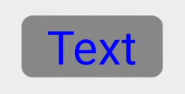

设置文本对齐方式：

<Text

ohos:id="$+id:text"

ohos:width="300vp"

ohos:height="100vp"

ohos:text="Text"

ohos:text_size="28fp"

ohos:text_color="#0000FF"

ohos:italic="true"

ohos:text_weight="700"

ohos:text_font="serif"

ohos:left_margin="15vp"

ohos:bottom_margin="15vp"

ohos:right_padding="15vp"

ohos:left_padding="15vp"

ohos:text_alignment="horizontal_center|bottom"

ohos:background_element="$graphic:background_text"/>

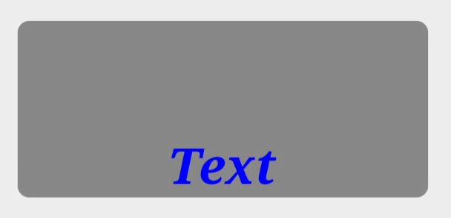

当文本过长时，可以设置跑马灯效果，实现文本滚动显示。前提是文本换行关闭且最大显示行数为1，默认情况下即可满足前提要求。

<Text

ohos:id="$+id:text"

ohos:width="75vp"

ohos:height="match_content"

ohos:text="TextText"

ohos:text_size="28fp"

ohos:text_color="#0000FF"

ohos:italic="true"

ohos:text_weight="700"

ohos:text_font="serif"

ohos:background_element="$graphic:background_text"/>

// 跑马灯效果

text.setTruncationMode(Text.TruncationMode.AUTO_SCROLLING);

// 始终处于自动滚动状态

text.setAutoScrollingCount(Text.AUTO_SCROLLING_FOREVER);

// 启动跑马灯效果

text.startAutoScrolling();

1. Button：

图标和文本共同组成的按钮

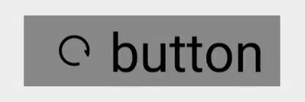

胶囊按钮是一种常见的按钮，设置按钮背景时将背景设置为矩形形状，并且设置ShapeElement的radius的半径，例如：

<Button

ohos:id="$+id:button"

ohos:width="match_content"

ohos:height="match_content"

ohos:text_size="27fp"

ohos:text="button"

ohos:background_element="$graphic:capsule_button_element"

ohos:left_margin="15vp"

ohos:bottom_margin="15vp"

ohos:right_padding="15vp"

ohos:left_padding="15vp"

/>

<?xml version="1.0" encoding="utf-8"?>

<shape xmlns:ohos="http://schemas.huawei.com/res/ohos"

ohos:shape="rectangle">

<corners

ohos:radius="100"/>

<solid

ohos:color="#007CFD"/>

</shape>

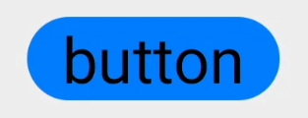

利用圆形按钮，胶囊按钮，文本组件可以绘制出如下拨号盘的UI界面。（此处不在详细说明）

1. TextField：

创建一个TextField：

<TextField

...

ohos:id="$+id:text_field"

ohos:height="40vp"

ohos:width="200vp"

ohos:top_margin="100vp"

ohos:left_margin="80vp"

ohos:left_padding="20vp"

/>

获取输入框的内容：

TextField textField = (TextField) findComponentById(ResourceTable.Id_text_field);

String content = textField.getText();

然后就可以在文本框中输入了，还可以设置气泡等等方面，此处不说明。

1. 结果分析（原始图示，测试数据与运行记录，分析正确性）

详细结果见程序清单中相应代码下图（如图示）

1. 调试报告

这里介绍了三个基本组件，分别是Text、Button和TextField,平时使用频繁，在上面程序清单中也对相应格式进行了改变，可以根据需求自行选择。

1. 实验内容3
2. 问题描述

完成“倾心家教”用户注册登录案例的UI设计；完成“倾心家教”应用程序主界面、消息界面等UI设计。

1. 设计思想与原理

通过使用布局和组件，实现我们所想要的一些功能，布局使用的是定向布局，组件使用的是Text、TextField、Button、Image组件，通过学习和界面设计，我们得到相应的界面。

1. 程序清单（含必要注释说明）
2. 前期准备

Bean类：

User.java

package com.example.myapplication.pojo;  
  
import java.util.Objects;  
  
public class User {  
 private String name;  
 private String password;  
 private String token;  
  
 public User(String name, String password) {  
 this.name = name;  
 this.password = password;  
 }  
  
 public String getName() {  
 return name;  
 }  
  
 public void setName(String name) {  
 this.name = name;  
 }  
  
 public String getPassword() {  
 return password;  
 }  
  
 public void setPassword(String password) {  
 this.password = password;  
 }  
  
 public String getToken() {  
 return token;  
 }  
  
 public void setToken(String token) {  
 this.token = token;  
 }  
  
 @Override  
 public String toString() {  
 return "User{" +  
 "name='" + name + '\'' +  
 ", password='" + password + '\'' +  
 ", token='" + token + '\'' +  
 '}';  
 }  
  
 @Override  
 public boolean equals(Object o) {  
 if (this == o) return true;  
 if (o == null || getClass() != o.getClass()) return false;  
 User user = (User) o;  
 return Objects.*equals*(name, user.name) && Objects.*equals*(password, user.password) && Objects.*equals*(token, user.token);  
 }  
  
}

自定义美化组件：

App主要背景颜色（background_ability.xml）:

*<?*xml version="1.0" encoding="UTF-8" *?>*<shape xmlns:ohos="http://schemas.huawei.com/res/ohos"  
 ohos:shape="rectangle">  
 <solid  
 ohos:color="#F2F2F2"/>  
</shape>

子背景颜色设置（background_ability_user）：

*<?*xml version="1.0" encoding="UTF-8" *?>*<shape xmlns:ohos="http://schemas.huawei.com/res/ohos"  
 ohos:shape="rectangle">  
 <solid  
 ohos:color="#FFFFFF"/>  
</shape>

Button按钮形状设置：

当按钮未被按下时（button_entry）：

*<?*xml version="1.0" encoding="utf-8"*?>*<shape  
 ohos:shape="rectangle"  
 xmlns:ohos="http://schemas.huawei.com/res/ohos">  
 <corners  
 ohos:radius="15vp"/>  
 <solid  
 ohos:color="#0FF0FF"/>  
 <stroke  
 ohos:color="#0FF0FF"/>  
</shape>

当按钮被按下时（button_shape）：

*<?*xml version="1.0" encoding="utf-8"*?>*<shape  
 ohos:shape="rectangle"  
 xmlns:ohos="http://schemas.huawei.com/res/ohos">  
 <corners  
 ohos:radius="15vp"/>  
 <solid  
 ohos:color="#00FFFF"/>  
 <stroke  
 ohos:color="#00FFFF"/>  
</shape>

状态设置（button_state）：

*<?*xml version="1.0" encoding="utf-8"*?>*<state-container  
 xmlns:ohos="http://schemas.huawei.com/res/ohos">  
 <item  
 ohos:state="component_state_pressed"  
 ohos:element="$graphic:button_shape"/>  
 <item  
 ohos:state="component_state_empty"  
 ohos:element="$graphic:button_entry"/>  
</state-container>

1. 登录界面

ability_main.xml

*<?*xml version="1.0" encoding="utf-8"*?>*<DirectionalLayout  
 xmlns:ohos="http://schemas.huawei.com/res/ohos"  
 ohos:height="match_parent"  
 ohos:width="match_parent"  
 ohos:background_element="$graphic:background_ability"  
 ohos:orientation="vertical"  
 >  
  
 <Text  
 ohos:height="50vp"  
 ohos:width="319vp"  
 ohos:background_element="#FFFFFFF"  
 ohos:layout_alignment="horizontal_center"  
 ohos:text="Login"  
 ohos:text_alignment="center"  
 ohos:text_color="black"  
 ohos:text_size="19fp"  
 ohos:top_margin="100vp"  
 />  
  
 <DirectionalLayout  
 ohos:height="match_content"  
 ohos:width="match_parent"  
 ohos:layout_alignment="horizontal_center"  
 ohos:orientation="horizontal"  
 ohos:top_margin="30vp"  
 >  
  
 <Image  
 ohos:height="50vp"  
 ohos:width="50vp"  
 ohos:image_src="$media:userpic"  
 ohos:left_margin="50vp"  
 ohos:scale_mode="inside"  
 />  
  
 <TextField  
 ohos:id="$+id:LoginUserName"  
 ohos:height="50vp"  
 ohos:width="210vp"  
 ohos:background_element="#FFFFFF"  
 ohos:hint="请输入手机号"  
 ohos:text_alignment="center"  
 ohos:text_color="#999999"  
 ohos:text_size="17fp"  
 />  
 </DirectionalLayout>  
  
 <DirectionalLayout  
 ohos:height="match_content"  
 ohos:width="match_parent"  
 ohos:layout_alignment="horizontal_center"  
 ohos:orientation="horizontal"  
 ohos:top_margin="25vp"  
 >  
  
 <Image  
 ohos:height="50vp"  
 ohos:width="50vp"  
 ohos:image_src="$media:passwordpic"  
 ohos:left_margin="50vp"  
 ohos:scale_mode="inside"  
 />  
  
 <TextField  
 ohos:id="$+id:LoginPassWord"  
 ohos:height="50vp"  
 ohos:width="210vp"  
 ohos:background_element="#FFFFFF"  
 ohos:hint="请输入密码"  
 ohos:hint_color="#999999"  
 ohos:layout_alignment="horizontal_center"  
 ohos:text_alignment="center"  
 ohos:text_input_type="pattern_password"  
 ohos:text_size="17fp"  
 />  
  
 </DirectionalLayout>  
  
 <Button  
 ohos:id="$+id:Login"  
 ohos:height="47vp"  
 ohos:width="300vp"  
 ohos:background_element="$graphic:button_state"  
 ohos:layout_alignment="center"  
 ohos:text="登录"  
 ohos:text_alignment="center"  
 ohos:text_color="#000000"  
 ohos:text_size="20fp"  
 ohos:top_margin="60vp"  
 />  
  
 <DirectionalLayout  
 ohos:height="match_parent"  
 ohos:width="370vp"  
 ohos:layout_alignment="horizontal_center"  
 ohos:orientation="horizontal"  
 ohos:top_margin="20vp"  
 >  
  
 <Text  
 ohos:id="$+id:RegisterPage"  
 ohos:height="match_content"  
 ohos:width="match_content"  
 ohos:clickable="true"  
 ohos:layout_alignment="left"  
 ohos:left_margin="40vp"  
 ohos:text="注册用户"  
 ohos:text_color="#979797"  
 ohos:text_size="17fp"  
 />  
  
 <Text  
 ohos:id="$+id:ForgetPass"  
 ohos:height="match_content"  
 ohos:width="match_content"  
 ohos:clickable="true"  
 ohos:layout_alignment="right"  
 ohos:left_margin="140vp"  
 ohos:text="忘记密码？"  
 ohos:text_color="#979797"  
 ohos:text_size="17fp"  
 />  
  
 </DirectionalLayout>  
</DirectionalLayout>

MainAbility.java

package com.example.myapplication;  
  
import com.example.myapplication.slice.MainAbilitySlice;  
import ohos.aafwk.ability.Ability;  
import ohos.aafwk.content.Intent;  
  
public class MainAbility extends Ability {  
 @Override  
 public void onStart(Intent intent) {  
 super.onStart(intent);  
 super.setMainRoute(MainAbilitySlice.class.getName());  
 }  
}

MainAbilitySlice.java

package com.example.myapplication.slice;  
  
import com.example.myapplication.ResourceTable;  
import com.example.myapplication.pojo.User;  
import ohos.aafwk.ability.AbilitySlice;  
import ohos.aafwk.content.Intent;  
import ohos.aafwk.content.Operation;  
import ohos.agp.components.Button;  
import ohos.agp.components.Component;  
import ohos.agp.components.Text;  
import ohos.agp.components.TextField;  
import ohos.agp.utils.Color;  
import ohos.multimodalinput.event.TouchEvent;  
  
*// 写逻辑功能 也可以写页面显示*public class MainAbilitySlice extends AbilitySlice implements Component.TouchEventListener, Component.ClickedListener{  
 private Text registerText; *// 注册用户* private Text forgetPassword; *// 忘记密码* private TextField username;  
 private TextField password;  
 private Button loginbutton;  
 private User user;  
 @Override  
 public void onStart(Intent intent) {  
 super.onStart(intent);  
 super.setUIContent(ResourceTable.Layout_ability_main);  
 registerText = (Text) findComponentById(ResourceTable.Id_RegisterPage);  
 loginbutton = (Button) findComponentById(ResourceTable.Id_Login);  
 username = (TextField) findComponentById(ResourceTable.Id_LoginUserName);  
 password = (TextField) findComponentById(ResourceTable.Id_LoginPassWord);  
 registerText.setTouchEventListener(this);  
 loginbutton.setClickedListener(this);  
  
 }  
  
 @Override  
 public void onActive() {  
 super.onActive();  
 }  
  
 @Override  
 public void onForeground(Intent intent) {  
 super.onForeground(intent);  
 }  
  
 *// 第一个参数 是监听的组件  
 // 第二个参数是组件状态  
 // 即 按下 滑动 松开 1 0 2* @Override  
 public boolean onTouchEvent(Component component, TouchEvent touchEvent){  
 if(component == registerText){  
 int action = touchEvent.getAction();  
 if(action == TouchEvent.*PRIMARY_POINT_UP*){  
 registerText.setTextColor(Color.*GRAY*);  
 Intent i = new Intent();  
 Operation operation = new Intent.OperationBuilder()  
 .withDeviceId("")  
 .withBundleName("com.example.myapplication")  
 .withAbilityName("com.example.myapplication.RegisterAbility")  
 .build();  
 i.setOperation(operation);  
 startAbility(i);  
 }  
 }  
 return true;  
 }  
  
 @Override  
 public void onClick(Component component) {  
 if (component == loginbutton){  
 String ur = (String) username.getText();  
 String pw = (String) password.getText();  
 if ( !ur.equals("") && !pw.equals("") ) {  
 user = new User(ur, pw);  
 }  
 */*  
 TODO　比对用户名和密码 获取token值后 跳转页面1  
 */* Intent i = new Intent();  
 Operation operation = new Intent.OperationBuilder()  
 .withDeviceId("")  
 .withBundleName("com.example.myapplication")  
 .withAbilityName("com.example.myapplication.UserAbility")  
 .build();  
 i.setOperation(operation);  
 startAbility(i);  
 }  
 }  
}

(3)注册界面

ability_register.xml

*<?*xml version="1.0" encoding="utf-8"*?>*<DirectionalLayout  
 xmlns:ohos="http://schemas.huawei.com/res/ohos"  
 ohos:height="match_parent"  
 ohos:width="match_parent"  
 ohos:orientation="vertical"  
 ohos:background_element="$graphic:background_ability"  
 >  
 <Text  
 ohos:height="50vp"  
 ohos:width="319vp"  
 ohos:layout_alignment="horizontal_center"  
 ohos:text="Register"  
 ohos:text_size="19fp"  
 ohos:background_element="#FFFFFFF"  
 ohos:text_color="black"  
 ohos:top_margin="100vp"  
 ohos:text_alignment="center"  
 />  
 <DirectionalLayout  
 ohos:height="match_content"  
 ohos:width="match_parent"  
 ohos:layout_alignment="horizontal_center"  
 ohos:orientation="horizontal"  
 ohos:top_margin="30vp"  
 >  
  
 <Image  
 ohos:height="50vp"  
 ohos:width="50vp"  
 ohos:image_src="$media:userpic"  
 ohos:left_margin="50vp"  
 ohos:scale_mode="inside"  
 />  
  
 <TextField  
 ohos:id="$+id:RegisterUserName"  
 ohos:height="50vp"  
 ohos:width="210vp"  
 ohos:background_element="#FFFFFF"  
 ohos:hint="请输入手机号"  
 ohos:text_alignment="center"  
 ohos:text_color="#999999"  
 ohos:text_size="17fp"  
 />  
 </DirectionalLayout>  
  
 <DirectionalLayout  
 ohos:height="match_content"  
 ohos:width="match_parent"  
 ohos:layout_alignment="horizontal_center"  
 ohos:orientation="horizontal"  
 ohos:top_margin="25vp"  
 >  
  
 <Image  
 ohos:height="50vp"  
 ohos:width="50vp"  
 ohos:image_src="$media:passwordpic"  
 ohos:left_margin="50vp"  
 ohos:scale_mode="inside"  
 />  
  
 <TextField  
 ohos:id="$+id:RegisterPassWord"  
 ohos:height="50vp"  
 ohos:width="210vp"  
 ohos:background_element="#FFFFFF"  
 ohos:hint="请输入密码"  
 ohos:hint_color="#999999"  
 ohos:layout_alignment="horizontal_center"  
 ohos:text_alignment="center"  
 ohos:text_input_type="pattern_password"  
 ohos:text_size="17fp"  
 />  
  
 </DirectionalLayout>  
  
 <DirectionalLayout  
 ohos:height="match_content"  
 ohos:width="match_parent"  
 ohos:layout_alignment="horizontal_center"  
 ohos:orientation="horizontal"  
 ohos:top_margin="25vp"  
 >  
  
 <Image  
 ohos:height="50vp"  
 ohos:width="50vp"  
 ohos:image_src="$media:passwordpic"  
 ohos:left_margin="50vp"  
 ohos:scale_mode="inside"  
 />  
  
 <TextField  
 ohos:id="$+id:AgainPassWord"  
 ohos:height="50vp"  
 ohos:width="210vp"  
 ohos:background_element="#FFFFFF"  
 ohos:hint="请再次输入密码"  
 ohos:hint_color="#999999"  
 ohos:layout_alignment="horizontal_center"  
 ohos:text_alignment="center"  
 ohos:text_input_type="pattern_password"  
 ohos:text_size="17fp"  
 />  
  
 </DirectionalLayout>  
  
 <Button  
 ohos:id="$+id:Register"  
 ohos:height="47vp"  
 ohos:width="300vp"  
 ohos:background_element="$graphic:button_state"  
 ohos:text="注册"  
 ohos:text_size="20fp"  
 ohos:top_margin="77vp"  
 ohos:layout_alignment="center"  
 ohos:text_alignment="center"  
 ohos:text_color="#000000"  
 />  
  
</DirectionalLayout>

Register.java

package com.example.myapplication;  
  
import com.example.myapplication.slice.RegisterAbilitySlice;  
import ohos.aafwk.ability.Ability;  
import ohos.aafwk.content.Intent;  
  
public class RegisterAbility extends Ability {  
 @Override  
 public void onStart(Intent intent) {  
 super.onStart(intent);  
 super.setMainRoute(RegisterAbilitySlice.class.getName());  
 }  
}

RegisterAbilitySlice.java

package com.example.myapplication.slice;  
  
import com.example.myapplication.ResourceTable;  
import ohos.aafwk.ability.AbilitySlice;  
import ohos.aafwk.content.Intent;  
import ohos.agp.components.Button;  
import ohos.agp.components.Component;  
import ohos.agp.components.TextField;  
  
public class RegisterAbilitySlice extends AbilitySlice implements Component.ClickedListener {  
 private TextField usernametext;  
 private TextField passwordtext;  
 private TextField againpasswordtext;  
 private Button registerbutton;  
  
  
 @Override  
 public void onStart(Intent intent) {  
 super.onStart(intent);  
 super.setUIContent(ResourceTable.*Layout_ability_register*);  
 usernametext = (TextField) findComponentById(ResourceTable.*Id_RegisterUserName*);  
 passwordtext = (TextField) findComponentById(ResourceTable.*Id_RegisterPassWord*);  
 againpasswordtext = (TextField) findComponentById(ResourceTable.*Id_AgainPassWord*);  
 registerbutton = (Button) findComponentById(ResourceTable.*Id_Register*);  
  
 registerbutton.setClickedListener(this);  
  
 }  
  
 @Override  
 public void onActive() {  
 super.onActive();  
 }  
  
 @Override  
 public void onForeground(Intent intent) {  
 super.onForeground(intent);  
 }  
  
 @Override  
 public void onClick(Component component) {  
 if (component == registerbutton){  
 String username = usernametext.getText();  
 String password = passwordtext.getText();  
 String againpassword = againpasswordtext.getText();  
 if (password.equals("")){  
 */*  
 TODO　用户名为空弹窗提醒  
 */* }  
 if (password.equals("")){  
 */*  
 TODO 第一次密码为空弹窗提醒  
 */* }  
 if (againpassword.equals("")){  
 */*  
 TODO 第二次密码为空弹窗提醒  
 */* }  
 if (!againpassword.equals(password)){  
 */*  
 TODO 密码两次不相同弹窗提醒  
 */* }  
 */*  
 TODO 向数据库中查找数据判断是否已经注册过  
 */  
  
 /*  
 TODO　注册成功后带token值转入主界面  
 */* }  
 }  
}

(4) 用户界面

ability_user.xml

*<?*xml version="1.0" encoding="utf-8"*?>*<DirectionalLayout  
 xmlns:ohos="http://schemas.huawei.com/res/ohos"  
 ohos:height="match_parent"  
 ohos:width="match_parent"  
 ohos:orientation="vertical"  
 ohos:background_element="$graphic:background_ability"  
 >  
 <DirectionalLayout  
 ohos:height="match_content"  
 ohos:width="match_parent"  
 ohos:background_element="#FF8C00"  
 ohos:orientation="horizontal"  
 >  
 <Text  
 ohos:left_padding="15vp"  
 ohos:height="50vp"  
 ohos:width="90vp"  
 ohos:text="地区"  
 ohos:text_size="30vp"  
 ohos:layout_alignment="center"  
 />  
 <DirectionalLayout  
 ohos:height="match_parent"  
 ohos:width="match_parent"  
 ohos:orientation="horizontal"  
 ohos:left_margin="10vp"  
 >  
 <Image  
 ohos:height="40vp"  
 ohos:width="50vp"  
 ohos:image_src="$media:find"  
 ohos:scale_mode="inside"  
 ohos:layout_alignment="center"  
 ohos:background_element="#FFFFFF"  
 />  
  
 <Text  
 ohos:height="40vp"  
 ohos:width="200vp"  
 ohos:layout_alignment="center"  
 ohos:text="请输入搜索内容"  
 ohos:text_color="#DCDCDC"  
 ohos:text_size="20vp"  
 ohos:background_element="#FFFFFF"  
 />  
 </DirectionalLayout>  
 </DirectionalLayout>  
  
 <DirectionalLayout  
 ohos:height="match_content"  
 ohos:width="match_parent"  
 ohos:orientation="vertical"  
 ohos:background_element="#FFFFFF"  
 >  
 <DirectionalLayout  
 ohos:height="match_content"  
 ohos:width="match_parent"  
 ohos:bottom_margin="20vp"  
 ohos:orientation="horizontal"  
 >  
 <DirectionalLayout  
 ohos:id="chinese"  
 ohos:height="match_parent"  
 ohos:width="match_content"  
 ohos:left_margin="10vp"  
 ohos:top_margin="20vp"  
 ohos:orientation="vertical"  
 >  
 <Image  
 ohos:height="60vp"  
 ohos:width="60vp"  
 ohos:scale_mode="inside"  
 ohos:image_src="$media:chinese"  
  
 />  
 <Text  
 ohos:height="20vp"  
 ohos:width="60vp"  
 ohos:text="语文"  
 ohos:text_size="20vp"  
 ohos:text_color="#000000"  
 ohos:layout_alignment="left"  
 ohos:left_margin="10vp"  
 />  
 </DirectionalLayout>  
  
 <DirectionalLayout  
 ohos:id="math"  
 ohos:height="match_parent"  
 ohos:width="match_content"  
 ohos:left_margin="20vp"  
 ohos:top_margin="20vp"  
 ohos:orientation="vertical"  
 >  
 <Image  
 ohos:height="60vp"  
 ohos:width="60vp"  
 ohos:scale_mode="inside"  
 ohos:image_src="$media:math"  
  
 />  
 <Text  
 ohos:height="20vp"  
 ohos:width="60vp"  
 ohos:text="数学"  
 ohos:text_size="20vp"  
 ohos:text_color="#000000"  
 ohos:layout_alignment="left"  
 ohos:left_margin="10vp"  
 />  
 </DirectionalLayout>  
  
 <DirectionalLayout  
 ohos:id="english"  
 ohos:height="match_parent"  
 ohos:width="match_content"  
 ohos:left_margin="20vp"  
 ohos:top_margin="20vp"  
 ohos:orientation="vertical"  
 >  
 <Image  
 ohos:height="60vp"  
 ohos:width="60vp"  
 ohos:scale_mode="inside"  
 ohos:image_src="$media:english"  
  
 />  
 <Text  
 ohos:height="20vp"  
 ohos:width="60vp"  
 ohos:text="英语"  
 ohos:text_size="20vp"  
 ohos:text_color="#000000"  
 ohos:layout_alignment="left"  
 ohos:left_margin="10vp"  
 />  
 </DirectionalLayout>  
  
 <DirectionalLayout  
 ohos:id="physics"  
 ohos:height="match_parent"  
 ohos:width="match_content"  
 ohos:left_margin="20vp"  
 ohos:top_margin="20vp"  
 ohos:orientation="vertical"  
 >  
 <Image  
 ohos:height="60vp"  
 ohos:width="60vp"  
 ohos:scale_mode="inside"  
 ohos:image_src="$media:physics"  
 />  
 <Text  
 ohos:height="20vp"  
 ohos:width="60vp"  
 ohos:text="物理"  
 ohos:text_size="20vp"  
 ohos:text_color="#000000"  
 ohos:layout_alignment="left"  
 ohos:left_margin="10vp"  
 />  
 </DirectionalLayout>  
  
 </DirectionalLayout>  
 <DirectionalLayout  
 ohos:height="match_content"  
 ohos:width="match_parent"  
 ohos:bottom_margin="20vp"  
 ohos:orientation="horizontal"  
 >  
 <DirectionalLayout  
 ohos:id="chemical"  
 ohos:height="match_parent"  
 ohos:width="match_content"  
 ohos:left_margin="10vp"  
 ohos:top_margin="20vp"  
 ohos:orientation="vertical"  
 >  
 <Image  
 ohos:height="60vp"  
 ohos:width="60vp"  
 ohos:scale_mode="inside"  
 ohos:image_src="$media:chemical"  
 />  
 <Text  
 ohos:height="20vp"  
 ohos:width="60vp"  
 ohos:text="化学"  
 ohos:text_size="20vp"  
 ohos:text_color="#000000"  
 ohos:layout_alignment="left"  
 ohos:left_margin="10vp"  
 />  
 </DirectionalLayout>  
  
 <DirectionalLayout  
 ohos:id="politics"  
 ohos:height="match_parent"  
 ohos:width="match_content"  
 ohos:left_margin="20vp"  
 ohos:top_margin="20vp"  
 ohos:orientation="vertical"  
 >  
 <Image  
 ohos:height="60vp"  
 ohos:width="60vp"  
 ohos:scale_mode="inside"  
 ohos:image_src="$media:politics"  
  
 />  
 <Text  
 ohos:height="20vp"  
 ohos:width="60vp"  
 ohos:text="政治"  
 ohos:text_size="20vp"  
 ohos:text_color="#000000"  
 ohos:layout_alignment="left"  
 ohos:left_margin="10vp"  
 />  
 </DirectionalLayout>  
  
 <DirectionalLayout  
 ohos:id="biology"  
 ohos:height="match_parent"  
 ohos:width="match_content"  
 ohos:left_margin="20vp"  
 ohos:top_margin="20vp"  
 ohos:orientation="vertical"  
 >  
 <Image  
 ohos:height="60vp"  
 ohos:width="60vp"  
 ohos:scale_mode="inside"  
 ohos:image_src="$media:biology"  
  
 />  
 <Text  
 ohos:height="20vp"  
 ohos:width="60vp"  
 ohos:text="生物"  
 ohos:text_size="20vp"  
 ohos:text_color="#000000"  
 ohos:layout_alignment="left"  
 ohos:left_margin="10vp"  
 />  
 </DirectionalLayout>  
  
 <DirectionalLayout  
 ohos:id="geography"  
 ohos:height="match_parent"  
 ohos:width="match_content"  
 ohos:left_margin="20vp"  
 ohos:top_margin="20vp"  
 ohos:orientation="vertical"  
 >  
 <Image  
 ohos:height="60vp"  
 ohos:width="60vp"  
 ohos:scale_mode="inside"  
 ohos:image_src="$media:geography"  
  
 />  
 <Text  
 ohos:height="20vp"  
 ohos:width="60vp"  
 ohos:text="地理"  
 ohos:text_size="20vp"  
 ohos:text_color="#000000"  
 ohos:layout_alignment="left"  
 ohos:left_margin="10vp"  
 />  
 </DirectionalLayout>  
  
 </DirectionalLayout>  
  
  
 </DirectionalLayout>  
  
 <DirectionalLayout  
 ohos:id="advertrsement"  
 ohos:top_margin="15vp"  
 ohos:height="40vp"  
 ohos:width="match_parent"  
 ohos:background_element="#FFFFFF"  
 ohos:orientation="horizontal"  
 >  
 <Image  
 ohos:left_margin="30vp"  
 ohos:height="15vp"  
 ohos:width="15vp"  
 ohos:image_src="$media:titlelog"  
 ohos:scale_mode="inside"  
 ohos:layout_alignment="center"  
 />  
 <Text  
 ohos:left_margin="30vp"  
 ohos:height="match_parent"  
 ohos:width="260vp"  
 ohos:text="名师一对一辅导啦"  
 ohos:text_size="20vp"  
 ohos:text_color="#B0B0B0"  
 />  
 <Image  
 ohos:height="match_parent"  
 ohos:width="15vp"  
 ohos:layout_alignment="center"  
 ohos:image_src="$media:rightarrow"  
 ohos:scale_mode="inside"  
 />  
 </DirectionalLayout>  
  
 <DirectionalLayout  
 ohos:height="match_content"  
 ohos:width="match_parent"  
 ohos:orientation="vertical"  
 >  
 <DirectionalLayout  
 ohos:top_margin="15vp"  
 ohos:height="50vp"  
 ohos:width="match_parent"  
 ohos:orientation="horizontal"  
 ohos:background_element="#FFFFFF"  
 >  
 <Image  
 ohos:left_margin="20vp"  
 ohos:height="match_parent"  
 ohos:width="50vp"  
 ohos:image_src="$media:smallspeakers"  
 ohos:scale_mode="inside"  
 />  
 <Text  
 ohos:left_margin="50vp"  
 ohos:height="match_parent"  
 ohos:width="match_parent"  
 ohos:text="热门名师"  
 ohos:text_color="#B0B0B0"  
 ohos:text_size="30vp"  
 ohos:layout_alignment="center"  
 />  
 </DirectionalLayout>  
  
 <DirectionalLayout  
 ohos:id="advertrsement2"  
 ohos:top_margin="15vp"  
 ohos:height="215vp"  
 ohos:width="match_parent"  
 ohos:background_element="#FFFFFF"  
 >  
 <Image  
 ohos:height="match_parent"  
 ohos:width="match_parent"  
 ohos:image_src="$media:teacher"  
 ohos:scale_mode="inside"  
 />  
 </DirectionalLayout>  
 </DirectionalLayout>  
  
 <DirectionalLayout  
 ohos:top_margin="1vp"  
 ohos:left_margin="2vp"  
 ohos:height="match_parent"  
 ohos:width="match_parent"  
 ohos:background_element="#FFFFFF"  
 ohos:orientation="horizontal"  
 >  
 <DirectionalLayout  
 ohos:id="frontpage"  
 ohos:height="match_parent"  
 ohos:width="89vp"  
 ohos:orientation="vertical"  
 ohos:layout_alignment="center"  
 ohos:left_padding="30vp"  
 >  
 <Image  
 ohos:height="35vp"  
 ohos:width="35vp"  
 ohos:image_src="$media:frontpage"  
 ohos:scale_mode="inside"  
 />  
 <Text  
 ohos:height="match_parent"  
 ohos:width="match_parent"  
 ohos:text="首页"  
 ohos:text_size="12vp"  
 ohos:text_color="#A0A0A0"  
 ohos:layout_alignment="center"  
 ohos:left_padding="5vp"  
 />  
 </DirectionalLayout>  
 <DirectionalLayout  
 ohos:id="findteacher"  
 ohos:height="match_parent"  
 ohos:width="89vp"  
 ohos:orientation="vertical"  
 ohos:layout_alignment="center"  
 ohos:left_padding="30vp"  
 >  
 <Image  
 ohos:height="35vp"  
 ohos:width="35vp"  
 ohos:image_src="$media:find2"  
 ohos:scale_mode="inside"  
 />  
 <Text  
 ohos:height="match_parent"  
 ohos:width="match_parent"  
 ohos:text="找老师"  
 ohos:text_size="12vp"  
 ohos:text_color="#A0A0A0"  
 ohos:layout_alignment="center"  
 />  
 </DirectionalLayout>  
 <DirectionalLayout  
 ohos:id="$+id:MessagePage"  
 ohos:height="match_parent"  
 ohos:width="89vp"  
 ohos:orientation="vertical"  
 ohos:layout_alignment="center"  
 ohos:left_padding="30vp"  
 >  
 <Image  
 ohos:height="35vp"  
 ohos:width="35vp"  
 ohos:image_src="$media:message"  
 ohos:scale_mode="inside"  
 />  
 <Text  
 ohos:height="match_parent"  
 ohos:width="match_parent"  
 ohos:left_padding="5vp"  
 ohos:text="消息"  
 ohos:text_size="12vp"  
 ohos:text_color="#A0A0A0"  
 ohos:layout_alignment="center"  
 />  
 </DirectionalLayout>  
 <DirectionalLayout  
 ohos:id="me"  
 ohos:height="match_parent"  
 ohos:width="89vp"  
 ohos:orientation="vertical"  
 ohos:layout_alignment="center"  
 ohos:left_padding="30vp"  
 >  
 <Image  
 ohos:height="35vp"  
 ohos:width="35vp"  
 ohos:image_src="$media:me"  
 ohos:scale_mode="inside"  
 />  
 <Text  
 ohos:height="match_parent"  
 ohos:width="match_parent"  
 ohos:text="我的"  
 ohos:text_size="12vp"  
 ohos:text_color="#A0A0A0"  
 ohos:layout_alignment="center"  
 ohos:left_padding="5vp"  
 />  
 </DirectionalLayout>  
 </DirectionalLayout>  
  
</DirectionalLayout>

UserAbility.java

package com.example.myapplication;  
  
import com.example.myapplication.slice.MessageSlice;  
import com.example.myapplication.slice.UserAbilitySlice;  
import ohos.aafwk.ability.Ability;  
import ohos.aafwk.content.Intent;  
  
public class UserAbility extends Ability {  
 @Override  
 public void onStart(Intent intent) {  
 super.onStart(intent);  
 super.setMainRoute(UserAbilitySlice.class.getName());  
 super.addActionRoute("messageslice", MessageSlice.class.getName());  
 }  
}

UserAbility.java

package com.example.myapplication;  
  
import com.example.myapplication.slice.MessageSlice;  
import com.example.myapplication.slice.UserAbilitySlice;  
import ohos.aafwk.ability.Ability;  
import ohos.aafwk.content.Intent;  
  
public class UserAbility extends Ability {  
 @Override  
 public void onStart(Intent intent) {  
 super.onStart(intent);  
 super.setMainRoute(UserAbilitySlice.class.getName());  
 super.addActionRoute("messageslice", MessageSlice.class.getName());  
 }  
}

UserAbilitySlice.java

package com.example.myapplication.slice;  
  
import com.example.myapplication.ResourceTable;  
import ohos.aafwk.ability.AbilitySlice;  
import ohos.aafwk.content.Intent;  
import ohos.agp.components.Component;  
import ohos.agp.components.DirectionalLayout;  
  
public class UserAbilitySlice extends AbilitySlice implements Component.ClickedListener {  
 DirectionalLayout messimg;  
  
  
 @Override  
 public void onStart(Intent intent) {  
 super.onStart(intent);  
 super.setUIContent(ResourceTable.*Layout_ability_user*);  
 messimg = (DirectionalLayout) findComponentById(ResourceTable.*Id_MessagePage*);  
 messimg.setClickedListener(this);  
 }  
  
 @Override  
 public void onActive() {  
 super.onActive();  
 }  
  
 @Override  
 public void onForeground(Intent intent) {  
 super.onForeground(intent);  
 }  
  
  
 @Override  
 public void onClick(Component component) {  
 if (component == messimg){  
 */*  
 TODO 跳转至消息页面  
 */* Intent i = new Intent();  
 present(new MessageSlice(),i);  
 }  
 }  
}

(5)消息页面

ability_message.xml

*<?*xml version="1.0" encoding="utf-8"*?>*<DirectionalLayout  
 xmlns:ohos="http://schemas.huawei.com/res/ohos"  
 ohos:height="match_parent"  
 ohos:width="match_parent"  
 ohos:orientation="vertical"  
 ohos:background_element="$graphic:background_ability"  
 >  
 <DirectionalLayout  
 ohos:height="match_content"  
 ohos:width="match_parent"  
 ohos:orientation="horizontal"  
 ohos:background_element="#A2CD5A"  
 >  
 <Image  
 ohos:height="40vp"  
 ohos:width="40vp"  
 ohos:left_margin="5vp"  
 ohos:image_src="$media:backarrow"  
 ohos:scale_mode="stretch"  
 ohos:layout_alignment="center"  
 ohos:background_element="#A2CD5A"  
 />  
 <Text  
 ohos:height="60vp"  
 ohos:width="match_parent"  
 ohos:left_padding="100vp"  
 ohos:text="消息通知"  
 ohos:text_size="20vp"  
 ohos:text_color="#FFFFFF"  
 ohos:layout_alignment="center"  
 />  
 </DirectionalLayout>  
  
 <DirectionalLayout  
 ohos:height="match_content"  
 ohos:width="match_parent"  
 ohos:orientation="horizontal"  
 ohos:background_element="$graphic:background_ability_user"  
 >  
 <Image  
 ohos:left_margin="10vp"  
 ohos:top_margin="2vp"  
 ohos:height="30vp"  
 ohos:width="30vp"  
 ohos:image_src="$media:smallspeakers"  
 ohos:layout_alignment="center"  
 ohos:scale_mode="stretch"  
 />  
 <Text  
 ohos:left_padding="20vp"  
 ohos:height="50vp"  
 ohos:width="280vp"  
 ohos:text_size="15vp"  
 ohos:layout_alignment="center"  
 ohos:text="预约老师信息"  
 />  
 <Image  
 ohos:height="30vp"  
 ohos:width="30vp"  
 ohos:image_src="$media:rightarrow"  
 ohos:layout_alignment="center"  
 ohos:scale_mode="stretch"  
 />  
 </DirectionalLayout>  
  
 <DirectionalLayout  
 ohos:height="match_content"  
 ohos:width="match_parent"  
 ohos:orientation="horizontal"  
 ohos:background_element="$graphic:background_ability_user"  
 >  
 <Image  
 ohos:left_margin="10vp"  
 ohos:top_margin="2vp"  
 ohos:height="30vp"  
 ohos:width="30vp"  
 ohos:image_src="$media:smallspeakers"  
 ohos:layout_alignment="center"  
 ohos:scale_mode="stretch"  
 />  
 <Text  
 ohos:left_padding="20vp"  
 ohos:height="50vp"  
 ohos:width="280vp"  
 ohos:text_size="15vp"  
 ohos:layout_alignment="center"  
 ohos:text="我要提建议"  
 />  
 <Image  
 ohos:height="30vp"  
 ohos:width="30vp"  
 ohos:image_src="$media:rightarrow"  
 ohos:layout_alignment="center"  
 ohos:scale_mode="stretch"  
 />  
 </DirectionalLayout>  
  
 <DirectionalLayout  
 ohos:top_margin="10vp"  
 ohos:height="match_content"  
 ohos:width="match_parent"  
 ohos:orientation="horizontal"  
 ohos:background_element="$graphic:background_ability_user"  
 >  
 <Image  
 ohos:left_margin="10vp"  
 ohos:top_margin="2vp"  
 ohos:height="30vp"  
 ohos:width="30vp"  
 ohos:image_src="$media:smallspeakers"  
 ohos:layout_alignment="center"  
 ohos:scale_mode="stretch"  
 />  
 <Text  
 ohos:left_padding="20vp"  
 ohos:height="50vp"  
 ohos:width="280vp"  
 ohos:text_size="15vp"  
 ohos:layout_alignment="center"  
 ohos:text="消息论坛"  
 />  
 <Image  
 ohos:height="30vp"  
 ohos:width="30vp"  
 ohos:image_src="$media:rightarrow"  
 ohos:layout_alignment="center"  
 ohos:scale_mode="stretch"  
 />  
 </DirectionalLayout>  
  
 <DirectionalLayout  
 ohos:height="match_content"  
 ohos:width="match_parent"  
 ohos:top_margin="10vp"  
 ohos:orientation="horizontal"  
 ohos:background_element="$graphic:background_ability_user"  
 >  
 <Image  
 ohos:left_margin="10vp"  
 ohos:top_margin="2vp"  
 ohos:height="30vp"  
 ohos:width="30vp"  
 ohos:image_src="$media:smallspeakers"  
 ohos:layout_alignment="center"  
 ohos:scale_mode="stretch"  
 />  
 <Text  
 ohos:left_padding="20vp"  
 ohos:height="50vp"  
 ohos:width="280vp"  
 ohos:text_size="15vp"  
 ohos:layout_alignment="center"  
 ohos:text="优惠信息"  
 />  
 <Image  
 ohos:height="30vp"  
 ohos:width="30vp"  
 ohos:image_src="$media:rightarrow"  
 ohos:layout_alignment="center"  
 ohos:scale_mode="stretch"  
 />  
 </DirectionalLayout>  
  
</DirectionalLayout>

MessageSilce.java

package com.example.myapplication.slice;  
  
import com.example.myapplication.ResourceTable;  
import ohos.aafwk.ability.AbilitySlice;  
import ohos.aafwk.content.Intent;  
  
public class MessageSlice extends AbilitySlice {  
 @Override  
 public void onStart(Intent intent) {  
 super.onStart(intent);  
 super.setUIContent(ResourceTable.*Layout_ability_message*);  
 }  
  
 @Override  
 public void onActive() {  
 super.onActive();  
 }  
  
 @Override  
 public void onForeground(Intent intent) {  
 super.onForeground(intent);  
 }  
}

1. 结果分析（原始图示，测试数据与运行记录，分析正确性）

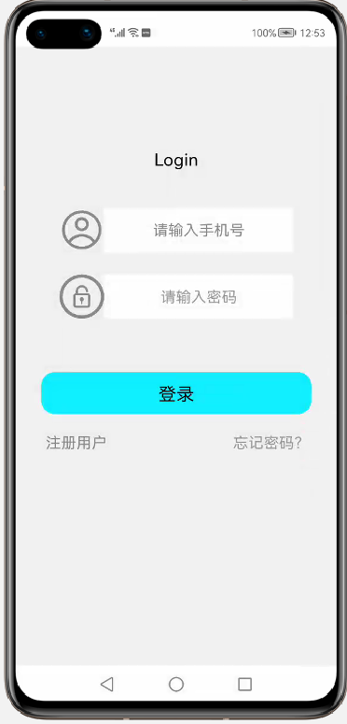 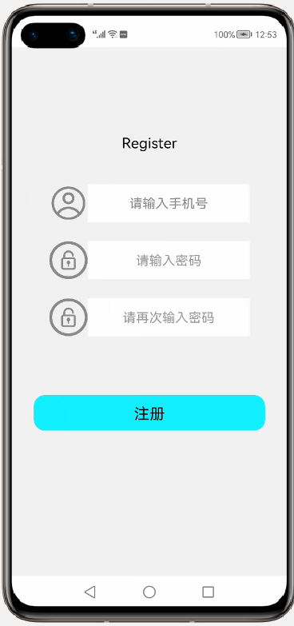

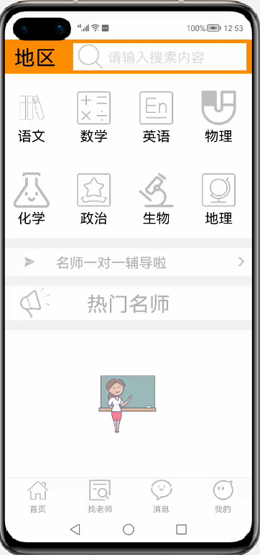 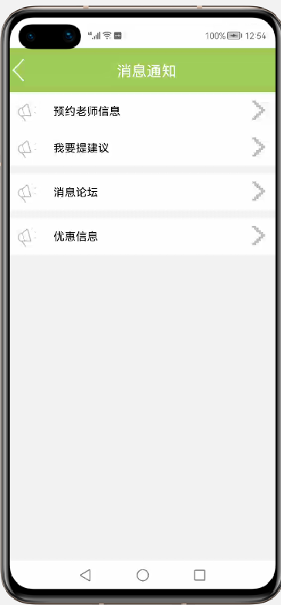

1. 调试报告

我们使用了鸿蒙开发的一些基本组件，完成了实验所需要的内容，只是完成了界面设计，但业务逻辑功能还未实现，在后续开发中我们会逐步完成数据库等内容开发，再次进行功能测试。以上呈现的就是登录、注册界面以及用户主程序界面和消息界面。