**OOP**

**Practical 3, Week 3**

**Submission**

1. Your submission should contain two files. One of these files is **PDF** document with screenshots of the implementation (Java code) and testing only. Another file is **ZIP** file with the Java project.
2. You must save the files with name

**{YourStudentNumber}-Pratical3.pdf;**

**{YourStudentNumber}-Pratical3.zip;**

For example: 202107081314-Pratical3.pdf, 202107081314-Pratical3.zip

1. You must upload from the student website: student.zy.cdut.edu.cn

**Marking scheme**

You will gain up to 5 marks for the completion of the exercise.

The markers will use the following marking scheme for each exercise.

|  |  |
| --- | --- |
| Rubric | marks |
| No attempt has been made to answer the question. No implementation at all, or completely inappropriate considerations | 0 |
| Some attempt has been made to answer the question and some considerations shown. No effort to implement a working solution and test it. | 1 |
| Incomplete programming, but significant effort has gone into it. Some consideration and implementation of the result, but very limited, some of the rules have not been properly implemented, no testing. | 2 |
| Mostly complete programming but the implementation does not follow a correct standard. The program works but does not match the testing given properly. | 3 |
| Complete programming and good implementation, and some testing shown. | 4 |
| Excellent programming and implementation of the whole problem, including testing and implementation. | 5 |

**OOP**

**Week 3, Assessed exercise**

**Invoice**

1. Implement a class called **Item** with the following specification:

* An attribute/field called **name** to store the name of the item
* An attribute/field called **price** that stores the price in pounds (real)
* An attribute called **origin** that stores the place of the item’s origin (String)
* A constructor with two parameters (the **name** of the item and the **price**) that initialises **origin** to null
* Accessor methods and mutator methods for the attributes
* A method to display the name, **price and origin** of the item.

1. Create in the **main program** a variable called **bill** that stores 3 items
2. Write code that asks the user to input the **name**, **price and origin** of 3 items, create instances of the class Item and add them to the variable **bill**.
3. Write code that given them information data in the bill variable, print an invoice by displaying the items bought with their prices and the total payment.

**Testing Data and Results**

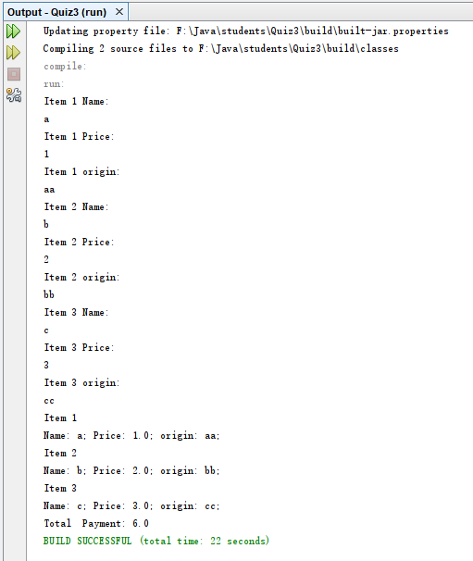

Your testing screenshot must contain the red area

**Your program should follow the test case with same input and output.**

**You also need to show your own different test case.**

Complete the implementation and testing.

（1） Implementation

**(Please show your design with some comments in your program and paste all of your source code here with screenshots)**

（2） Testing (screenshots)

**Testing 1(Same test case)**

**Testing 2(Your own different test case)**