**TICKET BOOKING SYSYTEM**

**TASKS 1: DATABASE DESIGN**

1. Create the database named "TicketBookingSystem"

Create database TicketBookingSystem;

2. Write SQL scripts to create the mentioned tables with appropriate data types, constraints, and relationships.

• Venu

• Event

• Customers

• Booking

**--CREATE VENUE TABLE**

create table venue (

venue_id int,

venue_name varchar(255),

address varchar(255));

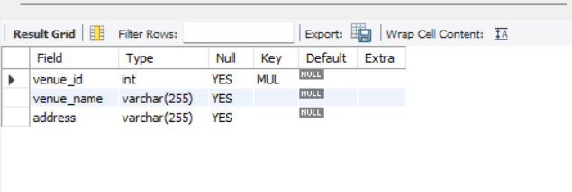

**--CREATE EVENT TABLE**

create table event (

event_id int,

event_name varchar(225),

event_date date,

event_time time,

total_seats int,

available_seats int,

ticket_price decimal,

event_type enum('movie', 'sports', 'concert'),

primary key (event_id));

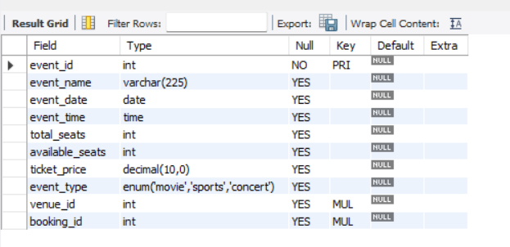

**--CREATE CUSTOMER TABLE**

create table booking(

booking_id int,

num_tickets int,

total_cost decimal,

booking_date date);

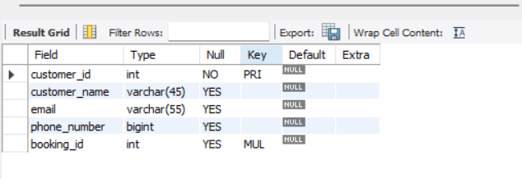

**--CREATE BOOKING TABLE**

create table booking(

booking_id int,

num_tickets int,

total_cost decimal,

booking_date date);

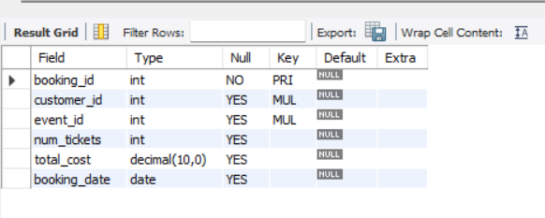

4. Create appropriate Primary Key and Foreign Key constraints for referential integrity.

-- Alter the Event Table to add Foreign Key Constraint for venue_id

ALTER TABLE event ADD CONSTRAINT fk_venue_id FOREIGN KEY (venue_id) REFERENCES venue(venue_id);

-- Alter the Event Table to add Foreign Key Constraint for booking_id

ALTER TABLE event ADD CONSTRAINT fk1_booking_id FOREIGN KEY (booking_id) REFERENCES booking(booking_id);

-- Alter the Customer Table to add Foreign Key Constraint for booking_id

ALTER TABLE customer ADD CONSTRAINT fk2_booking_id FOREIGN KEY (booking_id) REFERENCES booking(booking_id);

-- Alter the Booking Table to add Foreign Key Constraint for customer_id

ALTER TABLE booking ADD CONSTRAINT fk_customer_id FOREIGN KEY (customer_id) REFERENCES customer(customer_id);

-- Alter the Booking Table to add Foreign Key Constraint for event_id

ALTER TABLE booking ADD CONSTRAINT fk_event_id FOREIGN KEY (event_id) REFERENCES event(event_id);

**Entity Relationship Diagram**

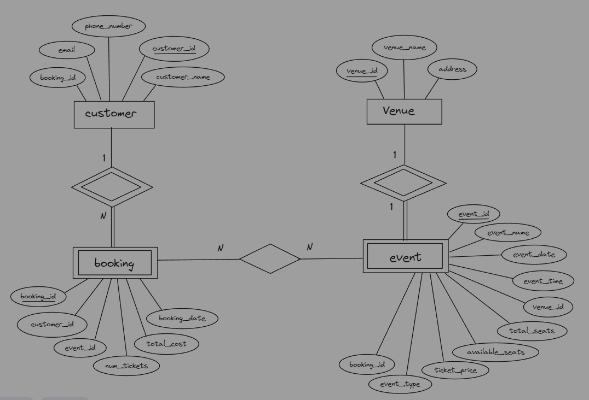

**TASKS 2: SELECT, WHERE, BETWEEN, AND, LIKE**

1. Write a SQL query to insert at least 10 sample records into each table.

*--Inserting Values To Venue Table*

INSERT INTO venue (venue_id,venue_name, address) VALUES

(101,'alpha city', '123 Alpha Avenue'),

(102,'beta street', '456 Beta Street'),

(103,'came street', '789 Came Street'),

(104,'delta park', '101 Delta Park Lane'),

(105,'epsilon avenue', '202 Epsilon Avenue'),

(106,'foo square', '303 Foo Square'),

(107,'gamma gardens', '404 Gamma Gardens'),

(108,'hotel indigo', '505 Hotel Indigo Blvd'),

(109,'ivy lane', '606 Ivy Lane'),

(110,'jupiter plaza', '707 Jupiter Plaza');

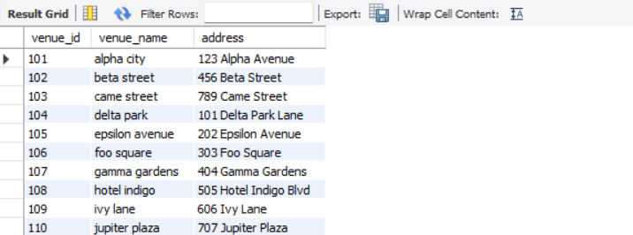

*-- Inserting Values In Event Table*

INSERT INTO event (event_id, event_name, event_date, event_time, total_seats, available_seats, ticket_price, event_type, venue_id, booking_id)

VALUES

(1, 'Movie Night', '2024-04-15', '19:00:00', 100, 90, 800.00, 'movie', 101, 111),

(2, 'Football Match', '2024-04-16', '15:30:00', 200, 180, 900.00, 'sports', 102, 222),

(3, 'Concert Under the Stars', '2024-04-17', '20:00:00', 150, 140, 1000.00, 'concert', 103, 333),

(4, 'Comedy Show', '2024-04-18', '18:00:00', 120, 110, 1200.00, 'concert', 104, 444),

(5, 'Basketball Game', '2024-04-19', '17:45:00', 180, 160, 1400.00, 'sports', 105, 555),

(6, 'Movie Marathon', '2024-04-20', '12:00:00', 80, 70, 1600.00, 'movie', 106, 666),

(7, 'Rock Concert', '2024-04-21', '21:00:00', 250, 220, 3000.00, 'concert', 107, 777),

(8, 'Tennis Tournament', '2024-04-22', '10:00:00', 300, 250, 800.00, 'sports', 108, 888),

(9, 'Stand-up Comedy', '2024-04-23', '19:30:00', 100, 90, 900.00, 'concert', 109, 999),

(10, 'Movie Premiere', '2024-04-24', '20:30:00', 150, 130, 1000.00, 'movie', 110, 1010);

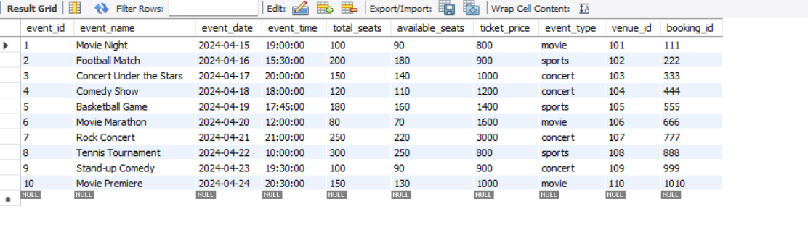

*-- Inserting Rows To Customer Table*

INSERT INTO customer (customer_id, customer_name, email, phone_number, booking_id) VALUES

(1, 'John Doe', 'john@example.com', 11111111, 111),

(2, 'Alice Smith', 'alice@example.com', 287654302, 222),

(3, 'Bob Johnson', 'bob@example.com', 32222114553, 333),

(4, 'Emily Davis', 'emily@example.com', 4151512314, 444),

(5, 'Michael Wilson', 'michael@example.com',5222211115, 555),

(6, 'Emma Brown', 'emma@example.com', 6111225566, 666),

(7, 'David Martinez', 'david@example.com', '755522277', 777),

(8, 'Sophia Garcia', 'sophia@example.com', 852426468, 888),

(9, 'Daniel Rodriguez', 'daniel@example.com', '9999999999', 999),

(10, 'Olivia Hernandez', 'olivia@example.com', '1010101010', 1010);

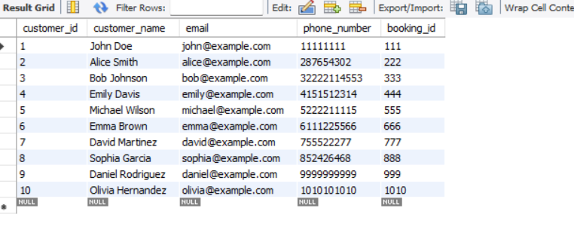

*--Inserting Rows in Booking Table*

INSERT INTO booking (booking_id, customer_id, event_id, num_tickets, total_cost, booking_date)

VALUES

(111, 5, 1, 2, 2000.00, '2024-04-11'),

(222, 9, 2, 4, 2300.00, '2024-04-12'),

(333, 2, 3, 1, 1000.00, '2024-04-13'),

(444, 10, 4, 3, 2900.00, '2024-04-14'),

(555, 1, 5, 2, 3020.00, '2024-04-15'),

(666, 7, 6, 2, 5400.00, '2024-04-16'),

(777, 6, 7, 5, 2100.00, '2024-04-17'),

(888, 8, 8, 3, 2340.00, '2024-04-18'),

(999, 3, 9, 2, 2340.00, '2024-04-19'),

(1010*, 4, 10, 4, 2500.00, '2024-04-20');*

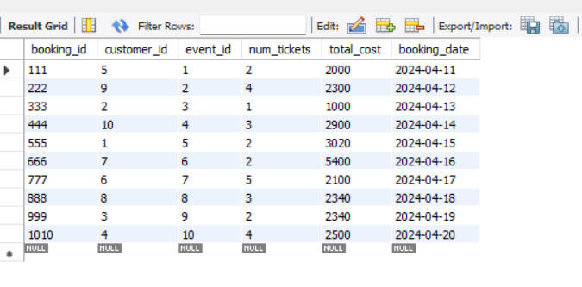

2. Write a SQL query to list all Events.

Select * FROM event;

**

3. Write a SQL query to select events with available tickets.

SELECT * FROM event WHERE available_seats > 0;

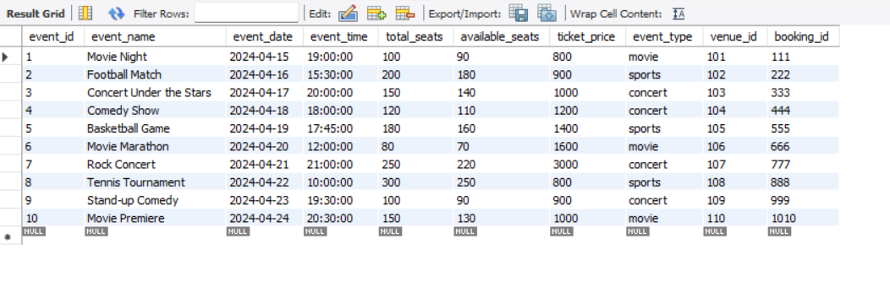

4. Write a SQL query to select events name partial match with ‘cup’.

SELECT * FROM event WHERE event_name LIKE '%cup%';

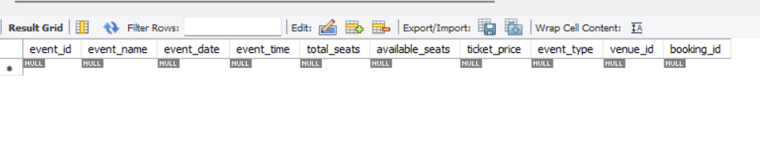

5. Write a SQL query to select events with ticket price range is between 1000 to 2500.

SELECT * FROM event WHERE ticket_price BETWEEN 1000 AND 2500;

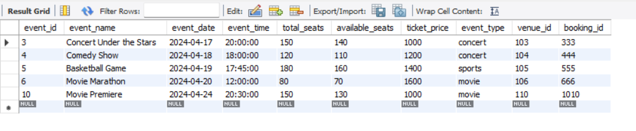

6. Write a SQL query to retrieve events with dates falling within a specific range.

SELECT * FROM event WHERE event_date BETWEEN '2024-04-20' AND '2024-04-30';

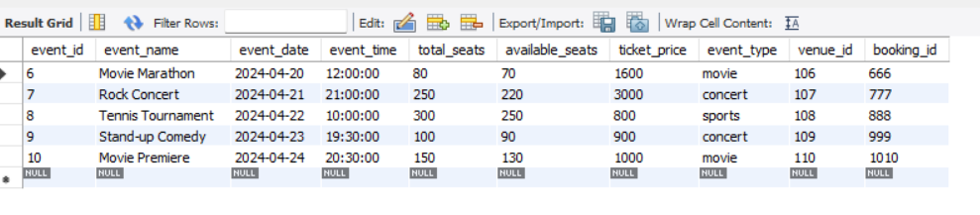

7. Write a SQL query to retrieve events with available tickets that also have "Concert" in name.

SELECT * FROM event WHERE available_seats > 0 AND event_name LIKE '%Concert%';

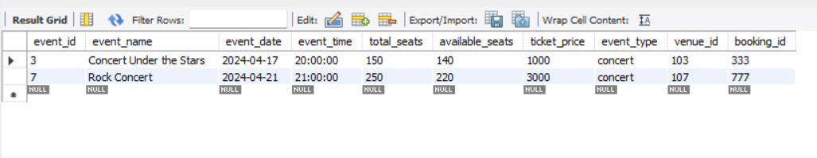

8. Write a SQL query to retrieve users in batches of 5, starting from the 6th user.

SELECT customer_name FROM customer ORDER BY customer_id LIMIT 5 OFFSET 5;

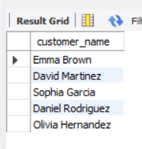

9. Write a SQL query to retrieve bookings details contains booked no of ticket more than 4.

SELECT * FROM booking WHERE num_tickets > 4;

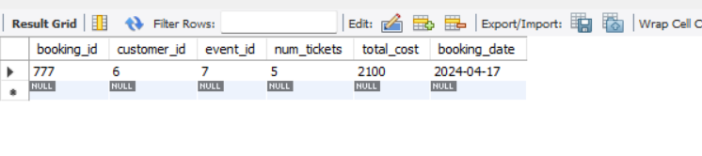

10. Write a SQL query to retrieve customer information whose phone number end with ‘000’.

SELECT * FROM customer WHERE phone_number LIKE '%000';

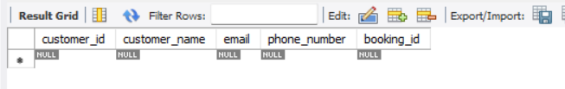

11. Write a SQL query to retrieve the events in order whose seat capacity more than 15000.

SELECT * FROM event WHERE total_seats > 15000 ORDER BY total_seats;

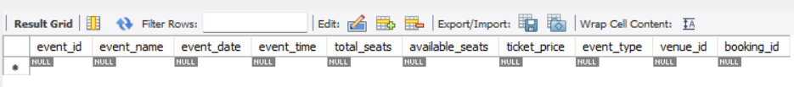

12. Write a SQL query to select events name not start with ‘x’, ‘y’, ‘z’.

SELECT * FROM event WHERE event_name NOT LIKE 'x%' AND event_name NOT LIKE 'y%' AND event_name NOT LIKE 'z%';

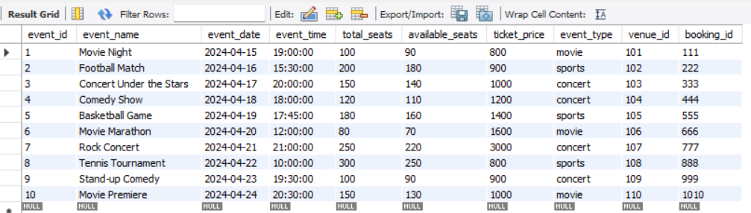

**TASKS 3: AGGREGATE FUNCTIONS, HAVING, ORDER BY, GROUPBY , JOINS:**

1. Write a SQL query to List Events and Their Average Ticket Prices.

SELECT event_name, AVG(ticket_price) AS avg_TicketPrice FROM event GROUP BY event_name;

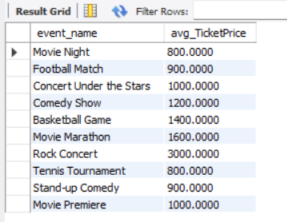

2. Write a SQL query to Calculate the Total Revenue Generated by Events.

SELECT SUM(total_cost) AS total_revenue FROM booking;

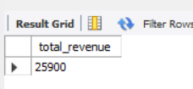

3. Write a SQL query to find the event with the highest ticket sales.

SELECT event_id, SUM(num_tickets) AS total_tickets_sold FROM booking GROUP BY event_id ORDER BY total_tickets_sold DESC LIMIT 1;

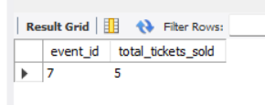

4. Write a SQL query to Calculate the Total Number of Tickets Sold for Each Event.

SELECT event_id, SUM(num_tickets) AS total_tickets_sold FROM booking GROUP BY event_id;

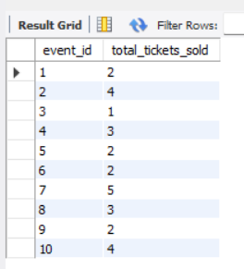

5. Write a SQL query to Find Events with No Ticket Sales.

SELECT event.event_id, event.event_name FROM event LEFT JOIN booking ON event.event_id = booking.event_id WHERE booking.booking_id IS NULL;

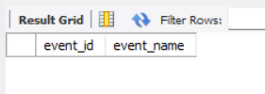

6. Write a SQL query to Find the User Who Has Booked the Most Tickets.

SELECT customer_id, SUM(num_tickets) AS total_tickets_booked FROM booking GROUP BY customer_id ORDER BY total_tickets_booked DESC LIMIT 1;

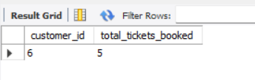

7. Write a SQL query to List Events and the total number of tickets sold for each month.

SELECT MONTH(booking_date) AS month, event_id, SUM(num_tickets) AS total_tickets_sold FROM booking GROUP BY MONTH(booking_date), event_id;

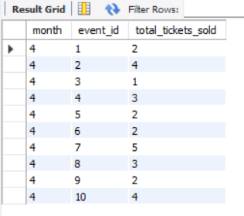

8. Write a SQL query to calculate the average Ticket Price for Events in Each Venue.

SELECT venue_id, AVG(ticket_price) AS average_ticket_price FROM event GROUP BY venue_id;

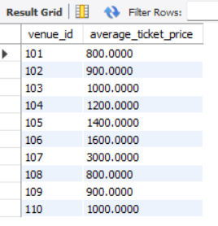

9. Write a SQL query to calculate the total Number of Tickets Sold for Each Event Type.

SELECT e.event_type, SUM(b.num_tickets) AS total_tickets_sold FROM event e JOIN booking b ON e.event_id = b.event_id GROUP BY e.event_type;

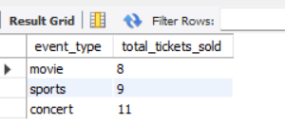

10. Write a SQL query to calculate the total Revenue Generated by Events in Each Year.

SELECT YEAR(b.booking_date) AS year, SUM(total_cost) AS total_revenue FROM booking b JOIN event e ON b.event_id = e.event_id GROUP BY YEAR(b.booking_date);

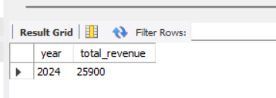

11. Write a SQL query to list users who have booked tickets for multiple events.

SELECT customer_id FROM booking GROUP BY customer_id HAVING COUNT(DISTINCT event_id) > 1;

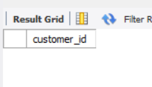

12. Write a SQL query to calculate the Total Revenue Generated by Events for Each User.

SELECT b.customer_id, SUM(total_cost) AS total_revenue FROM booking b JOIN event e ON b.event_id = e.event_id GROUP BY b.customer_id;

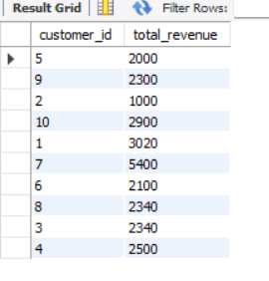

13. Write a SQL query to calculate the Average Ticket Price for Events in Each Category and Venue.

SELECT e.event_type, e.venue_id, AVG(e.ticket_price) AS average_ticket_price FROM event e GROUP BY e.event_type, e.venue_id;

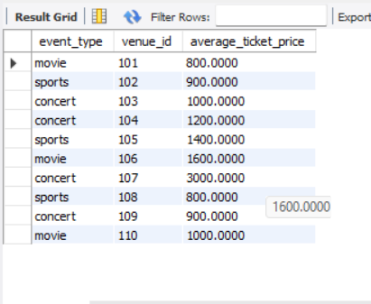

14. Write a SQL query to list Users and the Total Number of Tickets They've Purchased in the Last 30 Days.

Select customer_id, count(*) as total_tickets_purchased from booking where booking_date >= date_sub(current_date(), interval 30 day) group by customer_id;

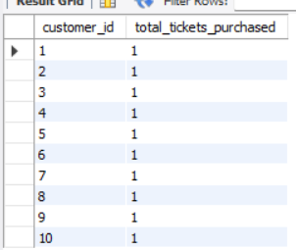

**TASKS 4: SUBQUERY AND ITS TYPES**

1. Calculate the Average Ticket Price for Events in Each Venue Using a Subquery.

SELECT venue_id, (SELECT AVG(ticket_price) FROM event WHERE venue_id=v.venue_id) AS average_ticket_price FROM venue v;

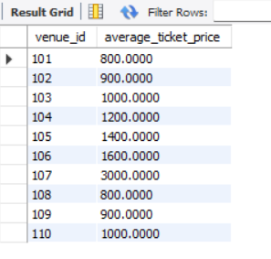

2. Find Events with More Than 50% of Tickets Sold using subquery.

SELECT event_id FROM booking GROUP BY event_id HAVING SUM(num_tickets) > (SELECT 0.5 * total_seats FROM event WHERE event.event_id = booking.event_id);

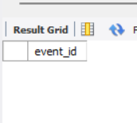

3. Calculate the Total Number of Tickets Sold for Each Event.

SELECT event_id,(SELECT SUM(num_tickets) FROM booking WHERE event_id = e.event_id) AS total_tickets_sold FROM event e;

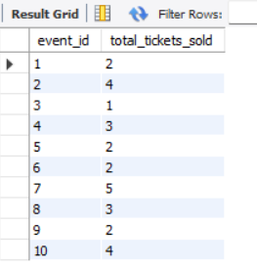

4. Find Users Who Have Not Booked Any Tickets Using a NOT EXISTS Subquery.

SELECT customer_id, customer_name FROM customer c WHERE NOT EXISTS (SELECT * FROM booking WHERE customer_id = c.customer_id);

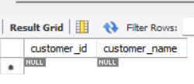

5. List Events with No Ticket Sales Using a NOT IN Subquery.

SELECT event_id, event_name FROM event WHERE event_id NOT IN (SELECT DISTINCT event_id FROM booking);

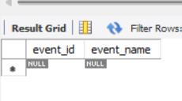

6. Calculate the Total Number of Tickets Sold for Each Event Type Using a Subquery in the FROM Clause.

SELECT event_type, SUM(total_tickets_sold) AS total_tickets_sold FROM (SELECT e.event_type, (SELECT SUM(num_tickets) FROM booking b WHERE b.event_id = e.event_id) AS total_tickets_sold FROM event e) AS subquery GROUP BY event_type;

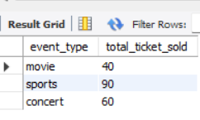

7. Find Events with Ticket Prices Higher Than the Average Ticket Price Using a Subquery in the WHERE Clause.

SELECT event_id, event_name, ticket_price FROM event WHERE ticket_price > (SELECT AVG(ticket_price) FROM event);

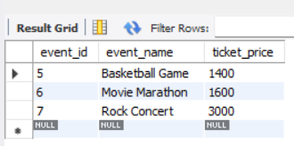

8. Calculate the Total Revenue Generated by Events for Each User Using a Correlated Subquery.

SELECT customer_id, (SELECT SUM(total_cost) FROM booking b WHERE b.customer_id = c.customer_id) AS total_revenue_generated FROM customer c;

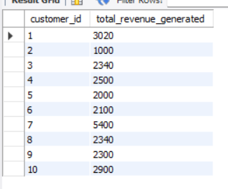

9. List Users Who Have Booked Tickets for Events in a Given Venue Using a Subquery in the WHERE Clause.

select customer_id, customer_name from Customer where customer_id in (select distinct customer_id from Booking where event_id in (select event_id from Event where venue_id = (select venue_id from Venue where venue_name = 'Venue A')));

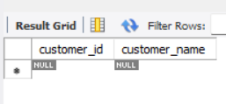

10. Calculate the Total Number of Tickets Sold for Each Event Category Using a Subquery with GROUP BY.

select event_type, sum(total_tickets_sold) as total_tickets_sold from (select event_type, event_id, (Select (num_tickets) from Booking where Booking.event_id = Event.event_id) as total_tickets_sold from event) as EventsByCategory group by event_type;

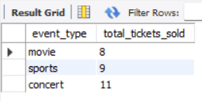

11. Find Users Who Have Booked Tickets for Events in each Month Using a Subquery with

DATE_FORMAT.

select c.customer_id, c.customer_name, (select b.booking_date from booking b where c.booking_id = b.booking_id) as booking_date from customer c order by booking_date;

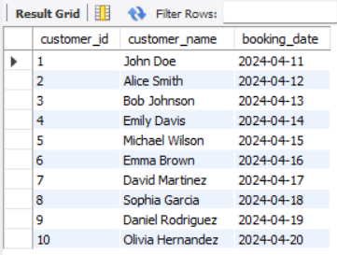

12. Calculate the Average Ticket Price for Events in Each Venue Using a Subquery.

SELECT venue_id, AVG(ticket_price) AS average_ticket_price FROM event GROUP BY venue_id;

