NAME: OSHINGBESAN ADEBAYO

ANDREWID: OAADEBAY

ASSIGNMENT NUMBER: 1

DATE: 07-SEP-2020

(1)

Since the initial thickness of the piece of paper is 1mm, folding the paper will get the fold thickness double to 2mm. Furthermore, additional folding will also double the thickness. In general, the relationship between the number of folds, n and the thickness is:

2n

Therefore, we are trying to obtain n such that:

2n  > 8 848 000

This relationship can be written as a while loop such that a count of how many times the loop runs with the break criteria being thickness < the height of Everest. When you solve the equation above, you will get n = 24.

(2)

While you can simply make t the subject of the formula and then solve for t, this equation can also be represented as a while loop such that the break value is v(t) > 0.5*v(0) while keeping track of the time t. Solving this gives 6.94.

(3)

By general knowledge, amount after compounding (A) can be obtained:

A = P(1+i)t

Since I = 0.05, this formula becomes:

A = P * (1.05)t

One can then write a function that takes in the principal (P) and time (t) and returns the amount after compounding. Since we are rounding to the nearest $, we can then use the round function in Python. Solving this, one obtains:

* $105.0 after year 1
* $110.0 after year 2
* $116.0 after year 3
* $122.0 after year 4
* $128.0 after year 5

(4)

By general knowledge, amount to be paid over a period is usually given as:

A = (i * P) / (1 – (1 + i)-t)

where A is the amount to be paid, P is the principal amount, i is the interest rate and t is the time

Since I = 0.01 and monthly and t = 12 * n when n is the number of years

A = 0.01P / (1 – 1.01)-12n)

Like question 3 above, one can write this in a function that takes in the principal amount and n is the number of years. Solving, one obtains:

* The monthly payment for one year is: $1777.0
* The monthly payment for two years is: $941.0
* The monthly payment for three years is: $664.0

(5)

We can set the initial cumulative profit to be -100,000 on day zero. We then store these values in two different lists. Setting initial customers on day 1 to be 100 and growth rate of 1%, customer number on any day n can be represented with:

Customers = Initial customers * 1.01n

The above equation can easily be written as a while loop where the customer number at each pass through the loop can be updated using the previous customer number * 1.01 and the cumulative profit will be customers * 10 – 100000 where the break criteria is when cumulative profit is less or equals to zero (the breakeven point). As seen in figure 1 below, the break-even day is **day 464**. We can clearly see that the relationship between cumulative profit and days in figure 1 is exponential in nature. This is expected because the number of customers which is responsible for the cumulative profit grows exponentially daily too.

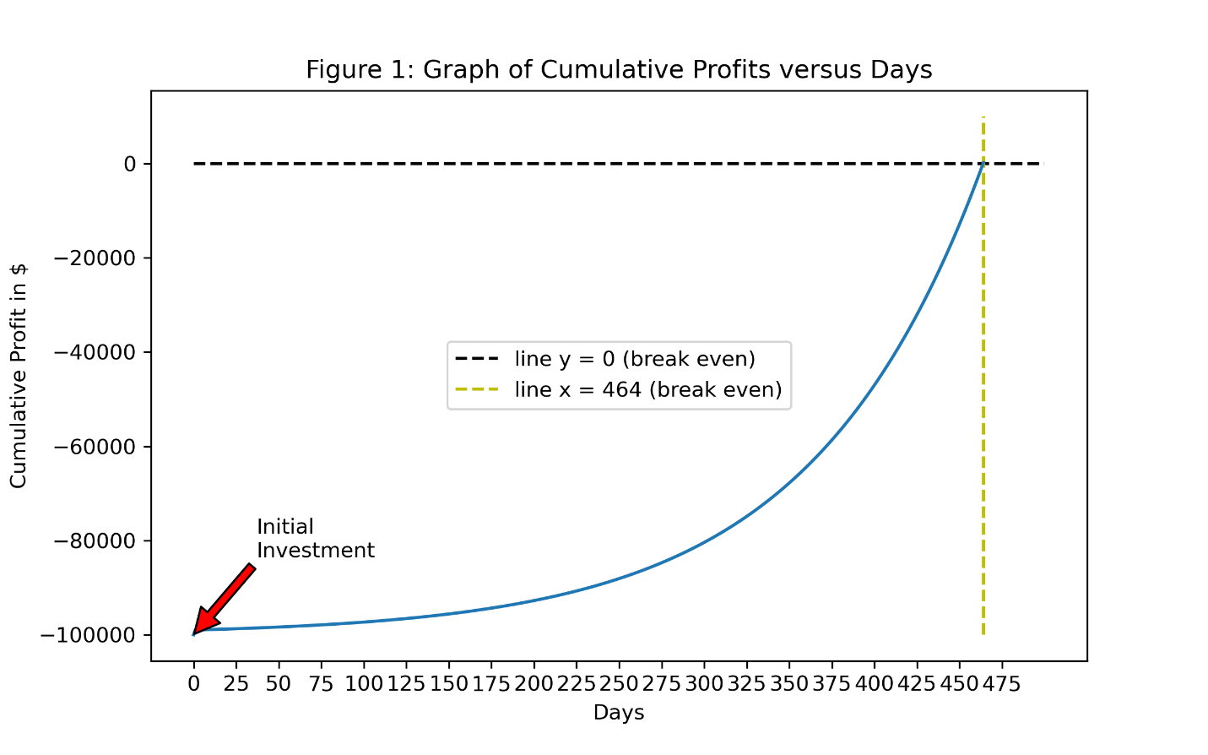

(6)

Figure 2 shows the graph of Ebola cases between 22-03-14 and 12-11-14 while Figure 3 shows the graph of Ebola cases deaths between 22-03-14 and 12-11-14. Using linear interpolation, the following dates were estimated:

* The date when Ebola cases exceeded 100 cases: 2014-03-27
* The date when Ebola cases exceeded 500 cases: 2014-06-13
* The date when Ebola cases exceeded 1000 cases: 2014-07-15
* The date when Ebola cases exceeded 2000 cases: 2014-08-12
* The date when Ebola cases exceeded 5000 cases: 2014-09-12
* The date when Ebola deaths exceeded 100 deaths: 2014-04-06
* The date when Ebola deaths exceeded 500 deaths: 2014-07-05
* The date when Ebola deaths exceeded 1000 deaths: 2014-08-09
* The date when Ebola deaths exceeded 2000 deaths: 2014-09-03
* The date when Ebola deaths exceeded 5000 deaths: 2014-10-24

In general, some form of exponential relationship can be seen between both the number of Ebola cases and death with time. This is usual for infectious diseases.

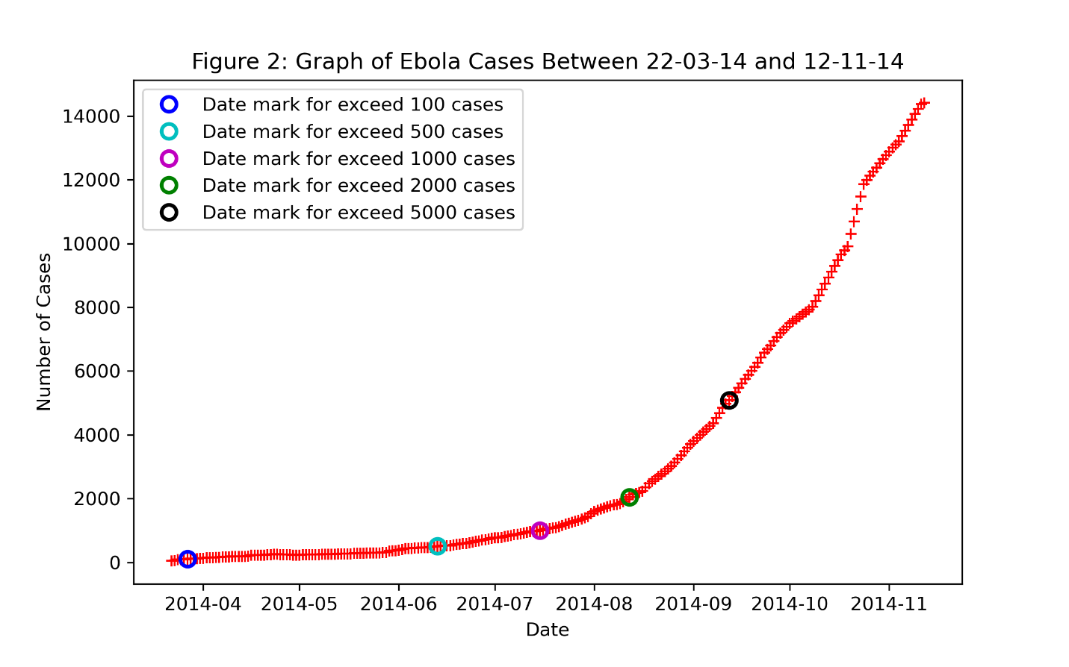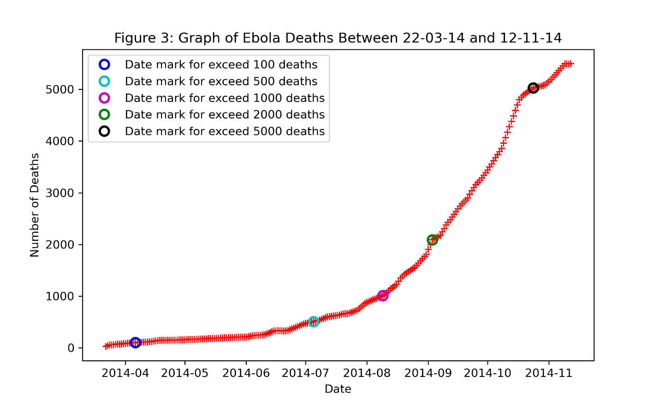

(7)

To calculate the growth rate one can use:

Growth rate = ((Cases on day t / Cases on day t-1) – 1)* 100

Using this formula, one would obtain the average growth per day to be 2.51% and 2.33% for ebola cases and deaths respectively.

(8)

Figure 4 shows the number of deaths versus the number of cases. While the average ratio of Ebola death to cases is 0.5578 ( roughly 14 deaths out of every 25 cases), one can also see the trend between the number of deaths and cases is almost linear with the latest sets of dates in the data deviating from this trend.

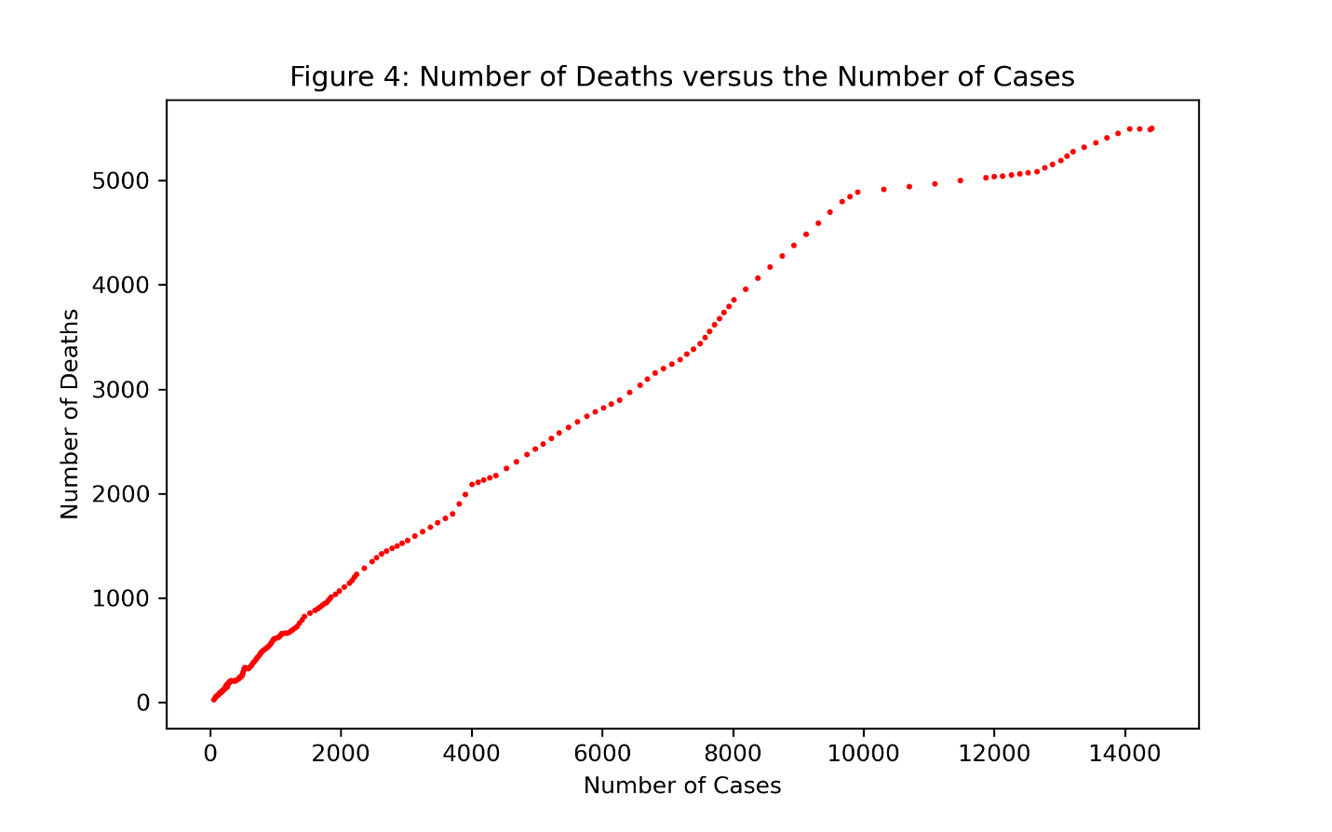

(9)

Figure 5 shows the normalized daily adjusted closing prices of S&P500 index and long-term treasury bonds from 01-01-2014 to 08-31-2015. To make them comparable, I divided the prices of each data with the first price in the data and multiplied by 100. One can easily see from figure 5 that TLT adjusted closing prices were consistently lower than the SPY adjusted closing prices. In general, both prices increased linearly over the time period with SPY suffering a significant dip in performance between December 2014 and August 2015.

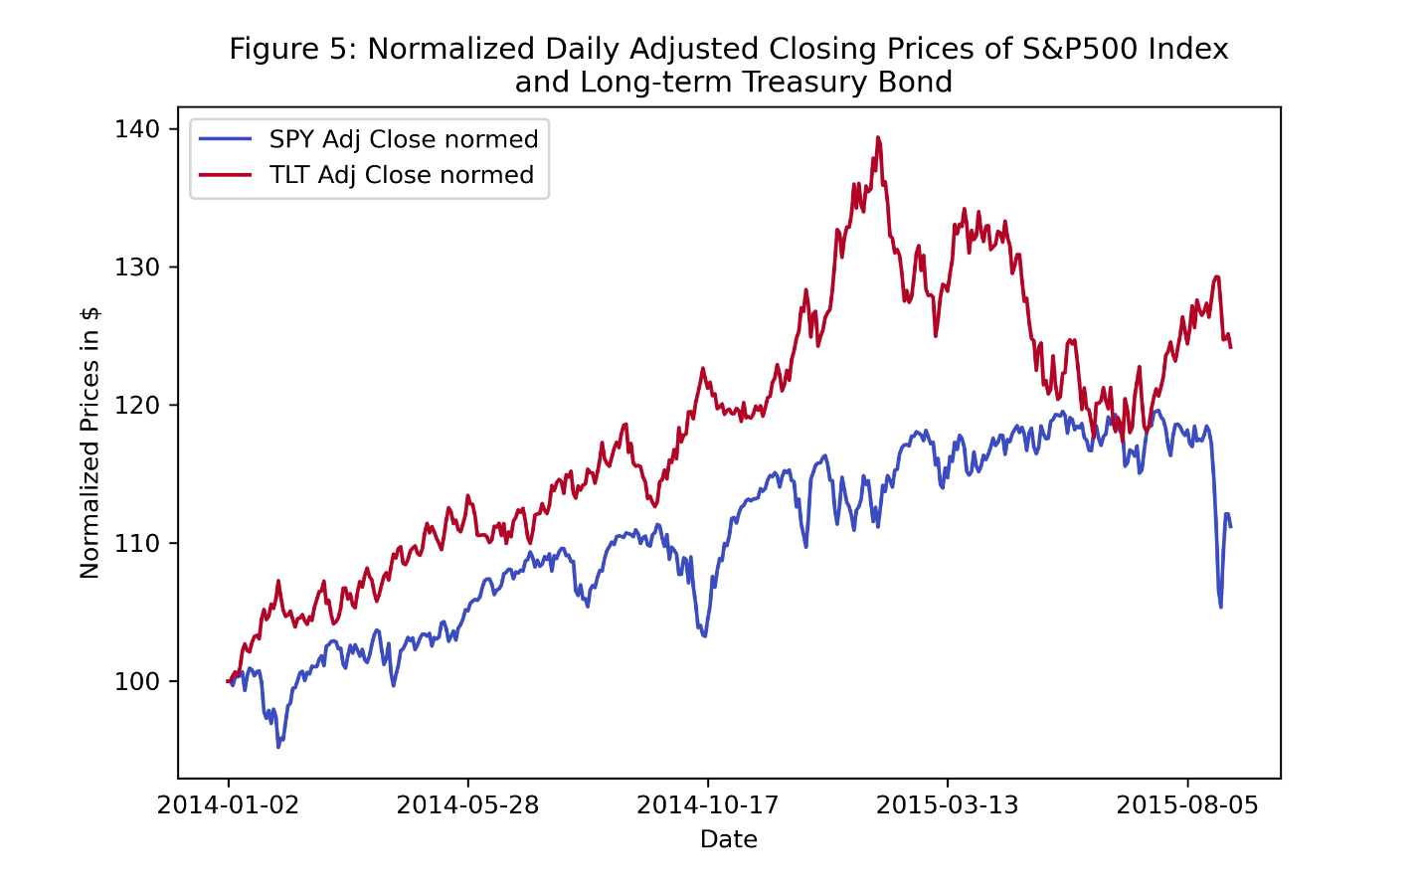

(10)

Table 1 shows the summary statistics (in %) for the daily return for S&P500 index and long-term treasury bonds from 01-01-2014 to 08-31-2015. One can easily tell from the table that SPY is more volatile daily than TLT. Also, TLT performed better over the period examined on average.

|  | **min** | **mean** | **max** |
| --- | --- | --- | --- |
| **SPY Adj Close Daily Returns (%)** | -4.210678 | 0.028612 | 3.839372 |
| **TLT Adj Close Daily Returns (%)** | -2.432472 | 0.055378 | 2.646892 |