TIC TAC TOE IMPLEMENTATION
board = [
['O', ' ', 'X'],
['X', ' ', ' '],
['X', 'O', 'O']
]

path_cost = 2

print("Initial State:")
for row in board:
print(row[0], "|", row[1], "|", row[2])

for i in range(3):
for j in range(3):

if board[i][j] == ' ':

board[i][j] = 'X'

print("\nNew State:")
for row in board:
print(row[0], "|", row[1], "|", row[2])

print("Path Cost =", path_cost)

if ((board[0][0] == board[0][1] == board[0][2] == 'X') or
(board[1][0] == board[1][1] == board[1][2] == 'X') or
(board[2][0] == board[2][1] == board[2][2] == 'X') or
(board[0][0] == board[1][0] == board[2][0] == 'X') or
(board[0][1] == board[1][1] == board[2][1] == 'X') or
(board[0][2] == board[1][2] == board[2][2] == 'X') or
(board[0][0] == board[1][1] == board[2][2] == 'X') or
(board[0][2] == board[1][1] == board[2][0] == 'X')):

print("X Wins!")

board[i][j] = ' '
OUTPUT
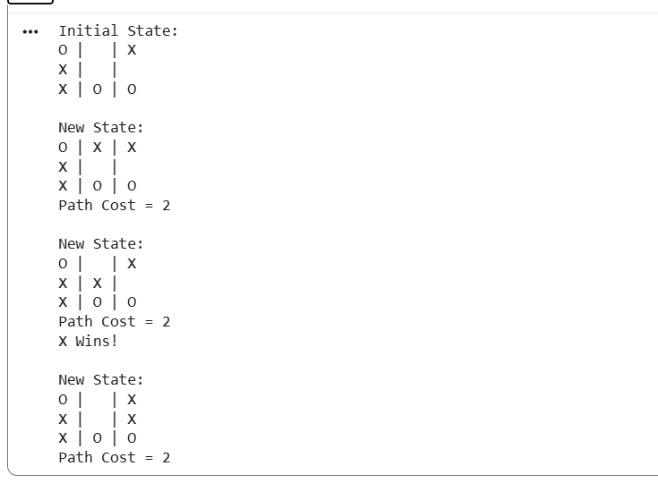

VACUUM CLEANER IMPLEMENTATION
import random
import time

# Initial environment
locations = {
'locA': random.choice(['Clean', 'Dirty']),
'locB': random.choice(['Clean', 'Dirty'])
}

current_location = random.choice(['locA', 'locB'])

print("--- Initial State ---")
print(f"Room A: {locations['locA']} | Room B: {locations['locB']}")
print(f"Vacuum starts in: {current_location}\n")

# 4-step cleaning loop
for step in range(1, 5):
print(f"[Step {step}] Vacuum is in {current_location}")

if locations[current_location] == 'Dirty':
print(f"Found dirt! Cleaning {current_location}...")
locations[current_location] = 'Clean'
else:
print(f"{current_location} is already clean.")

if current_location == 'locA':
print("Moving Right to locB...")
current_location = 'locB'
else:
print("Moving Left to locA...")
current_location = 'locA'

print(f"Current Status - Room A: {locations['locA']} | Room B: {locations['locB']}\n")
time.sleep(1)

print("--- Final Result ---")
print(f"Room A: {locations['locA']} | Room B: {locations['locB']}")
print("Cleaning complete!")
OUTPUT
