WEEK-3
1.a)#include<stdio.h>
int main()
{
int n,i,j,time=0,small;
int at[20],bt[20],ct[20],tat[20],wt[20],done[20]={0};
printf("Enter number of processes: ");
scanf("%d",&n);
for(i=0;i<n;i++)
{
printf("Enter AT and BT for P%d: ",i+1);
scanf("%d%d",&at[i],&bt[i]);
}
for(i=0;i<n;i++)
{
small=-1;
for(j=0;j<n;j++)
{
if(done[j]==0 && at[j]<=time)
{
if(small==-1 || bt[j]<bt[small])
small=j;
}
}
if(small==-1)
{
time++;
i--;
continue;
}
time+=bt[small];
ct[small]=time;
tat[small]=ct[small]-at[small];
wt[small]=tat[small]-bt[small];
done[small]=1;
}
printf("\nP\tAT\tBT\tCT\tTAT\tWT\n");
for(i=0;i<n;i++)
printf("P%d\t%d\t%d\t%d\t%d\t%d\n",i+1,at[i],bt[i],ct[i],tat[i],wt[i]);
return 0;
}
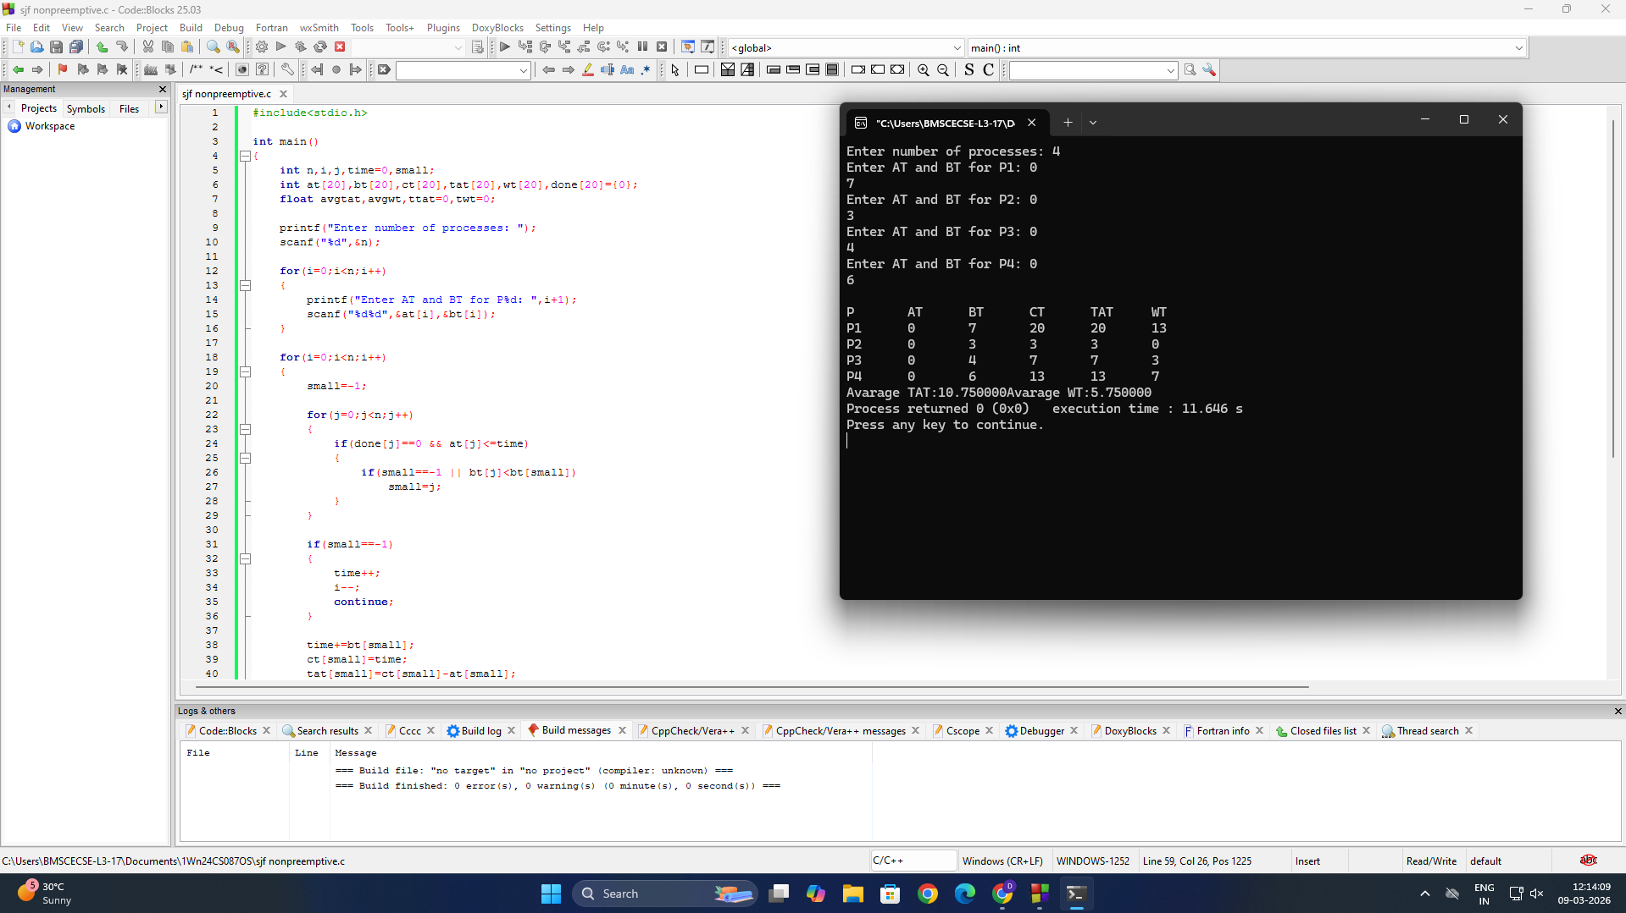

1.b)#include<stdio.h>
int main()
{
int n,i,time=0,remain,small;
int at[20],bt[20],rt[20],ct[20],tat[20],wt[20];
printf("Enter number of processes: ");
scanf("%d",&n);
remain=n;
for(i=0;i<n;i++)
{
printf("Enter AT and BT for P%d: ",i+1);
scanf("%d%d",&at[i],&bt[i]);
rt[i]=bt[i];
}
while(remain!=0)
{
small=-1;
for(i=0;i<n;i++)
{
if(at[i]<=time && rt[i]>0)
{
if(small==-1 || rt[i]<rt[small])
small=i;
}
}
if(small==-1)
{
time++;
continue;
}
rt[small]--;
time++;
if(rt[small]==0)
{
remain--;
ct[small]=time;
tat[small]=ct[small]-at[small];
wt[small]=tat[small]-bt[small];
}
}
printf("\nP\tAT\tBT\tCT\tTAT\tWT\n");
for(i=0;i<n;i++)
printf("P%d\t%d\t%d\t%d\t%d\t%d\n",i+1,at[i],bt[i],ct[i],tat[i],wt[i]);
return 0;
}

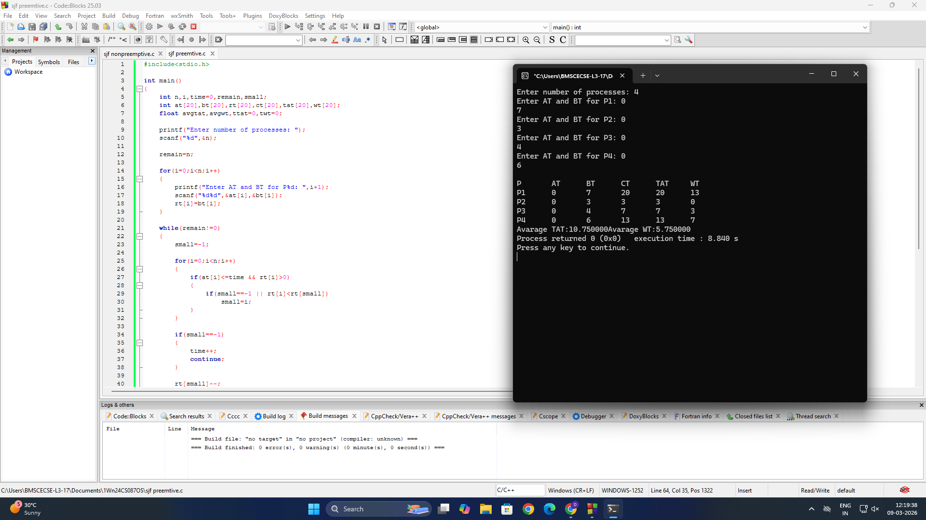

2.a)#include<stdio.h>
int main()
{
int n,i,j,time=0,high;
int at[20],bt[20],pr[20],ct[20],tat[20],wt[20],done[20]={0};
printf("Enter number of processes: ");
scanf("%d",&n);
for(i=0;i<n;i++)
{
printf("Enter AT BT Priority for P%d: ",i+1);
scanf("%d%d%d",&at[i],&bt[i],&pr[i]);
}
for(i=0;i<n;i++)
{
high=-1;
for(j=0;j<n;j++)
{
if(done[j]==0 && at[j]<=time)
{
if(high==-1 || pr[j]<pr[high])
high=j;
}
}
if(high==-1)
{
time++;
i--;
continue;
}
time+=bt[high];
ct[high]=time;
tat[high]=ct[high]-at[high];
wt[high]=tat[high]-bt[high];
done[high]=1;
}
printf("\nP\tAT\tBT\tPR\tCT\tTAT\tWT\n");
for(i=0;i<n;i++)
printf("P%d\t%d\t%d\t%d\t%d\t%d\t%d\n",
i+1,at[i],bt[i],pr[i],ct[i],tat[i],wt[i]);
return 0;
}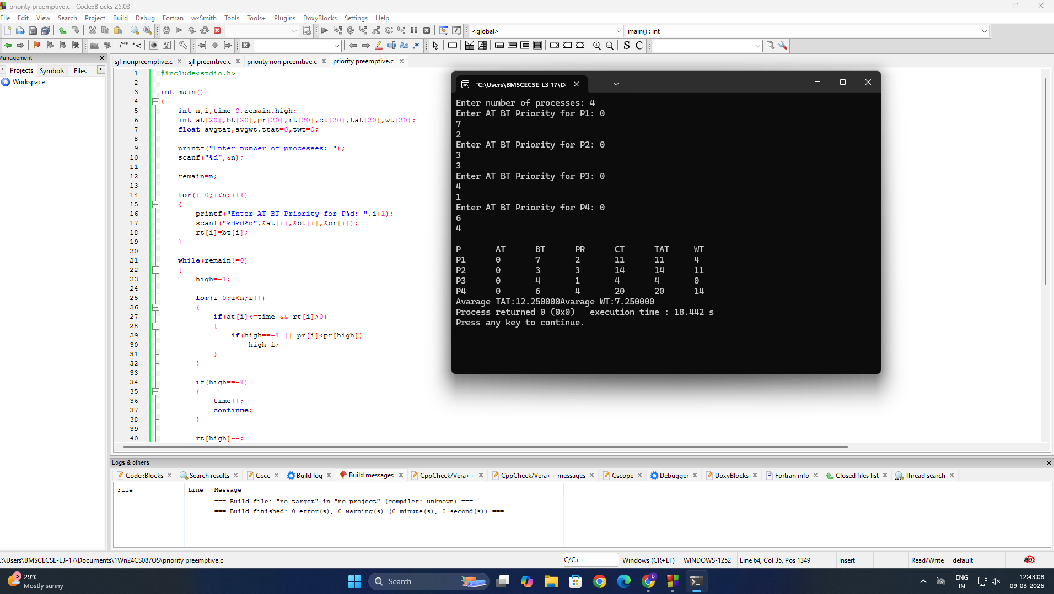

2.b)#include<stdio.h>
int main()
{
int n,i,time=0,remain,high;
int at[20],bt[20],pr[20],rt[20],ct[20],tat[20],wt[20];
printf("Enter number of processes: ");
scanf("%d",&n);
remain=n;
for(i=0;i<n;i++)
{
printf("Enter AT BT Priority for P%d: ",i+1);
scanf("%d%d%d",&at[i],&bt[i],&pr[i]);
rt[i]=bt[i];
}
while(remain!=0)
{
high=-1;
for(i=0;i<n;i++)
{
if(at[i]<=time && rt[i]>0)
{
if(high==-1 || pr[i]<pr[high])
high=i;
}
}
if(high==-1)
{
time++;
continue;
}
rt[high]--;
time++;
if(rt[high]==0)
{
remain--;
ct[high]=time;
tat[high]=ct[high]-at[high];
wt[high]=tat[high]-bt[high];
}
}
printf("\nP\tAT\tBT\tPR\tCT\tTAT\tWT\n");
for(i=0;i<n;i++)
printf("P%d\t%d\t%d\t%d\t%d\t%d\t%d\n",
i+1,at[i],bt[i],pr[i],ct[i],tat[i],wt[i]);
return 0;
}