Практическая работа №1
Приложение с типовой архитектурой JakartaEE
Общее задание
Вам необходимо разработать приложение, используя типовую архитектуру и технологии JakartaEE. Оно должно иметь три слоя (данные, логика, представление) и предоставлять средства для работы с базой данных (включая добавление, редактирование и удаление данных).
Настоятельно рекомендуется использовать систему контроля версий и управления исходным кодом (например, GitHub).
Вы можете выбрать любую IDE.
Но вы не можете использовать IDE для развёртывания проекта на сервере приложений. Развёртывание следует выполнять через консоль администратора или конфигурационные файлы сервера приложений.
Задание 1
Скачайте сервер приложений GlassFish или иной доступный вам сервер приложений.
Установите его.
Запустите сервер приложений.
Откройте консоль администратора и ознакомьтесь с её элементами управления.
Скачал сервер приложений WildFly.
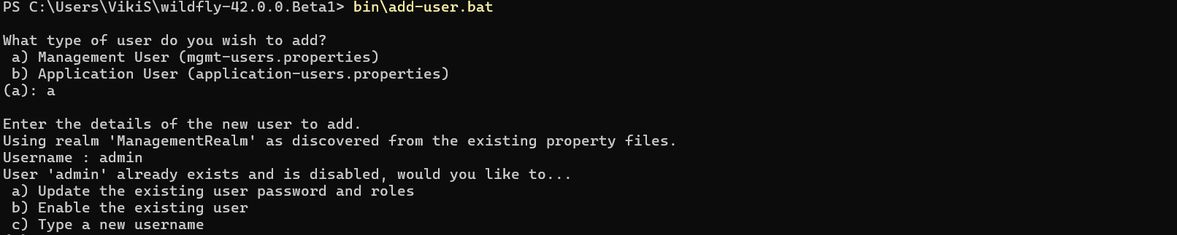
Начало его настройки

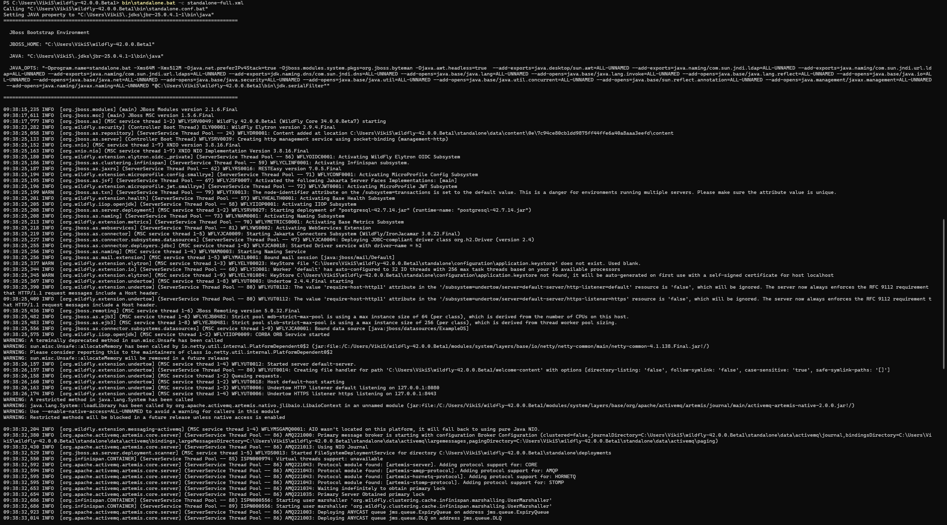
Скрин запуска сервера командой bin\standalone.bat -c standalone-full.xml
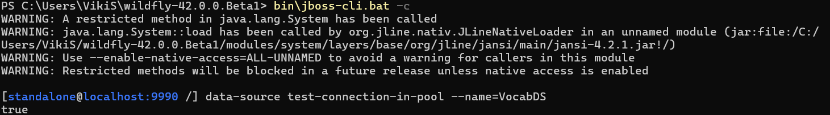
Скрин подключения к бд
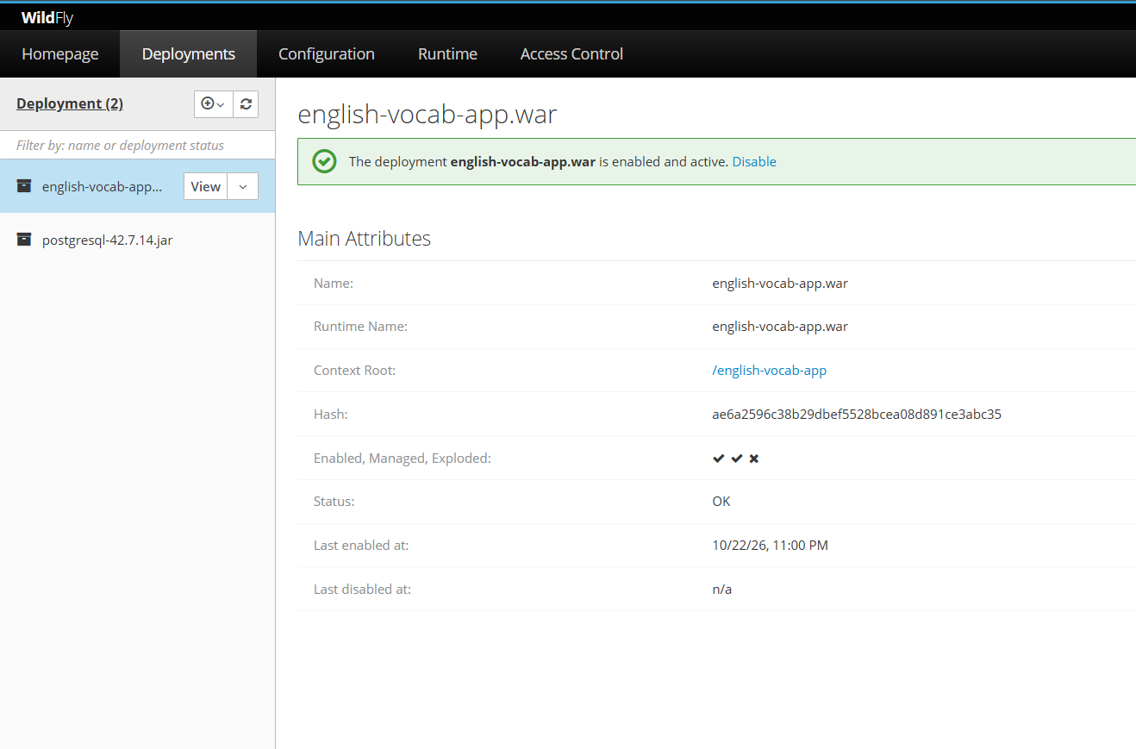
Поды в консоли разработчика widfly, ч1
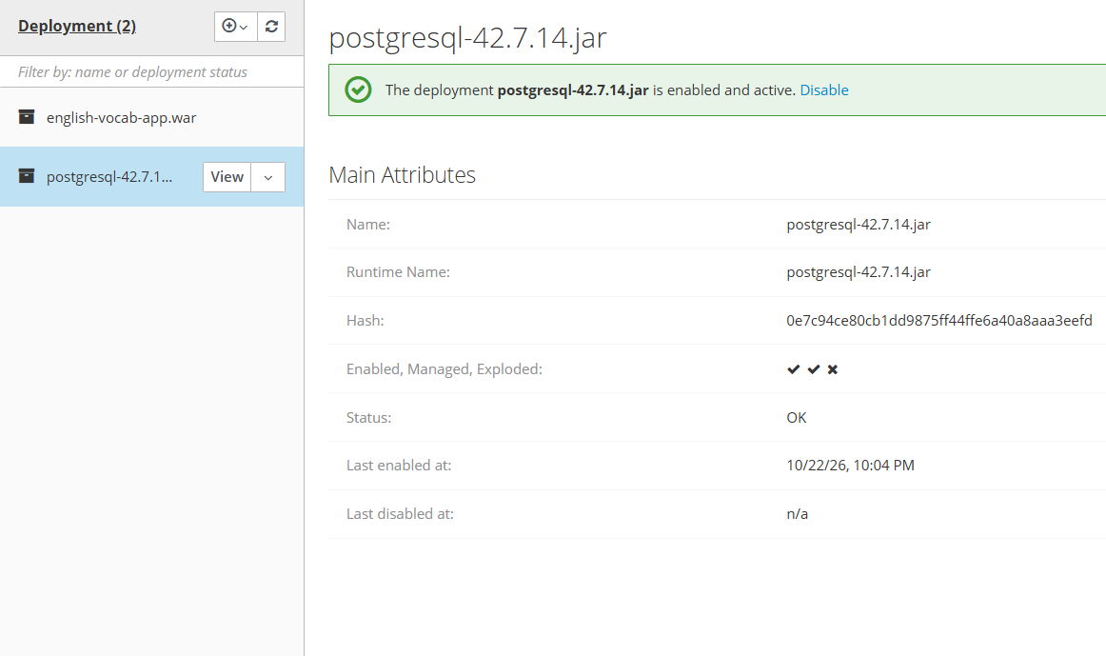
Поды в консоли разработчика widfly, ч1
2
Задание 2
Если у вас не установлена СУБД, установите её. Вы можете выбрать любую реляционную СУБД, но предпочтительна PostgreSQL.
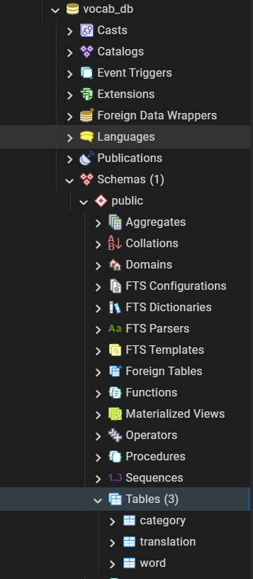
Скрин бд в pgadmin4

Задание 3
Выберите любую предметную область и разработайте модель, содержащую как минимум две сущности с несколькими свойствами. Сформируйте скрипт для создания и заполнения базы данных для вашей модели.

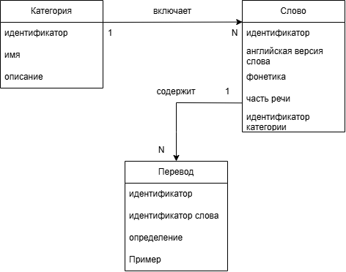
Диаграмма сущностей проекта - PDOM

CREATE TABLE category (
id BIGSERIAL PRIMARY KEY,
name VARCHAR(100) NOT NULL UNIQUE,
description VARCHAR(500)
);

CREATE TABLE word (
id BIGSERIAL PRIMARY KEY,
english_word VARCHAR(100) NOT NULL,
phonetics VARCHAR(100) NOT NULL,
part_of_speech VARCHAR(30) NOT NULL,
category_id BIGINT NOT NULL,
CONSTRAINT uq_word_lexical_entry
UNIQUE (english_word, phonetics, part_of_speech, category_id),
CONSTRAINT chk_word_part_of_speech
CHECK (part_of_speech IN (
'noun', 'verb', 'adjective', 'adverb', 'pronoun',
'preposition', 'conjunction', 'numeral', 'interjection', 'article'
)),
CONSTRAINT fk_word_category
FOREIGN KEY (category_id)
REFERENCES category(id)
ON DELETE RESTRICT
ON UPDATE CASCADE
);

CREATE TABLE translation (
id BIGSERIAL PRIMARY KEY,
word_id BIGINT NOT NULL,
meaning VARCHAR(200) NOT NULL,
example TEXT,
CONSTRAINT fk_translation_word
FOREIGN KEY (word_id)
REFERENCES word(id)
ON DELETE CASCADE
ON UPDATE CASCADE
);

CREATE INDEX idx_word_category ON word(category_id);
CREATE INDEX idx_translation_word ON translation(word_id);

INSERT INTO category (id, name, description) VALUES
(1, 'Food', 'Еда и напитки'),
(2, 'Travel', 'Путешествия и транспорт'),
(3, 'Business', 'Бизнес и работа'),
(4, 'General', 'Общая лексика'),
(5, 'Sports', 'Спорт');

INSERT INTO word (id, english_word, phonetics, part_of_speech, category_id) VALUES
(1, 'apple', '[ˈæp.əl]', 'noun', 1),
(2, 'banana', '[bəˈnɑː.nə]', 'noun', 1),
(3, 'ticket', '[ˈtɪk.ɪt]', 'noun', 2),
(4, 'airport', '[ˈeə.pɔːt]', 'noun', 2),
(5, 'meeting', '[ˈmiː.tɪŋ]', 'noun', 3),
(6, 'record', '[ˈrek.ɔːd]', 'noun', 4),
(7, 'record', '[rɪˈkɔːd]', 'verb', 4),
(8, 'run', '[rʌn]', 'verb', 4),
(9, 'light', '[laɪt]', 'noun', 4),
(10, 'light', '[laɪt]', 'adjective', 4),
(11, 'swim', '[swɪm]', 'verb', 5);

INSERT INTO translation (id, word_id, meaning, example) VALUES
(1, 1, 'яблоко', 'I eat an apple every day.'),
(2, 2, 'банан', 'Bananas are yellow.'),
(3, 3, 'билет', 'I need to buy a ticket.'),
(4, 3, 'штраф', 'He got a parking ticket.'),
(5, 4, 'аэропорт', 'The airport is far from the city.'),
(6, 5, 'встреча', 'We have a meeting at 3 p.m.'),
(7, 5, 'совещание', 'The meeting lasted two hours.'),
(8, 6, 'запись', 'She kept a record of every expense.'),
(9, 6, 'пластинка', 'He bought an old record.'),
(10, 7, 'записывать', 'Please record the interview.'),
(11, 8, 'бежать', 'I run every morning.'),
(12, 8, 'управлять (компанией)', 'She runs a successful company.'),
(13, 9, 'свет', 'The room was filled with light.'),
(14, 10, 'лёгкий', 'This bag is very light.'),
(15, 10, 'светлый', 'She has light hair.'),
(16, 11, 'плавать', 'I swim twice a week.');

SELECT setval('category_id_seq', (SELECT MAX(id) FROM category));
SELECT setval('word_id_seq', (SELECT MAX(id) FROM word));
SELECT setval('translation_id_seq', (SELECT MAX(id) FROM translation));

SELECT
c.name AS category,
w.english_word,
w.phonetics,
w.part_of_speech,
t.meaning,
t.example
FROM word w
JOIN category c ON c.id = w.category_id
JOIN translation t ON t.word_id = w.id
ORDER BY c.name, w.english_word, w.part_of_speech, t.id;
Задание 4
Разработайте слой данных в виде Java Beans для вашей модели и подготовьте их к использованию с Entity Persistence.
Слой данных таблицы word
package com.vocab.entity;
import jakarta.persistence.*;
import java.io.Serializable;
import java.util.ArrayList;
import java.util.List;
@Entity
@Table(name = "word")
public class Word implements Serializable {
private static final long serialVersionUID = 1L;
@Id
@GeneratedValue(strategy = GenerationType.IDENTITY)
private Long id;
@Column(name = "english_word", nullable = false, length = 100)
private String englishWord;
@Column(name = "phonetics", nullable = false, length = 100)
private String phonetics;
@Column(name = "part_of_speech", nullable = false, length = 50)
private String partOfSpeech;
@ManyToOne(fetch = FetchType.EAGER, optional = false)
@JoinColumn(name = "category_id", nullable = false)
private Category category;
@OneToMany(mappedBy = "word", cascade = CascadeType.ALL, orphanRemoval = true)
private List<Translation> translations = new ArrayList<>();
public Word() {
}
public Long getId() {
return id;
}
public void setId(Long id) {
this.id = id;
}
public String getEnglishWord() {
return englishWord;
}
public void setEnglishWord(String englishWord) {
this.englishWord = englishWord;
}
public String getPhonetics() {
return phonetics;
}
public void setPhonetics(String phonetics) {
this.phonetics = phonetics;
}
public String getPartOfSpeech() {
return partOfSpeech;
}
public void setPartOfSpeech(String partOfSpeech) {
this.partOfSpeech = partOfSpeech;
}
public Category getCategory() {
return category;
}
public void setCategory(Category category) {
this.category = category;
}
public List<Translation> getTranslations() {
return translations;
}
public void setTranslations(List<Translation> translations) {
this.translations = translations;
}
}

Слой данных таблицы category
package com.vocab.entity;
import jakarta.persistence.*;
import java.io.Serializable;
import java.util.ArrayList;
import java.util.List;
@Entity
@Table(name = "category")
public class Category implements Serializable {
private static final long serialVersionUID = 1L;
@Id
@GeneratedValue(strategy = GenerationType.IDENTITY)
private Long id;
@Column(name = "name", nullable = false, unique = true, length = 100)
private String name;
@Column(name = "description", length = 500)
private String description;
@OneToMany(mappedBy = "category")
private List<Word> words = new ArrayList<>();
public Category() {
}
public Long getId() {
return id;
}
public void setId(Long id) {
this.id = id;
}
public String getName() {
return name;
}
public void setName(String name) {
this.name = name;
}
public String getDescription() {
return description;
}
public void setDescription(String description) {
this.description = description;
}
public List<Word> getWords() {
return words;
}
public void setWords(List<Word> words) {
this.words = words;
}
}

Слой данных таблицы translation
package com.vocab.entity;
import jakarta.persistence.*;
import java.io.Serializable;
@Entity
@Table(name = "translation")
public class Translation implements Serializable {
private static final long serialVersionUID = 1L;
@Id
@GeneratedValue(strategy = GenerationType.IDENTITY)
private Long id;
@ManyToOne(fetch = FetchType.EAGER, optional = false)
@JoinColumn(name = "word_id", nullable = false)
private Word word;
@Column(name = "meaning", nullable = false, length = 200)
private String meaning;
@Column(name = "example")
private String example;
public Translation() {
}
public Long getId() {
return id;
}
public void setId(Long id) {
this.id = id;
}
public Word getWord() {
return word;
}
public void setWord(Word word) {
this.word = word;
}
public String getMeaning() {
return meaning;
}
public void setMeaning(String meaning) {
this.meaning = meaning;
}
public String getExample() {
return example;
}
public void setExample(String example) {
this.example = example;
}
}

Задание 5
Реализуйте бизнес-слой на основе сессионных EJB-компонентов для доступа к данным и их редактирования.
WordEJB
package com.vocab.ejb;
import com.vocab.entity.Category;
import com.vocab.entity.Translation;
import com.vocab.entity.Word;
import jakarta.ejb.EJBException;
import jakarta.ejb.Stateless;
import jakarta.persistence.EntityManager;
import jakarta.persistence.PersistenceContext;
import java.util.List;
import java.util.Set;
@Stateless
public class WordEJB {
private static final Set<String> PARTS_OF_SPEECH = Set.of(
"noun", "verb", "adjective", "adverb",
"pronoun", "preposition", "conjunction", "interjection"
);
@PersistenceContext(unitName = "vocabPU")
private EntityManager em;
public List<Word> findPaged(int firstResult, int maxResults) {
return em.createQuery(
"select distinct w from Word w " +
"join fetch w.category left join fetch w.translations " +
"order by w.englishWord", Word.class)
.setFirstResult(firstResult)
.setMaxResults(maxResults)
.getResultList();
}
public long count() {
return em.createQuery("select count(w) from Word w", Long.class).getSingleResult();
}
public List<Word> search(String query, int firstResult, int maxResults) {
if (query == null || query.trim().isEmpty()) {
return findPaged(firstResult, maxResults);
}
return em.createQuery(
"select distinct w from Word w " +
"join fetch w.category left join fetch w.translations " +
"where lower(w.englishWord) like lower(:query) " +
"order by w.englishWord", Word.class)
.setParameter("query", "%" + query.trim() + "%")
.setFirstResult(firstResult)
.setMaxResults(maxResults)
.getResultList();
}
public long countSearch(String query) {
if (query == null || query.trim().isEmpty()) {
return count();
}
return em.createQuery(
"select count(w) from Word w where lower(w.englishWord) like lower(:query)", Long.class)
.setParameter("query", "%" + query.trim() + "%")
.getSingleResult();
}
public Long createWordWithTranslation(String englishWord, String phonetics, String partOfSpeech,
Long categoryId, String meaning, String example) {
validate(englishWord, phonetics, partOfSpeech);
if (meaning == null || meaning.isBlank()) {
throw new EJBException("Перевод (значение) обязателен при создании слова");
}
Word word = new Word();
word.setEnglishWord(englishWord.trim());
word.setPhonetics(phonetics.trim());
word.setPartOfSpeech(partOfSpeech);
word.setCategory(resolveCategory(categoryId));
em.persist(word);
Translation translation = new Translation();
translation.setWord(word);
translation.setMeaning(meaning.trim());
translation.setExample(example);
em.persist(translation);
return word.getId();
}
public void updateWordWithTranslation(Long id, String englishWord, String phonetics,
String partOfSpeech, Long categoryId,
Long translationId, String meaning, String example) {
Word word = em.find(Word.class, id);
if (word == null) throw new EJBException("Слово не найдено: " + id);
validate(englishWord, phonetics, partOfSpeech);
word.setEnglishWord(englishWord.trim());
word.setPhonetics(phonetics.trim());
word.setPartOfSpeech(partOfSpeech);
word.setCategory(resolveCategory(categoryId));
Translation translation = (translationId != null) ? em.find(Translation.class, translationId) : null;
if (translation == null) {
translation = new Translation();
translation.setWord(word);
}
translation.setMeaning(meaning != null ? meaning.trim() : "");
translation.setExample(example);
if (translation.getId() == null) {
em.persist(translation);
}
}
public Word find(Long id) {
List<Word> result = em.createQuery(
"select w from Word w " +
"left join fetch w.category " +
"left join fetch w.translations " +
"where w.id = :id", Word.class)
.setParameter("id", id)
.getResultList();
return result.isEmpty() ? null : result.get(0);
}
public void delete(Long id) {
Word word = em.find(Word.class, id);
if (word != null) {
em.remove(word);
}
}
private Category resolveCategory(Long categoryId) {
if (categoryId == null) throw new EJBException("Выберите категорию");
Category category = em.find(Category.class, categoryId);
if (category == null) throw new EJBException("Категория не найдена: " + categoryId);
return category;
}
private void validate(String englishWord, String phonetics, String partOfSpeech) {
if (englishWord == null || englishWord.isBlank()) throw new EJBException("Слово не может быть пустым");
if (phonetics == null || phonetics.isBlank()) throw new EJBException("Транскрипция не может быть пустой");
if (partOfSpeech == null || !PARTS_OF_SPEECH.contains(partOfSpeech)) throw new EJBException("Некорректная часть речи");
}
}

CategoryEJB
package com.vocab.ejb;
import com.vocab.entity.Category;
import jakarta.ejb.EJBException;
import jakarta.ejb.Stateless;
import jakarta.persistence.EntityManager;
import jakarta.persistence.PersistenceContext;
import java.util.List;
@Stateless
public class CategoryEJB {
@PersistenceContext(unitName = "vocabPU")
private EntityManager em;
public List<Category> findAll() {
return em.createQuery("select c from Category c order by c.name", Category.class).getResultList();
}
public Category find(Long id) {
return id == null ? null : em.find(Category.class, id);
}
public Long create(String name, String description) {
if (name == null || name.trim().isEmpty()) {
throw new EJBException("Название категории обязательно");
}
Category category = new Category();
category.setName(name.trim());
category.setDescription(description != null ? description.trim() : "");
em.persist(category);
return category.getId();
}
public void update(Long id, String name, String description) {
Category category = em.find(Category.class, id);
if (category == null) {
throw new EJBException("Категория не найдена: " + id);
}
if (name == null || name.trim().isEmpty()) {
throw new EJBException("Название категории обязательно");
}
category.setName(name.trim());
category.setDescription(description != null ? description.trim() : "");
}
public void delete(Long id) {
Category category = em.find(Category.class, id);
if (category != null) {
try {
em.remove(category);
} catch (Exception e) {
throw new EJBException("Невозможно удалить категорию: в ней есть слова. Сначала удалите или перенесите слова.");
}
}
}
}

TranslationEJB
package com.vocab.ejb;
import com.vocab.entity.Translation;
import com.vocab.entity.Word;
import jakarta.ejb.EJBException;
import jakarta.ejb.Stateless;
import jakarta.persistence.EntityManager;
import jakarta.persistence.PersistenceContext;
import java.util.List;
@Stateless
public class TranslationEJB {
@PersistenceContext(unitName = "vocabPU")
private EntityManager em;
public List<Translation> findAll() {
return em.createQuery(
"select distinct t from Translation t " +
"join fetch t.word join fetch t.word.category " +
"order by t.word.englishWord, t.id", Translation.class
).getResultList();
}
public Long create(Long wordId, String meaning, String example) {
Word word = resolveWord(wordId);
validateMeaning(meaning);
Translation translation = new Translation();
translation.setWord(word);
translation.setMeaning(meaning.trim());
translation.setExample(example);
em.persist(translation);
return translation.getId();
}
public void update(Long id, Long wordId, String meaning, String example) {
Translation translation = em.find(Translation.class, id);
if (translation == null) {
throw new EJBException("Перевод не найден: " + id);
}
validateMeaning(meaning);
translation.setWord(resolveWord(wordId));
translation.setMeaning(meaning.trim());
translation.setExample(example);
}
public void delete(Long id) {
Translation translation = em.find(Translation.class, id);
if (translation != null) {
em.remove(translation);
}
}
private Word resolveWord(Long wordId) {
if (wordId == null) {
throw new EJBException("Выберите слово");
}
Word word = em.find(Word.class, wordId);
if (word == null) {
throw new EJBException("Слово не найдено: " + wordId);
}
return word;
}
private void validateMeaning(String meaning) {
if (meaning == null || meaning.isBlank()) {
throw new EJBException("Перевод не может быть пустым");
}
}
}

Задание 6
Реализуйте слой представления, используя любую подходящую технологию на ваш выбор.
package com.vocab.web;
import com.vocab.ejb.CategoryEJB;
import com.vocab.ejb.TranslationEJB;
import com.vocab.ejb.WordEJB;
import com.vocab.entity.Category;
import com.vocab.entity.Translation;
import com.vocab.entity.Word;
import jakarta.annotation.PostConstruct;
import jakarta.ejb.EJB;
import jakarta.faces.view.ViewScoped;
import jakarta.inject.Named;
import java.io.Serializable;
import java.util.List;
@Named("vocab")
@ViewScoped
public class VocabularyBean implements Serializable {
private static final long serialVersionUID = 1L;
private Category categoryForm = new Category();
private Long editingCategoryId;
@EJB private WordEJB wordEJB;
@EJB private TranslationEJB translationEJB;
@EJB private CategoryEJB categoryEJB;
private List<Word> words;
private List<Category> categories;
private List<String> partsOfSpeech = List.of("noun", "verb", "adjective", "adverb", "pronoun", "preposition", "conjunction", "interjection");
private int page = 1;
private int pageSize = 5;
private long totalElements = 0;
private String searchQuery = "";
private Word wordForm = new Word();
private Long categoryId;
private Long editingWordId;
private Long editingTranslationId;
private String primaryMeaning = "";
private String primaryExample = "";
@PostConstruct
public void init() {
categories = categoryEJB.findAll();
loadPage();
}
private void loadPage() {
int firstResult = (page - 1) * pageSize;
if (searchQuery != null && !searchQuery.trim().isEmpty()) {
words = wordEJB.search(searchQuery, firstResult, pageSize);
totalElements = wordEJB.countSearch(searchQuery);
} else {
words = wordEJB.findPaged(firstResult, pageSize);
totalElements = wordEJB.count();
}
}
public int getTotalPages() {
return (int) Math.ceil((double) totalElements / pageSize);
}
public void nextPage() {
if (page < getTotalPages()) {
page++;
loadPage();
}
}
public void prevPage() {
if (page > 1) {
page--;
loadPage();
}
}
public void search() {
page = 1;
loadPage();
}
public void resetSearch() {
searchQuery = "";
page = 1;
loadPage();
}
public void prepareNewWord() {
resetWordForm();
}
public void editWord(Long id) {
Word found = wordEJB.find(id);
editingWordId = id;
wordForm = new Word();
wordForm.setEnglishWord(found.getEnglishWord());
wordForm.setPhonetics(found.getPhonetics());
wordForm.setPartOfSpeech(found.getPartOfSpeech());
categoryId = found.getCategory().getId();
if (found.getTranslations() != null && !found.getTranslations().isEmpty()) {
Translation t = found.getTranslations().get(0);
editingTranslationId = t.getId();
primaryMeaning = t.getMeaning();
primaryExample = t.getExample();
} else {
editingTranslationId = null;
primaryMeaning = "";
primaryExample = "";
}
}
public void saveWord() {
if (editingWordId == null) {
wordEJB.createWordWithTranslation(wordForm.getEnglishWord(), wordForm.getPhonetics(),
wordForm.getPartOfSpeech(), categoryId, primaryMeaning, primaryExample);
} else {
wordEJB.updateWordWithTranslation(editingWordId, wordForm.getEnglishWord(), wordForm.getPhonetics(),
wordForm.getPartOfSpeech(), categoryId, editingTranslationId, primaryMeaning, primaryExample);
}
resetWordForm();
loadPage();
}
public void deleteWord(Long id) {
wordEJB.delete(id);
if (words.size() == 1 && page > 1) {
page--;
}
loadPage();
}
public void cancelWordEdit() {
resetWordForm();
}
private void resetWordForm() {
editingWordId = null;
editingTranslationId = null;
categoryId = null;
primaryMeaning = "";
primaryExample = "";
wordForm = new Word();
wordForm.setPartOfSpeech("noun");
}
public List<Word> getWords() { return words; }
public List<Category> getCategories() { return categories; }
public List<String> getPartsOfSpeech() { return partsOfSpeech; }
public int getPage() { return page; }
public int getPageSize() { return pageSize; }
public long getTotalElements() { return totalElements; }
public String getSearchQuery() { return searchQuery; }
public void setSearchQuery(String searchQuery) { this.searchQuery = searchQuery; }
public Word getWordForm() { return wordForm; }
public Long getCategoryId() { return categoryId; }
public void setCategoryId(Long categoryId) { this.categoryId = categoryId; }
public Long getEditingWordId() { return editingWordId; }
public String getPrimaryMeaning() { return primaryMeaning; }
public void setPrimaryMeaning(String primaryMeaning) { this.primaryMeaning = primaryMeaning; }
public String getPrimaryExample() { return primaryExample; }
public void setPrimaryExample(String primaryExample) { this.primaryExample = primaryExample; }
public void prepareNewCategory() {
editingCategoryId = null;
categoryForm = new Category();
}
public void editCategory(Long id) {
Category found = categoryEJB.find(id);
editingCategoryId = id;
categoryForm = new Category();
categoryForm.setName(found.getName());
categoryForm.setDescription(found.getDescription());
}
public void saveCategory() {
if (editingCategoryId == null) {
categoryEJB.create(categoryForm.getName(), categoryForm.getDescription());
} else {
categoryEJB.update(editingCategoryId, categoryForm.getName(), categoryForm.getDescription());
}
cancelCategoryEdit();
categories = categoryEJB.findAll();
}
public void deleteCategory(Long id) {
categoryEJB.delete(id);
categories = categoryEJB.findAll();
}
public void cancelCategoryEdit() {
editingCategoryId = null;
categoryForm = new Category();
}
public Category getCategoryForm() { return categoryForm; }
public Long getEditingCategoryId() { return editingCategoryId; }
}

Задание 7
Добейтесь того, чтобы всё это вместе заработало…
Заработало на localhost:8080.
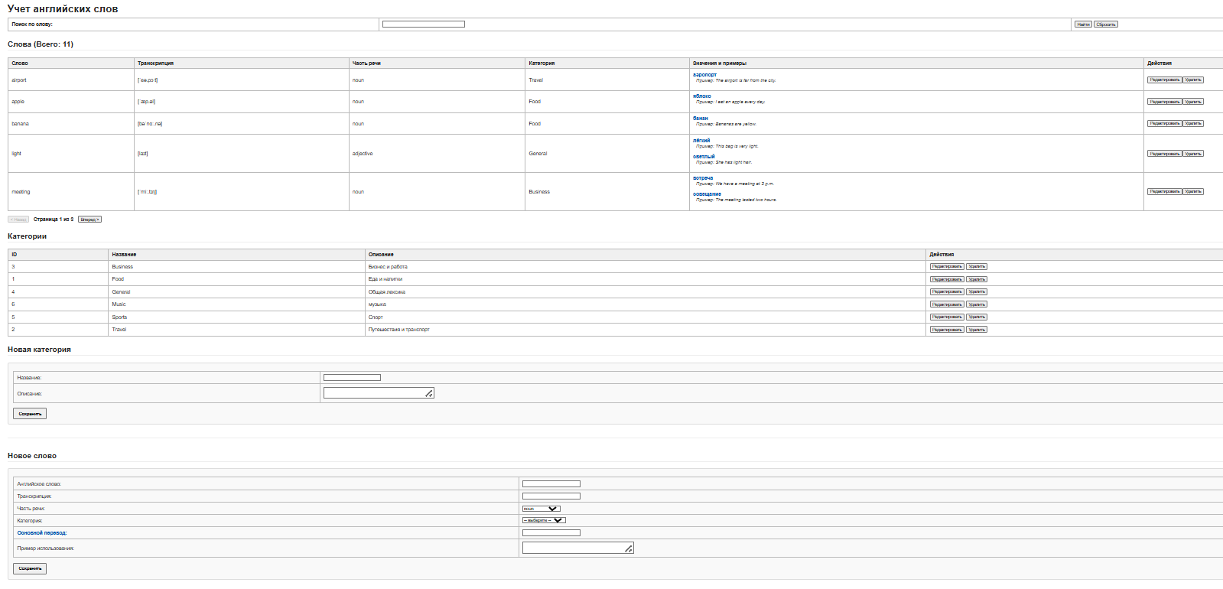
Общий вид
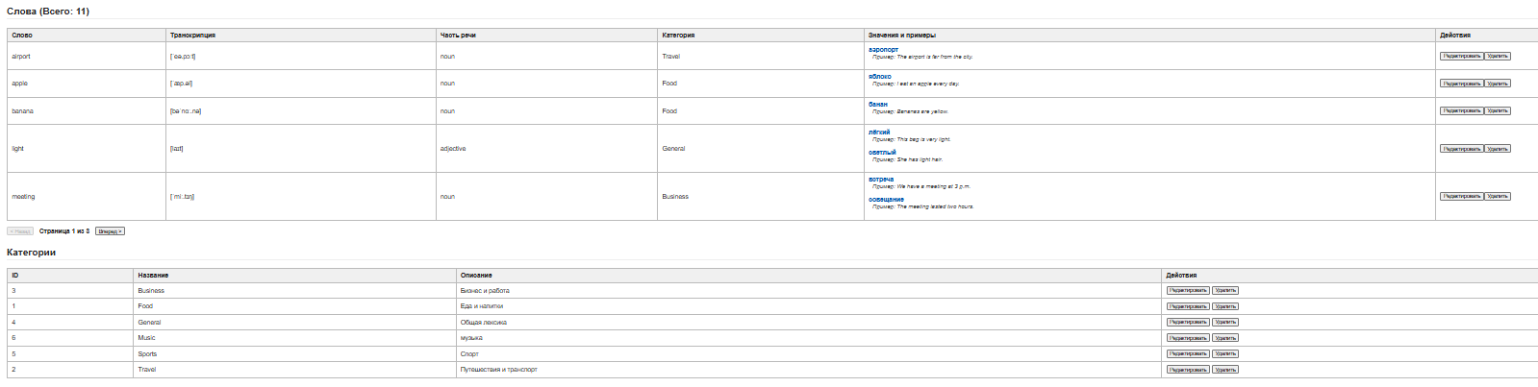
Пагинация
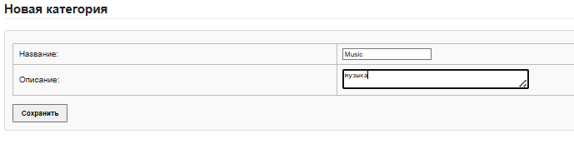
Добавление новой категории
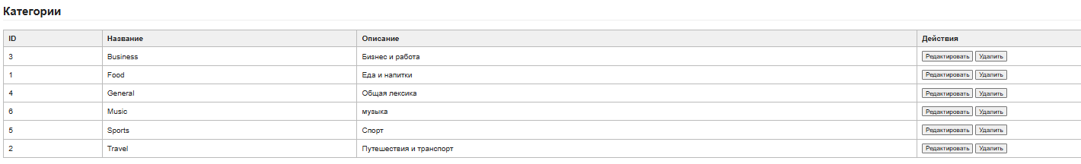
Отображение добавленной новой категории
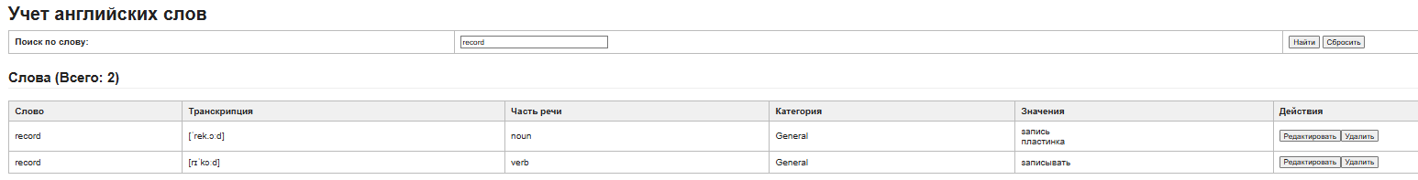
Поиск по слову
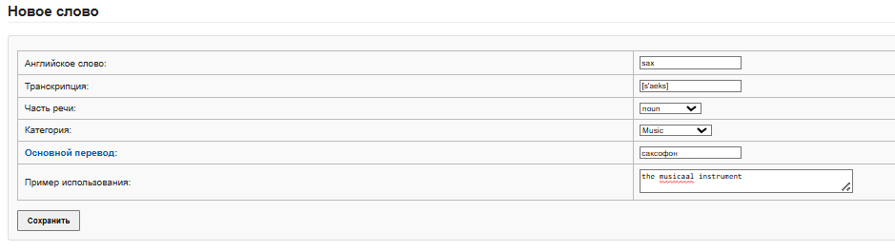
Добавление нового слова
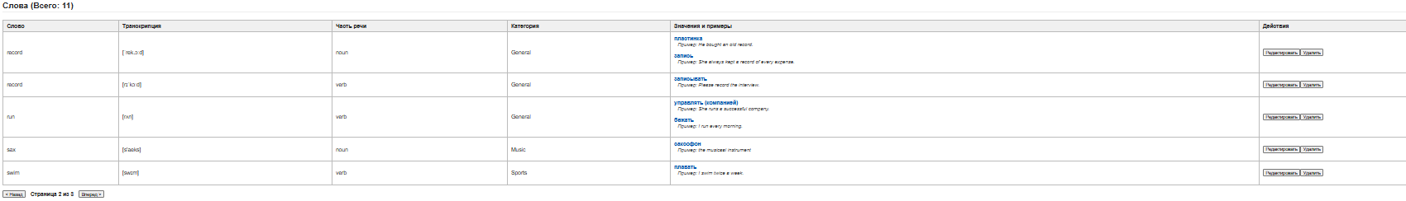
Показ нового слова

