Hybrid Technique Using Traditional and Deep Learning-Based Method for Underwater Image Enhancement

Alain
1st author's affiliation
1st line of address
2nd line of address
Telephone number, incl. country code
1st author's E-mail address

Roni Inocencio
2nd author's affiliation
1st line of address
2nd line of address
Telephone number, incl. country code
2nd E-mail

Ann Margaret J. Siquioco
Polytechnic University of the Philippines
Ramona Apartment, Barangka Drive
Mandaluyong City
+639955238623
ann.siquioco@gmail.com

Aeron Brylle R. Lazo
Polytechnic University of the Philippines, Manila
1st line of address
Muntinlupa City
Telephone number, incl. country code
3rd E-mail

ABSTRACT
The proposed hybrid method aimed to address the existing challenges in current underwater image enhancement techniques, including color distortion, contrast, texture, visual artifacts, and sharpness. To evaluate its performance, the proposed method was compared with the Two-Step Approach, TEBCF, and WaterNet methods, utilizing both qualitative and quantitative assessments of image quality.
The results demonstrated that the proposed method outperformed the other methods in terms of removing visual artifacts and improving image sharpness. It achieved the lowest Mean Squared Error (MSE) of 98.7762 and the highest Peak Signal-to-Noise Ratio (PSNR) of 28.2434. The Structural Similarity Index (SSIM) value for the proposed method was 0.82, which ranked second after the WaterNet method. Regarding the Underwater Image Quality Measure (UIQM) and Texture Analysis Assessment (TAA), the proposed method ranked third (0.7936) and last (0.7765), respectively.
In conclusion, the proposed method exhibited remarkable performance in removing unwanted artifacts, graininess, and noise compared to the other three methods. It also proved to be highly effective in color correction, resulting in visually appealing underwater images. Additionally, the proposed method demonstrated improvements in image contrast and sharpness.
Conference’10, Month 1–2, 2010, City, State, Country.
Copyright 2010 ACM 1-58113-000-0/00/0010 …$15.00.

Permission to make digital or hard copies of all or part of this work for personal or classroom use is granted without fee provided that copies are not made or distributed for profit or commercial advantage and that copies bear this notice and the full citation on the first page. To copy otherwise, or republish, to post on servers or to redistribute to lists, requires prior specific permission and/or a fee.

Categories and Subject Descriptors
D.3.3 [Programming Languages]: Language Constructs and Features – abstract data types, polymorphism, control structures. This is just an example, please use the correct category and subject descriptors for your submission. The ACM Computing Classification Scheme: http://www.acm.org/class/1998/
General Terms
Hybrid Technique, Mean Opinion Score, Observers, Quality Image Assessment, Quantitative Image Quality Assessment, Texture Filtering, Texture Information, Traditional Methods, UIEBD.
Keywords
Underwater Image Enhancement, Hybrid Technique, Deep Learning, Texture Smoothing, Image Quality Assessment

INTRODUCTION
Underwater images are important across various domains of technology and scientific research. Marine researchers and engineers greatly benefit from its applications, particularly in underwater surveillance, resource exploitation, oceanic geological exploration, and computer vision tasks like object recognition, surface defect detection, and pattern recognition. As underwater technology advances, exploring submerged archaeological sites to uncover cultural heritage inventories and monitoring coral reefs for environmental purposes is becoming increasingly expensive.
The absorption and polarization of light, when passed through water, causes underwater degradation. Colors degrade due to the different light wavelengths that travel in water. Red wavelengths are the first to be absorbed, followed by green and blue. It causes underwater images to appear greenish-blue in color. Additionally, limited visibility range and depth, bright artifacts and flickering effects, the presence of particles, and other biological activities also cause underwater image degradation (Bhadouria, 2022).
Over the years, numerous techniques for enhancing underwater images have been developed. Dark channel prior (DCP), commonly used to recover haze-free images, enhanced underwater images since an underwater environment is similar to an outdoor foggy environment (He et al., 2019). Since the DCP is based on the red, blue, and green channels, the resulting restored outcome could be better as this method tends to select the red channel as the dark channel because of erroneous transmittance estimation. To solve this problem, the underwater dark channel prior (UDCP) and the red, dark channel prior (RDCL) were introduced to solve this problem.
Other traditional methods that are not DCP-based are Contrast Stretching (Negi & Bhandari, 2014), Homomorphic Filtering Technique (Abbas & Habri, 2017), Color Correction Method (Zhang et al., 2017), and Guided Filtering Technique (Li et al., 2016). These techniques are mainly used to solve problems regarding color distortion, lighting, haze, contrast, and blur. While traditional methods based on the dark channel prior can effectively preserve foreground textures, they tend to introduce many parameters. Some of the gaps in the traditional methods can be supplemented by combining them with other methods. The utilization of deep learning in enhancing underwater images has also gained prominence because of its strong classification performance and capability to learn features.
Instant image enhancers available publicly can only enhance ordinary images such as portraits of a human or a picture of land nature. Since underwater images have blurry, hazy, color-distorted, bluer, and greener tones (A. et al., 2017), these standard instant image enhancements may over- or under-enhance the underwater image. In addition, graphical or image editors may require people with specific knowledge and skills to produce better-quality underwater images.
In many traditional methods for enhancing underwater images, texture improvement is often overlooked as they primarily focus on enhancing lighting, color distortion, haze, contrast, and blur. A novel approach has been proposed combining traditional and deep learning algorithms. This method explicitly targets the enhancement of texture features that are frequently neglected. Furthermore, the proposed method also aims to reduce the equipment costs associated with capturing higher-quality underwater images.

REVIEW OF RELATED LITERATURE

This chapter reviews and provides literature and studies that are connected to the study: causes of underwater image degradation, image quality assessment, traditional and deep learning-based underwater image enhancement techniques, texture filtering, color correction, and contrast enhancement, Deep Edge-Aware filters, Discrete Wavelet Based Image Fusion, recent developments of underwater image enhancement, and synthesis of the study.

Related Literature and Studies

Causes of Underwater Image Degradation
Degraded underwater images caused by color deterioration and poor visibility affect the capability to extract valuable information for further underwater exploration and inspection processing. This valuable information includes textural information for identifying underwater objects (Yuan et al., 2022).
Color degradation in underwater environments results from the varying light wavelengths that traverse through the water. As light penetrates the ocean, the red wavelength ceases at depths of around 4-5 meters, while the green wavelength becomes absorbed at approximately 20 meters. In contrast, with its higher frequency, the blue wavelength can persist at greater depths, often reaching over 50 meters beneath the sea surface. Consequently, due to these effects, underwater images tend to exhibit a bluish coloration. It is important to note that color degradation impacts the overall color appearance and affects the visibility of textural features in underwater images (Bhadouria, 2022).
Underwater images also tend to be of low quality due to the inherent properties of water and its contaminants. Consequently, underwater photographs exhibit several issues, including low contrast and brightness, blurriness, uneven lighting, the presence of brilliant specks, reduced color vibrancy, indistinct features, dominant bluish and greenish color tones, and poor object visibility.

Image Quality Assessment
Various methods have been developed to enhance degraded underwater images and evaluate their quality. Subjective observation, where human observers rate the images, has traditionally been used for evaluation but is costly and time-consuming. The development of objective metrics for image quality assessment (IQA) has been employed (Hou et al., 2021). MSE is a widely employed and straightforward metric for Image Quality Assessment (IQA) that quantifies the level of similarity or distortion between two images. A lower MSE value indicates a higher quality of the enhanced image. PSNR is another widely applied metric that is simple to calculate and provides clear physical meaning. Higher PSNR values indicate effective image enhancement methods. MSE and PSNR are computationally inexpensive (Rangaruju et al., 2012).
The SSIM assesses the similarity between two images by analyzing their contrast, luminance, and structure. A higher SSIM value indicates a greater level of similarity between the images. The UIQM integrates colorfulness, sharpness, and contrast measurements and has demonstrated favorable performance across diverse underwater scenarios, as Zheng et al. (2022) reported. A higher UIQM score indicates better consistency with human visual perception (Li et al., 2019). TAA is employed to assess the quality of conventionally distorted and channel decomposition images, where higher scores indicate superior visual quality as perceived by human observers, as described by Titijaroonroj et al. (2016).
MOS is a standard metric for subjective assessment to assess perceived image quality. It quantitatively represents the overall quality assigned by knowledgeable or experienced observers, obtained through surveys where observers rate or rank images on a scale (e.g., from 1 to 5, where one is bad and five is excellent) (Katsigiannis et al., 2018). MOS is widely utilized in various domains, including static image compression, music codecs, video codecs, and streaming sessions affected by network conditions. Typically, a MOS rating of around 4.3-4.5 indicates excellent quality, while a MOS below approximately 3.5 is deemed unacceptable in terms of quality (Twilio, 2022).

Traditional and Deep Learning Underwater Image Enhancement Techniques
Underwater image enhancement methods can be broadly categorized into three groups: non-physical-based methods, physical model-based methods, and deep learning methods.
Non-physical model enhancement methods involve enhancing the image by manipulating pixel values based on their relationship with spatial features. One commonly employed technique in the spatial domain is Contrast Limited Adaptive Histogram Equalization (CLAHE), which is widely used for enhancing low-contrast medical images (Hailakar et al., 2022). The CLAHE technique has also been adapted and applied to enhance underwater images. Hitam et al. (2013) introduced the CLAHE-Mix method, which combines RGB and HSV models. This approach effectively enhances image contrast while reducing noise and artifacts.
Moreover, Xiao et al. introduced two image enhancement algorithms based on histograms that can adjust the enhanced image's contrast and brightness by manipulating specific parameters. Image fusion methods are also used non-physical based methods. Image fusion is done by extracting useful information from multiple images to form a single output image (Kaur et al., 2021). A limitation of non-physical-based methods is that they can result in over- or under-enhanced regions within the image, as they do not consider the underlying underwater image formation process.
Physical—based methods use prior knowledge to estimate the intensity of the degradation in the underwater images, then use these estimates to enhance the images. These methods use the image formation model to find the background light and transmission maps (Ahamed et al., 2021). Dark channel prior (DCP) was used initially to recover haze-free outdoor images. Many underwater image enhancement methods were derived from DCP due to the similarities between the underwater imaging model and the outdoor fogging model. Enhancing underwater images using DCP often results in using the red channel as the dark channel, which leads to unsatisfying restored images. Underwater dark channel prior (UDCP) is a DCP-based method that only considers green and blue channels in estimating transmission maps. Red channel prior (RCP) uses the inverted red, green, and blue channels to estimate the transmission map. Bright channel prior (BCP) was proposed to estimate background light and used deducted histogram equalization for color distortion. (Xi et al.,2021) These physical-based methods perform poorly on serious degrader underwater scenarios because of the inaccuracy of the estimated parameters, optical model, and assumptions (Li et al., 2019).
Deep learning has gained considerable momentum in image processing because of its strong classification performance and ability to learn intricate features. Consequently, deep learning-based algorithms for underwater image enhancement have rapidly emerged. These algorithms can be categorized into two types based on deep learning network models: Convolutional Neural Network (CNN) and Generative Adversarial Network (GAN) methods. CNN-based underwater image enhancement algorithms can be classified into non-physical and combined physical methods. In combined physical methods, CNN's powerful feature extraction ability is utilized to estimate parameter values, such as transmission maps, in the imaging model. In non-physical methods, the original underwater image is fed into the CNN model, leveraging its learning ability to directly output an enhanced underwater image through convolution, pooling, and deconvolution operations.
On the other hand, GAN-based algorithms leverage the adversarial learning process between a generator and a discriminator to produce improved outputs. The generator aims to generate images that resemble actual images, while the discriminator distinguishes between composite and authentic images. The generator attempts to generate images that deceive the discriminator by iteratively learning and refining.
These traditional and deep learning-based methods can enhance underwater images but usually ignore texture information mainly due to computational requirements. Real-time texture enhancement is feasible for low-resolution images, but as the resolution increases, the computational cost becomes more significant due to excessive storage (Pu et al., 2010).

2.2.1 Texture Filtering
Texture enhancement aims to reduce the indistinctness caused by scattering while enhancing profile texture and restoring colors. Previous studies have employed texture-filtering techniques to address these challenges.
One approach is involved using double-guided-filter images to eliminate insignificant texture while preserving underlying structures (Lu et al., 2017). However, using a double-guided filter can lead to the inadvertent blurring of specific structures as it attempts to eliminate prominent textures through successive iterations. Another technique called structure extraction from texture via Relative Total Variation yielded visually pleasing outcomes with sharp boundaries, even when using large scaling factors. However, this method can misinterpret structures as texture since it does not rely on prior texture information (Xu et al., 2012).
Robust image filtering utilizing joint static and dynamic guidance achieved complete texture removal without introducing artifacts while preserving and smoothing structures. However, this method can cause blurriness in the resulting images (Ham et al., 2015). Deep edge-aware filters have demonstrated preserving smooth edges while removing many small-scale structures. On the other hand, deep joint image filtering enhances degraded target images affected by noise or low spatial resolution, avoids transferring extraneous structures that were not originally present, and can handle complex scenarios that may be challenging to capture. However, these models may mistakenly treat specific small-scale details as noise (Li et al., 2019).

The interaction of light with water causes different wavelengths to travel, resulting in color distortion and the characteristic bluish-green appearance of underwater images. A two-step enhancing strategy was designed to solve color distortion and low contrast in underwater images. A robust method based on piecewise linear transformation was implemented for color correction, outperforming other color-correcting methods. Contrast enhancement was achieved through a novel approach that offers improved efficiency compared to traditional methods. Fast Fourier Transformation expedites the process, making the proposed method suitable for real-time applications.

The performance of the proposed method was evaluated through qualitative and quantitative assessments. Three images from the EAQA dataset, each representing different water conditions, were used in the qualitative evaluation. The results demonstrated that the proposed color-correcting method yielded a superior overall appearance compared to other methods. For the quantitative evaluation, two blind image quality assessment approaches were adopted. The first approach was based on the sparse representation of natural scenes, and the proposed method achieved the highest value, indicating the highest visual quality. The second approach, natural image quality evaluation (NIQE), assessed the deviation from the observed statistical regularities in the images. The results showed that the proposed method attained the lowest average value, indicating the lowest distortion and the highest quality among the enhanced images.

Furthermore, the proposed method demonstrated efficient computational time. The proposed method achieved a processing time of just 9 seconds for enhancing a single image with around 12 million pixels, indicating its suitability for real-time applications (Fu et al., 2017).

2.2.3 Deep Edge-Aware Filters
Image smoothing is a fundamental aspect of image processing that focuses on refining images by preserving important features while eliminating insignificant textures. Conventional techniques often require prior knowledge to differentiate between texture and structure. These techniques typically assume structures exhibit gradients, whereas textures manifest as smaller oscillations in color intensities. However, identifying textures can be challenging due to their repeated patterns, which may be distributed regularly or irregularly. Moreover, textures can display spatial distortions. In this context, double-guided filters have been introduced, incorporating the concept of "texture guidance" to locate textures and combining it with "structure guidance" to effectively remove textures while preserving the underlying structure. However, there are cases where structures are blurred when a double-guided filter removes strong textures after several iterations.
There are numerous edge-aware or texture filters with different methods of creation and filtering capabilities, such as double-guided filters. Deep Edge-Aware Filters were introduced to create a comprehensive and efficient system for studying and reproducing diverse filtering effects. This system incorporates a Deep Convolutional Network and utilizes a gradient-domain training procedure, enabling the approximation of filters without requiring knowledge of the original models and implementation specifics. Notably, the proposed system offers the flexibility to adjust the smoothing strength, preventing excessive image smoothing. The framework provides a unified approach to represent and expedite various filtering operations (Xu et al., 2015).

2.2.4 Discrete Wavelet Based Image Fusion
Image fusion involves merging multiple input images that ensure the preservation of their most significant features to create a merged image incorporating information from all the inputs. Wavelet transforms have emerged as a vital tool in signal processing, particularly in image fusion, as they enable the extraction of intricate details from one image and their integration into another. The Discrete Wavelet Transform (DWT) utilizes discrete parameters for dilation and translation and performs discrete sampling on the continuous signal. This process can be visualized as a collection of filters, forming a filter bank. The signal undergoes a division into high-frequency and low-frequency components at each level of decomposition. The low-frequency components are subsequently decomposed iteratively until the desired resolution is achieved.
Moreover, the advancement of deep learning has significantly contributed to the progress of image fusion. Deep learning techniques have been widely adopted in image fusion due to their ability to extract differentiated features using neural networks. This progress has generated increased interest in enhancing colored images and producing visually appealing results with vibrant colors and improved clarity of the visual scene (Zhang et al., 2021).

2.2.5 Recent Developments of Underwater Image Enhancement
A study by Xueyang et al. (2017) introduced a two-step approach to address color shift and contrast degradation in underwater images. The first step involves a color-correcting strategy based on linear transformation, which builds upon and enhances the gray-world hypothesis. This approach assumes that the average color in a scene appears achromatic. The second step is optimizing contrast by generating a modified image that strikes a desired tradeoff between the original and reference images. Both images contain valuable information that can be utilized for achieving the desired contrast enhancement.
The effectiveness of the proposed method was evaluated through qualitative and quantitative assessments. The qualitative evaluation demonstrated that the proposed approach exhibits outstanding performance in color correction, contrast improvement, preservation of naturalness, and enhancement of image details. Overall, the proposed method outperformed conventional techniques in these aspects. Furthermore, the quantitative evaluation confirmed the superiority of the proposed approach by achieving the highest scores across all tested images. It indicates superior visual quality perception. Additionally, the computational time of the proposed method was found to be efficient, rendering it suitable for real-time applications.
The major drawback of deep learning-based algorithms in underwater image enhancement is the limited availability of real-world underwater image datasets. Moreover, simultaneously capturing natural underwater scenes with different water types is practically infeasible. Li et al. (2020) proposed a comprehensive real-world Underwater Image Enhancement Benchmark (UIEB) Dataset to overcome this challenge. This benchmark dataset consisted of 950 images captured under various conditions and was compiled from sources such as Google, YouTube, related papers, and self-captured videos.
To leverage the UIEB dataset, Hou et al. (2021) developed a CNN-based underwater image enhancement model called Water-Net, which was trained using the UIEB dataset. WaterNet employs a gated fusion combining three input images to enhance results. Its performance was evaluated using the UIEB dataset and was evaluated using quantitative results of different methods: MSE, PSNR, and SSIM. The proposed WaterNet achieved the best performance in full-reference metrics and got the highest subjective evaluation score.
Yuan et al. proposed a novel fusion strategy named TEBCF to mitigate color cast and coarse texture issues commonly observed in underwater raw images. The proposed method utilizes the Dark Channel Prior (DCP) dehazing model to enhance the sharpness of background scenes, thereby improving the overall texture of the panoramic scene. Additionally, the model converts the raw images from RGB color space into the CIELAB model, which comprises three channels: the two chroma channels for correcting color casts and the lightness channel for extracting and enhancing the target contour brightness to improve texture. Once the brightness and chroma have been enhanced, the three channels merge and return to the RGB color space. In the image fusion process, the first input image is used to mitigate degradation caused by scattering, while the second input image helps recover detail and color attenuation. Three weighted graphs are combined into a normalized map, subsequently employed to produce smooth images while retaining the extracted features. A multiscale fusion process is employed, incorporating the Laplacian and Gaussian pyramid techniques, using the two input images and the normalized weight map. The fused results effectively enhance texture and correct colors. Furthermore, contrast and brightness are further enhanced using adaptive contrast stretch.
TEBCF utilizes the UIEB dataset for non-data-driven methods and the U45 dataset for experiments involving data-driven methods. The results of TEBCF surpass those of other traditional methods in terms of texture and sharpness recovery. However, the images contain a substantial amount of unexpected noise.

METHODOLOGY

This chapter presents the methodology of the study. The research method, sources, descriptions of data, instruments, system architecture, data gathering, and statistical analysis are also discussed in this chapter. Lastly, the ethical considerations that were followed in the process are also discussed..

Research Design

The study aimed to test the hypothesis of combining multiple underwater image enhancement algorithms, precisely the fusion of traditional and deep learning image enhancement methods. Then, we compared it with other conventional methods and deep learning-based methods of Underwater Image enhancement using Quantitative Assessment Metrics (MSE, PSNR, SSIM, UIQM, and TAA); thus, we employed Experimental Research Design.

We also used a questionnaire given to the observers to rank the output images based on their perspectives. In this case, we utilized both qualitative and quantitative research approaches.

Sources of Data

Underwater Image Enhancement Benchmark Dataset

The underwater images we used were gathered from an existing dataset available online (GitHub and Google Drive). Different types of datasets are used according to their uses, like image classification, image recognition, image segmentation, and human-robot cooperation. However, this study used dataset designed only for image enhancement. In our study, we utilized the Underwater Image Enhancement Benchmark Dataset (UIEBD) developed by Chongyi Li et al. (2019). This dataset comprises 950 real-world images, including 890 raw and 60 challenging images. These images were captured under various lighting conditions, such as natural, artificial, and a combination of both, from different scenes and angles. The dataset was compiled by gathering images from diverse sources, including Google, YouTube, relevant research papers, and the authors' own recorded videos. The underwater images that we used from this dataset are 150 images for the quantitative IQA and seven images for qualitative IQA, which are all randomly selected.

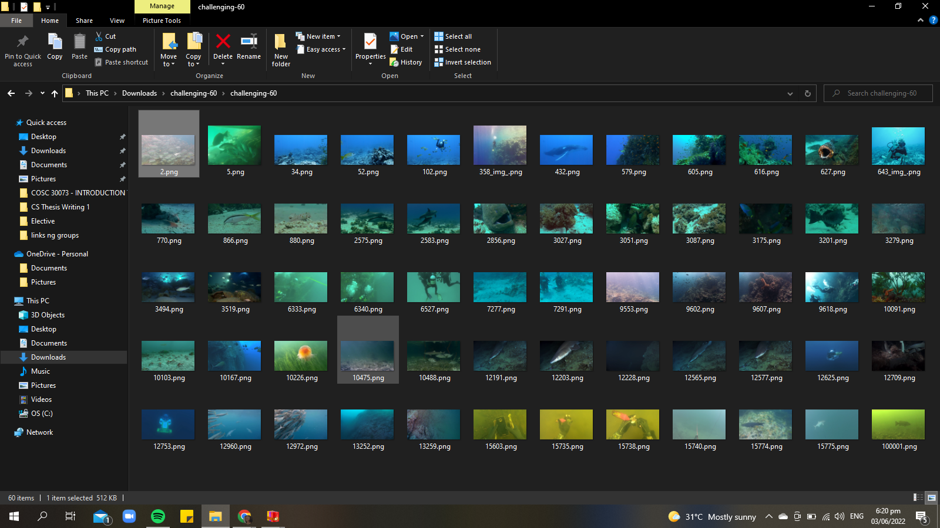
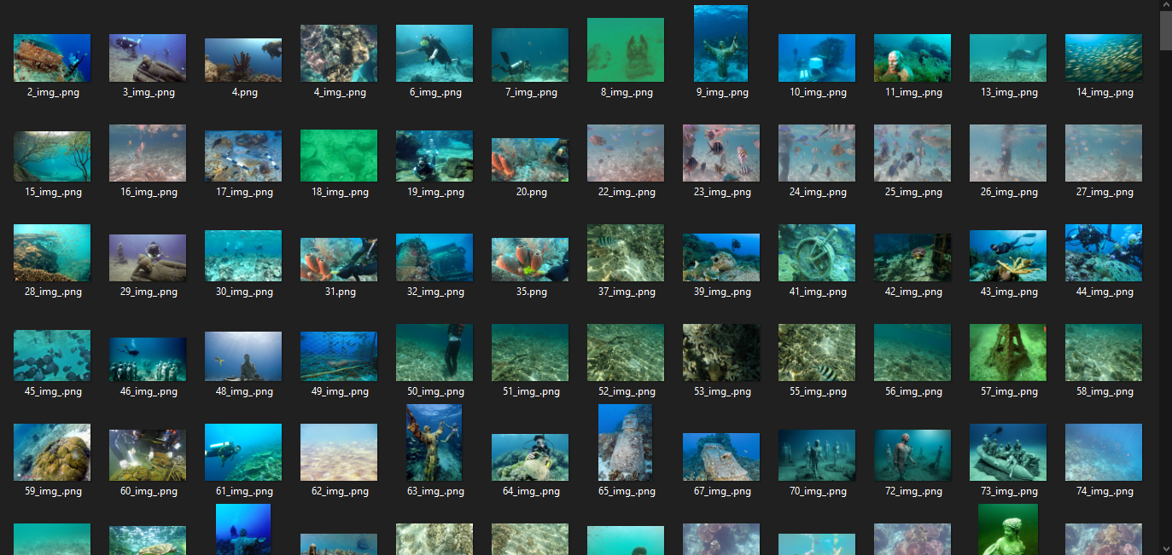
Figure 3. Underwater Image Enhancement Benchmark Dataset (UIEBD

Observers

We gathered 50 observers for the subjective image quality assessment. The observers are either students, professors, or someone who is verified, skilled, or has knowledge in photography, image processing, or image editing from different universities and institutions in the Philippines. Demographic profiles of the observers, like gender, age, and religion of the students, were not considered. The observers were informed regarding the nature of the study before conducting the assessment.

Research Instrument

Software Tools and Libraries for the Research Development

Development Details
For the image processing platform and libraries, we used OpenCV, Visual Studio Code, Qt Designer, NumPy, PyTorch, PyWT, and Python Language to develop and test our proposed method. Visual Studio Code is the main IDE used, and Qt Designer was used to create the GUI of the proposed system.

The libraries we used are OpenCV, NumPy, PyWT, and PyTorch, which are usually used in Image processing. These mentioned libraries support Python, which is often considered a beginner-friendly programming language. The Python Language has better syntax than other languages, making it easy to use and understand.

The computer we used for the research development has an AMD Ryzen 5 3600 6-Core Processor, NVIDIA GeForce RTX 2060 SUPER, and 16.0GB RAM. This machine supplemented the specification requirements of the software tool (TensorFlow) that was used.

For color correction of the image and the optimal contrast, the proposed method by (Xueyang et al., 2017) was used. The color correction is based on piecewise linear transformation and their novel method of optimal contrast. The Deep Edge-Aware Filtering Pre-trained Models by (Xu et al., 2015) were used for Image Filtering and Texture Smoothing. For the Image Fusion, we used the Image Fusion technique that is based on the Wavelet Discrete Transformation.

Research Instrument
Survey Questionnaire. For the subjective assessment, questionnaires were distributed to the participants to evaluate the performance of the proposed and other methods.
Experiment Paper. Objective assessment was also conducted by computing and comparing the MSE, SSIM, PSNR, UIQM, and TAA of the methods.

System Architecture
In this section, the image enhancement algorithms that were used and combined into one framework is discussed.
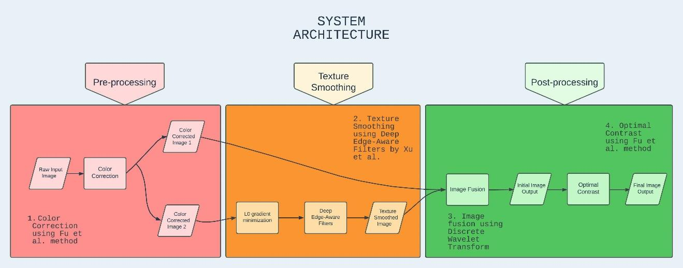
Figure 4. System Architecture of the Proposed Method

Color Correction
To solve the color distortion of an underwater image due to light being attenuated while it propagates through water, we utilized the improved piecewise linear transformation by Xueyang et al. (2017). The enhanced piecewise linear transformation is based on the gray-world hypothesis, which assumes that the average color in an image is achromatic, resulting in a mean value of 128 in an 8-bit image.

Texture Smoothing
Texture information is essential and significantly affects high-level underwater vision (Xie et al., 2021). With this, we used deep learning texture filtering and smoothing to address this improvement. We implemented the Deep Edge-Aware Filters for Images by Xu et al. (2015) since the usage of Deep Edge-Aware Filters is to uniformly represent and accelerate the different Edge-Aware or Texture Filters in a single framework. In addition, it not only adapts and reproduces from the other filters but can improve them by producing better quantitative and visual results. We initially used L0 gradient minimization before feeding it to the Deep Edge Aware Filter, having three convolutional layers. The first layer has an input channel size of 3, an output channel size of 256, a kernel size of 3 x 3, a stride of 1, and an activation layer of Tanh. The second layer has an input and output channel size of 256, and kernel size is 1 x 1, stride of 1, and an activation layer of Tanh. The last layer consists of an input channel size of 256, an output channel size of 3, a kernel size of 8 x 8, a stride of 1, and 7 paddings.

Image Fusion

To fuse the output images from the color-corrected and texture-smoothed images while retaining their image information, we used an image fusion technique based on Discrete Wavelet Transformation.

Optimal Contrast
We employed a novel method for optimal contrast proposed by Xueyang et al. to mitigate the haziness in underwater images.
Following the image fusion process, we subsequently utilized the optimal contrast technique by Lu et al. This approach involves finding a modified image that lies between the original image and a reference image. The objective is to strike a desired balance between the information contained in the original and reference images.
The proposed method of Underwater Image Enhancement was implemented utilizing the following steps:
1. The input image will undergo Color Correction from the “Two-Step Approach for Single Underwater Image Enhancement” proposed by Xueyang Fu et al. (2017) and produce two Color Corrected images.
2. The second Color Corrected Image will go through L0 gradient minimization to generate the initial smoothing effects. Then, the generated image will go through the Deep Edge Aware Filter to modify it for better results with the gradient domain process and to produce the final Texture Smoothed Image.
3. Then, the first Color Corrected Image and the Texture Smoothed Image will be fused using Discrete Wavelet Transform.
Lastly, to produce the Final Output Image, the contrast of the initial output image will be enhanced using the novel method of Optimal Contrast by Xueyang et al.

Data Gathering
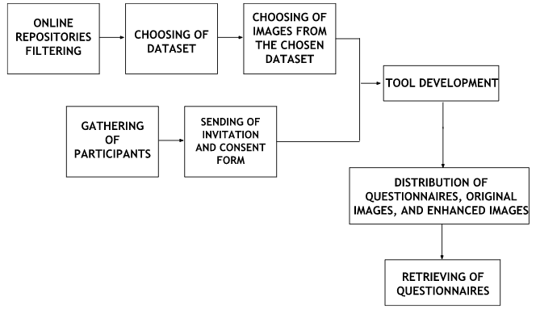
Figure 5. Acquisition of Dataset and Observers

We collected the dataset from the existing repositories available online. Social media, online forums, and online research panels were used to look for participants. Invitations and questionnaires were distributed to them. The following stages further discuss data gathering procedure:

Preparatory Stage
All repositories provided from different articles were gathered. These repositories contain different datasets, such as image classification, object detection or recognition, image segmentation, and image enhancement. To reach out to more potential participants more easily and quickly, we used and maximized social media, online forums, and online research panels via the Internet. A personalized invitation for observers and rating scale questionnaires were also prepared.

Data Collection Stage
We distributed invitations and consent forms to the participants. The UIEBD dataset, created by Chongyi Li et al. (2019), was selected for image enhancement. Specifically, we utilized images from this dataset that featured subjects or objects with intricate details to test the images' texture and structure improvement.
After enhancing images using the proposed method and other methods, the questionnaires were distributed to the final list of participants for the subjective image quality assessment. The questionnaire contains seven images enhanced by our proposed method and the other three methods, with 28 enhanced images and seven other images, which are reference images. We asked the observers to rate the 28 enhanced images and also asked for their annotations and observations about the image outputs.
The MSE, PSNR, SSIM, UIQM, and TAA of image outputs enhanced by our proposed method and other methods were computed for the objective image quality assessment. The number of images used for this assessment is 150 images for our proposed method, 150 images for the Two-Step Approach method, 150 for the WaterNet method, and 150 for the TEBCF method, with a total of 600 enhanced images

Final Stage
The questionnaires were retrieved, and the rankings and comments of the observers were gathered, analyzed, and organized. For the subjective assessment, ratings for each image of each method were added to get the MOS. These values and the values computed in the objective IQA were analyzed. Images and comments of the observers were also presented in the paper.

Statistical Analysis
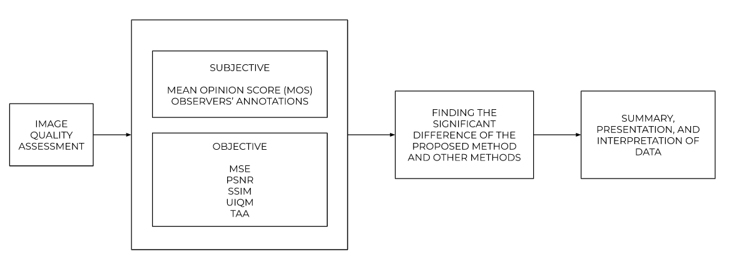
Figure 6. Statistical Analysis and Interpretation of Findings
To assess and compare the effectiveness of the proposed method in enhancing underwater images and its performance compared to traditional methods and deep learning-based methods, we used the following methods for qualitative and quantitative comparison and evaluation:
a. Two-Step Approach Method by Xueyang Fu et al. (2017);
b. WaterNet method by Xie et al. (2021); and
c. TEBCF method by Yuan et al. (2022)
Image enhancement is a subjective processing technique that can yield varying desired results depending on individual preferences. But in this study, we performed two kinds of image quality assessment for both of our research questions: subjective and objective.
For the qualitative image quality assessment: In the traditional approach, the enhanced images generated by previous traditional methods are randomly presented on a screen. But in this study, we used Google Forms because of the pandemic. To rank the enhanced images, 50 observers were given a questionnaire and asked to mark the images from ‘1’ (lowest quality) to ‘4’ (highest quality), in terms of color accuracy, visual artifacts, sharpness, and overall quality depending on their own visual perspective. After the process, MOS was computed and summarized in a table. The method that achieves the highest MOS indicates that the method outperforms other methods. Formula to get the MOS is:
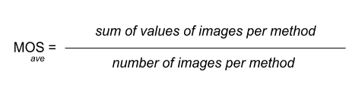
Observers’ annotations and observations were also collected and analyzed from the retrieved questionnaires. The results from this assessment and the images enhanced by our proposed method and other methods were also presented in the paper.
For the quantitative image quality assessment, we compared the following IQA metrics results of our proposed method with other methods. To see if the proposed method outperforms the other method.
a. MSE - the proposed method must achieve closer to zero value
b. PSNR - the proposed method must achieve the high PSNR
c. SSIM - the proposed method must achieve the high SSIM
d. UIQM – the proposed method must achieve a high UIQM
e. TAA - the proposed method must achieve the high TAA
To determine the significant differences of the methods’ performances, we used the ANOVA F test and Tukey Post-hoc Test using Microsoft Excel and Jamovi software.

RESULTS AND DISCUSSION
Various techniques are being employed to enhance the quality of underwater images, and their efficacy is being evaluated through subjective and objective assessments using diverse underwater image datasets. It could be by visual inspections, IQA metrics, estimations, and histogram analysis.
The proposed method's effectiveness is assessed through qualitative and quantitative evaluations and then compared with TEBCF, WaterNet, and Two-Step Approach methods. These methods are selected for their reportedly good performance on underwater image enhancement. We gathered 50 observers to rank the enhanced images for the qualitative evaluation using a questionnaire. We used the image quality assessment metrics MSE, PSNR, SSIM, UIQM, and TAA for the quantitative evaluation.
This chapter analyzes and interprets the findings of the data collected to address the problems in the study.
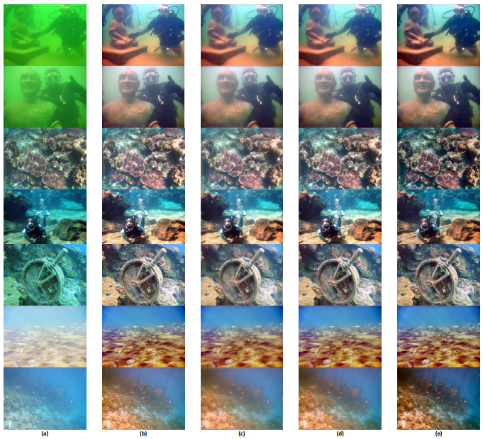
Figure 7. Figure of proposed method phases. (a) The original images. (b) The color corrected images. (c) The texture-enhanced images. (d) The fused images of the first color corrected image and textured-enhanced image. (e)The final image with application of optimal contrast

Qualitative Assessment
Table 1. Image Quality Evaluation Based On Color Accuracy
IMAGES | TWO-STEP APPROACH | TEBCF METHOD | WATERNET METHOD | PROPOSED METHOD
Raw 1 | 3.14 | 1.26 | 2.46 | 3.14
Raw 2 | 3.14 | 1.22 | 2.18 | 3.46
Raw 3 | 3.42 | 1.42 | 1.82 | 3.34
Raw 4 | 3.04 | 1.82 | 2.12 | 3.02
Raw 5 | 3.02 | 1.82 | 2 | 3.16
Raw 6 | 3.26 | 1.34 | 2.34 | 3.06
Raw 7 | 3.1 | 2.42 | 1.96 | 2.52
MOS | 3.16 | 1.6143 | 2.1257 | 3.1

Table 2. Image Quality Based On Visual Artifacts
IMAGES | TWO-STEP APPROACH | TEBCF METHOD | WATERNET METHOD | PROPOSED METHOD
Raw 1 | 3 | 1.52 | 2.32 | 3.16
Raw 2 | 2.94 | 1.4 | 2.2 | 3.46
Raw 3 | 3.38 | 1.62 | 1.68 | 3.32
Raw 4 | 3.02 | 2.02 | 1.9 | 3.06
Raw 5 | 3.02 | 1.82 | 1.92 | 3.24
Raw 6 | 3.3 | 1.4 | 2.06 | 3.24
Raw 7 | 3.12 | 2.58 | 1.7 | 2.6
MOS | 3.1114 | 1.7657 | 1.9686 | 3.1543

Table 3. Image Quality Evaluation Based on Sharpness
IMAGES | TWO-STEP APPROACH | TEBCF METHOD | WATERNET METHOD | PROPOSED METHOD
Raw 1 | 2.86 | 1.92 | 2.06 | 3.16
Raw 2 | 2.52 | 1.86 | 2.24 | 3.38
Raw 3 | 3.32 | 1.9 | 1.64 | 3.14
Raw 4 | 2.92 | 2.34 | 1.78 | 2.96
Raw 5 | 2.8 | 2.24 | 1.98 | 2.98
Raw 6 | 3.2 | 1.88 | 2.06 | 2.86
Raw 7 | 3.1 | 2.76 | 1.76 | 2.38
MOS | 2.96 | 2.1286 | 1.9314 | 2.98

Table 4. Image Quality Evaluation Based On Overall Quality
IMAGES | TWO-STEP APPROACH | TEBCF METHOD | WATERNET METHOD | PROPOSED METHOD
Raw 1 | 3.16 | 1.44 | 2.28 | 3.12
Raw 2 | 2.96 | 1.3 | 2.2 | 3.54
Raw 3 | 3.4 | 1.44 | 1.86 | 3.3
Raw 4 | 3.14 | 1.9 | 1.94 | 3.02
Raw 5 | 3 | 1.68 | 2.12 | 3.2
Raw 6 | 3.3 | 1.42 | 2.24 | 3.04
Raw 7 | 3.02 | 2.42 | 2 | 2.56
MOS | 3.14 | 1.6571 | 2.0914 | 3.1114

Quantitative Assessment
Table 5. Average Results of MSE, PSNR, SSIM, UIQM, and TAA.
Metrics  Methods | MSE | PSNR | SSIM | UIQM | TAA
Two-Step Approach | 99.2166729330953 | 28.2265661438071 | 0.813953010649882 | 0.926882792631745 | 0.843613687541405
TEBCF | 103.477870662192000 | 27.991566279103800 | 0.596533598523851 | 1.395073930618130 | 0.842900902993048
WaterNet | 104.8896977742270 | 27.9945996286638 | 0.850346125276019 | 0.659936236479110 | 0.854569499257600
Proposed | 98.776278653668 | 28.2437728210747 | 0.829940027704872 | 0.793549643820564 | 0.776496611665198

The TEBCF method performs the highest in UIQM evaluation compared with the other methods, however the image processed by this method results in severe color distortion and produces too much noise effect and artifacts. The value of the proposed method in this metric doesn’t outperform the TSA method however it effectively removes the small artifacts present in the image which indicates that it can remove the hazy effect of underwater images. The proposed method doesn’t perform well also in the Texture Analysis Assessment having the lowest value which is 0.77 metric value among the other methods. This may be caused by the image smoothing which blurs out some parts of the image to reduce the noise and artifacts thus the value might be lowered.

Table 6. One-Way ANOVA Results of MSE, PSNR, SSIM, UIQM and TAA
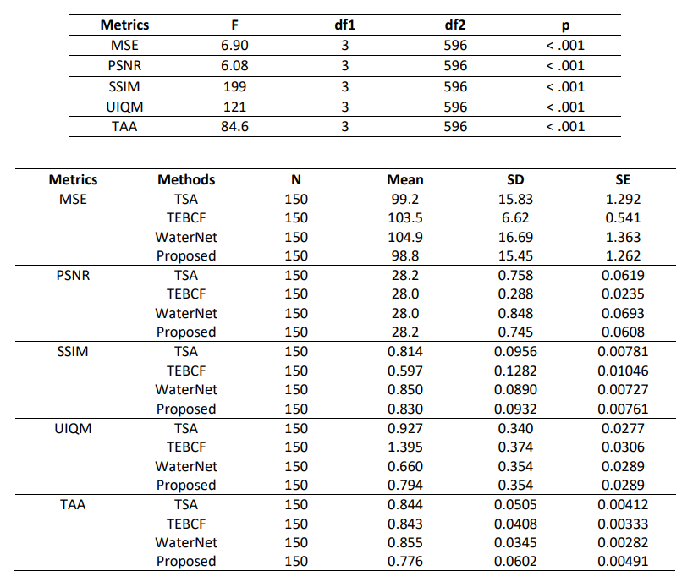

Since the ANOVA F test provided us the information that there is a significant overall difference among the means of these methods, we then used the Tukey Post-Hoc Test to uncover the specific differences between these methods and to identify which pairs of methods are significantly different from each other.

CONCLUSION
The researchers from the study entitled "Hybrid Technique Using Traditional and Deep Learning-based Method for Underwater Image Enhancement" have arrived at the following conclusions following their thorough analysis and implementation of the study:
- The proposed hybrid technique got the second-highest overall MOS of 3.1114. Therefore, the proposed technique is effective in retrieving and enhancing colors, removing visual artifacts, and enhancing sharpness.

- The proposed method had the lowest MSE (98.77) and the highest PSNR (28.24) among the three methods, indicating low noise and errors in image enhancement. It also had a second highest SSIM score (0.82) and was second to the WaterNet method, meaning the proposed method still retains most of the valuable image information of the original images. The proposed method had the lowest scores in UIQM and TAA metrics (0.79 and 0.77 respectively) due to texture smoothing which can cause blurriness but also removes artifacts. The proposed method performed well in a qualitative assessment, showing better image quality in terms of removing visual artifacts and sharpness, and had the second-highest MOS in overall image quality, close to the TSA method. This indicates that the proposed method produced better image quality than the other methods based on both qualitative and quantitative assessments.

- The F values obtained from the ANOVA Table are greater than the F critical values from the F-table. This indicates that there is a significant performance differences between the Two-Step Approach method, TEBCF method, WaterNet method, and the proposed method.

- To answer one recommendation from one of our related studies, “explore the performance of a hybrid traditional and deep learning method for underwater image enhancement”, the researchers concluded that combining traditional and deep learning methods for underwater image enhancement could yield better results in performance compared to state-of-the-art methods.

To further examine this study, researchers could use these recommendations of the researchers: (1) Try different Traditional or Deep Learning-Based methods and compare the results with our Proposed method to further improve the overall tool. (2) Explore the potential applications of the proposed method in the field of underwater imaging and real-world implementation. (3) The images used for evaluating the performance of our proposed method in terms of brightness were manually edited since no dark images can be found from the dataset, so the researchers recommend using naturally dark degraded images. (4) Incorporation of additional image quality assessment metrics to enhance the evaluation of the proposed method. (5) Explore the performance of the proposed method in enhancing other kinds of images.

ACKNOWLEDGEMENTS
The researchers would like to extend their heartfelt gratitude to:
Prof. Ria A. Sagum, the thesis adviser, for her guidance throughout the study. Her expertise, wisdom, and supervision have been instrumental in shaping this thesis and helping them to stay focused on research objectives.
The members of the Faculty and Staff of the College of Computer and Information Sciences, particularly the Department of Computer Science, for their professional assistance and support in our four years in the institution.
The panelists for their comments, insights, and recommendations for the document.
Mr. Bong Occeña, Mr. Salvador Lagrimas, and Mr. Marco Tualla for being the experts in this research and providing their time to check our survey questionnaire and give valuable feedback.
Friends and family for their love, support, and encouragement during this process. Their encouragement and belief have been a constant source of motivation and inspiration.
Above all, to Almighty God for gracing us with wisdom and knowledge and for His everlasting love and guidance.

REFERENCES
[1] Bhadouria, A. S. 2022. Underwater Image Enhancement Techniques: An Exhaustive Study. International Journal for Research in Applied Science and Engineering Technology 10, 2 (Feb. 2022), 812–827. DOI: 10.22214/ijraset.2022.40388.

[2] Zhang, Y., Yang, F., & He, W. 2020. An approach for underwater image enhancement based on color correction and dehazing. International Journal of Advanced Robotic Systems 1-10. DOI: 10.1177/1729881420961643.
[3] Chrispin, A. J., & Nagaraj, R. 2017. Deblurring Underwater Image degradations based on Adaptive Regularization. In Proceedings of the 2017 IEEE International Conference on Computational Intelligence and Computing Research (ICCIC). DOI: 10.1109/ICCIC.2017.8524166.
[4] Li, C., Guo, C., Ren, W., Cong, R., Hou, J., Kwong, S., & Tao, D. 2020. An Underwater Image Enhancement Benchmark Dataset and Beyond. IEEE Transactions on Image Processing 29.
[5] Fu, X., Fan, Z., Ling, M., Huang, Y., & Ding, X. 2017. Two-step approach for single underwater image enhancement. In Proceedings of the International Symposium on Intelligent Signal Processing and Communication Systems (pp. 789-794).
[6] Xu, L., Ren, J., Yan, Q., Liao, R., & Jia, J. 2015. Deep Edge-Aware Filters. In Proceedings of the 32nd International Conference on Machine Learning (ICML), in Proceedings of Machine Learning Research 37 (pp. 1669-1678). Available from https://proceedings.mlr.press/v37/xub15.html.
[7] Xie, J., Hou, G., Wang, G., & Pan, Z. 2021. A Variational Framework for Underwater Image Dehazing and Deblurring. IEEE Transactions on Circuits and Systems for Video Technology 1. DOI: 10.1109/tcsvt.2021.3115791.
[8] Yuan, J., Cai, Z., & Cao, W. 2022. TEBCF: Real-World Underwater Image Texture Enhancement Model Based on Blurriness and Color Fusion. IEEE Transactions on Geoscience and Remote Sensing 60, 1–15. DOI: 10.1109/tgrs.2021.3110575.

