PATH:

If I execute

set PATH=%PATH%;C:\\Something\\bin

from cmd and then execute

echo %PATH%

I see this string added in path.

ClassPATH:

set CLASSPATH=*path1*;*path2* ...

set CLASSPATH=C:\Program Files\Java\jdk1.8.0_05\db\lib\derby.jar; C:\Program Files\Java\jdk1.8.0_05\db\lib\derbytools.jar;%CLASSPATH%

You need to set the path to ij and maybe java.exe

And the classpath to

Derby.jar and derbytools.jar

You are ready to create a database.

In a dos box type

C:\.... Prompt>Ij

>**connect 'jdbc:derby:c:\users\yourname\documents\firstdb;create=true';**

**// connect 'jdbc:derby:firstdb;create=true';**

/* This is some directory that your are allowed to access */

>**CREATE TABLE FIRSTTABLE (ID INT PRIMARY KEY, NAME VARCHAR(12));**

**/* Table is created */**

>**INSERT INTO FIRSTTABLE VALUES (10,'TEN'),(20,'TWENTY'),(30,'THIRTY');**

**/* Data inserted */**

**>SELECT * FROM FIRSTTABLE;**

**/* SQL Query tested on table*/**

**>exit;**

**/* back to box*/**

**Vogella data etc maybe required.**

[**http://www.vogella.com/tutorials/EclipseDataToolsPlatform/article.html**](http://www.vogella.com/tutorials/EclipseDataToolsPlatform/article.html)

**Now go to Eclipse and tell eclipse about this database. Eclipse EE.**

**Select “DataBase Perspective” DataBase development.**

**Right click Database Connections and select new.**

**Select Derby.**

**Click next.**

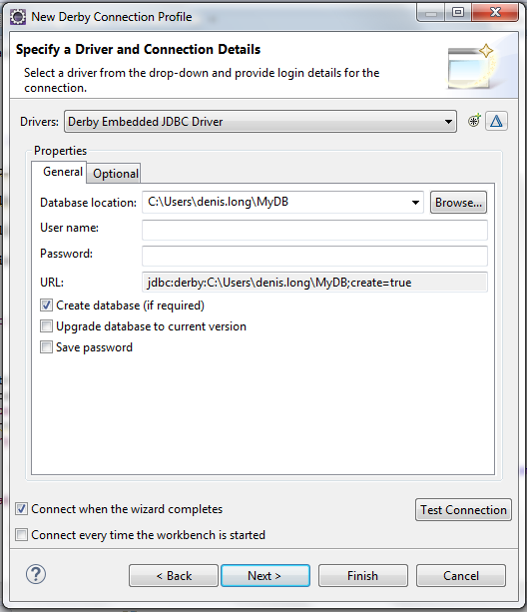

**Edit the driver definition the triangle symbol above and make sure that the driver knows where to find the appropriate jar files: derby.jar, derbytools.jar and derbyclient.jar.**

Now test connection. If all is ok then you should have no problem using databases from a java program.

Next right click the database and open sql scrapbook.

Use the scrapbook to add tables etc. to the database. If you have not done this from ij.

To execute the commands in the scrapbook then right click anywhere on the scrapbook screen and click execute all.You should see the output in theoutput area.

Next thing is to write a java program to use the database.

**import** java.sql.Connection;

**import** java.sql.Statement;

**import** java.sql.DriverManager;

**import** java.sql.ResultSet;

**import** java.sql.ResultSetMetaData;

**import** java.sql.SQLException;

**public** **class** ConnectToFirst {

**static** **final** String ***DATABASE_URL*** = "jdbc:derby:f://firstdb";

**public** **static** **void** main( String args[] )

{

Connection connection = **null**; // manages connection

Statement statement = **null**; // query statement

ResultSet resultSet = **null**; // manages results

// connect to database books and query database

**try**

{

// establish connection to database

connection = DriverManager.*getConnection*( ***DATABASE_URL***, "", "" );

// create Statement for querying database

statement = connection.createStatement();

// query database

resultSet = statement.executeQuery(

"SELECT ID, NAME FROM FIRSTTABLE" );

// process query results

ResultSetMetaData metaData = resultSet.getMetaData();

**int** numberOfColumns = metaData.getColumnCount();

System.***out***.println( "FirstTable Table of firstdb Database:\n" );

**for** ( **int** i = 1; i <= numberOfColumns; i++ )

System.***out***.printf( "%-8s\t", metaData.getColumnName( i ) );

System.***out***.println();

**while** ( resultSet.next() )

{

**for** ( **int** i = 1; i <= numberOfColumns; i++ )

System.***out***.printf( "%-8s\t", resultSet.getObject( i ) );

System.***out***.println();

} // end while

} // end try

**catch** ( SQLException sqlException )

{

sqlException.printStackTrace();

} // end catch

**finally** // ensure resultSet, statement and connection are closed

{

**try**

{

resultSet.close();

statement.close();

connection.close();

} // end try

**catch** ( Exception exception )

{

exception.printStackTrace();

} // end catch

} // end finally

} // end main

}

Lastly add the derby jar files to the jre system library.

Right click configure build path.

Add external Jars (add the jars).

Run the program.

Issues, only one thing can access the database at one time, so if trying to run a program to access the db ,then shutdown ij/scrapbook and vice versa.