Self-Driving Cars – Challenges and Opportunities

Index

I. Introduction 2

II. Overview of Self-Driving Cars 2

III. Challenges of Self-Driving Cars 4

IV. Opportunities from Self-Driving Cars 5

V. Bibliography 6

# Introduction

A self-driving car, commonly referred to as an autonomous car, is a vehicle that can drive by itself. As unmanned aerial vehicle (UAV) technology is advancing, and along with it more drones flying around in Earth’s air space, so too, is the equivalent unmanned road vehicle gaining more traction. That is, if legislative bodies allow for such an advancement to classify as a safe, road-worthy vehicle within the respective country’s established driving legal system.

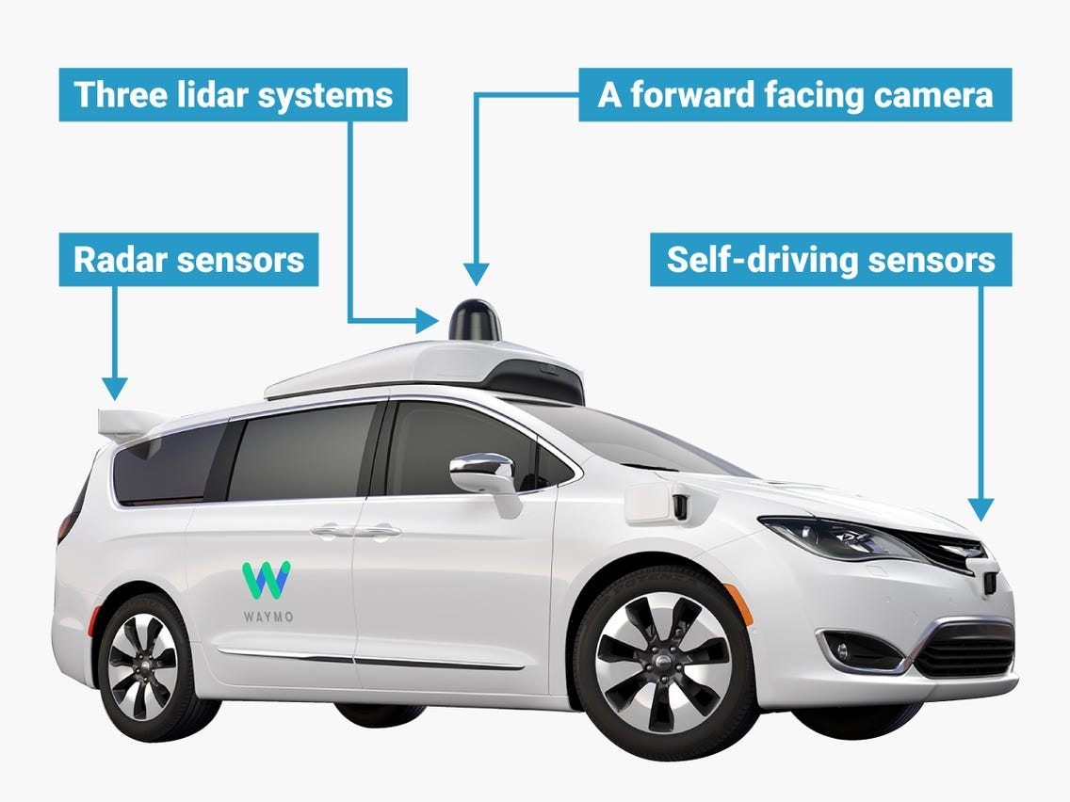

Figure 1 – Alphabet’s Waymo, Self-Driving Vehicle

# Overview of Self-Driving Cars

There are six levels of vehicle autonomy, ranging from Level 0 to Level 5, as defined by the Society of Automotive Engineers (SAE), namely:

1. No automation
2. Driver assistance
3. Partial automation
4. Conditional automation
5. High automation
6. Full automation

In the first three cases, from no automation to partial automation, the human driver monitors the driving environment. In the latter three cases, from conditional automation to full automation, the automated driving system monitors the driving environment. The United States Department of Transportation acknowledges these levels.

Level 0 is the current state of the majority of cars on the road worldwide, that is to say, there is zero automation. The human driver manually controls the vehicle, and is responsible in making decisions related to their driving manner. If the driving style was found to be against the local governing laws, if the behaviour was reckless, the fault would remain entirely with the human driver. It is the human driver’s prerogative in how they choose to operate the vehicle. While in many cases it may be beneficial to remove human error from the driving process, by adopting fully automated technologies, there may be some cases where having a manual driver is more optimal. If an automated car finds itself in a situation in which it does not have clear programming instructions, or it fails to recognise a potentially dangerous situation in a timely manner, there is a chance that the human driver could completely negate the dangerous situation by taking control of the vehicle.

Level 1 introduces the basics of automated driving. The human driver is still in control of the driving mechanics for steering and braking, but they can activate a cruise control system in certain environments. This feature assists the driver by controlling the steering and accelerating, keeping the car at a safe distance from the vehicle in front. This can be safe to use on long, relatively straight stretches of road, such as U.S. highways. The human driver must still monitor the road and their surroundings, and be actively ready to take back full control of the vehicle. In some countries, it is required that the driver maintains their hand positioning on the steering wheel at all times when using the adaptive cruise control feature, so as to lessen their reaction time if an incident were to occur.

Level 2 introduces advanced driver assistance systems (ADAS), granting the vehicle more control over the steering, and the accelerating and decelerating of the car. The human driver remains in the driver’s seat, and can still intervene, taking control of the car at any moment. The autopilot system from Tesla, and the Super Cruise system in Cadillacs from General Motors are both categorised as Level 2 vehicle automation.

Level 3 increases the car’s automation capabilities, giving vehicles the ability to make decisions. The vehicles have environmental detection features implemented. They monitor the surrounding area of the car, and make judgements based on the input they receive from cameras and sensors. The software can make the decision to accelerate past a slow-moving vehicle, for example. Undifferentiated from the previous levels, the human driver can still take control of the vehicle, overring the automation. Despite the car becoming aware of its surroundings, the human driver must still remain diligent in their observation while driving. They must be able to react quickly in the event of a possible

mistake occurring, such as if a pedestrian suddenly emerged in front of the vehicle, but the environment detection systems did not sense the movement in time, thus meaning the car would remain on its trajectory as if there were no deterrents on the road ahead. The 2019 Audi A8L car boasts this feature, using its Traffic Jam Pilot. This system utilises a combination of a lidar scanner along with advanced sensor fusion and processing power, including built-in redundancies in the event of a component failing. In Europe, Audi were allowed to roll out the full Level 3 A8L with its Traffic Jam Pilot system, initiating in Germany. However, in the U.S. the car is classified under Level 2, with manufactures shipping the vehicle without the key hardware and software required to enable Level 3 automation. This is due to a regulatory process in the U.S. to shift from federal guidance to state-by-state mandates, meaning each state can set out their own governing rules and regulations in relation to autonomous driving.

Level 4 vehicles can operate in self-driving mode, if there is legislation and infrastructure in place to allow for it. These cars have the capability to intervene if something goes wrong, or in the event of a system failure. While they can perform driving routines autonomously, there is still the capacity available for the human driver to intervene and manually take control, should the need arise. Along with this level, enters the term “geofencing”. This refers to a set limited area, usually an urban environment where top speeds reach an average of 30mph (50km/h), wherein these self-driving vehicles are permitted to operate to their fullest extent. Alphabet, Google’s parent company, have a self-driving project named Waymo, formally known as the Google self-driving car project. At the end of 2018, Waymo unveiled their fleet of Level 4, self-driving taxi cars in Arizona, U.S. Beginning in 2016, the company had been carrying out tests

of driverless cars in the city of Phoenix, Arizona, covering over 10 million miles (1.6 million kilometres). To use the self-driving service, customers must download the required mobile phone app, providing their payment details, as one would when riding with Uber of Lyft. The car will arrive at your pick-up point, although there will be a human driver behind the wheel, as a safety precaution, to intervene in case of emergency.

Level 5 cars, fully automated vehicles, do not require any human interaction in the driving process. Without the presence of a human driver, there is no longer a need for steering wheels and driving pedals, thus those mechanics will be eliminated from the car design. This will allow for more space, both for passenger’s comfort, as well as mechanically in the build. When these fully automated vehicles fully come into fruition, alongside the required legislation, they will no longer be limited by geofencing, accomplishing the competence and qualification to drive anywhere, at any time.

# Challenges of Self-Driving Cars

In pursuance of fully automated self-driving cars becoming the norm, passengers must actually feel safe and comfortable riding in a driverless vehicle. Additionally, other road users, including pedestrians, must also accept driverless vehicles. Part of that safety comes from knowing that the car cannot be hacked. Another factor is how the car is programmed to deal with potentially fatal situations – if a child unexpectedly runs in front of the car, how does the vehicle react? Does it suddenly slam the brakes? Does it have a faster or slower reaction time than that of a human driver? Should the vehicle swerve, and if so, in which direction? What if a sudden lane change meant hitting oncoming traffic? How are the answers to these decisions made? Does the software engineer decide? Perhaps the CEO of the company producing the cars? Can the owner of the car dictate how the vehicle should react? Should the district government create an incrementing list, inscribing least to most ruinous outcomes, to which the software programming is written with the aim of handling a situation accordingly, if that is even possible? If a fatal accident occurred, should blame be put onto a person, or persons, in the same manner that reckless driving can potentially result in imprisonment? If driverless vehicles accounted for 100 percent of road users, would motor accidents even occur? What would happen if a malicious hacker had access to the vehicle’s programming, could they cause a mass tragic event on a global-scale?

Are autonomous cars really safer than human drivers? In an attempt to answer this, robust testing of driving ability of each set must occur. Not only should accidents of both sets be recorded, but also non-collisions. Knowing this information will aid in determining the respective crash rates for each. Are humans better at avoiding crashes? Decades of driving experience hones a person’s skill. We can plan ahead, extending our observation to our surroundings. Where a person sees children playing on the roadside, they can change their driving behaviour, slowing down in case a child run outs. Will an automation vehicle be able to do the same? It will depend on the range of vision the car has, its blind spots, and if it has been tested in these scenarios. At present, the majority of driverless car testing has been carried out in the U.S., typically on multilane highways in large urban cities. Waymo’s geofencing was in Phoenix, Arizona, an arid climate that does not experience rain often. Driving along a highway is relatively easy-going, the main incidents occurring where drivers miss their turn-offs and react recklessly. Water on the road surface can have a huge impact on driving. If there was a long period of dry weather, followed by a downpour, that water mixes with dirt and oil that collated on the road, forming a greasy layer. This can lead to hydroplaning, where a driver can lose control of their vehicle. What about foggy weather, or excessive sunshine? Both can impair visibility. Self-driving cars need more qualitative testing in a variety of situations, road conditions, traffic density, and other such scenarios. Scenarios in which humans have experience.

One such matter of the human condition that does not affect machinery is emotions. People can become tired, angry, frustrated, suicidal. Machines cannot. People can consume alcohol or drugs, which will impact their driving capacity. Machinery cannot. People have a tendency to become distracted, be it from a phone ringing, a child screaming in the backseat, or gawping at an accident that came into view. Machines are not affected in this way. Another factor, although a less common one, is a sudden health emergency. If a human driver were to suffer a precipitous heart attack, their vehicle could continue accelerating, moving erratically. Such an event would not affect a driverless car, it would   
  
continue onward to its destination with the instructions it was given. Some cars may even utilise sensors on the passengers, and could be programmed to pull over in a safe place if no input is detected for a certain length of time.

An important element to consider is security of the software, including the rollout of updates. In 2015, *Wired* writer Andy Greenburg was invited to participate as a test subject for Charlie Miller and Chris Valasek, who had been researching car hacking methods. [13] As Andy drove down the highway in a Jeep Cherokee, the car began to act, as if someone else was controlling it – which was the case. The two hackers successfully took control of the Jeep’s entrainment system, switching to a different radio station, and increasing the volume, which the driver could not override. More worrisome, the hackers had proved that they could take control of the vehicle’s steering, brakes, and transmission, all wirelessly via the Internet. Their method, known in the security industry as a zero-day exploit, enabled them to send commands to Andy’s vehicle, fully taking control of his vehicle, and potentially thousands of other Jeep Cherokees across the world. In an effort to avoid terrifying situations just like this, proper security measures must be implemented to eliminate software vulnerabilities, to be supported by government and industry legislation.

# Opportunities from Self-Driving Cars

Self-driving cars can offer us many opportunities and freedom, revolutionising the transport industry and infrastructure. In an interview with Elon Musk, CEO of Tesla, a major proponent in the car automation industry, he likened self-driving cars to elevators in buildings. He said, "*I think [autonomous driving]'s just going to become normal. Like an elevator. They used to have elevator operators, and then we developed some simple circuitry to have elevators just come to the floor that you're at, you just press the button."* Furthermore, he talked about the safety of automated cars, "*It'll be an order of magnitude safer than a person. In fact, in the distant future, I think [...] people may outlaw driving cars, because it's too dangerous. You can't have a person driving a two-tonne death machine. [...] Autonomy is really about what level of reliability and safety do you want. Even with the current sensor suite, we could make the car go fully autonomous, but not to a level of reliability that would be safe in, say, a complex urban environment where [...] children are playing. [...] From the point at which a car is definitely safer than a person, there's at least another two or three years after that before regulators allow it to be the case. They all want to see a large amount of statistical proof that it's not merely as safe as a person, but much safer.*" [14]

Automated vehicles would make an excellent taxi service. If a human driver is not required, the company offering the service does not need to hire, train, and pay any employees to perform as the driver. The cars can be called to where they are needed. They would negate the dangerous effects of driving under the influence of alcohol or drugs, as well as human fatigue. If a person needs to undergo a long road trip, they could sleep throughout the journey, with the car taking them right to their destination. All passengers could spend their time on in-car entertainment systems, with the interior design of cars taking on a new approach in the absence of steering mechanics. Daily commuting to work would now allow the driver to spend this time more productively – be it sleeping, grooming themselves, reading literature, or replying to work emails – instead of concentrating on the solo task of driving. Self-driving cars may also be the solution to traffic congestion, driving in a more predictable hivemind fashion, while also communicating with a network of interconnected vehicles in the surrounding area to avoid congested roads.

The future of self-driving cars brings excitement, and many hopeful opportunities, though getting there requires thought-out, well-tested, secure systems in order to convince the human population to welcome this technological revolution.

# Bibliography

1. <https://arxiv.org/abs/1906.05113>
2. <https://dl.acm.org/doi/10.1145/2971482>
3. <https://ieeexplore.ieee.org/document/6894181>
4. <https://www.youtube.com/watch?v=ixIoDYVfKA0>
5. <https://www.youtube.com/watch?v=PRg5RNU_JLk>
6. <https://www.youtube.com/watch?v=EzylsrXtkxI>
7. <https://www.synopsys.com/automotive/what-is-autonomous-car.html>
8. <https://www.synopsys.com/automotive/autonomous-driving-levels.html>
9. <https://www.sae.org/standards/content/j3016_201806/>
10. <https://www.reuters.com/article/us-waymo-selfdriving-focus/waymo-unveils-self-driving-taxi-service-in-arizona-for-paying-customers-idUSKBN1O41M2>
11. <https://www.irishtimes.com/business/transport-and-tourism/jaguar-land-rover-to-partner-with-autonomous-car-hub-in-shannon-1.4409884>
12. <https://www.vox.com/energy-and-environment/2018/3/27/17163264/autonomous-car-self-driving-advertising-business>
13. <https://www.wired.com/2015/07/hackers-remotely-kill-jeep-highway/>
14. <https://www.roadandtrack.com/new-cars/car-technology/news/a25316/everything-musk-said-yesterday-about-self-driving-cars/>