Assignment 2

Update version of POX on Mininet VM to the “Eel” branch

* git clone http://github.com/noxrepo/pox
* cd pox
* git checkout eel

Use PuTTY to connect to Mininet VM via SSH

Create Python script

* nano sdntopo2.py

Run Python script

* python sdntopo2.py

Change file permissions, if needed

* chmod 755 sdntopo2.py

Run Python script

* sudo ./sdntopo2.py

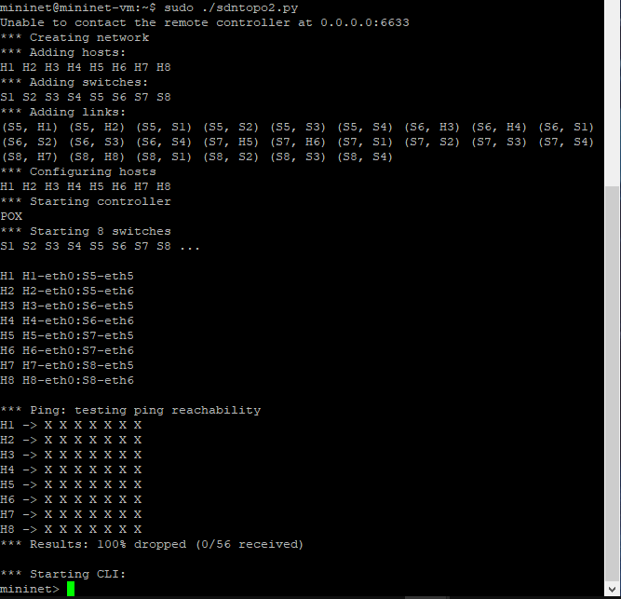

Run POX

* sudo ~/pox/pox.py forwarding.l2_learning

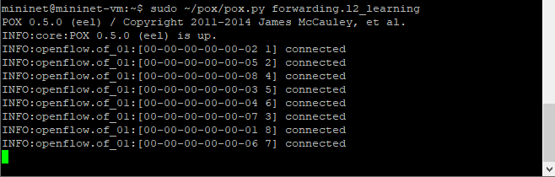

I have no idea how to implement all of the policy rules. I tried reading through your code examples to understand, but am still lost.