Assignment 01

Index

I. Introduction 2

II. Visualisation Techniques for the Web 2

III. The Relationship Between Melting Ice in the Arctic and the Global Rise in Temperature 3

IV. Evaluation of Interactive Functionality 3

V. Bibliography 7

# Introduction

As we progress through the current time period known as the Information Age, the vast volume of data that is being collected and displayed is staggering. In order for any data to be understood by a layperson in a meaningful way, it must be presented in a manner that is easily understood. Any design choices made regarding how the data could be displayed should prioritise clarity, which will aid in illustrating a pleasant aesthetic. There should be a goal of lessening the amount of confusion when reading the information, such as in that in a graph or table format, while maintaining the reader’s attention through engaging graphs.

Different types of data can be better suited to different types of visualisations. Some data sets, especially large ones, may be too dense when displayed in certain ways. If too much data is presented, the visualisation will become crowded, making matters difficult to understand. Instead, an alternative option should be considered. In some situations, it may be beneficial to categorise the values into ranges. When choosing the range, the minimum and maximum values must be known, which may not always be the case. This may occur in instances where the data is dynamic, that is, constantly changing. The minimum and maximum values may change dramatically from day-to-day, causing the output to display inconsistently depending on the input. The format of the data is crucial; it must be homogeneous. Date formats in particular can vary depending on culture and region, including the format of time. For example, the United States is unique in using the “MM-DD-YYYY format, compared to the more popular “DD-MM-YYYY” and “YYYY-MM-DD” formats. These differences must be taken into account when cleaning the data, ensuring consistency and accuracy even before beginning the visualisation process.

The choices made regarding how to display data can also be used to manipulate how a person will interpret the data. You could present data in such a manner that you create a skewed narrative, in order to suggest a misleading result to the person reading the data. To maintain integrity, the output must be unambiguous.

# Visualisation Techniques for the Web

When designing a data visualisation for the web, there is more to offer when compared to a graph on paper. Interactive elements may be utilised, wherein the person viewing the data can make changes to the graph, depending on what information they are most concerned about. They may want to “drill down” into a specific detail, and such could click on a section of the chart to delve into that component. Or, they may simply want an overview, and can zoom out to look at the “big picture” the graph is depicting. The person may want to inspect the data from a specific year, or compare the data year-by-year. To accommodate this, a sliding time scale could be included that they can adjust. The web allows for this dynamic transformation, whereas a printed book or newspaper does not. To go even further, the data could be presented as a video or gif, to be embedded into a website or article. Comparatively, static visualisations do not offer these elements of interactivity. As soon as a graph is printed, there is no way to change it. Any errors to be corrected would infer a second edition to be printed, compared to a website where a change to the code could be committed immediately.

Adding interactive elements can help to maintain the attention span of the person reading the data. Simply put, it adds fun. It can be useful in breaking down a complex data set into smaller, more manageable sets. A visually appealing graph will draw the eye. This can be done with techniques such as the use of colour theory, whitespace, and animations, for example. These techniques may make the data easier to digest at a glance, while also communicating the information in a form that is more memorable.

It is important to consider accessibility also. It is imperative that the font size is readable, or can be adjusted to suit those with eyesight issues, while still maintaining the integrity of the design. In addition, fonts should ideally be printed in such a way that a dyslexic person can comprehend it. Perhaps the user can choose their own font. It should still be possible for a colour-blind person to be able to distinguish the differences that the use of colour aimed to portray, such as by using different intensities or shades that they can perceive. Maybe the web page would allow the use of a greyscale theme to be enabled. Another fact to consider is the end-device. Will the design be adaptable to be reasonably read on mobile, or is it more complex and only supports the screen size of a computer?

# The Relationship Between Melting Ice in the Arctic and the Global Rise in Temperature

For the purpose of this report, the specified data domain shall refer to the rate of ice melting in the Arctic, comparing these levels to the average global temperature. The increasing rate of melting ice, thus the decreasing area of ice, or ice extent, is a hugely important factor in the acceleration of global climate change. Not only is there less ice on both the North and South poles, but the seasonal ice that forms each year is also much younger and thinner. [2] Older ice that remains frozen solid throughout the seasons, year after year, is much thicker and stronger than this younger ice.

As the ice extent deceases, the surrounding water begins to heat up, thus leading to more ice melting. This accelerated process has a significant impact on the global temperature. As the Earth’s poles, its coldest regions, begin to warm, so does the rest of the planet. This rise in temperature will prove catastrophic, wreaking havoc on Earth’s climate and its ecosystem. As the area of ice decreases, the sea levels rise, giving way to extreme weather patterns reflected across the globe. Summers will become hotter, winters colder. In areas where the population are not familiar with vast ranges in temperature, where proper infrastructure to deal with this weather may not exist, these extremes could lead to loss of life, as well as damage to property.

# Evaluation of Interactive Functionality

The author aims to create an interactive visualisation, in order to clearly depict the relationship of the chosen data domain. The purpose is to be educational, functional, and visually pleasing, while introducing an interactive element for the user to utilise. This will be done using D3.js, a JavaScript library for manipulating documents based on data. [13]

First and foremost, a suitable dataset must be used. For this, two possibilities have been selected. The first, measuring Arctic sea ice in terms of ice extent and area, between the years 1979 and 2015. The second, recorded values for Earth’s global temperature, as well as the level of atmospheric gases, taken between the years 1983 and 2008. Note that for the purposes of comparison, the date ranges used must be identical, and thus only these years will be used when plotting a graph.

As the data domain is concerned with a geographic location, the use of a geographic projection using D3 could be a suitable design choice, such as an area graph or choropleth. This would be fine for the ice extent data. However, is not ideal for the second dataset. Perhaps, if only using the data concerning the Arctic ice levels, a map of the location could be shown, and using a time slider, the change in area could be represented on the graph. In doing research, the following examples shown below were discovered.

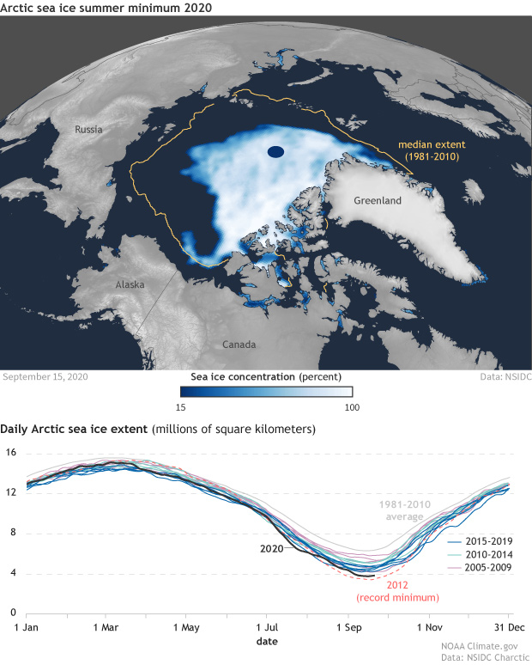

[13]

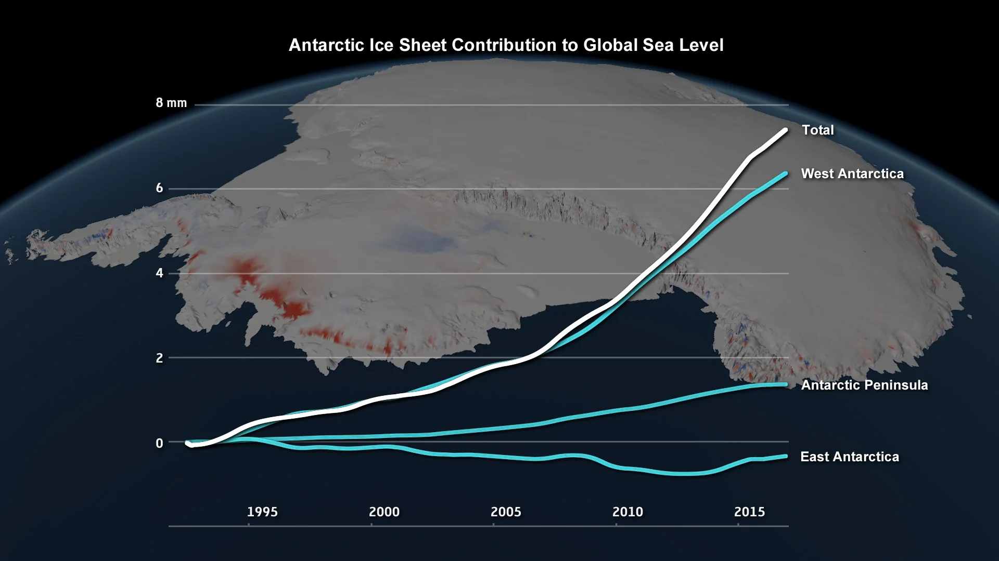

[14]

The above designs could be adapted, instead displaying measurements for temperature and atmospheric gases, perhaps which could be selected and de-selected to fit the user’s needs. The background image could be dynamic, reflecting the rate of ice melting. If a user hovered or clicked on the graph to pinpoint a certain year, the background image of a map could be updated to visually display the area of ice at that period in time. A scatter plot could be used to represent the global temperature trends, with the use of colour to depict cold and hot temperatures, as seen in the following example.

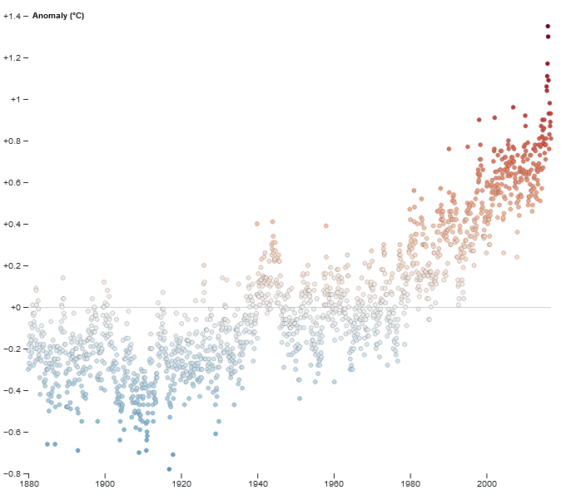

[15]

A multi-line chart could be used to display the levels of various atmospheric gases, as shown below. This graph, upon hovering over an individual data line, could display a specific gas with its name appearing as a label.

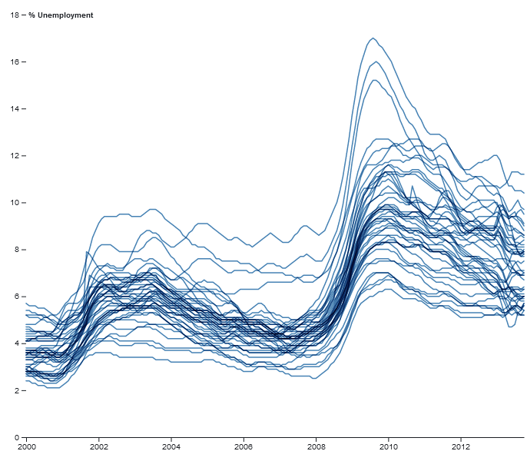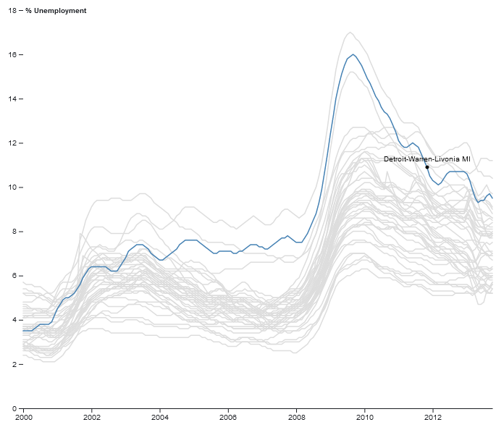

[16]

# Bibliography

1. Lecture notes provided on Canvas
2. Arctic Sea Ice: The New Normal

<https://sos.noaa.gov/datasets/arctic-sea-ice-the-new-normal/>

1. Quick Facts on Arctic Sea Ice

<https://nsidc.org/cryosphere/quickfacts/seaice.html>

1. Warming at the poles will soon be felt globally in rising seas, extreme weather  
   <https://www.nationalgeographic.com/science/2019/12/arctic/>
2. Re-calibration of Arctic sea ice extent datasets using Arctic surface air temperature records  
   <https://www.heartland.org/publications-resources/publications/re-calibration-of-arctic-sea-ice-extent-datasets-using-arctic-surface-air-temperature-records>
3. Improved data set shows no global warming ‘hiatus’  
   <https://theconversation.com/improved-data-set-shows-no-global-warming-hiatus-42807>
4. Daily Sea Ice Extent Data  
   <https://www.kaggle.com/nsidcorg/daily-sea-ice-extent-data>
5. Sea Ice Prediction Network – Data Sets  
   <https://nsidc.org/data/sipn/data-sets.html>
6. Definition of “ice extent”  
   <https://nsidc.org/cryosphere/glossary/term/ice-extent>
7. IMS Daily Northern Hemisphere Sea Ice Coverage  
   <https://www.kaggle.com/lsind18/ims-daily-northern-hemisphere-snow-and-ice>
8. World Glacier Inventory  
   <https://www.kaggle.com/nsidcorg/glacier-inventory>
9. Antarctica’s contribution to global sea level rise  
   <http://www.antarcticglaciers.org/2013/01/antarcticas-contribution-to-global-sea-level-rise/>
10. Arctic sea ice summer minimum 2020  
    <https://www.climate.gov/news-features/understanding-climate/climate-change-minimum-arctic-sea-ice-extent>
11. Antarctic Melt Rate Has Tripled in the Last 25 Years  
    <https://www.scientificamerican.com/article/antarctic-melt-rate-has-tripled-in-the-last-25-years/>
12. D3 Example: Global Temperature Trends  
    <https://observablehq.com/@mbostock/global-temperature-trends>
13. D3 Example: Multi-Line Chart  
    <https://observablehq.com/@d3/multi-line-chart>