**Tell me about yourself:**

My name is Deivakumaran Dhanasegaran, a Software Developer and I am currently pursuing Master of Science in Information Systems at Northeastern University with the focus on big data. I have two years of professional work experience as a Software Engineer in Aricent, India where I gained hands on experience in Java web development and database management. I have worked on various projects by directly interacting with client such as Cisco , Coriant .

From my experience as Software Engineer, I have gained hands on experience in languages such as JavaScript /HTML/CSS which are used for front end development and Java that used for backend development stuff (software that running on server). I have also designed, developed and maintained back end database MySQL which we have used for Database connectivity to the web application.

Further, with the successful completion of automatic manual reservation tool project, I got an opportunity to present my project in front of the client and received ‘Vibrant Player’ Award from them.

I am enthusiastically looking for a big data development opportunity to join your organization to optimize the acquired skills and gain more exposure to develop new skills in future.

**What is your Short term goals?**

**I want to see myself as a effective and efficient software developer where by with all my skills and enhanced learning I shall be able to make valuable and meaningful contribution to the organization where I am working for.**

**Where do you see yourself in 5 years?**

**In 5 years I like to become software architecture of a company .In order to gain this position I like to be efficient software developer where by with all my skills and enhanced learning I shall be able to make valuable and meaningful contribution to the organization where I am working for.**

**What is your long term goals?**

Although I really enjoy working as a software Engineer , I want to eventually become project manager thereby I shall be able to make upa valuable and meaningful contribution to your organization.

**What is your weakness?**

As far as weaknesses, at my previous job sometimes I am very shy to ask technical questions but I constantly worked on it. Since, master degree in USA provides global exposure it has helped me lot to overcome this. Now I feel comfortable interacting with different kind of people.

**What is your strength?**

* My biggest strength is self-confidence
* Since I am quick learner I am flexibility to handle new things in the changing field of engineering and technology.
* Since I pay attention to details, I am patient enough to solve complex problems

**Why should I hire you?**

I am self-motivated, quick learner and a hard working one I can complete my work within stipulated time. I can work easily under pressure as well as in the team.

With all my technical skills and enhanced learning I shall be able to make valuable and meaningful contribution to the organization where I am working for. **.**

I have the capability to put all my efforts for good progress of my organization and try my best to fulfill all needs of the company from me with honest and smart work.-

**Can you work under pressure?**

I enjoy working under pressure because I believe it helps me grow.

In my previous experience, since I work in agile software development methodologies I complete my deliverable in 3weeks period. Ialways worked well during deadlines, and I always learned how to work more efficiently afterwards. I work well under pressure because I don't panic. I maintain self-control and work as efficiently as possible.

**Why did you pursue a graduate degree and why Northeastern?**

My main objective in pursuing a graduate degree at Northeastern University is to enhance both managerial skills and technical skills to elevate to a leadership position and to get competitive advantage in the changing field of engineering and technology. I believe that Northeastern University, Information System program with the focus on big data analytics has renowned faculty members to guide along with an intense curriculum, experiential learning, prominent alumni and multiethnic diversity among students would be the ideal place to mold my professional career. Further, pursuing Master’s level of education will help me reach the next level of advanced knowledge and to a new horizon in Big Data; therefore Master of Science in Information Systems at Northeastern University will be a stepping stone to achieve my goal.

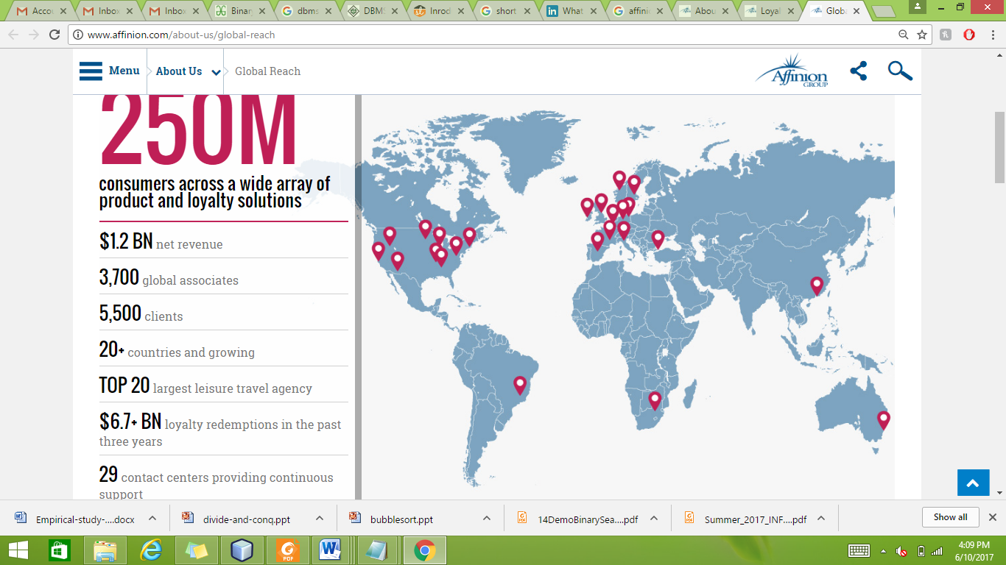

**-**

1. **Why do you want to leave your job?**

I really enjoyed working as a Software Engineer at Aricent India. The culture and the people make it a great place to work. . I have worked on and successfully completed several projects, from start to finish during the past two years. But in order to enhance my technical skills and to get competitive advantage in the changing field of Information and technology, I need to upgrade to master degree

Why Master in Information System?

My main objective in pursuing a graduate degree is to enhance both managerial skills and technical skills to elevate to a leadership position and to get competitive advantage in the changing field of engineering and technology. Pursuing Master’s level of education will help me reach the next level of advanced knowledge and to a new horizon.

**3. How do accept criticism?**

Like everyone, I have received input from my technical leader that helped me to see how my project work could be improved. Once I was asked to revise the functionality that I had spent a lot of time on, but after listening carefully to the critique, I saw how I could make changes that would strengthen the finished product. I am eager to learn from people with different views and experiences.

“I openly accept criticism without taking any offense and politely thank the person for their comments.”

Criticism always helped be to grow as a well civilized person. So criticism is always good if it results in positive behavioral change.

**5. Do you prefer working with others or alone?**

I enjoy both working as a team and alone. Depending on the project that needs to be done, I can work independently to complete my tasks on time as I don’t need to be constantly reassured of my work., but I also enjoy brainstorming and collaborating with my colleagues as I believe much more work can be accomplished when everyone is pulled together.

**6. How do you get along with different types of people?**

On a personal level, I enjoy interacting with all types of people.

On a professional level, I have respect for all individuals that work hard and maintain a professional work environment. Provided both of those are met, I will always get along with my coworkers without any personal disagreement.

7. Give me an example of a time you did something wrong?

While working as a software engineer in critical project, I realized I was going to miss the deadline, I contacted my project delivery manager to smooth things over, and we all put in the extra hours needed to get it completed quickly.

**Loyalty programs** are structured marketing strategies designed by merchants to encourage customers to continue to shop at or use the services of businesses associated with each program.[[1]](https://en.wikipedia.org/wiki/Loyalty_program#cite_note-1) These programs exist covering most types of business, each one having varying features and rewards schemes.