Crlt+shift+b → compilar projeto
Banco Postgress → Pg Admin4
string de conexão = "Server=localhost;Username=postgres;Password=1234567;Port=5432;Database=saleswebmvcappdb;Pooling=true;MinPoolSize=1;MaxPoolSize=100;"

Dentro do Program.cs →
builder.Services.AddDbContext<MySalesWebMvcContext>(options =>
options.UseNpgsql(
builder.Configuration.GetConnectionString("MySalesWebMvcContext"),
npgsqlOptions => npgsqlOptions.MigrationsAssembly("MySalesWebMvc")
)
);
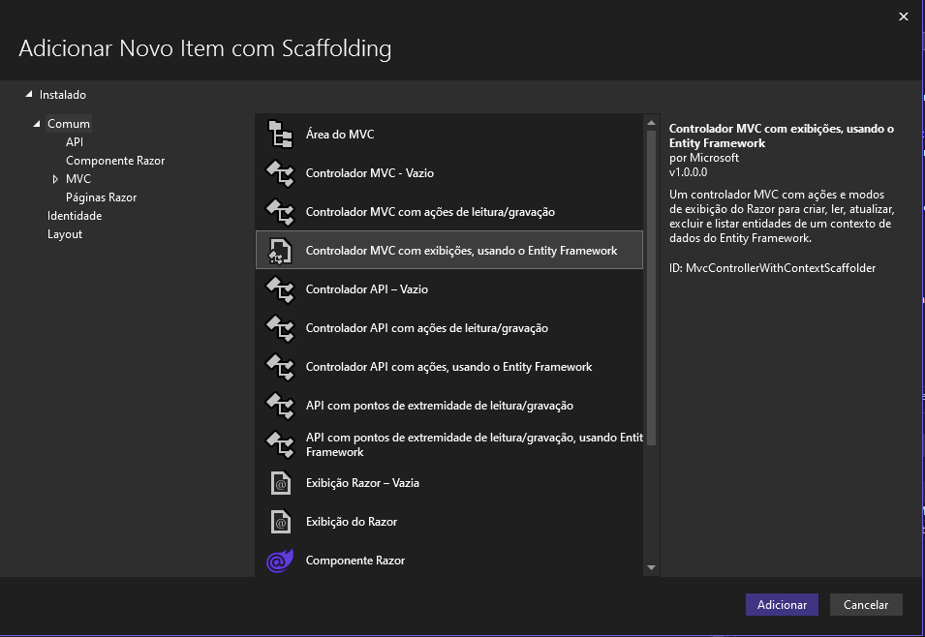
UseNpgsql → necessario baixar a dependencia no nuget – ferramentas/gerenciador de pacote do nuget/console do gerenciador do nuget; irá abrir o console
Para o dotnet 6 seria esse comando
Install-Package Npgsql.EntityFrameworkCore.PostgreSQL -Version 6.0.10
Criar a migration -
Add-Migration Initial
Executar a migration e criar o servidor com o banco de dados, executar o comando Update-Database

