Global economic research note September 2026
Crude Driving the Global Economy
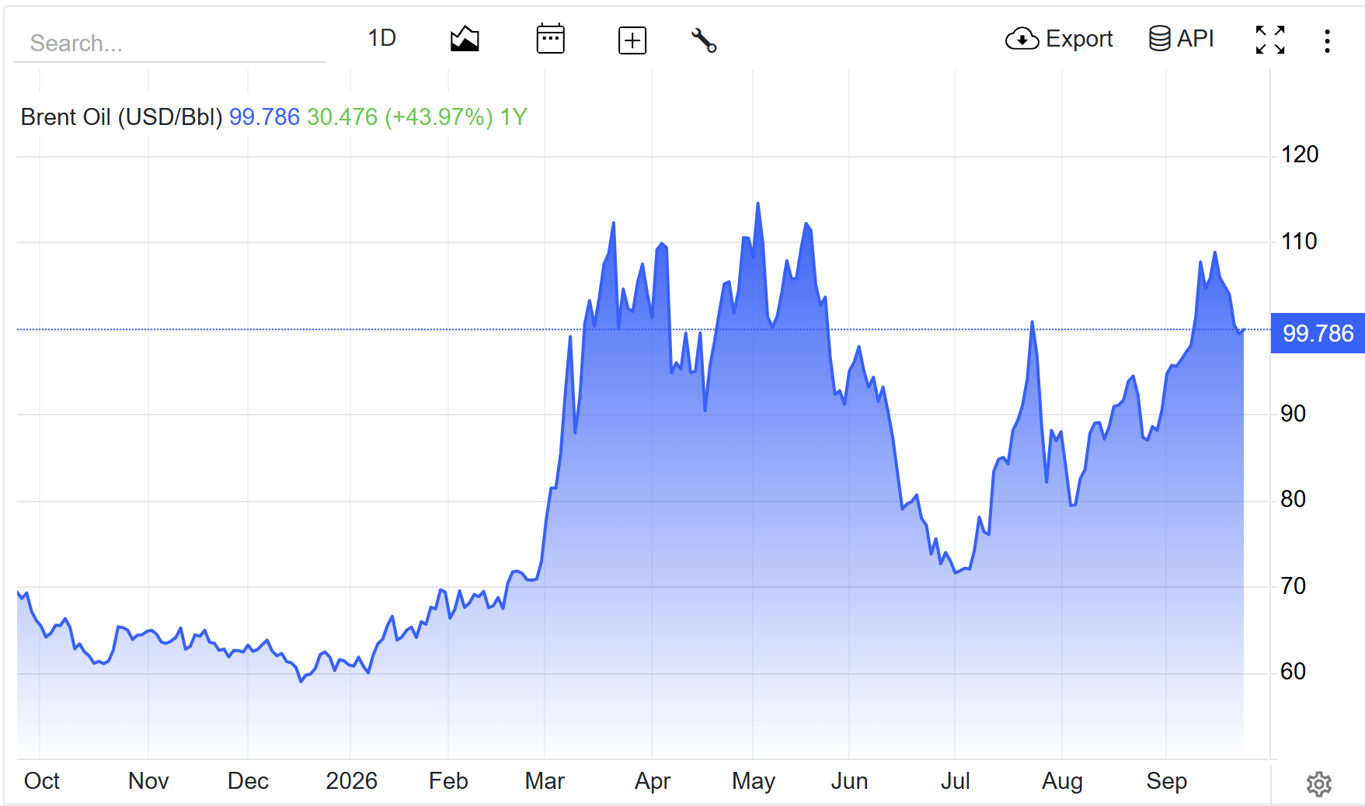
Understanding outcomes and probabilities of outcomes in the oil markets.

Despite oil exports dropping from pre war levels of 21.6 MBPD (Q4 25) to about 4 MBPD (Q2 26) out of the strait of Hormuz, we saw a decline in oil prices from its peak during Apr/May. [https://www.eia.gov/outlooks/steo/report/energysecurity/article.php]
This initial physical supply shortage was valid explanation to the price increase of brent, so why did we find ourselves at $70 a barrel in mid-July? What is the reason for this climb back up to $100 per barrel?
Many point towards dwindling oil reserves, with US oil reserves currently the lowest since initiation – they will have to restock or face salt cave walls collapsing, devastating the oil drums. ** Get some figures, and clearer sentencing here.**
But this subsequent oil price decline is better explained by 4 factors:
- Demand destruction
- Saudi East West supply pipe and UAE’s Habshan-Fujairah pipeline
- Straight is a sieve
- Inventories

Demand Destruction
Summary/quick read notes:
- Demand destruction major reason oil crisis initially subdued.
- Evidence now points to partial recovery rather than full normalisation
Peak to trough demand loss was close to 8MBPD, with the largest portion coming from Asia.
This demand destruction was much underestimated by analysts. Consensus forecasts at the beginning of the conflict anticipated only hundreds of thousands of barrels of demand destruction per day. Rather than the 8mbpd in we saw in reality.
Asian Trade Flows
Oil movements through the Strait of Malaca fell from:
- 24.9mn b/d in Q4 2025
- To 21.3mn b/d in Q1 2026
- To 16.6mn b/d in Q2 2026
This represents a 8.3mbpd or a 33% decline between Q4 2025 and Q2 2026.
This is not a direct measure of demand, rather a culmination of supply shortages, rerouting and other factors discussed later.
Refineries

Is Demand Normalising?
https://www.iea.org/reports/oil-market-report-september-2026?language=de&utm_ states a:
- 8mn b/d: maximum decline reached during the crisis
- 4.5mn b/d: Rystad’s estimate of average Q2 demand destruction
- 3.5mn b/d: Rystad’s estimate for Q3
- 2.5mn b/d: IEA forecast decline in average 2026 demand relative to 2025
- 2.6mn b/d: 2027 anticipated recovery
These figures suggest that demand destruction has peaked and is gradually fading.
Chinese Demand
Chinese crude imports have moved from approx. 7mn b/d in June (41.3% lower than the previous year) to 8.6mbpd in august. A 23% increase MoM and an indication of demand destruction normalising.
How far will this go?
Graph of Chinese Crude Oil Imports - https://tradingeconomics.com/china/crude-oil-imports
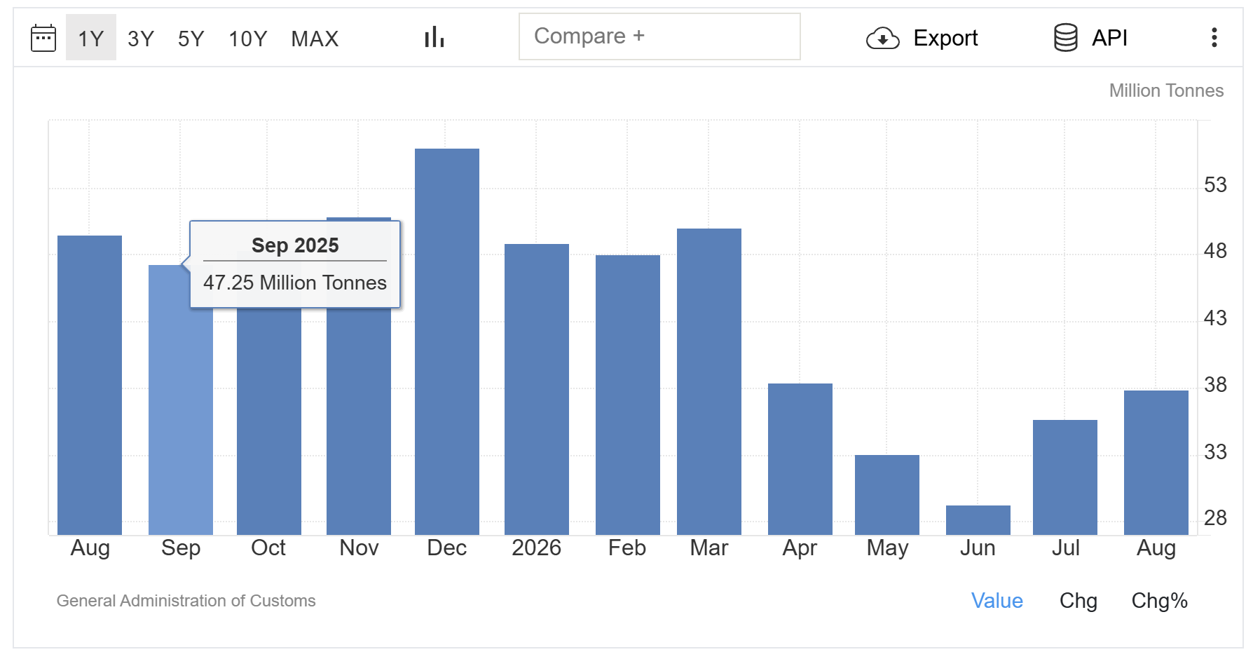
It will be interesting to see September figures for Chinese crude oil imports.
How much Chinese demand has really been destroyed?
https://www.reuters.com/business/energy/china-oil-demand-fall-89-2026-sinopec-research-says-2026-09-09/
mentions that Sinopecs research arm forecasts Chinas oil demand will fall 3.9% in 2026. This will make the third consecutive year of contraction.
With 2026 estimates of:
- Gasoline -8.7%
- Diesel demand -11.7%
- Jet fuel +1.7%
This data is equivalent to around 600,000 bp/d decline. Partly cushioning the loss of Middle Eastern supply.
India: Less evidence of demand destruction
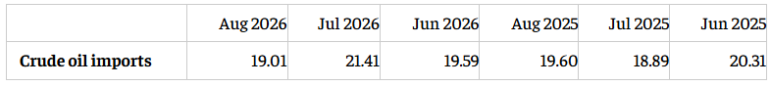
Some articles (https://economictimes.indiatimes.com/industry/energy/oil-gas/indias-august-crude-oil-imports-fall-over-11-month-on-month/articleshow/134333444.cms?utm_source=contentofinterest&utm_medium=text&utm_campaign=cppst) and others point toward demand destruction in India but when checking the numbers it doesn’t seem as likely:
https://economictimes.indiatimes.com/industry/energy/oil-gas/indias-august-crude-oil-imports-fall-over-11-month-on-month/articleshow/134333444.cms
this tells a story of pretty consistent oil imports and demand.
August imports fell approximately:
- 11.2% month on month
- But only 3.0% year on year

Its reported that India have replaced disrupted Gulf barrels through alternative suppliers. Namely being Russia; India imported approx. 2.1 mnbpd from Russia in august approx. 47.3% of their total supply.
- Add link to Russia story (cover this later)
Unlike China, India has so far displayed limited evidence of sustained crude-demand destruction. Imports were only 3% lower year on year in August, with refiners replacing disrupted Gulf barrels through Russian and other alternative suppliers. Nevertheless, weaker domestic fuel consumption indicates that high prices may be starting to affect end-user demand.

Russia Story

Links to a separate story on green energy transition.
Inventories
According to X the total global inventory draw was approximately 566mn barrels.
Average draw was approx. 3.06mn b/d
How does this compare with the Hormuz flows?
Pre was there was approx.:
- 16mn b/d of crude and condensate
- 4mn b/d of refined products
Over 184 days this represents 3.68bn barrels. (20mn b/d x 184)
So you can estimate that 15.4% (566 / 3,680) of global oil was supplied by reserves.
So the rest of the supply must be coming from other sources.
3. Bypass routes
There are three main bypass routes with different levels of capacity, restraints and risks.
Saudi Arabia’s East-West Pipeline
Approx. reported capacity of 7mn b/d transporting crude from the East to Yanbu on the Red Sea. When considering the Yanbu’s operational capacity and deliveries to Saudi refineries along the Red Sea, this capacity figure is closer to 4/5mn b/d.
During June Saudi Arabia was rerouting ~4% of global oil supply, roughly 4mn b/d.
**Scenario analysis of likely news reports and potential trades:
- Pipes get attacked again, how much did fuel go up last time? Then dropped $2 when reports came out that it was being fixed.
  - Create a trade that executes a buy order on crude based on news, hold to a certain take profit level.
  - Create a sell order when news comes out that the pipe is being fixed.
  - How quick would you have to be for this to work? How can you set this up?
UAE Habshan-Fujairah Pipeline
Reported capacity of 1.8mn b/d, it delivers crude to Fujairah on the Gulf of Oman, allowing exports to avoid the Strait of Hormuz completely.
How much supply is actually being rerouted?
The IEA estimates that combined exports through Yanbu and Fujairah moved from approximately:
- 4.1mn b/d in February
- 7.8mn b/d in June
- 5.5mn b/d in August
The increase between February and June was approximately 3.7mn b/d.
This additional bypass capacity was equivalent to:
- approximately 17% of total pre-war Hormuz flows of 21.6mn b/d; or
- approximately 22% of the 16.7mn b/d decline in Hormuz flows between Q4 2025 and Q2 2026.
September 11 attacks
These routes have become targets themselves. Three of the pipelines 11 pumping stations were damaged, causing the pipeline to close and the price of crude to spike.
The attack was launched from Iraqi territory and was attributed by Saudi Arabia and other reports to be initiated by Iran aligned Iraqi militias. The accused groups have denied responsibility.
In my view discovering whether Iran ordered the attacks or not is unimportant. What it does highlight is how easily one of the leading pressure release valves of global inflation can be disrupted. With a handful of inexpensive drones, the attackers were able to raise oil prices by roughly 5%. Assuming the attacks are a result of Iran, this means that they can strategically apply pressure to both Hormuz and the largest bypass route without openly attacking Saudi Arabia and with the uncertainty on who carried out the attack it makes direct retaliation more difficult; a big win for Iran.
This potentially gives greater leverage in upcoming peace talks with Mr Trump.

The good news is that there was a quick turnaround in fixing these pipelines, they are already operational but at around 40% of capacity. This news of the pipeline restarting had an immediate effect on the price of crude which dropped $2 to $97 over the course of X time.
The houthis in yemen, something that the US usually takes care of for Saudi Arabia but no longer can because of their lack of recourses whilst dealing with the srait of Hormuz and iran. The pot is stirring and leaving Mr Trump with a tough decision as mid terms approach and declining approval ratings

