Project: Todo Web Application
Course: CSD 380 DevOps
Description: Functional test plan based on “Todo Business Requirements” for the Todo application deployed
Date: 2025/11/14
.
TABLE OF CONTENTS
Test 1 - 2 2
Test 2 - 4 3
Test 4 - 5 4

Test 1 | Access the website through the provided URL, and the page will load.
 | Test Objective: Allows the user to visit the website (https://buwebdev.github.io/todo/) | Developer: Kris Kuenning  Date tested: 2025/11/14 | Peer tester: Juedeja Richard  Date tested: 2025/11/15
Step | Action | Expected results: | Developer pass/fail | Tester pass/fail  + Screenshot
1 | Open a web browser | Any web browser you choose to use will run smoothly without encountering network errors or 404 connection errors. | yes | Yes  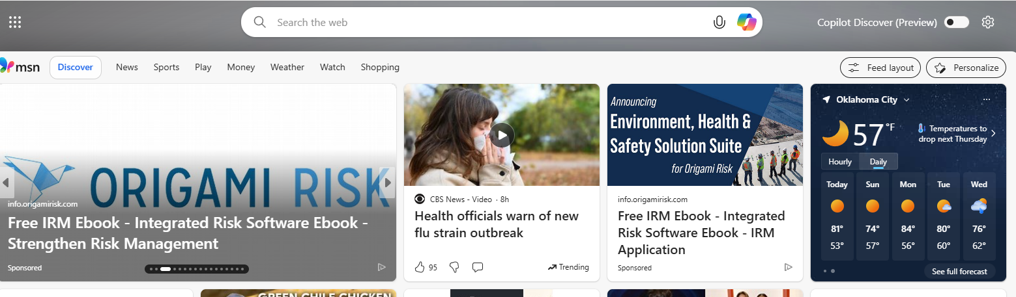
2 | In the address bar, enter https://buwebdev.github.io/todo/ and press Enter. | The ToDo application loads without a network error or 404 connection error. | yes | Yes  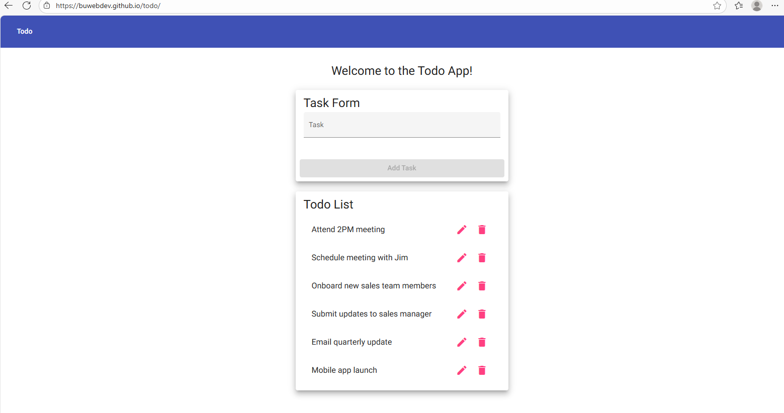
3 | Validate the browser behavior as the page loads. | The ToDo application loads without a network error or 404 connection error. | yes | Yes  
4 | Refresh the browser window. | The ToDo application loads without a network error or 404 connection error. | yes | Yes  
5 | Close the window and redo steps 1-3 | The ToDo application loads without a network error or 404 connection error. | yes | Yes  
Comments | Very specific steps. Todo list loads in Microsoft Edge and Chrome Browsers

Test 2 | View the list of ToDo task items.
 | Test Objective: View the list of ToDo task items | Developer: Kris Kuenning  Date tested: 2025/11/14 | Peer tester: Juedeja Richard  Date tested: 2025/11/15
Step | Action | Expected results: | Developer pass/fail | Tester pass/fail
1 | Test 1 has passed (site loads successfully) | The site is now open and ready for use. | yes | Yes  
2 | Observe the section of the page where to-do items should display | Each todo item shows | yes | Yes  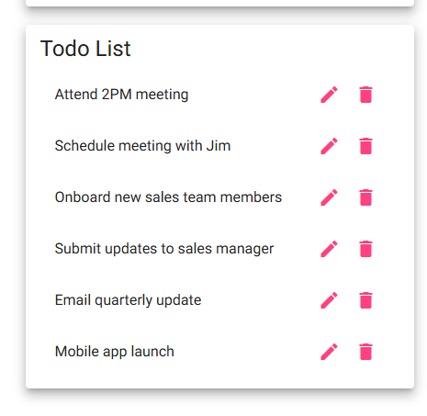
Comments | Todo list comes pre-populated with list items and is easy to see and read

Test 3 | Create a new ToDo item & prevent empty submissions.
 | Test Objective: Create a todo item while preventing submission | Developer: Kris Kuenning  Date tested: 2025/11/14 | Peer tester: Juedeja Richard  Date tested: 2025/11/15
Step | Action | Expected results: | Developer pass/fail | Tester pass/fail
1 | Locate the “new todo” input on the main page. | Your cursor should be ready to type a new to-do task in the empty bar. | yes | Yes  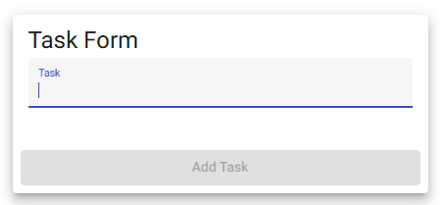
2 | Click into the input field and enter a valid task description | A new task item with the entered description appears in the list. | yes | Yes  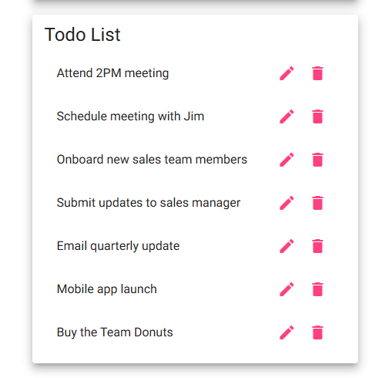
3 | Click the Add/Submit button with the input field. | The new item is displayed in the same format as other items. | yes | Yes  
4 | Ensure the “new todo” input field is empty | The system does not create a new todo item. | yes | Yes  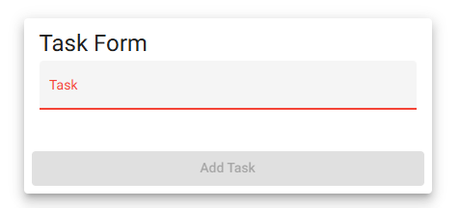
5 | Click the Add/Submit button without entering any text. | The list of todo items remains unchanged. | yes | Yes  
Comments | A confirmation that the item was added to the list could help ensure the user it is working properly without having to check each item themselves. Everything passes for this Test

Test 4 | Delete an existing ToDo item.
 | Test Objective: Delete a ToDo item | Developer: Kris Kuenning  Date tested: 2025/11/14 | Peer tester: Juedeja Richard  Date tested: 2025/11/15
Step | Action | Expected results: | Developer pass/fail | Tester pass/fail
1 | Identify an existing ToDo item in the list. | Task is checked off. | yes | No  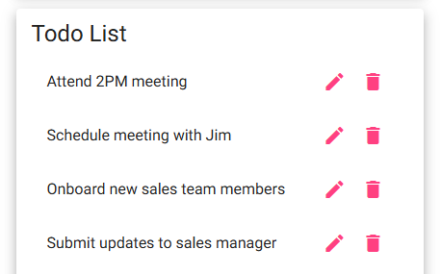
2 | Click the Delete control associated with the item. | The selected todo item is removed from the list. | yes | Yes  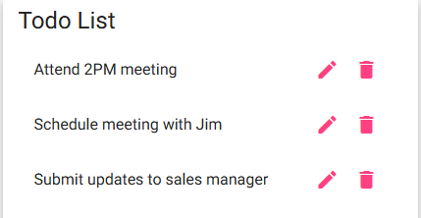
Comments | Items do not get checked off but they do get removed from the list. Items do reappear after refreshing the page

Test 5 | 404 page for invalid URLs
 | Test Objective: Provide users with a custom 404 error page. | Developer: Kris Kuenning  Date tested: 2025/11/14 | Peer tester: Juedeja Richard  Date tested: 2025/11/15
Step | Action | Expected results: | Developer pass/fail | Tester pass/fail
1 | In the browser of your choice, enter an invalid URL under the ToDo site. Try (https://buwebdev.github.io/todo/nonexistent) | A custom 404 page created by the application is displayed. | yes | No  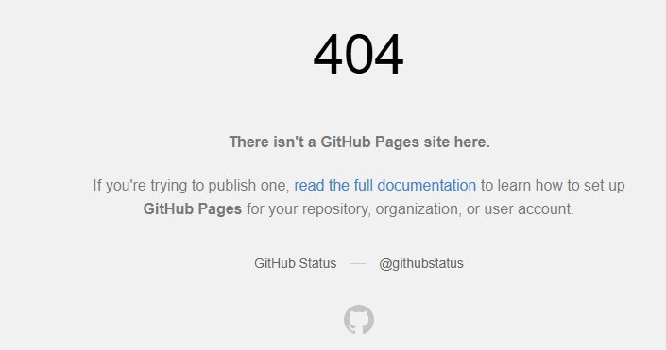
2 | Press Enter and record the page that loads. | The page indicates the requested page was not found. | yes | Yes  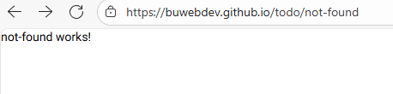
Comments | No custom 404 page, just default 404 or blank page with “not-found works!”

