The Decimal Function can be used when you need to Convert an Int to a Float to have the same data types for a division operation done to the data

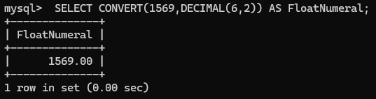

Date_Format function ensures that multiple date entries have the same order and display for a shipping report. All Numerical, all character or a mix of the two

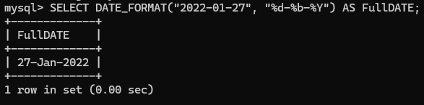

Position Function acts like an Index does for Dictionaries like trying to find the number that corresponds to the name “Athena” in a performance review

