City_functions.py

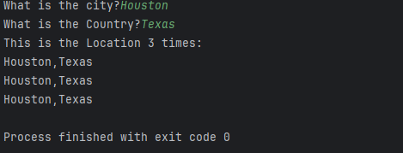

Test_citites.py

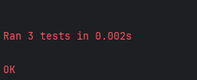

Added population parameter

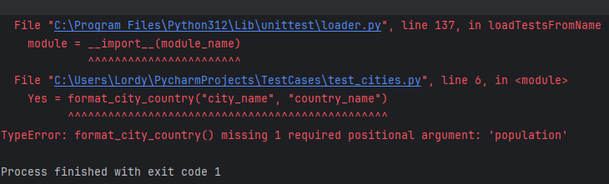

Made population optional

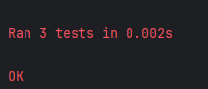

Added language parameter

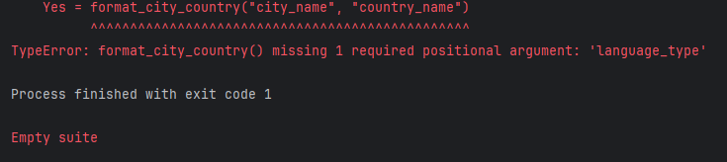

Made language optional

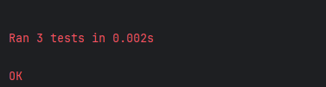

Called function 3 different times in 3 different ways

