GitHub repository Link: [Deja-R-Git/csd-402: Java for Programmers with Josh Guardino](https://github.com/Deja-R-Git/csd-402)

GitHub repository

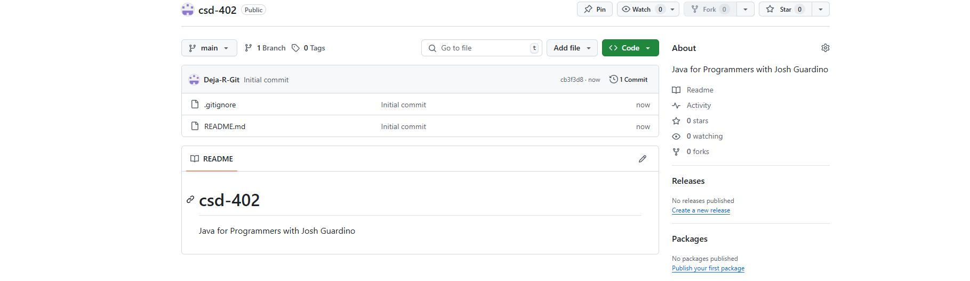

Local Directory

